# HexagonTool v1.20

The Tools HexagonTool lets you create hexagons for your current map extent or around a selected polygon.

You access the functionality of the tool from the “*Regions*” dropdown in the “*Edit*” group on the “*Spatial*” tab. Click on the “*Hexagon*” button.

Before activation the tool consider what input area you want to provide to the HexagonTool. As mentioned above, it can be the current extent of your map window or a selected polygon.

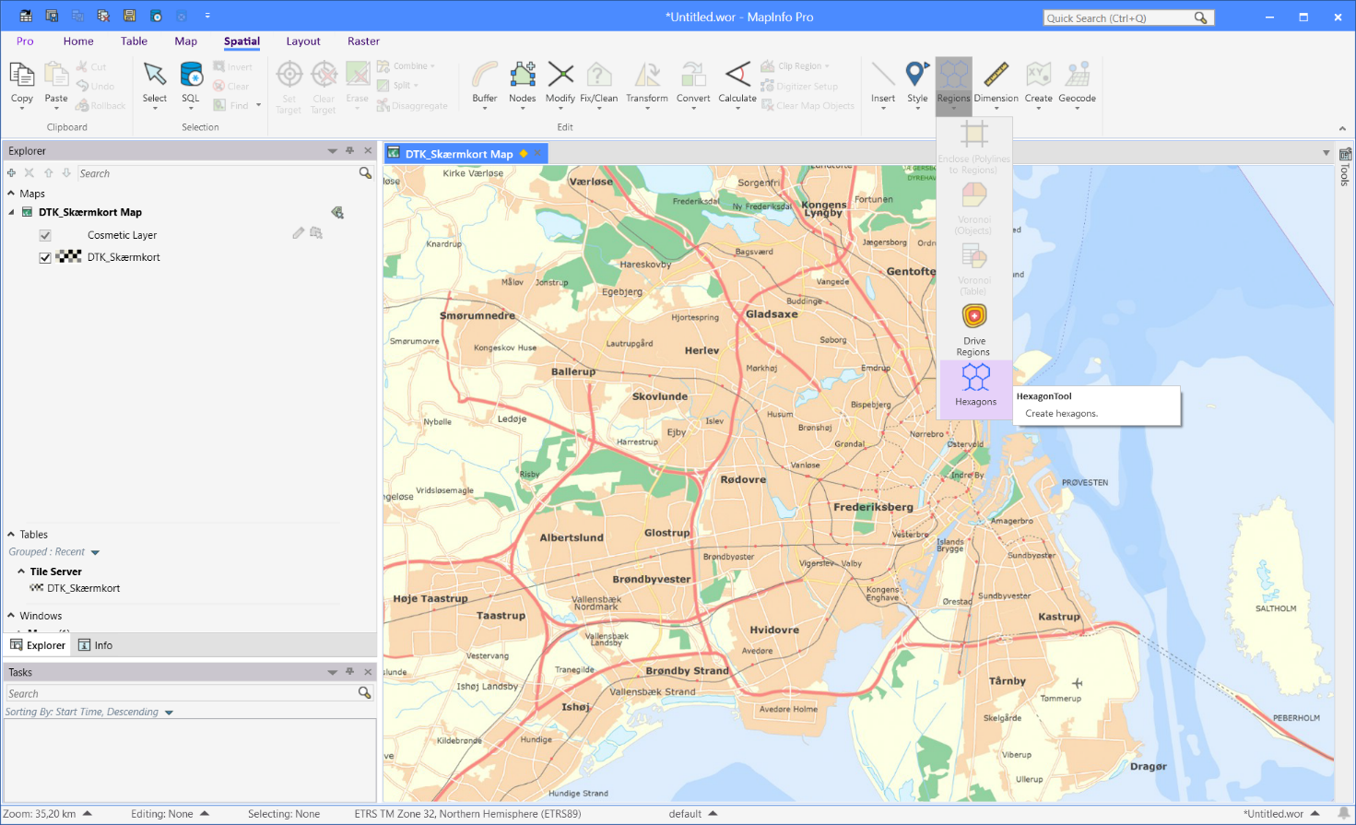

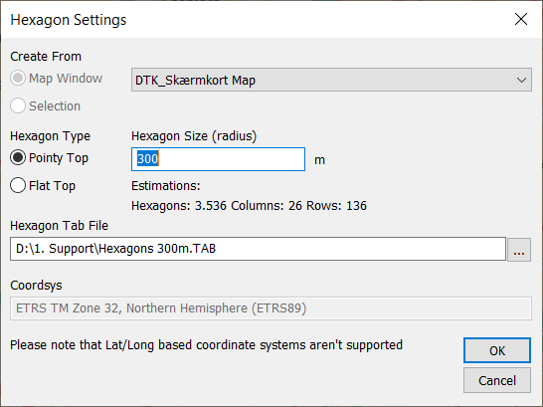In the dialog “*Hexagon Settings*” you can control the type and size of the hexagons, and the area you want them to cover.

You will also specify the location of the file for the hexagons.

You can create hexagons with a flat top or hexagons with a “pointy” top.

You also need to specify the size of the hexagons. The size is specified by the distance from the center to each of the six nodes in the hexagon.

Notice that the dialog gives you can estimation of how many hexagons will be created. This depends on the size, the type and the area you want them to cover. You can switch between the two Hexagon Types to refresh the estimated number of hexagons.

Below you can see the coordinate system that will be used when creating the hexagons. Notice that this tools does not support Lat/Long based coordinate systems for the hexagon creation.

Click the “*OK*” button to start the hexagon creation.

Once created the table with the hexagons will be added to your map.

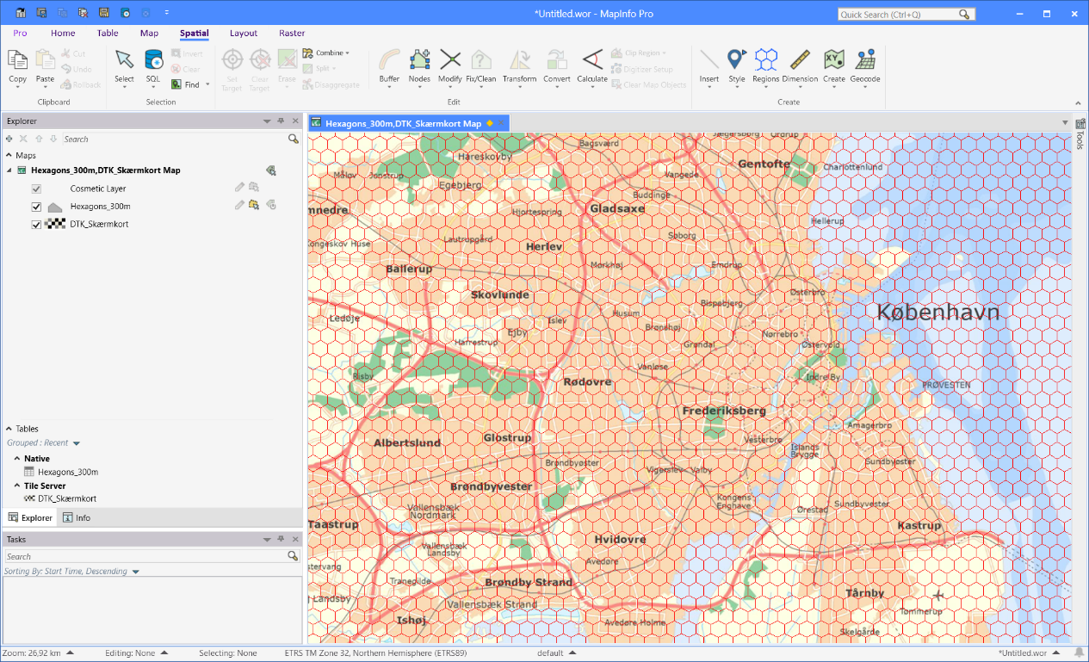

You can now for example use Update Column to add a count of points such as addresses or people within each hexagon and create a thematic to illustrate the density of these data points.

