# InfoSelHandler 3.3

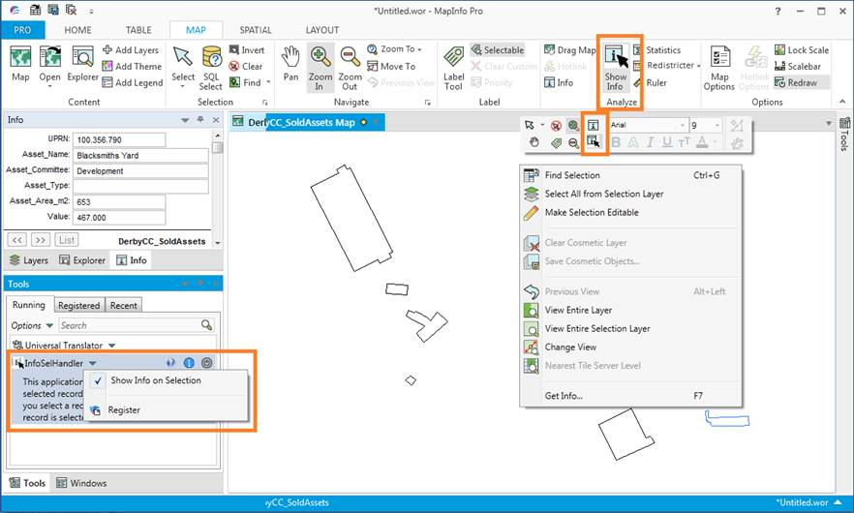

# Install InfoSelHandler

You install InfoSelHandler by downloading the InfoSelHandler.zip file. Extract the files into a new folder or into the folder with your other MapInfo tools.

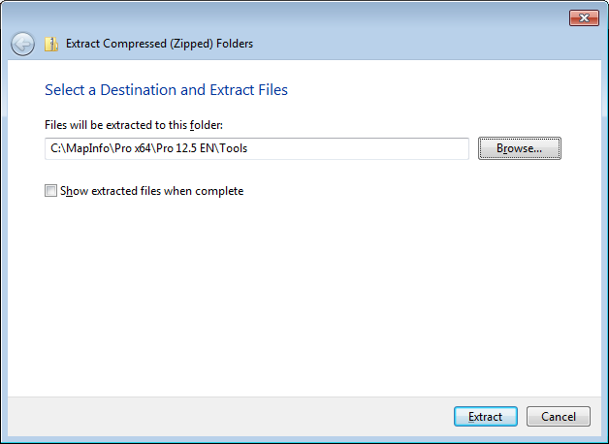We recommend installing InfoSelHandler into its own folder and not install it directly into for example the tools folder.

With InfoSelHandler you can use the standard Extract function in Windows 7 and just pick the location to unzip the file. The zip file contains a sub folder and so InfoSelHandler will be installed into its own subfolder.

## Add tool to Tool Manager

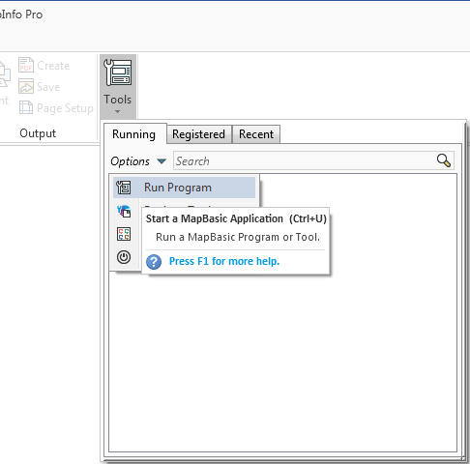Go to Home > *Tools* and click on the *Run Program* in the *Options* menu.

Now navigate to the location where you unzipped InfoSelHandler and select the file InfoSelHandler.mbx.

Once the tool has been loaded you can go back to the Tools and click on context menu of InfoSelHandler in the list of Running tools.

Then click on *Register* to add InfoSelHandler to the list of registered tools.

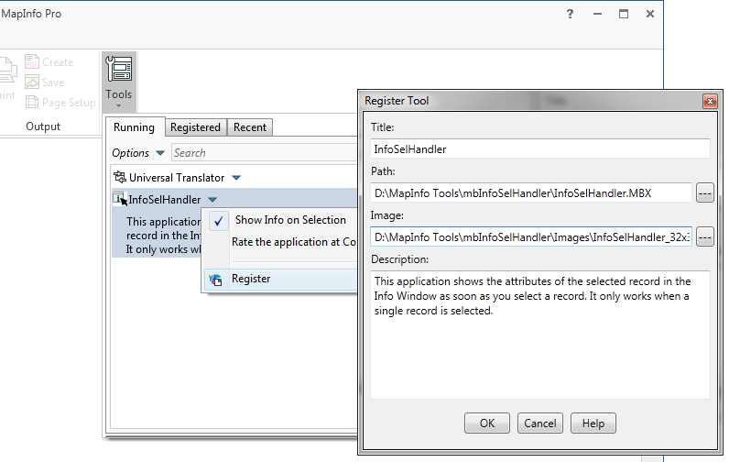

Notice that the values have been prefilled for you so you just have to hit OK to add InfoSelHandler to the list of tools.

Click *OK*. Go back to the *Tools* window select the Registered tab to see the registered tools. Here you can check the *Autoload* checkbox for this tool to load it whenever MapInfo Pro starts up.

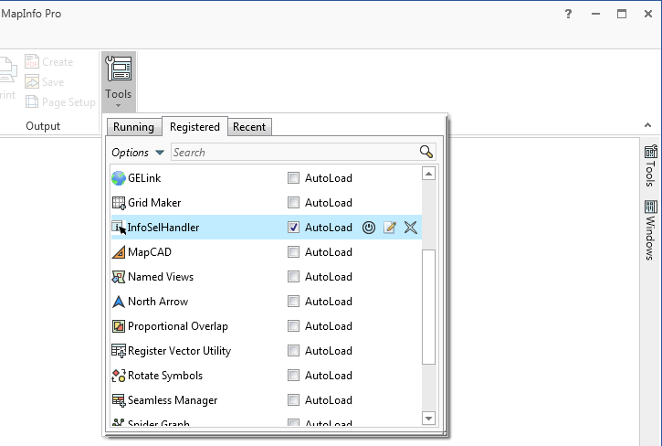

# What’s new

## Version 3.3

The application has been compiled for MapInfo Pro 16.0 and will no longer work with older versions of MapInfo Pro.

The button has been moved to the group *Options* on the *MAP* tab.

The application no longer adds button to the Map Mini Toolbar if you are running MapInfo Pro 17.0 or newer.

## Version 3.2

To support MapInfo Pro 15.2 we had to change some function calls that were using WinAPI calls to find files in a folder.

No new features have been added.

## Version 3.1

We received some reports of errors occurring when using Close All while an object was selected. When doing so, two dialogs appeared saying “Table cannot be opened”.

We have fixed this issue when running MapInfo Pro 64 bit.

If you are running MapInfo Pro 32 bit, you will have to add this line to the configuration file (InfoSelHandler.ini) that can be found in the installation folder of the tool:

SHOWINFOONDESELECT=0

Make sure you insert the line below the Settings section ([SETTINGS]). If the line already exists in the configuration file, make sure the value is set to 0 and not to 1.

This setting will disable the show info on deselect feature of InfoSelHandler. This means that the tool will no longer show the information of the latest deselected record in the Info window.

# The features

InfoSelHandler only has two basic features:

* It can show the attributes of the selected/deselected record in the Info tool window
* It adds the Info tool to the Map MiniToolbar

You only have to select or deselect an object and the InfoSelHandler tool will immediately show the attributes of this record in the Info tool window.

If you are running InfoSelHandler on MapInfo Pro 16.0 it will also add the Info tool to the Map MiniToolbar

You can enable/disable the feature via a few ways:

* On the *MAP* tab in the *Analyze* group, click *Show Info* to enable/disable SelInfoHandler
* In the *Tools* window, on the context menu on the SelInfoHandler tool, click *Show Info on Selection* to enable/disable SelInfoHandler
* On the *Map MiniToolbar* click on the *Show Info* button to enable/disable SelInfoHandler

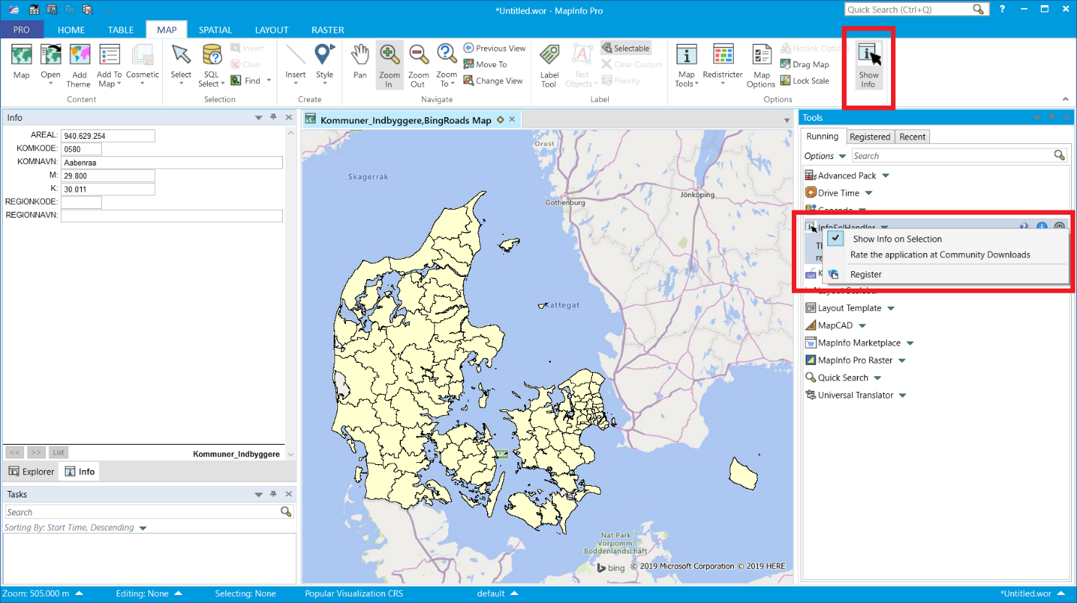

# Languages

InfoSelHandler allows the user to switch between multiple languages.

The user can extend the list of languages - see further down.

### Switching language

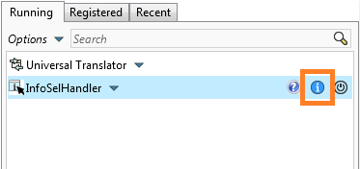To switch language you simple go to the Tool window and locate InfoSelHandler in the list. Now click on the Info icon.

In the About dialog you can see the available languages in the dropdown list.

You can pick any of the available languages.

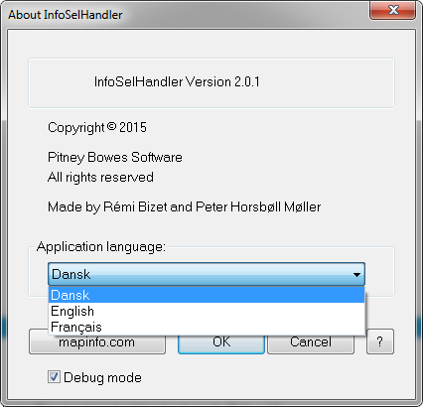

When you click a different language, do note that the language used will not change in the menus until you restart InfoSelHandler.

### Adding your own language

You can add you own language if you like simply by creating a copy of one of the existing language files (*.str) that you can see in the Folder called *Strings* in the folder where you installed InfoSelHandler.

You can name your language file whatever you want. I would recommend that you name it like the name of the language, German.str, Greek.str and so on.

Now open the new language file in a text editor and translate the existing strings.

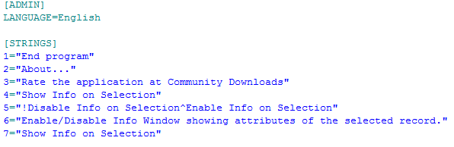Make sure that you also change the name of the language in the top of the language file.

Save the changes and restart InfoSelHandler. The new language will now be available in the about box.