**MapInfo2Excel 2.3**

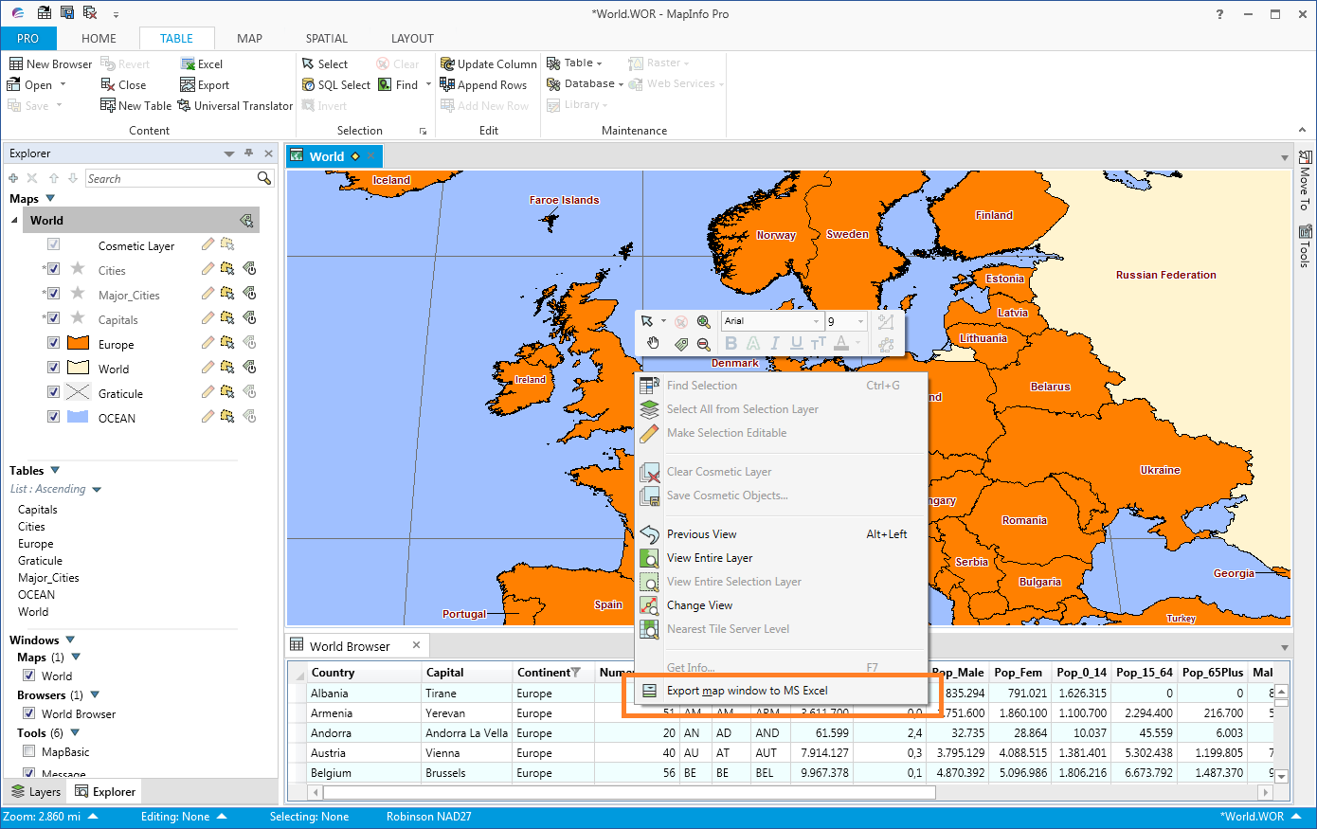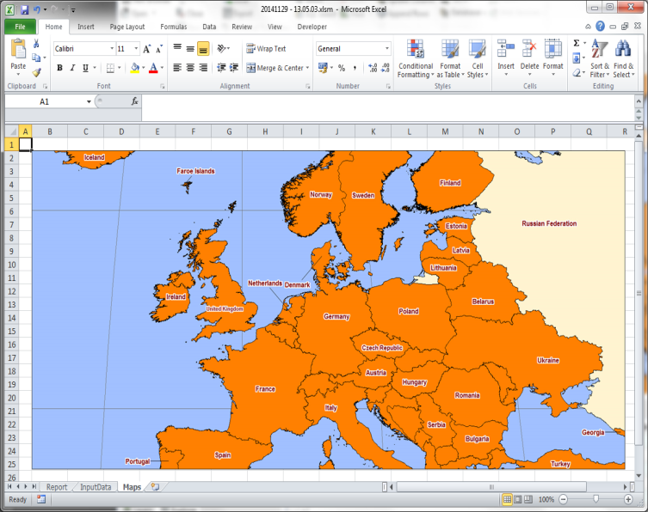

# About MapInfo2Excel

MapInfo2Excel is a tool that helps you to get data from a MapInfo table within MapInfo Pro to an Excel file.

This data can be an entire MapInfo table, a query or the data that you currently are viewing in your browser window.

MapInfo2Excel lets you also export a map window to an open MS Excel file.

To get the most out of this tool, it’s recommended to register the tool in the Tools Window and set it to Autoload.

The features of this tool have all been made in response to requests from customers.

MapInfo2Excel 2.3 is made for MapInfo Pro 15.2 x64 so it will not run on an older version. If you are using an older version, you can use MapInfo2Excel 1.8 that has been made for MapInfo Pro 11.5.

If you have any requests or feedback on the MapInfo2Excel tool, please send your feedback thru the MapInfo Pro Community, [communities.pitneybowes.com](https://community.pitneybowes.com/communities/community-home/digestviewer?CommunityKey=fe4d1ee2-f1c6-4307-87d2-00bea1344885).

# Install MapInfo2Excel

If you download the MapBasic tool from the MapInfo Marketplace in MapInfo Pro 17.0.3 or newer, you don’t need to worry about the installation process. MapInfo Pro will take care of this for you.

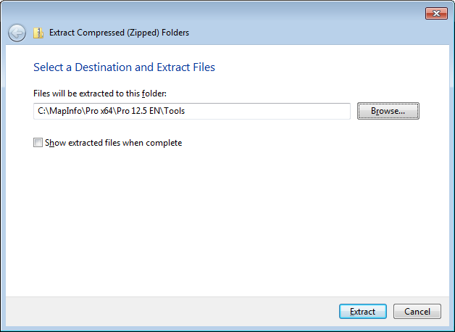You install the MapBasic tool by downloading the ZIP file. Extract the files into a new folder or into the folder with your other MapInfo tools.

We recommend installing the MapBasic tool into its own folder and not install it directly into for example the tools folder.

With this ZIP file, you can use the standard Extract function in Windows and just pick the location to unzip the file. The zip file contains a sub folder and so the MapBasic tool will be installed into its own subfolder.

## Add tool to Tool Manager

If you download the MapBasic tool from the MapInfo Marketplace in MapInfo Pro 17.0.3 or newer, you don’t need to worry about adding the tool to the Tools Manager. MapInfo Pro will take care of this for you.

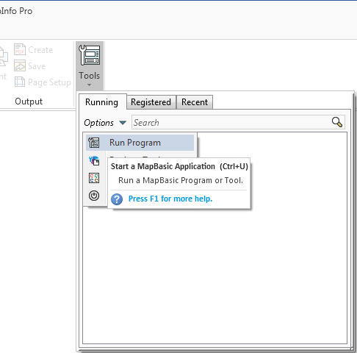Go to Home > *Tools* and click on the *Run Program* in the *Options* menu.

Now navigate to the location where you unzipped the MapBasic tool and select the file MBX file.

Once the tool has been loaded you can go back to the Tools and click on context menu of InfoSelHandler in the list of Running tools.

Then click on *Register* to add the MapBasic tool to the list of registered tools.

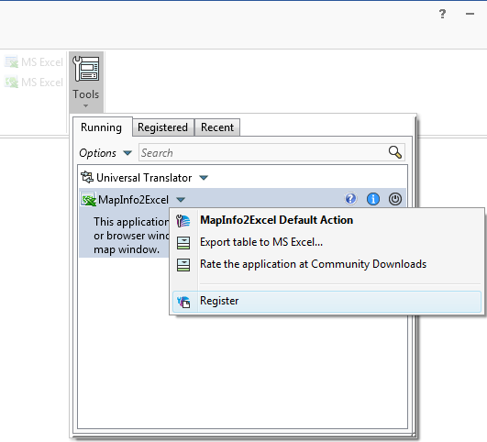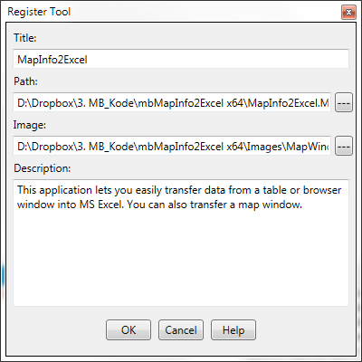

Notice that the values have been prefilled for you so you just have to hit OK to add the tool to the list of tools.

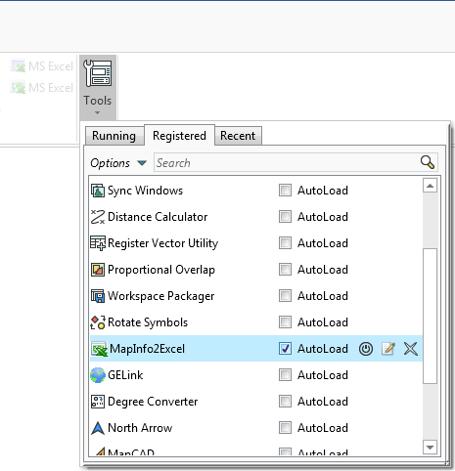Click *OK*. Go back to the *Tools* window and select the *Registered* tab to see the registered tools. Here you can check the *Autoload* checkbox for this tool to load it whenever MapInfo Pro starts up.

# New features in MapInfo2Excel 2.x

## 2.30

The language files are now saved using UTF-8, which makes it possible to save special characters in these files. This makes it also possible to read the files on computer that don’t use typical European/Western character sets/locales.

On first launch, the tool will pick up the language of MapInfo Pro and use this if it’s supported. Otherwise, it will switch to English.

The link to the Community Download page has been removed.

## 2.20

### Wait time

We saw a couple of times where Excel was too slow when starting up for MapInfo Pro to wait for it. We have therefor added a Wait Time setting that can be used to set MapInfo2Excel to wait a second or so before continuing after having launched Microsoft Excel.

The issue was first seen with Microsoft Excel 2016

### Output file validation

We have also added a output file validation which checks that the correct file type and an existing output folder has been given before continuing the export operation.

### Larger dialogs

Some of the dialogs have been made larger to better show the file name and to make sure there is enough room for the translated texts.

## 2.10

We came across an issue when running MapInfo2Excel on MapInfo Pro 15.2 and 16.0. The file used to transfer data from MapInfo Pro to Excel did not get send correctly to Excel and therefor Excel was not able to load the data.

We have now fixed this issue and the data can again be send from MapInfo Pro to Excel. The fixed required us to make some changes to the application itself but also to the Excel Template file that is included. To be more specific we changed the macro called to load the data (ImportMIData).

## 2.02

### Window 8

If you were running MapInfo2Excel 2.01 on a Windows8 computer there was a big chance of MapInfo Pro crashing.

The issue has been fixed by using the new IntPtr variable in some of the WinAPI calls.

## 2.0

### Ribbon integration

As the new MapInfo Pro 12.5.1 x64 has a ribbon based user interface we decided to integrate MapInfo2Excel into this new interface instead of only having the features appear in the context menu of the tool in the Tools window.

You can now find the MapInfo2Excel features in these places:

* Home > Output > Export Table to Excel
* Home > Output > Export Map to Excel
* Table > Content > Export Table to Excel
* Table > Browser Tools > Export Browser to Excel
* Map > Analyze > Export Map to Excel

Besides these places you can also find Export Browser to Excel in the context menu of the browser window and Export Map to Excel in the context menu of the map window.

## 1.7

### Language

The biggest improvement in this release is support for several languages.

Out of the box MapInfo2Excel comes with support for English and Danish. English is the default language.

## 1.5

### Performance

In this release the speed of exporting data from MapInfo Pro to MS Excel has been improved.

Previously the data was sent from MapInfo Pro to MS Excel one value at a time using basic DDE communication.

Now we have changed this to writing the data into a semicolon separated text file and using a macro in MS Excel to import this data in this file into the sheet.

A basic test showed that exporting approximate 70 000 records to MS Excel now can be done in close to 20 seconds.

### MS Excel template file

Also notice that we have changed the template file between version 1.0 and version 1.5 and now again in version 1.5.

Between the two versions we had to update the macro that inserted images into a sheet in MS Excel as Microsoft had changed the way an image was stored.

For v1.5 we have added a new macro that allows a very fast import of the data from MapInfo Pro, see the section on Performance.

### Menu item to take you to the Community Downloads site

The tool now also has a new menu item that will take you directly to the Community Download site where you can find other useful tools – and even rate this tool.

# Features of MapInfo2Excel

When you run the MapInfo2Excel tool you will see MapInfo2Excel is being added to the list of running tools in the Tools window.

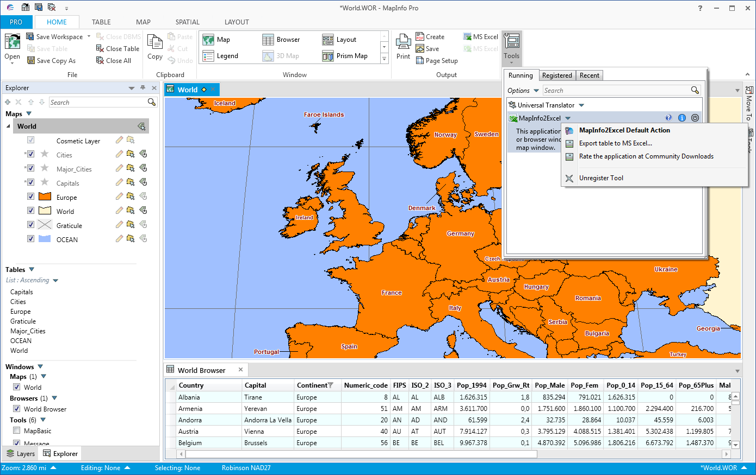

In the picture above you can see the MapInfo2Excel context menu in the Tools window.

The features of MapInfo2Excel have been integrated into the ribbon interface and are available in a number of places.

### HOME tab

The *HOME* tab holds the *Export table to Excel* and *Export Map to Excel*. They are both located in the *Output* group.

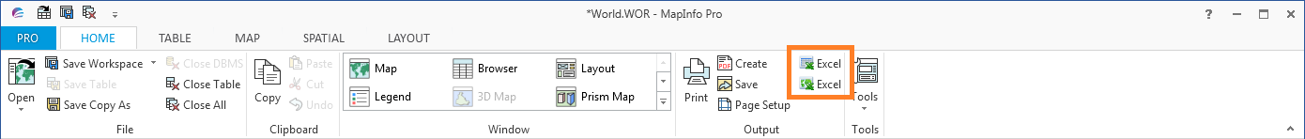

### TABLE tab

On the *TABLE* tab you can find the *Export table to Excel* option in the *Content* group.

And in the *Browser Tools* group you can find *Export browser data to Excel*. Notice that this group only is visible on the tab when you have a browser window active.

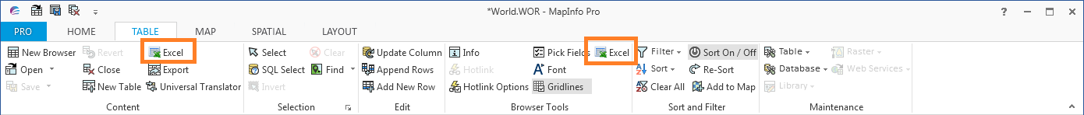

### MAP Tab

The option Export map to Excel can also be found on the MAP tab in the Analyze group

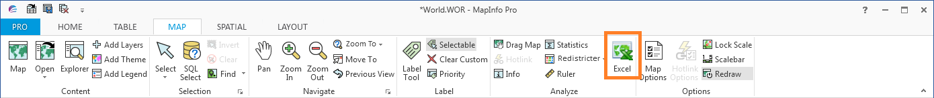

### Context menus

In the browser windows you will have access to the feature for exporting the attribute data into a new MS Excel file.

In the map windows you can export the current map window into a MS Excel file. Currently you’ll have to export the attribute data before you’ll be able to export the map window as well.

## Export a table into MS Excel

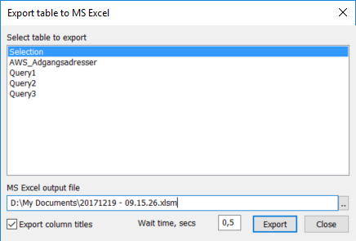You can export all the data from a table with attributes into a new MS Excel file.

You can launch this feature from:

* The MapInfo2Excel context menu in the *Tools* window and then *Export table to MS Excel*
* By double clicking on the MapInfo2Excel tool in the *Tools* window
* *HOME* tab > *Output* > *Export table to MS Excel*
* *TABLE tab* > *Content* > *Export table to MS Excel*

When you select this menu item, you will get prompted with the dialog *Export table to MS Excel*.

If you don’t have any attribute tables open, such as native tables, you’ll be told to open at least one native table.

Pick the table you want to export to MS Excel. Notice that the list will contain base tables as well as query results.

Enter the name of the output MS Excel file. By default it will get created in your “My Documents” folder and have the current date and timestamp as name. You can use the small button with the two dots (..) to select a different location and name or you can change the name directly in the text field.

Check the option *Export column titles* if you want the column titles to get exported to MS Excel as well.

The *Wait Time* field lets you set a time for MapInfo2Excel to wait before continuing after launching MS Excel. The value given should be in seconds. The default value is 0.5 seconds.

Click the *Export* button to export the selected table to MS Excel.

After the table has been exported the dialog stays on the screen, so you can export several tables easily. Close the dialog by clicking the *Close* button when you are done.

## Export current browser data into MS Excel

If you have used the new filter and sort capabilities of the new browser window, you can also export the current data from your browser into a new MS Excel file.

The data will get exported just as it looks in the browser. The filter condition and sort order will be maintained.

You can access this feature from a number of places:

* *TABLE* tab > *Browser Tools* > *Export current browser data to MS Excel*
* 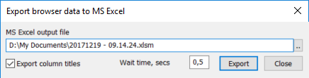Browser window, context menu > Export current browser data to MS Excel

When you click one of these menu items, you’ll be presented with the dialog *Export browser data to MS Excel*.

The *Wait Time* field lets you set a time for MapInfo2Excel to wait before continuing after launching MS Excel. The value given should be in seconds. The default value is 0.5 seconds.

In this dialog you can select the output MS Excel and decide whether you want the titles exported or not. This is similar to the way you export an entire table.

In this case however, you’ll only export the current data in the browser.

## Export map window to MS Excel

When you have exported either an entire table or the data from a browser window, you’ll also be able to export a map window as an image to the same MS Excel file.

This feature is available in:

* *MAP* tab > *Analyze* > *Export map window to MS Excel*
* Map window, context menu > *Export map window to MS Excel*



The currently active map window will get exported into the Maps worksheet in the latest created MS Excel file.

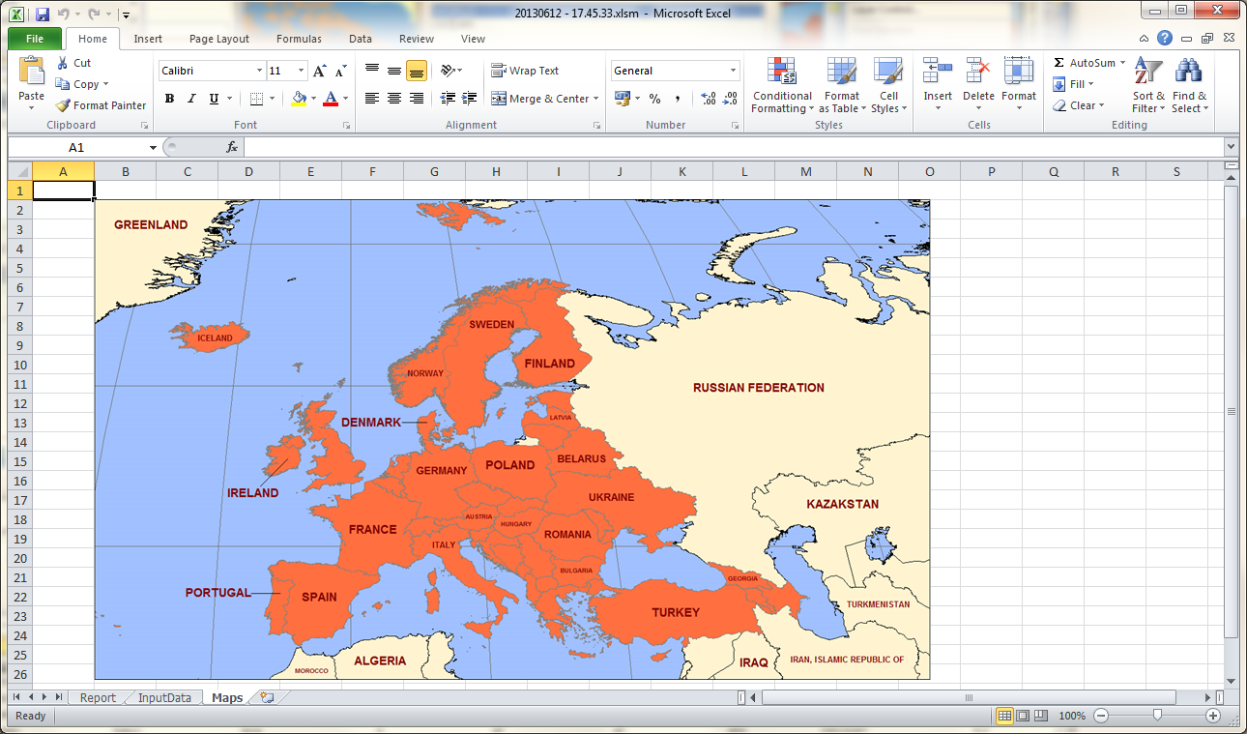

# The MS Excel template file

MapInfo2Excel comes with a MS Excel template file called MapInfo2Excel. This file is located in the same folder as the application.

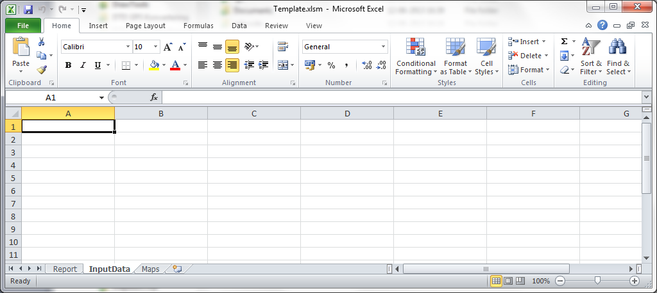

When you open this MS Excel file in MS Excel you will see that it has three tabs or worksheets:

* InputData: This is the worksheet where MapInfo2Excel will dump the chosen data into. It will start in the cell A1 and fill the necessary cells depeding on the number of rows and the number of columns.

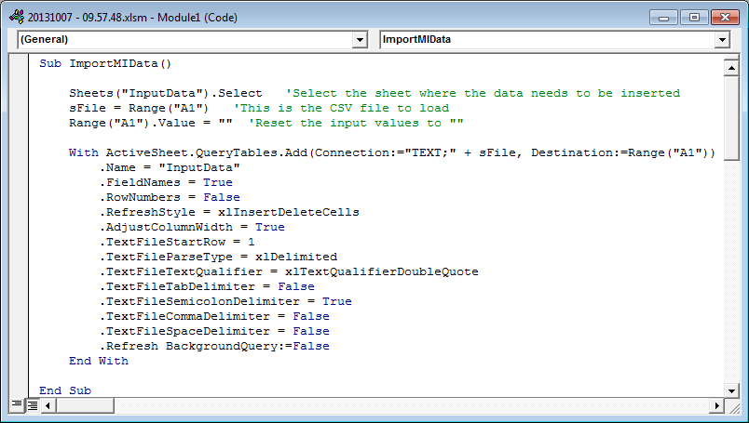The data will not be formatted in any way in this sheet. If you want to format the data in a certain way, make it look like a report, you should use another worksheet, for example the worksheet Report to read the values from the InputData worksheet and show it in a certain way, with a specific font, colour and size.

MapInfo2Excel creates a temporary file in your Windows Temp folder, adds the name of the file to cell A1 in the InputData sheet.

Then the macro ImportMIData I called and the data from the temporary file is loaded into the InputData sheet, starting in cell A1.

* Report: The report worksheet, as mentioned, above can be used to modify the formatting of the data that has been copied from MapInfo Pro to the MS Excel file.

As the data always will be copied into the same cells (from A1 and onwards) the Report worksheet could reference these cells and just show whatever data has been copied over.

If you always use the same table structure when copying the data to MS Excel you’ll also know the number of columns and where this data gets inserted in the InputData worksheet.

In this case you’ll more precisely know where which data is moved to and this gives you a better chance of formatting the result in an appropriate way.

* 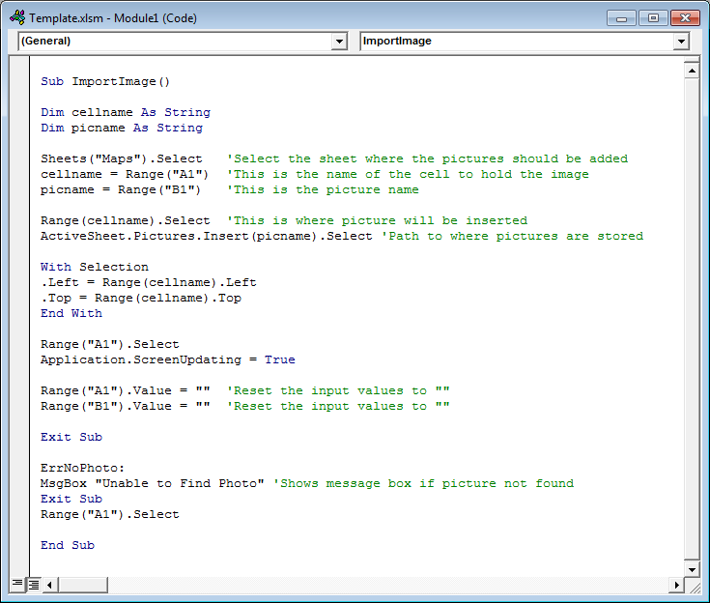Maps: The Maps worksheet is used when you want to copy a map window into your MS Excel file.

MapInfo2Excel creates an image in the folder where you have created the new MS Excel file using MapInfo2Excel. It then adds some information about this file to two cells (A1 and B1) about this file.

After this it calls the ImportImage macro in the MS Excel file and this macro will import the image into the designated cell.

So the MS Excel template file can be modified in a number of ways by you. Just make sure that the names of the worksheets and the name of the macro doesn’t change.

# Languages

MapInfo2Excel now allows the user to switch between multiple languages.

The user can extend the list of languages - see further down.

### Switching language

To switch language you simple go to the *Tool* window and locate *MapInfo2Excel* in the list. Now click on the *Info* icon.

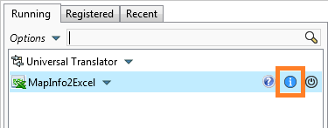

In the *About* dialog you can see the available languages in the dropdown list.

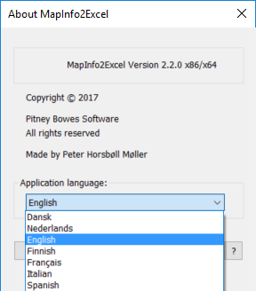You can pick any of the available languages.

When you select a different languages, do note that the language used will not change in the menus until you restart the MapBasic tool.

### Adding your own language

You can add you own language if you like simply by creating a copy of one of the existing language files (*.str) that you can see in the folder called *Strings* in the folder where you installed the MapBasic tool.

You can name your language file whatever you want. I would recommend that you name it like the name of the language, German.str, Greek.str and so on.

Now open the new language file in a text editor and translate the existing strings.

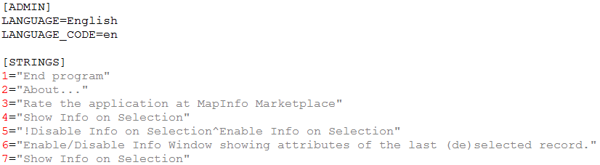

Make sure that you also change the name of the language in the top of the language file (LANGUAGE=) You also need to enter a two-letter language code for the language, for example “da” for Danish, “en” for English and “de” for German (LANGUAGE_CODE=).

Save the changes and restart the MapBasic tool. Make sure that you save the file using the charset UTF-8.

The new language will now be available in the about box.

# Known issues

### Large datasets

Exporting a large table with thousands of records will take some time.

With version 1.5 we have improved this. Exporting around 70 000 records now only takes just around 20 seconds.

### Empty Date, Time and DataTime fields

When exporting columns of type Date, Time or Date/Time fields that have no value assigned will appear with a value of “F” in the MS Excel file.

MapInfo Pro also complains about the missing data, but MapInfo2Excel suppresses the error and only shows it in the Message window

### Excel Security Settings

As the MS Excel template contains some macros that must be able to be run, you’ll need to allow MS Excel to enable macros.

In MS Excel 2010 go to *File > Options*. On the *Trust Center* option click the *Trust Center Settings…* button.

Then select *Enable All Macros* on the *Macro Settings* option.

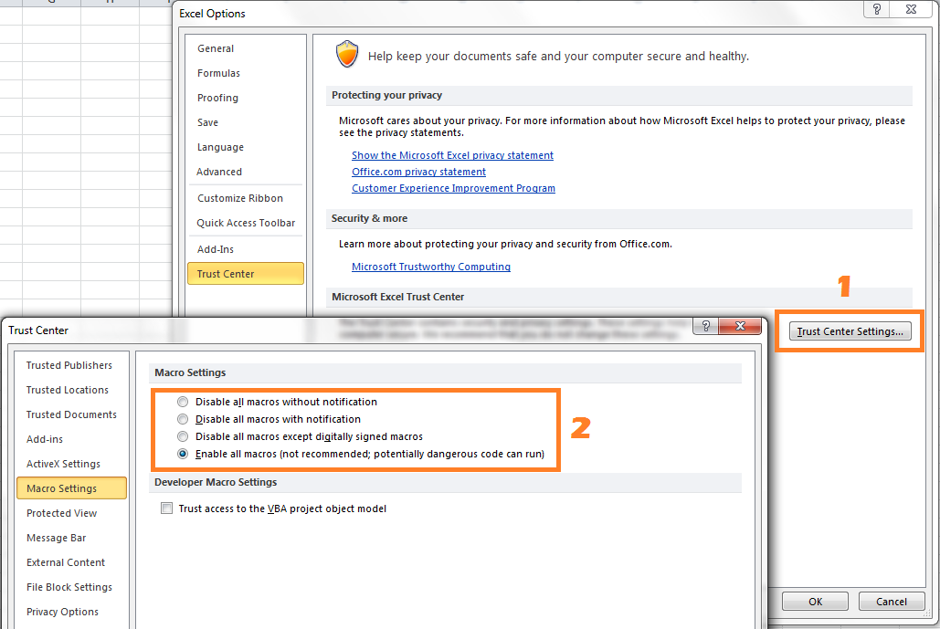

### New line feeds

If your character columns contain new line feed characters, this will affect the result in the CSV file created by MapInfo2Excel as the new line feed character will result in a new line in the CSV file.

In the final Excel file the data after the record/column will the new line feed character, will be moved to a new row.