**MapInfo2Excel 1.7**

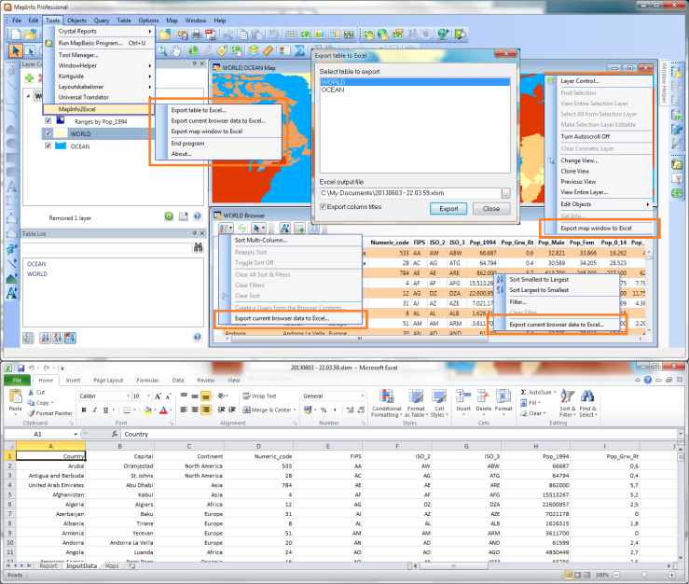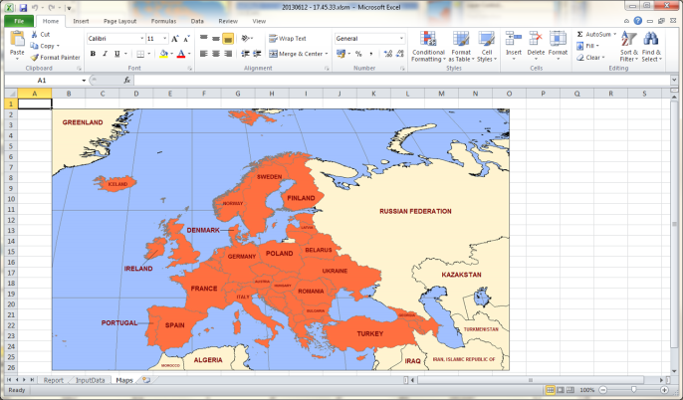

# About MapInfo2Excel

MapInfo2Excel is a small tool that helps you to get data from a MapInfo table within MapInfo Professional to an Excel file.

This data can be an entire MapInfo table, a query or the data that you currently is viewing in your browser window.

MapInfo2Excel lets you also export a map window to an open MS Excel file.

To get the most out of this tool it’s recommended that you add this tool to the Tool Manager and sets it to Autoload.

The features of this tool have all been made in response to requests from customers.

As this tool takes advantage of the new browser window added in MapInfo Professional 11.5 you need to be running MapInfo Professional 11.5 or later to be able to use MapInfo2Excel.

If you have any requests or feedback on the MapInfo2Excel tool, please send your feedback thru the Ideas Community: <http://ideas.pb.com/>

Add your feedback to the MapInfo Professional product and mark the subject with “MapInfo2Excel tool”.

# Install MapInfo2Excel

You install MapInfo2Excel by downloading the MapInfo2Excel.zip file. Extract the files into a new folder or into the folder with your other MapInfo tools.

## Add tool to Tool Manager

Go to *Tools > Tool Manager* and click on the *Add tool…* button.

Enter a title for the tool (for instance: MapInfo2Excel).

Use the small button to pick the MapInfo2Excel.mbx from the folder where you installed it.

You can also add a description (for instance: This tool helps you copying your attribute data into MS Excel)

Click *OK* and make sure you also check the *Autoload* checkbox for this tool to load it whenever MapInfo Professional starts up.

Click *OK* to add the MapInfo2Excel tool to the Tool Manager.

# New features in MapInfo2Excel 1.5

## 1.7

### Language

The biggest improvement in this release is support for several languages.

Out of the box MapInfo2Excel comes with support for Danish, English, Finnish, Italian and Spanish. English is the default language.

## 1.5

### Performance

In this release the speed of exporting data from MapInfo Professional to MS Excel has been improved.

Previously the data was sent from MapInfo Professional to MS Excel one value at a time using basic DDE communication.

Now we have changed this to writing the data into a semicolon separated text file and using a macro in MS Excel to import this data in this file into the sheet.

A basic test showed that exporting approximate 70 000 records to MS Excel now can be done in close to 20 seconds.

### MS Excel template file

Also notice that we have changed the template file between version 1.0 and version 1.5 and now again in version 1.5.

Between the two versions we had to update the macro that inserted images into a sheet in MS Excel as Microsoft had changed the way an image was stored.

For v1.5 we have added a new macro that allows a very fast import of the data from MapInfo Professional, see the section on Performance.

### Menu item to take you to the Community Downloads site

The tool now also has a new menu item that will take you directly to the Community Download site where you can find other useful tools – and even rate this tool.

## 1.0

This is the first released version so have a look at the features below. When new releases are made available, the changes will be described here

# Features of MapInfo2Excel

When you run the MapInfo2Excel tool you will get a menu called *MapInfo2Excel* in the Tools menu.

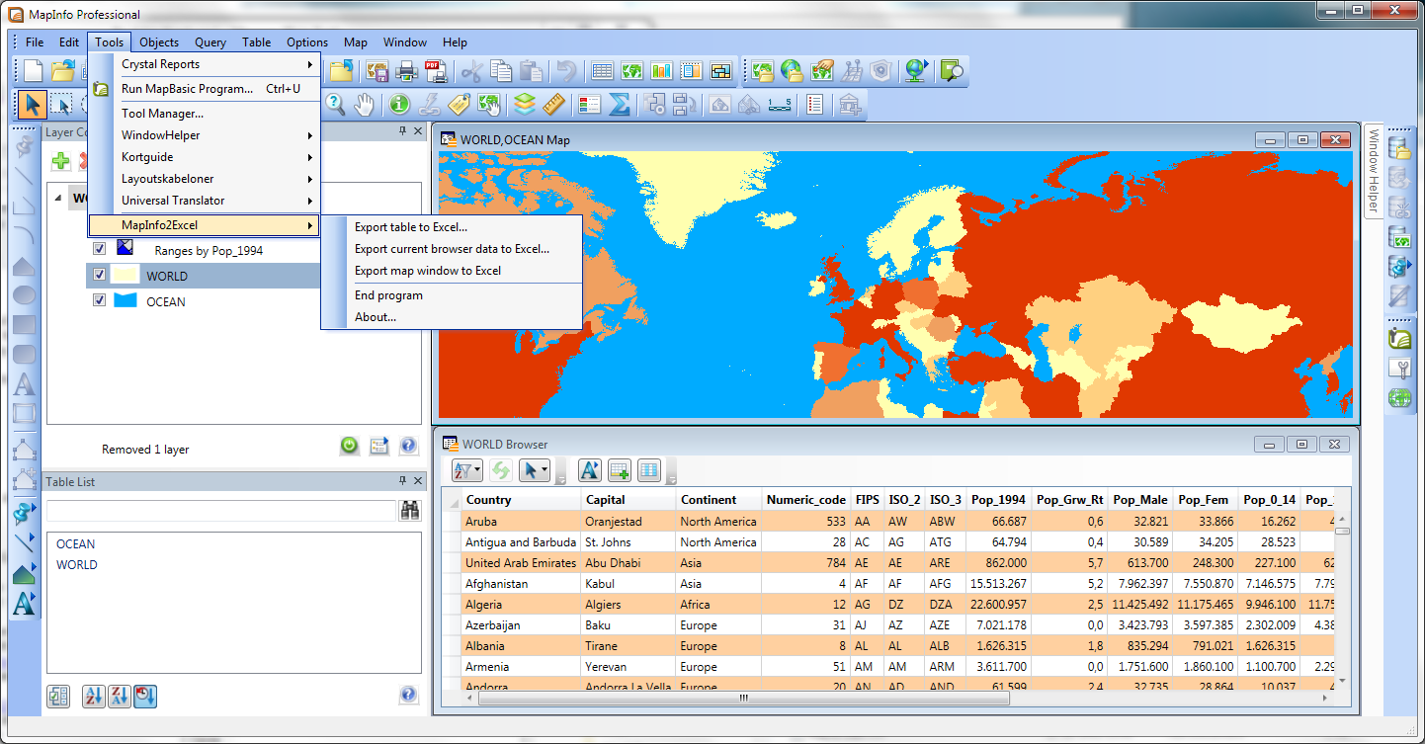

In the picture above you can see the MapInfo2Excel menu unfolded from the Tools menu.

You can also find features of MapInfo2Excel in the Sort & filter menu in the browser windows, in the context menu of the browser windows and in the context menu of the map windows.

In the browser windows you will have access to the feature for exporting the attribute data into a new MS Excel file.

In the map windows you can export the current map window into a MS Excel file. Currently you’ll have to export the attribute data before you’ll be able to export the map window as well.

## The MS Excel template file

MapInfo2Excel comes with a MS Excel template file called MapInfo2Excel. This file is located in the same folder as the application.

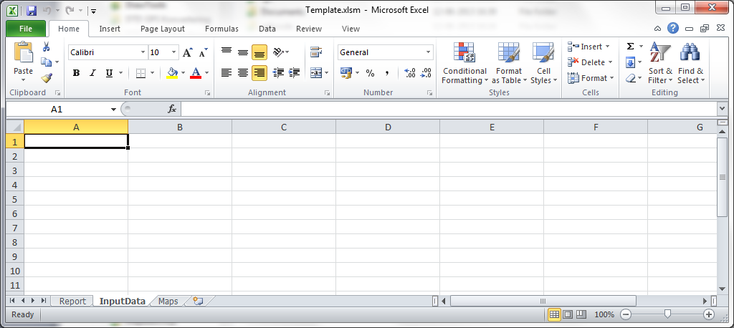

When you open this MS Excel file in MS Excel you will see that it has three tabs or worksheets:

* InputData: This is the worksheet where MapInfo2Excel will dump the chosen data into. It will start in the cell A1 and fill the necessary cells depeding on the number of rows and the number of columns.

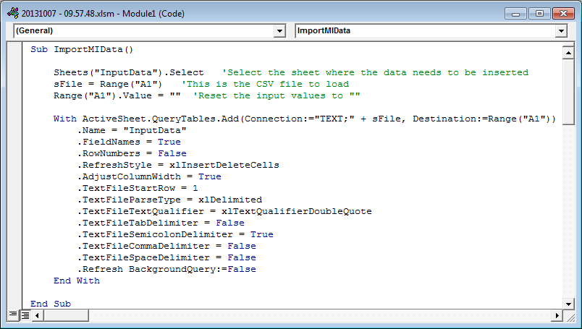The data will not be formatted in any way in this sheet. If you want to format the data in a certain way, make it look like a report, you should use another worksheet, for example the worksheet Report to read the values from the InputData worksheet and show it in a certain way, with a specific font, colour and size.

MapInfo2Excel creates a temporary file in your Windows Temp folder, adds the name of the file to cell A1 in the INputData sheet.

Then the macro ImportMIData I called and the data from the temporary file is loaded into the InputData sheet, starting in cell A1.

* Report: The report worksheet, as mentioned, above can be used to modify the formatting of the data that has been copied from MapInfo Professional to the MS Excel file.

As the data always will be copied into the same cells (from A1 and onwards) the Report worksheet could reference these cells and just show whatever data has been copied over.

If you always use the same table structure when copying the data to MS Excel you’ll also know the number of columns and where this data gets inserted in the InputData worksheet.

In this case you’ll more precisely know where which data is moved to and this gives you a better chance of formatting the result in an appropriate way.

* 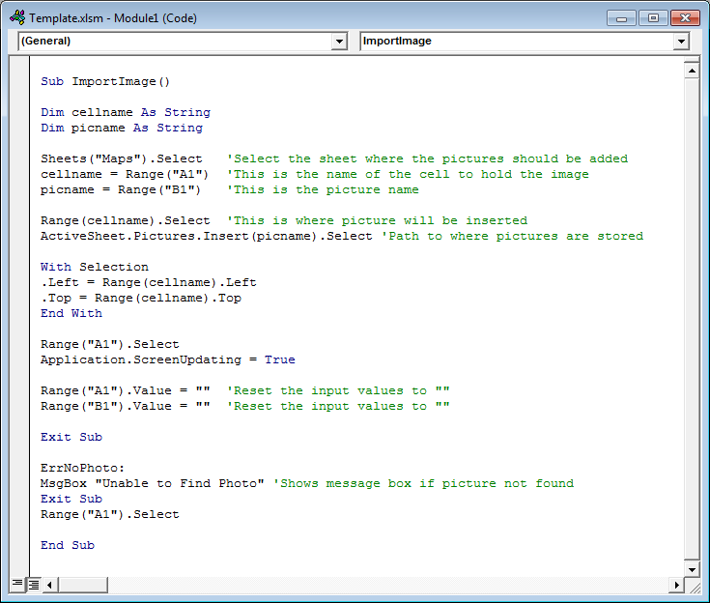Maps: The Maps worksheet is used when you want to copy a map window into your MS Excel file.

MapInfo2Excel creates an image in the folder where you have created the new MS Excel file using MapInfo2Excel. It then adds some information about this file to two cells (A1 and B1) about this file.

After this it calls the ImportImage macro in the MS Excel file and this macro will import the image into the designated cell.

So the MS Excel template file can be modified in a number of ways by you. Just make sure that the names of the worksheets and the name of the macro doesn’t change.

## Export a table into MS Excel

You can export all the data from a table with attributes into a new MS Excel file.

You can launch this feature from:

* Tools > MapInfo2Excel > Export table to MS Excel

When you select this menu item, you will get prompted with the dialog *Export table to MS Excel*.

If you don’t have any attribute tables open, , such as native tables, you’ll be told to open at least one native table.

Pick the table you want to export to MS Excel. Notice that the list will contain base tables as well as query results.

Enter the name of the output MS Excel file. By default it will get created in your “My Documents” folder and have the current date and timestamp as name. You can use the small button with the two dots (..) to select a different location and name or you can change the name directly in the text field.

Check the option *Export column titles* if you want the column titles to get exported to MS Excel as well.

Click the *Export* button to export the selected table to MS Excel.

After the table has been exported the dialog stays on the screen, so you can export several tables easily. Close the dialog by clicking the *Close* button when you are done.

## Export current browser data into MS Excel

If you have used the new filter and sort capabilities of the new browser window, you can also export the current data from your browser into a new MS Excel file.

The data will get exported just as it looks in the browser. The filter condition and sort order will be maintained.

You can access this feature from a number of places:

* Tools > MapInfo2Excel > Export current browser data to MS Excel
* Browser window, Sort & Filter menu > Export current browser data to MS Excel
* 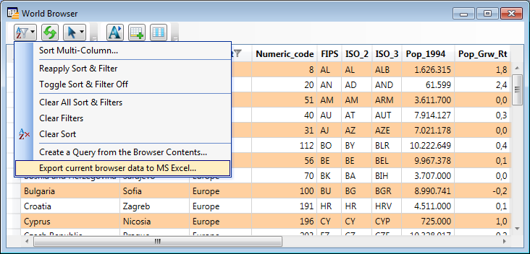Browser window, context menu > Export current browser data to MS Excel

Make sure that you have a browser window as the active window before using the menu item from the *Tools* menu.

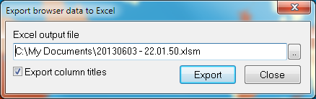When you click one of these menu items, you’ll be presented with the dialog *Export browser data to MS Excel*.

In this dialog you can select the output MS Excel and decide whether you want the titles exported or not. This is similar to the way you export an entire table.

In this case however, you’ll only export the current data in the browser.

## Export map window to MS Excel

When you have exported either an entire table or the data from a browser window, you’ll also be able to export a map window as an image to the same MS Excel file.

This feature is available in:

* Tools > MapInfo2Excel > Export map window to MS Excel
* Map window, context menu > Export map window to MS Excel

Make sure that you have a map window as the active window before using the menu item from the Tools menu.

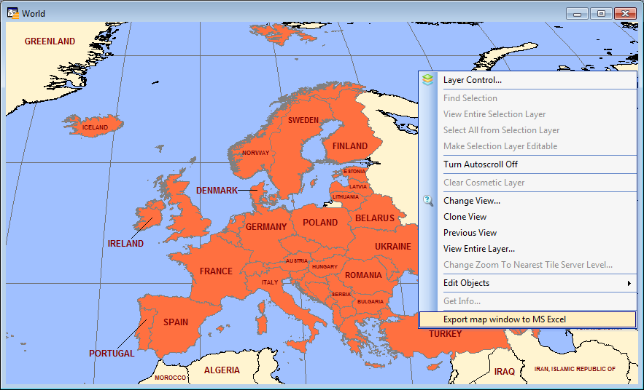

The currently active map window will get exported into the Maps worksheet in the latest created MS Excel file.

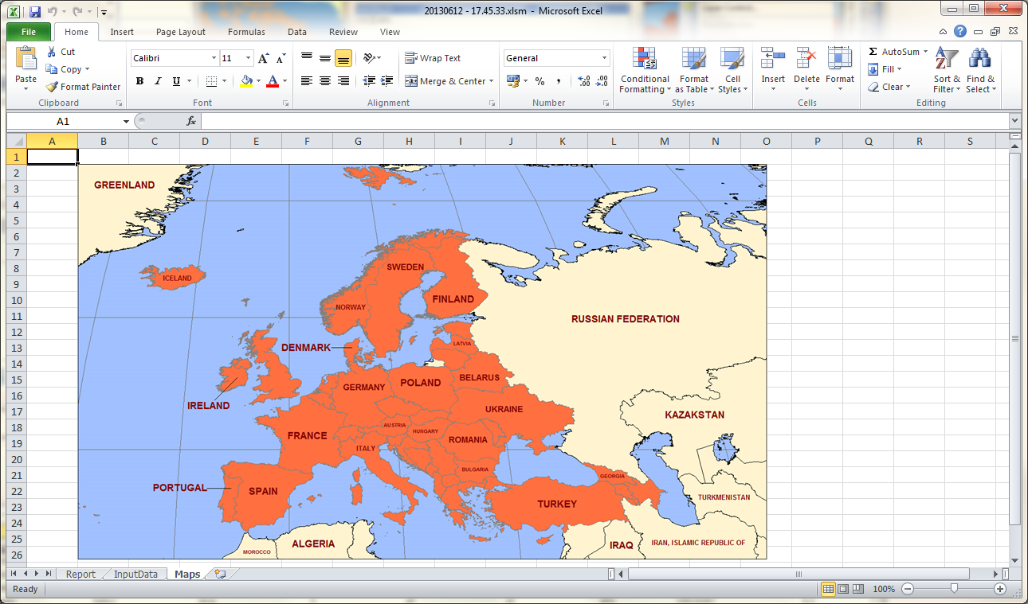

# Languages

MapInfo2Excel now allows the user to switch between a number of languages.

The number of languages can be extended by the user himself, see further down.

### Switching language

To switch language you simple go to Tools > MapInfo2Excel > About.

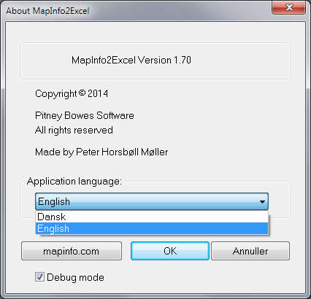In the About dialog you can see the available languages in the dropdown list.

You can pick any of the available languages.

When you lick a different languages, do note that the language used will not change in the menus until you restart MapInfo2Excel

### Adding your own language

You can add you own language if you like simply by creating a copy of one of the existing language files (*.str) that you can see in the folder where you installed MapInfo2Excel.

You can name your language file whatever you want. I would recommend that you name it like the name of the language, German.str, Greek.str and so on.

Now open the new language file in a text editor and translate the existing strings.

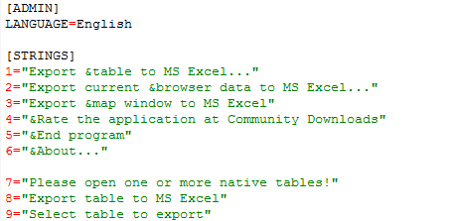Make sure that you also change the name of the language in the top of the language file.

Save the changes and restart MapInfo2Excel. The new language will now be available in the about box.

# Known issues

### Large datasets

Exporting a large table with thousands of records will take some time.

With version 1.5 we have however improved this, so that exporting around 70 000 records now only takes just around 20 seconds.

### Empty Date, Time and DataTime fields

When exporting columns of type Date, Time or Date/Time fields that have no value assigned will appear with a value of “F” in the MS Excel file.

MapInfo Professional also complains about the missing data, but MapInfo2Excel suppresses the error and only shows it in the Message window

### Excel Security Settings

As the MS Excel template contains some macros that must be able to be run, you’ll need to allow MS Excel to enable macros.

In MS Excel 2010 goto *File > Options*. On the *Trust Center* option click the *Trust Center Settings…* button.

Then select *Enable All Macros* on the *Macro Settings* option.

