**Multi Search Tool**

For MapInfo Pro v17.0.3

September 2022

# Installation

Multi Search Tool is to be downloaded from the MapInfo Marketplace.

This distribution is automated so that you only have to click a button to get the add-in installed and loaded into MapInfo Pro.

If any updates to the tool gets published, you will see the small ***Notification*** symbol in the lower right corner of the MapInfo Pro window turn red. Double-click on the symbol to open the ***Notification*** window and from here access the updates from the MapInfo Marketplace where you easily can install the updates.

Please note that Multi Search Tool requires MapInfo Pro v17.0.3 or newer to work.

# Configuration

To access the ***Configuration*** dialog, click on ***Configuration…*** from the context menu of the application in the ***Tools*** window.

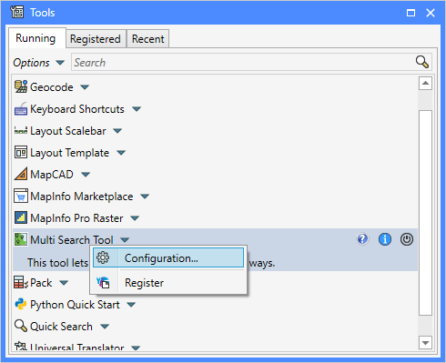

This will bring up the ***Configuration*** dialog where you can set up the application.

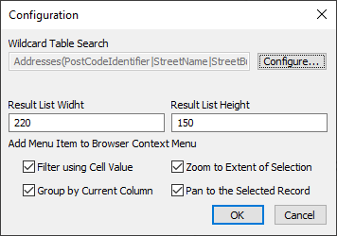At the top you can configure a Wildcard Search option. We will get back to that further down.

Next you can specify the size of the Result List in the Wildcard Search dialog. Use values between 180 and 500 for the width, and values between 100 and 500 for the height.

At the bottom, you can pick which tools/menu items you want the tool to add to the context menu of the ***Browser*** window.

If you click the ***Configure*** button at the top, you will see the ***Configure Wildcard Search*** dialog that allows you to configure a search in a table using one, two or three columns where the search is using a equal to operator or a Like operator.

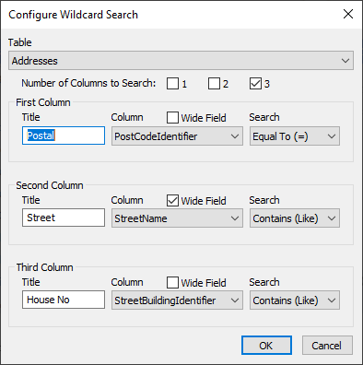In the dialog, you must first select the ***Table*** you want to use for your search.

Next, you need to specify the ***Number of Columns to Search***. Assuming it’s addresses, you can pick

* one column if the entire address is in a single column.
* two columns if you have one column with the postal code and another with the address
* three columns if you have one column with the postal code, another column with the house no and a third column with the street name.

For each column you want to search you can give it a ***Title***, select the ***Column***, and specify the ***Search Operator***.

For the ***Search Operator***, use ***Equal To (=)*** if you want to find value that match your entered value completely. Or use ***Contains (Like)*** if the entered value should be part of the value in the column. If you specify ***Contains (Like)***, you can use the % and _ as wildcards.

You can also decide which of your columns should have the ***Wide Field***. That would typically be the street name for addresses. It’s used when building the ***Wildcard Search*** dialog. The widest will have a wider search field than the other columns.

# Using Wildcard Search

If you have configured Wildcard Search, it will be accessible from the Find dropdown control on the ***Table***, ***Map***, and ***Spatial*** tabs.

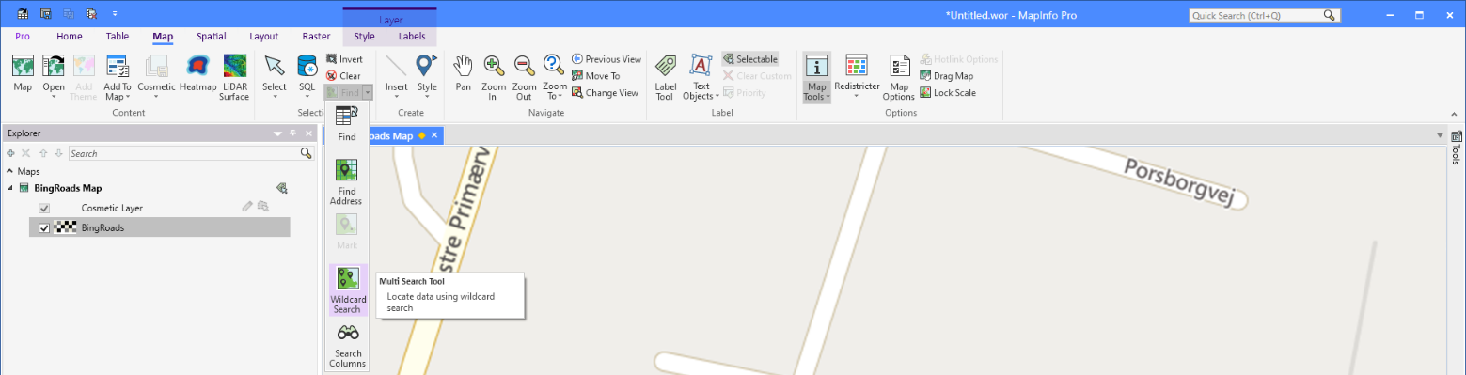

You will need to have a map open to use the tool. You do not have to have the table you specified to search through open. The tool will open this table if it isn’t open.

Below you can see the Wildcard Search dialog. The one on the left is how it looks when you launch it, the one on the right is how it can look once you have done a search.

To run a search, enter a value in the one or more of the fields available. If you don’t enter a value into a field, the search will not include that column in the query executed.

The strings <=> and <Like>are there to help you understand what search method is applied. These strings will always appear in the fields if they are left empty. The strings are the same as not entering a value into a field.

If you are using the Like operator for one of the columns, you can apply wildcards using the _ (underscore) and the % (percentage) characters. If you don’t enter any of these, the application will automatically add a % at the beginning and the end of the value entered.

_ matches one character and % matches zero or more characters.

In the example below, “Sten%” means that the Street must begin with “Sten”.

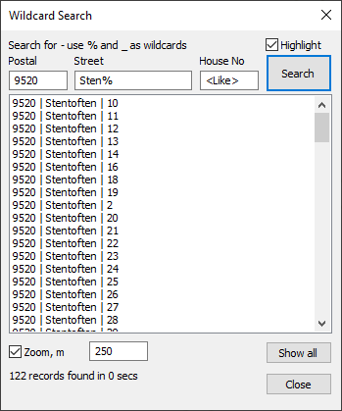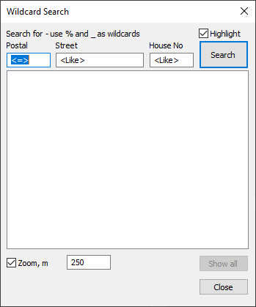

Once you have found some matching records, you can click on any of them in the list and the map will be centered on this location. If you have checked the ***Zoom, m*** option, the map will also be zoomed to the specified zoom width.

The dialog will also tell you how many records were found in how many seconds.

If you have checked the Highlight option at the top of the dialog, the records you clicked on in the list, will also be highlighted in the map. This only works if the table you are searching exists as a layer in the map window.

Finally, the ***Show All*** button allows you save the records found into a new table and add all these to your map window. The map will also change the zoom so that all the records fit in the map extent.

# Using Search All Columns

Search All Columns allows you to search for a specific text across all the columns of a table. The search can be limited to columns of a given type, say character columns only, but you can search numerical columns too.

You can access the ***Search (All) Column*** feature from the ***Find*** dropdown on the ***Table***, ***Map***, and ***Spatial*** tabs. On the ***Table*** tab, you can also access ***Search (All) Columns*** from the ***Sort and Filter*** group.

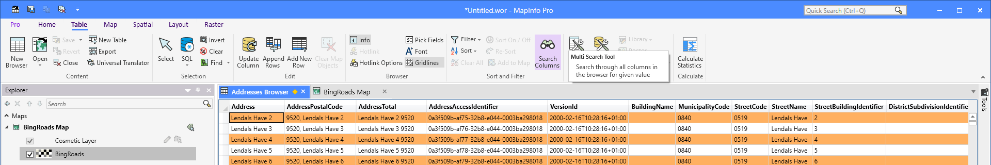

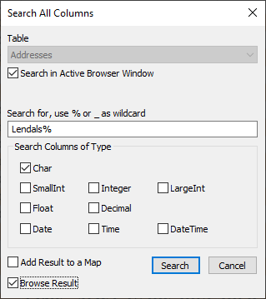In the ***Search All Columns*** dialog, you can control the search.

First, you will have to select the ***Table*** to search. If your active window is a table, the dialog will presume you want to search the table in the browser window. You can overrule this by unchecking ***Search in Active Browser Window*** and select a different ***Table***.

Then you have the enter the term to search for. You can use _ and % as wildcards. _ matches one character and % matches zero or more characters.

You can also select which column types you want to search through. By default, the dialog has only checked ***Char***.

Finally, you can decide how to show the result: ***Add Result to a Map***, ***Browse Result*** or not showing the result besides selecting it.

Click on ***Search*** to execute the search.

# Tools sin the Browse Context menu

This application can add up to four additional features to the context menu of the browser window to help you work in the browser.

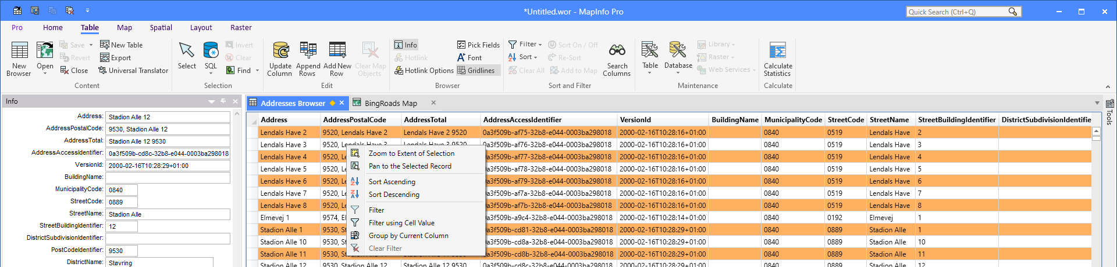

***Zoom to Extent of Selection*** allows you to zoom to the selection in your map window. Note that you will need to have the table open as a layer in the map. If you have multiple windows open, it might not be the map window you expect that the tool zooms in.

***Pan to the Selected Record*** only works for a single selected record. If you have selected more than one record, it will not work.

***Filter using Cell Value*** allows you to quickly filter your browser window using the value from the cell you currently have placed the mouse on. This doesn’t work if you have selected the cell of the first records first column.

***Group by Current Column*** gives you a quick overview of the values in the column. It groups the values, sorts them alphabetically and adds a count giving you an overview of how often each value exists in the table.

Below you can see how the result is presented in a floating browser window.

