**PSYTE Analyzer 1.0**

For MapInfo Pro

December 2023

# Installation

PSYTE Analyzer is to be downloaded from the MapInfo Marketplace.

This distribution is automated so that you only have to click a button to get the add-in installed and loaded into MapInfo Pro.

If any updates to the tool gets published, you will see the small ***Notification*** symbol in the lower right corner of the MapInfo Pro window turn red. Double-click on the symbol to open the ***Notification*** window and from here access the updates from the MapInfo Marketplace where you easily can install the updates.

Please note that PSYTE Analyzer requires MapInfo Pro v2021 or newer to work.

# Configuration

Currently, the configuration is very basic.

Use the command PSYTE Table to select the table containing the PSYTE data. You may also get prompted to select this table the first time you start PSYTE Analyzer.

# Use

PSYTE Analyzer currently has two use cases: analyze a single site/catchment and compare two sites/catchment areas.

Both work by first selecting the catchment area(s) to analyze and then clicking on the analysis you want to perform.

You will now be prompted to share some details and select what layout template to use for your analysis.

The tool will then run some processing and finally it will create a new layout using the template that you selected.

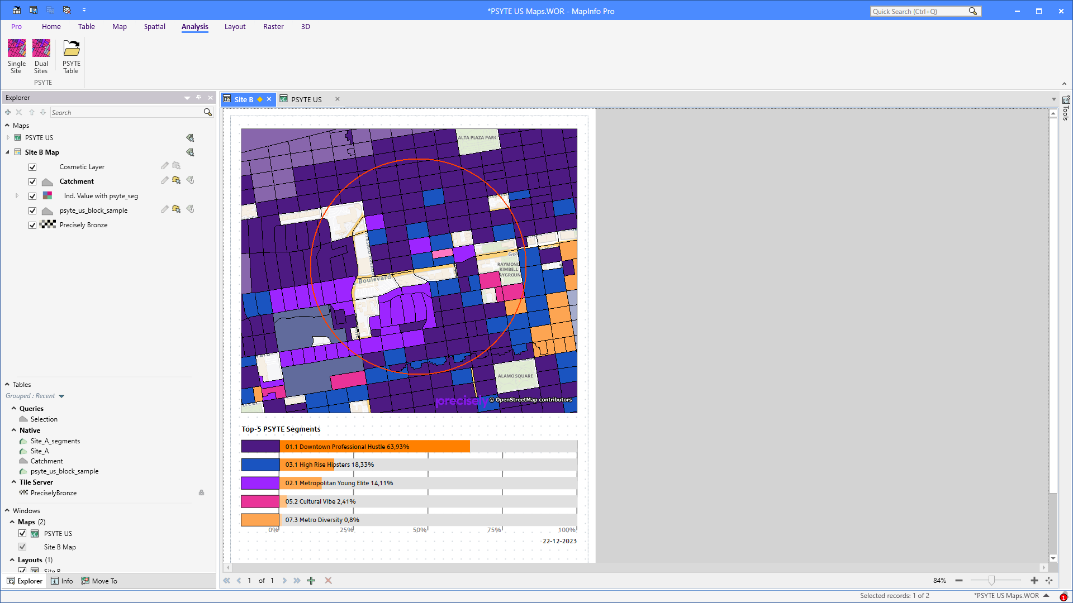

# Layout Templates

# Functions

PSYTE Analyzer comes with several functions that can be used in SmartTexts in the layout for extracting values from the sites you are analyzing.