# SearchTool 1.5

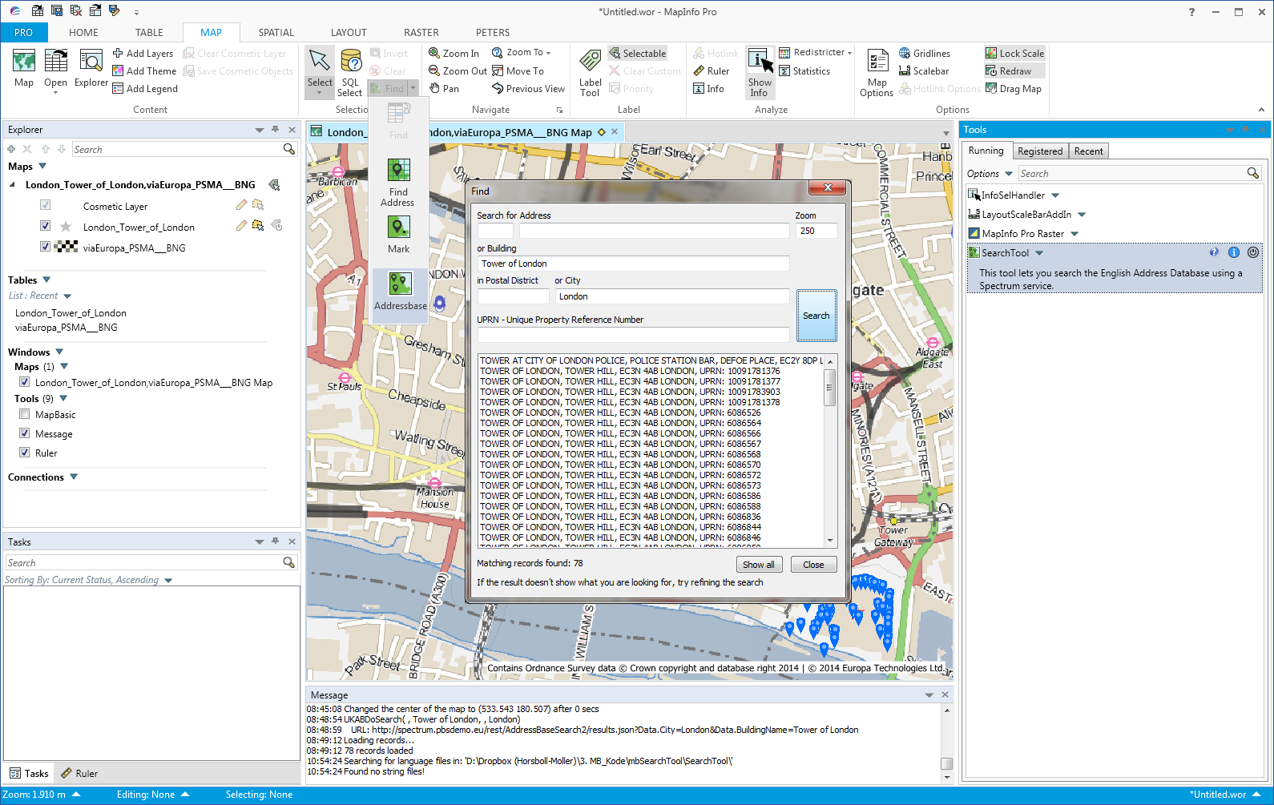

# Install SearchTool

You install SearchTool by downloading the SearchTool.zip file. Extract the files into a new folder or into the folder with your other MapInfo tools.

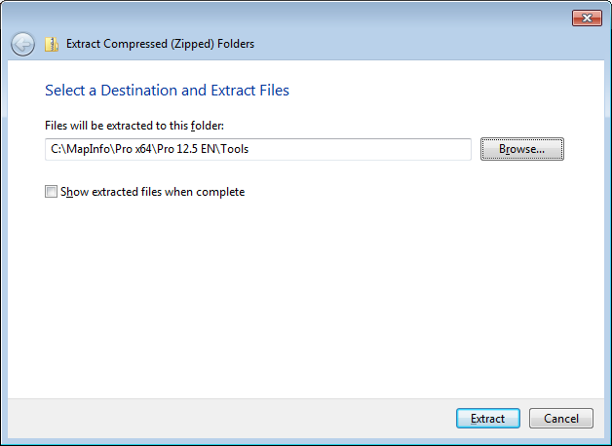We recommend installing SearchTool into its own folder and not install it directly into for example the tools folder.

With SearchTool you can use the standard Extract function in Windows 7 and just pick the location to unzip the file. The zip file contains a sub folder and so SearchTool will be installed into its own subfolder.

## Add tool to Tool Manager

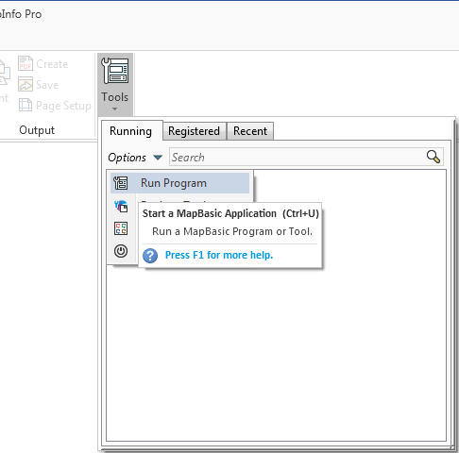Go to Home > *Tools* and click on the *Run Program* in the *Options* menu.

Now navigate to the location where you unzipped SearchTool and select the file SearchTool.mbx.

Once the tool has been loaded you can go back to the Tools and click on context menu of SearchTool in the list of Running tools.

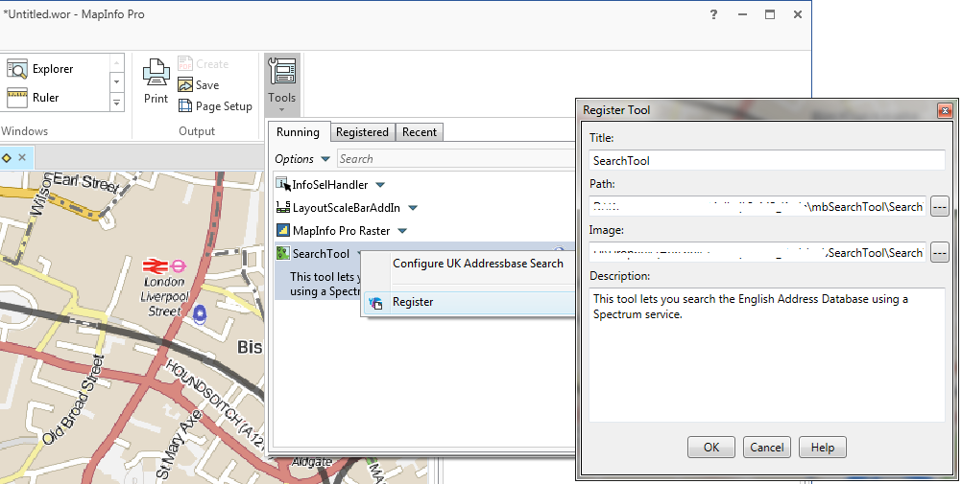Then click on *Register* to add SearchTool to the list of registered tools.

Notice that the values have been prefilled for you so you just have to hit OK to add SearchTool to the list of tools.

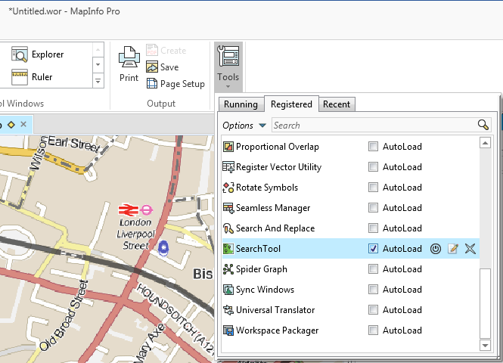Click *OK*. Go back to the *Tools* window select the Registered tab to see the registered tools. Here you can check the *Autoload* checkbox for this tool to load it whenever MapInfo Pro starts up.

# The features

SearchTool only has one basic features:

* It can search a version of the Ordney Survey Addressbase dataset via a Spectrum service.

Make sure you have a map window active when trying to activate the tool.

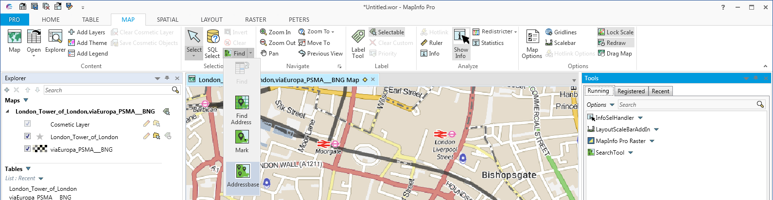You find the tool on the MAP tab in the Find control.

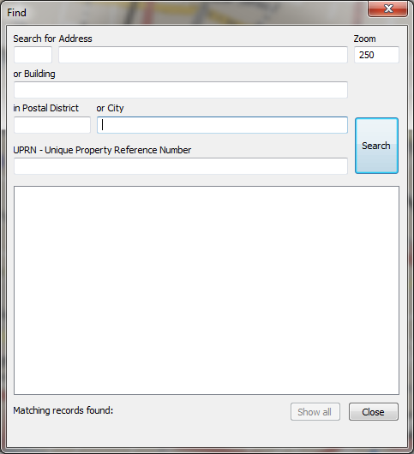Click on the Addressbase control to get to the Find dialog

In the Find dialog, you can specify a number of combinations. Just keep these things in mind:

* You need to specify either a Postal District or a City.
* For Street and Building Names, you need to enter at least four characters.
* When searching within a City, you also have to specify either a Street Name or a Building Name.

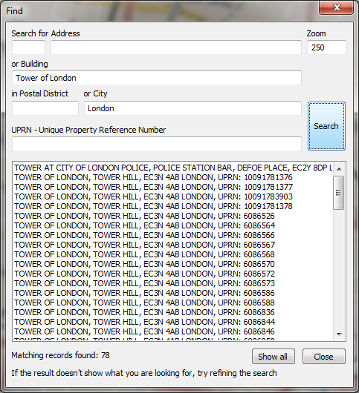When you have performed a search, you can click on the individual addresses to move the map to the selected address. There is an option that controls whether a marker is shown in the cosmetic layer when the map is moved to the address that you clicked on.

You can also use the Show All button to save all the addresses into a table and show it on the map as points.

# Configuration

SearchTool comes with a configuration dialog for the most common settings and you can specify the size of the Find dialog via settings in the configuration file.

## Addressbase OnDemand Settings

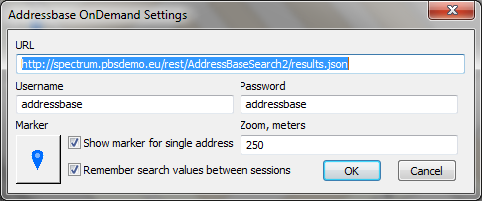You access the Configuration dialog via the Running tab in the Tools window. Right click on the SearchTool and select *Configure UK Addressbase Search*.

In this dialog you can specify the URL for the Spectrum service and the user credentials for accessing the service.

You can also specify the default zoom level for panning to a selected address.

And you can specify the marker used for marking the addresses when you save them to a table. Note that the option Show Marker for Single Address controls whether a marker will be added to the cosmetic layer when you click on the individual addresses listed in the dialog.

If you check the Remember search values between sessions, the Find dialog will remember the latest used search values and present these to the user next time the Find dialog is shown.

## Configuration File

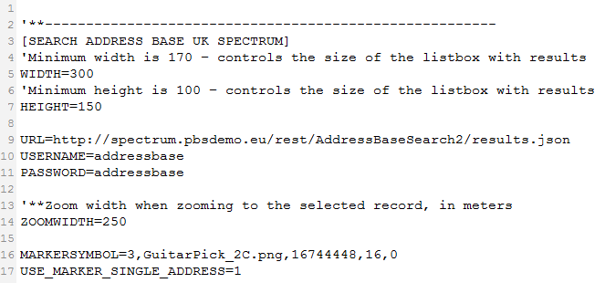Via the configuration file, SearchTool.ini, located in the installation folder, you can specify the width and height of the Find dialog via the WIDTH and HEIGHT parameters.

It is recommended to update this file with the default values in general for the service as these then will be shared amongst all the users.

The options changed via the dialog will be saved to the users profile and will not change the configuration file stored locally with the application.