WindowHelper 3.0

About WindowHelper
WindowHelper is a tool that adds additional features to MapInfo Pro which helps you while working in especially map and browser windows.
With this new release of WindowHelper the tool has been ported to the new ribbon based interface.
WindowHelper 3.0 is consider a new tool even though it has been build on top of the earlier WindowHelper 2.1. But moving the tool to the 64-bit has made big parts of the tool obsolete as these features now are supported directly in the MapInfo Pro interface.
To get the most out of this tool it is recommended that you add this tool to the Tool Manager and sets it to Autoload.
The features of this tool have all been made in response to requests from customers.
If you have any requests or feedback on the WindowHelper, please send your feedback thru the Ideas Community: http://ideas.pb.com/
Add your feedback to the MapInfo Pro product and mark the subject with “WindowHelper tool”.

Install WindowHelper
You install WindowHelper by downloading the WindowHelper.zip file. Extract the files into a new folder or into the folder with your other MapInfo tools.
It is not recommended to put this tool on a network drive as it is using a number of .NET resources that not easily can be run from a network drive.
So make sure you put the tool on your local hard drive.

Add tool to Tool Manager
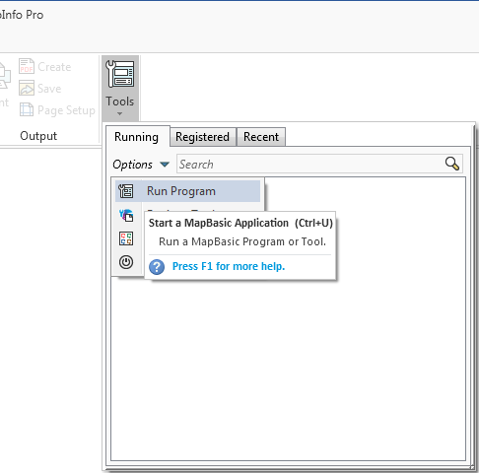
Go to Home > Tools and click on the Run Program in the Options menu.
Now navigate to the location where you unzipped WindowHelper and select the file WindowHelper.mbx.
Once the tool has been loaded you can go back to the Tools window and click on the context menu of WindowHelper in the list of Running tools.
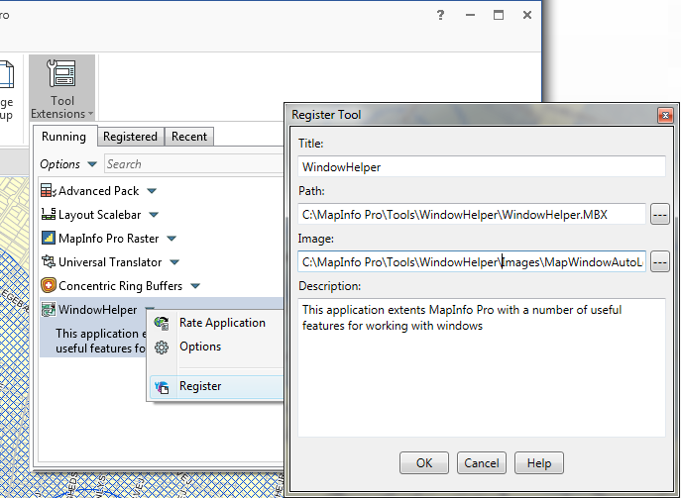
Then click on Register to add WindowHelper to the list of registered tools.

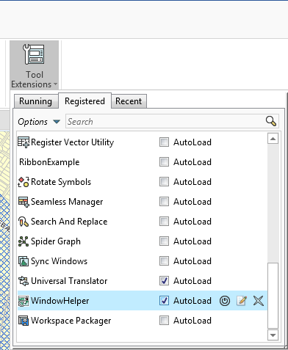
Notice that the values have been prefilled for you. Click OK to add WindowHelper to the list of tools.
Go back to the Tools window select the Registered tab to see the registered tools. Here you can check the Autoload checkbox for this tool to load it whenever MapInfo Pro starts up.

New features in WindowHelper 3.0
Advanced Rename Layer is one new feature in WindowHelper. This features lets you rename a layer or cosmetic layer in a map window. You can also save this new Friendly name as the default friendly layer name for the table so that the table always will use it. And you can ask to have the table renamed in all map windows.
Rename Multiple Layers is another new feature. This lets you rename all the layers of a map to match the file name of the table. It means that the underscores of the table name can be removed with spaces.
Filter Using Cell Value lets you quickly filter the records in a browser using the cell value of the cell you right click on.
Show Info on Selection shows the attributes of the selected record in the Info window.

Features of WindowHelper
When you run the WindowHelper tool, it will place buttons on the ribbon, menu items in a number of context menus and embed itself in the Tools window.
The WindowHelper tool embeds itself in a number of places. Some features are placed directly on tabs of the ribbon and you will also find many feature in context menu/right click menus in a number of places.

Creating Map Extent
You can use the WindowHelper tool to create the extent from one map window in another map window. This can be used for printing or simply for positioning your detailed map in an overview map.
You can also create the map extent of the map window it the window itself. This can be useful it you need to find objects within the current map extent.
On the MAP tab in the group Options, click on Map Extent to start the process. You can also access this feature via the right click menu in the map window.
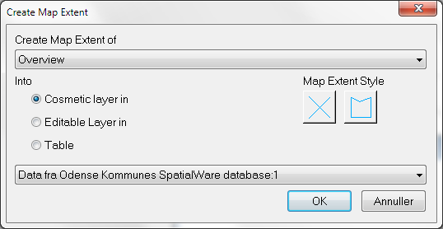
In the dialog Create Map Extent you can now pick the window which map extent you want to create.
You can choice three ways of storing the map extent:
- The cosmetic layer of a map
- The editable layer of a map
- A table
If you pick 1 or 2, you must also pick what map window to store the map extent into. If you pick the 3rd option you must pick what table to store the map extent into.
In the dialog, you can also change the style for the map extent created. The style will be written to the configuration file and used again next time you create a map extent.

Show Info on Selection
The feature has been moved into WindowHelper from a stand-alone tool called InfoSelHandler.
When activated, the tool show the attributes of the selected (and deselected) record in the Info window.
You can turn the tool on and off via the Show Info control in the Options group on the MAP tab.

Locate File In Windows Explorer
In the right click menu of the Tables window and the right click menu of the layers in the Layers and the Explorer window you find this menu item, which lets you locate and select the file of a table/layer in Windows Explorer.
This feature works on one selected table or layer.
If you have selected a raster layer/table, you will be asked if you want to locate the tab file or the raster file.

Open File In Favorite Text Editor
In the right click menu of the Tables window and the right click menu of the layers in the Layers and the Explorer window you find this menu item, which lets you open the tab file of a table/layer in your preferred text editor, for example Notepad.
This feature works on one selected table or layer.
This gives you quick access to the content of the tab file and an overview of the table structure as well as the metadata of the tab file.

Close Table
In the right click menu of the layers in the Layers and the Explorer window you find t the Close table menu item, that makes it easy to close the table for a specific layer.
This feature works on one selected layer.
Notice that when you close the table thru the layer, all windows only showing this table and queries based on this table are also closed.

Set Default View/Set Default View on All Layers
You will find this menu item in the right click menu of the Maps and of the Layers in the Layer Control.
If you use the menu item from the Maps right click menu, the default view will be set on all layers of the map that support this.
If you use the menu item from the Layers, you will set the default view of one layer at a time.
The default view is the zoom and center of a table used when the table is open as the first table in a new map window.

Restore Closed Windows
On the MAP tab in the group Options you also find the feature Restore Windows.
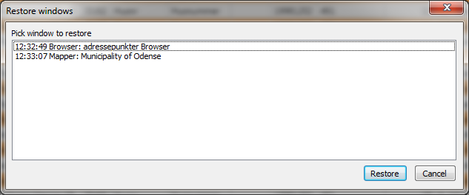
This option lets you restore windows that have been closed during the current session. This can help you recreate a map that you closed by accident.
Click on the Restore Windows button and select the window that you want to restore. Then click on Restore. When you have restored all the windows, you want to, close the Restore Windows dialog via Cancel.
What happens is that WindowHelper takes a snap shot of the window just before the window is being closed. This snap shot is similar to the statement that you will find in a workspace.
There is however one difference: WindowHelper does not “capture” which tables needs to be open. All it captures is the Window statement. So if you have closed some tables since you closed the window, the restore window might not work.

Advanced Rename Layer
The Advanced Rename Layer feature builds on the new feature added with MapInfo Pro 15.0 that lets you give a layer a friendly name.
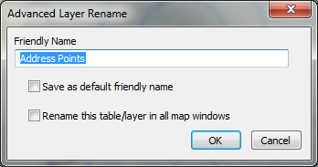
This feature extends the capability slightly. You will find Advanced Rename in the context menu of the Layers in the Explorer and then Layers window.
When renaming a layer of a base table, you can now also save the friendly name as the default friendly name. This saves the friendly name as the table description to the metadata section of the table and MapInfo Pro can then automatically apply this name when you add the table to a map.
You can also rename the table in other map windows, if it should exist multiple times.

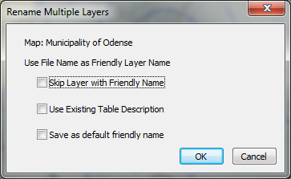
Rename Multiple Layers
Rename Multiple Layer is found in the context menu of the Map in the Explorer and Layers window.
With this feature, you can easily change the friendly name of all the layers in your map.
It will rename the tables to match the file name of the tables. This means that where MapInfo Pro normally would use an underscore instead of a space, you will now see a space and so a nicer looking layer name.
You have a few options when renaming all your layers:
- Skip Layer with Friendly Name lets you keep the friendly name of layers that already have been given a different layer name
- Use Existing Table Description will check if the table has a description stored in the metadata section. If there is, this description will be used as the friendly name.
- Save as default friendly name will save the friendly name used as the table description in the metadata section of the individual tab file.

Filter by Cell Value
This feature can be found in two places:
- In the context menu of the browser window
- And in the Filter menu in the Sort and Filter group on the TABLE tab.
The feature gives you are very easy way to filter your browser window using a value in a cell.
Click in the cell with the value that you want to filter the table using. Be aware that the tool by default ignores the top left cell, so avoid using this cell.
Now click on Filter by Cell Value in one of the two places.
The browser window will now only show records matching the value you highlighted.

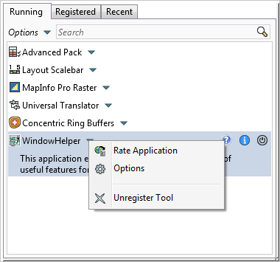
Options
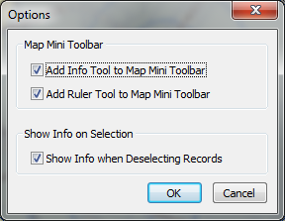
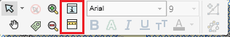
If you right click on the WindowHelper tool in the Tools window, you can access the options for the tool.

The options lets you specify if you want to add the Info Tool and the Ruler Tool to the Map Mini Toolbar.
We have in certain cases seen issues when the tool shows information about the deselected features. If you start to see misbehaviour, you can turn of the showing of information when deselecting records.

Known issues

