WindowHelper 2.0

About WindowHelper
WindowHelper is a tool that can help you manager the windows within MapInfo Professional.
It has a number of features that will be described in this document. Among the features you’ll find cloning any windows, storing the size and position of certain window types and the ability to restore a closed window.
With this new release of WindowHelper the tool has been made into a floating dockable window that also shows a list of currently open windows. You can thru this floating window work with and manage your windows.
To get the most out of this tool it’s recommended that you add this tool to the Tool Manager and sets it to Autoload.
The features of this tool have all been made in response to requests from customers.
As this tool takes advantage of docking capability added in MapInfo Professional 10.5 you need to be running MapInfo Professional 10.5.2 or later to be able to use WindowHelper.
If you have any requests or feedback on the WindowHelper, please send your feedback thru the Ideas Community: http://ideas.pb.com/
Add your feedback to the MapInfo Professional product and mark the subject with “WindowHelper tool”.

Install WindowHelper
You install WindowHelper by downloading the WindowHelper.zip file. Extract the files into a new folder or into the folder with your other MapInfo tools.
It’s not recommended to put this tool on a network drive as it is using a number of .NET resources that not easily can be run from a network drive.
So make sure you put the tool on your local hard drive.

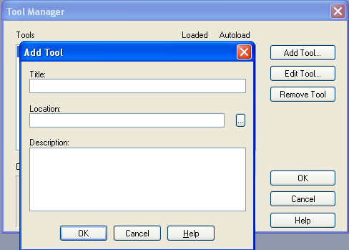
Add tool to Tool Manager
Go to Tools > Tool Manager and click on the Add tool… button.

Enter a title for the tool (for instance: WindowHelper).
Use the small button to pick the WindowHelper.mbx from the folder where you installed it.
You can also add a description (for instance: This tool helps you manage Windows)
Click OK and make sure you also check the Autoload checkbox for this tool to load it when ever MapInfo Professional starts up.
Click OK to add the WindowHelper tool to the Tool Manager.

New features in WindowHelper 2.0
General improvements
- Support for the new Legend Designer added to MapInfo Professional 11.5
New menu items
- New right click menu item in the Layer Control on the Map nodes
  - for zooming to the entire map
  - for setting the default view on all layers in the map
- New right click menu items in the Layer Control on the Layer nodes
  - for locating the tab file or image of a layer
  - for opening the tab file in your preferred text editor
  - for closing the table of the layer
  - for setting the default view
- New right click menu items in the Table List window on the Table nodes
  - for locating the tab file or image of a table
  - for opening the tab file in a text editor
- New menu item in the right click menu of a layout window
  - for cloning the view
WindowHelper window
- Buttons for zooming to first, previous, next and last view of a Map window
- Newly designed icons
- Button for accessing the Modify Window dialog
- Modify Window now also has an OK button
- The tools on the WindowHelper window now work on the active window

2.0.8 Fixes
- Saving and restoring window positions only worked if both auto save and auto restore was activated
- Added two menu items for opening Layer Control and TableList windows on start up

Features of WindowHelper
When you run the WindowHelper tool you will get a new floating window within MapInfo Professional called WindowHelper.
And you will get a menu called WindowHelper in the Tools menu.
In the picture below you can see the WindowHelper window in the right side of the MapInfo Professional program window and the menu unfolded from the Tools menu.
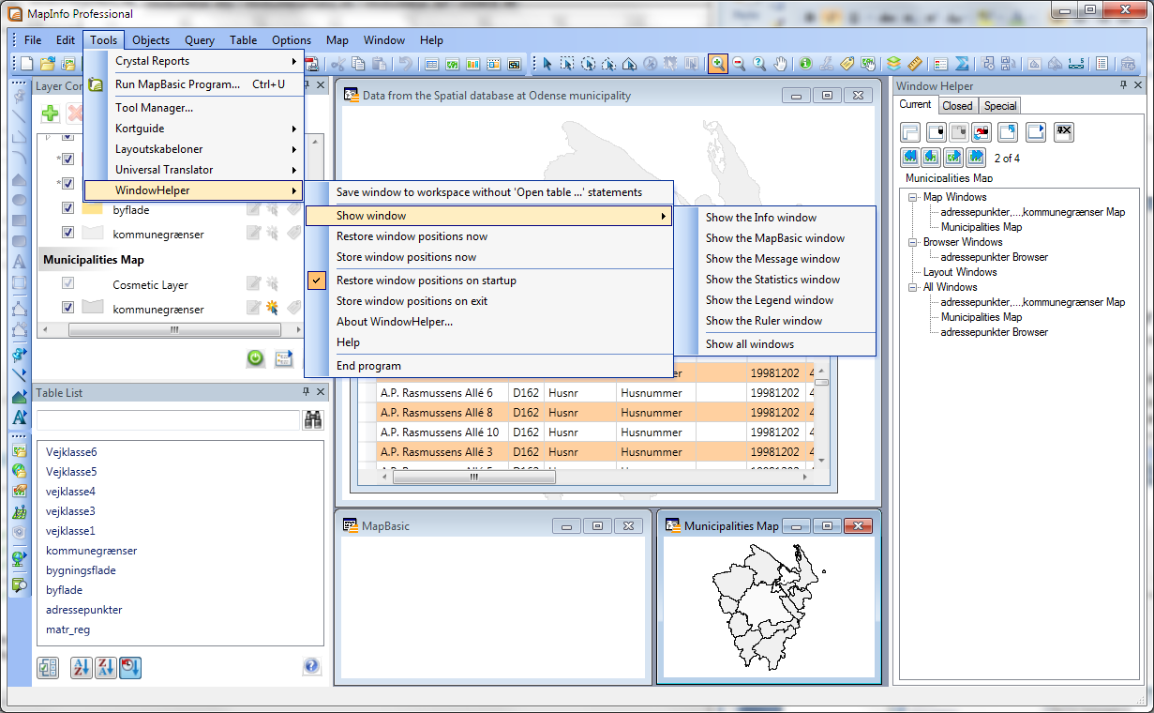

The WindowHelper window
The WindowHelper window can be floating on top of the normal map and browser windows or you can dock it to one of the four sides of MapInfo Professional. Simply drag the window using the title bar to the location you want it, and you will see some “helper icons” that will help you position the window as you like.
As you can see the WindowHelper window has three tabs at the top:
- Current will give you a list of the currently open windows within MapInfo Professional. You can select any of these windows an for instance clone them.
- Closed will give you a list of windows that have been closed in the current session. You can easily reopen one of the closed windows
- Special contains a list of special windows. A special window is for instance the MapBasic window, the Info window and the Statistics window. Thru the WindowHelper you are able to make these windows dockable.
Let’s look a bit more at the features of each of these three tabs.

Current windows
As mentioned earlier this is a list of currently open windows in MapInfo Professional. There is a number of way to interact and manage these windows.
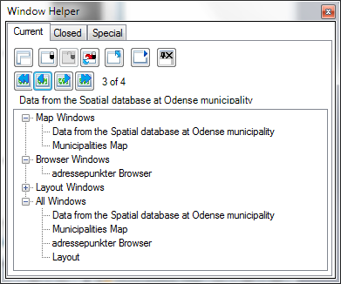
Notice that the list is grouped into a number of window types such as Map Windows, Browser Windows, Layout Windows and All Windows. This is do make it easier to locate the window you need.
- If you select one these windows, it will be made the active window appear on top of the other windows.
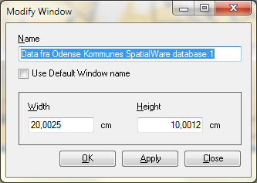
- If you double click on one of the windows you will be able to set the window title and the size (height and width) of the window thru the Modify Window dialog.
Enter the new name for the window and hit the Apply button. The name of the window has now changed. If you use the OK button in stead of the Apply button, the window will be changed and the Modify Window dialog will be closed.
If you check the Use Default Window name MapInfo Professional will use the default and dynamical name for the window.
You can also specify the width and size of the window. Note that the unit here is the paper unit of the current MapInfo Professional session. If you want to change this, you can do so thru Options > Preferences > System.
You also have a number of buttons at the top of the Current tab.
The first, Clone Selected Window, will let you clone or make a copy of the currently selected window. Normally you can only clone a map window in MapInfo Professional.
Lock and Unlock Selected Window will let you lock the close button of the window. This will prevent that you by mistake close a window instead of minimizing it.
Autolock All Windows will lock all current and new windows.
Close Selected window will close the currently selected window. If you have locked the window, you will be asked if you really want to close the window. You might also get the normal MapInfo warning that unsaved changes in the window will get lost.
The Modify Window button lets you set the title and the size of the window, just as you can do by double clicking on the window in the list.
The last button, Make Selected Window Dockable, lets you turn an ordinary MapInfo window into a dockable window that can stay on top of the other windows and even can be docked within the program window of MapInfo Professional, see picture below.
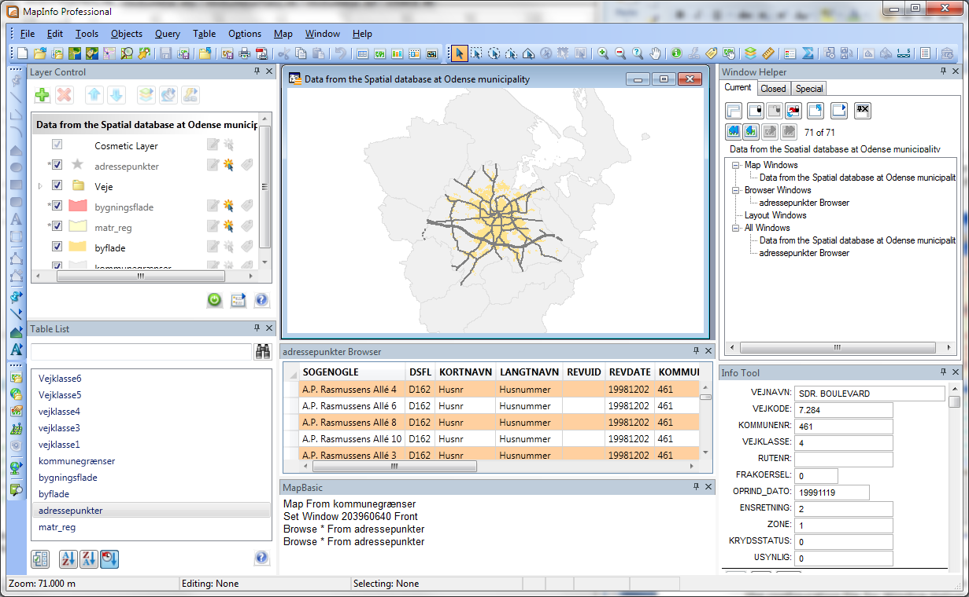
Notice the docked browser window and the docked MapBasic and Info window.
Please note that the dockable state of a window is stored anywhere. It’s not stored in the configuration file for WindowHelper nor will it be stored when you save you current session into a workspace.
The second row of buttons lets you switch between the map extents that you have used during the current session of a Map window.
When you open a new map, these buttons might be disabled as only a single extent exists. As you start zooming and panning around this map, you will notice that the buttons get enabled.
These buttons lets you zoom to the first (initial) extent of the map, zoom to the previous extent (similar to Map > Previous View), zoom to the next extent and to the last extent.
After the buttons you can see which view/extent you are current at. If you are at the first, you can't zoom to the first or to the previous extent. If you are at the last, you can't zoom to the last or the next extent.
The Map Extents are stored as a Center Coordinate using the current coordinate system of the map and a Map Width using the current distance units of the map.
WindowHelper does support a Map Extent list for each Map Window.
Under the second row of buttons you can see the name of the current active window. This is also the window the buttons of the WindowHelper window will effect when pushed.

Closed windows
When selecting the Closed tab you will see a list of windows that have been closed during this session.
This list is just like the list of currently open windows grouped into window types, Closed Map Windows, Closed Browser Windows, Closed Layout Windows and All Closed Windows. Again this will make it easier for you to locate the window you are looking for.
Also note that there is a time stamp in front of all the closed window names – this can give you an idea of where to locate the window you need.
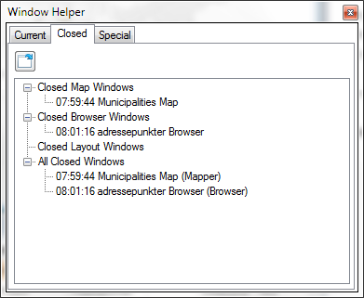
The Closed Windows view currently only supports a single feature, namely the Restore Selected Closed Window. This will let you restore a closed window as it looked when you closed it.
What happens is that WindowHelper takes a snap shot of the window just before the window is being closed. This snap shot is similar to the statement that you will find in a workspace.
There is however one difference: WindowHelper does not “capture” which tables needs to be open. All it captures is the Window statement. So if you have closed some tables since you closed the window, the restore window might not work.

Special Windows
The final tab is the Speciel tab – or the list of special windows. A special window is any window in MapInfo Professional that isn’t a document window, such as a Map, a Browser or Redistricter, a Layout, a Graph, a Cartographic Legend or a 3D Map.
Special windows are those shown in the picture below.
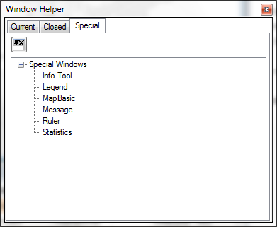
Thru WindowHelper you can make a special window dockable. Select one of the special windows and click the Make Selected Window Dockable.
You can now dock this special window next to for instance the Layer Control. Have a look at the picture to the right to see an example of some docked special windows.
Here the MapBasic window and the Message window are docked at the bottom of the MapInfo Professional program window.

The menu options
From the menu WindowHelper in the Tools menu you find a number of extra features and you will also find some feature in context menu/right click menus in a number of places.

Save Window To Workspace Without ‘Open Table …’ Statements
If you want to save a layout that you have setup with a number of windows as a template to be reused but without the open table and windows statements you can use the menu item Save window to workspace without ‘Open Table … “ statements.
This will only store the window statement of the currently active window. It will not store information on which tables to open or which other windows to create.
The stored workspace will therefore require that the tables and/or windows using by this window are open when you reopen the workspace.

Show Window
Have you ever wondered why your Info window doesn’t show on the screen when you use the Info tool? I’m sure you have.
This is an often seen issue when a workspace is shared by several users who have different monitor sizes or if you are working on a laptop where you have a large monitor at work, but not at home.
The Show window menu lets you easily show a “disappeared” window inside the MapInfo Professional program window. Just choose the window you want to see and it will appear inside the current size of MapInfo Professional.

Store And Restore Window Positions
WindowHelper can help you manage where a number of the special MapInfo windows appear.
The windows that are managed are:
- The Info window
- The Message window
- The MapBasic window
- The Legend window
- The Statistics window
- The Ruler window (only position)
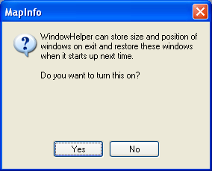
- The MapInfo window
You can turn on this feature thru Tools > WindowHelper > Autostore Positions Of Windows. When you click on this menu item you’ll see this question:
Click Yes to turn on this feature or click No to disable this feature.
The size and position of the windows are stored depending on the screen resolution. So they can have a different size and position if your computer is connected to an external monitor with a better resolution.

Locate File In Windows Explorer
In the right click menu of the TableList window and the right click menu of the layers in the Layer Control you find this menu item, which lets you locate and select the file of a table/layer in Windows Explorer.
This feature works on one selected table or layer.
If you have selected a raster layer/table, you will be asked if you want to locate the tab file or the raster file.

Open File In Favorite Text Editor
In the right click menu of the TableList window and the right click menu of the layers in the Layer Control you find this menu item, which lets you open the tab file of a table/layer in your preferred text editor, for example Notepad.
This feature works on one selected table or layer.
This gives you quick access to the content of the tab file and an overview of the table structure as well as the meta data of the tab file.

Close Table
In the right click menu of the layers in the Layer Control you will find the Close table menu item, that makes it easy to close the table for a specific layer.
This feature works on one selected layer.
Notice that when you close the table thru the layer, all windows only showing this table and queries based on this table will also be closed.

Set Default View/Set Default View on All Layers
You will find this menu item in the right click menu of the Maps and of the Layers in the Layer Control.
If you use the menu item from the Maps right click menu, the default view will be set on all layers of the map that support this.
If you use the menu item from the Layers, you will set the default view of one layer at a time.
The default view is the zoom and center of a table used when the table is open as the first table in a new map window.

View Entire Map
You will find this menu item in the right click menu of the Maps in the Layer Control. If you click this menu item, the map will zoom to the extent of all the layers in the map.
It is similar to Map > View Entire Layer > All Layers.

Clone View
You will find this in the right click menu of the Layout window. It will let you make a copy of the current Layout window.
This is similar to the Clone View menu item that you find in the Map menu and the right click menu of the Maps.
You can also make a copy of a window thru the WindowHelper window using the Clone Selected Window button on the Current tab.

Known issues
You might see some strange behavior if you have made a window dockable and then close the WindowHelper.
If you do, close MapInfo Professional and start it again.

