

Project report
02-2006

Comparison of DFT-OFMDA concept with common OFDMA

Distribution list:
Name Department Location
Hric Peter MSS MCS RA8 PSE SK / BRA
Svac Pavol MSS MCS RA8 PSE SK / BRA
Document Management

History of changes

Version | Status | Date | Person resp. | Reason for Change
01-2006 | AFI | 28.02.2006 | Hric Peter | Document creation
02-2006 | AFI | 13.03.2006 | Hric Peter | Document update

Persons authorized to make changes
Hric Peter MSS MCS RA PSE SK / BRA
Svac Pavol MSS MCS RA8 PSE SK / BRA

Document was created using the following tools:
Microsoft Word 2000, MS Visio, Mathworks Matlab 6.5…

Contents
Contents 3
1 Introduction 4
2 Simulation parameters and assumptions 4
3 Simulation results 5
3.1 rawBER waterfall curves comparison 5
3.2 Burst error and error statistics Error! Bookmark not defined.
3.3 PAPR Complementary Cumulative Distribution Function (CCDF) comparison 10
3.3.1 Results obtained by random input data 10
3.3.2 Results obtained by highly correlated input data 11
3.3.3 Results obtained by searching over whole OFDM symbol set 12
3.4 Conclusion 16
Definitions of terms and abbreviations 18

Introduction
Common OFDMA systems suffer from two major drawbacks, limiting their performance and versatility of use. The first drawback is significant sensitivity to frequency and time synchronization inaccuracies. The second one, common for any multi-carrier modulations, is unfavorable Peak to Average Power Ratio (PAPR) parameter. Problem of high PAPR is especially limiting for the uplink transmission and thus it is of high interest for many researchers to develop methods or algorithms which could compensate for this drawback.
In this report we focus on one of the possible solutions for PAPR reduction based on a pre-coding. The report contains some elementary investigations and provides comparison in the system performance and PAPR reduction between DFT pre-coded OFDMA (DFT-OFDMA) and OFDMA systems.

Simulation parameters and assumptions
Description of the LL simulator can be found in [1]. Channel model and OFDM parameters are the same as in [2]. Figure 2-1 depicts the processing chain of modulator in our simulations. Since besides DFT pre-coding also DCT pre-coding simulations have been carried out and described in this report, the drawing below comprises also this fact. DFT/DCT pre-coded OFDMA modulation scheme as simulated is depicted in Figure 2-1.
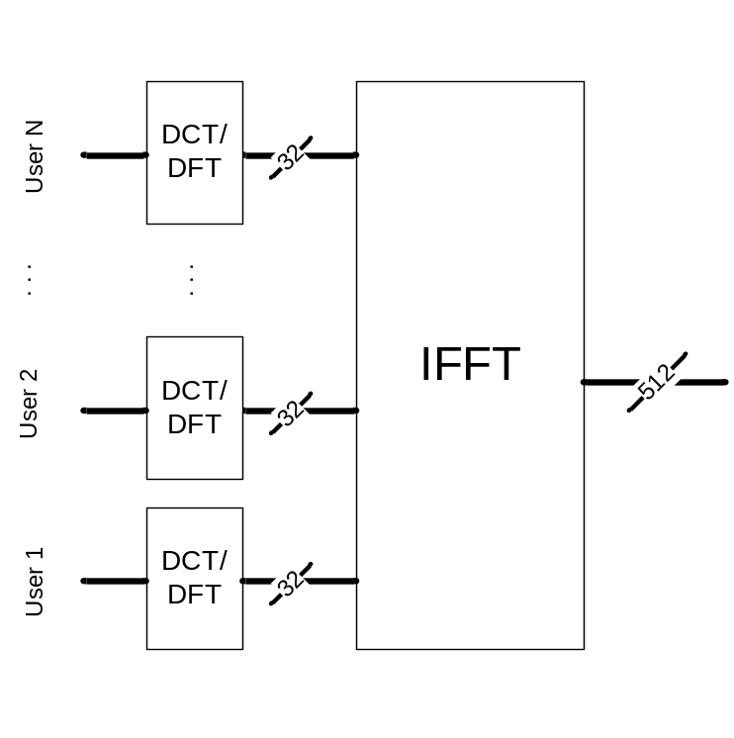
Figure 2-1: DFT/DCT pre-coded OFDMA modulation scheme
As can be seen from the Figure 2-1, each user transmits data within assigned band of 32 sub-carriers. Therefore, an OFDMA system with 512 sub-carriers and 20 MHz total bandwidth can accommodate N = 16 users following this resource allocation model.

Simulation results

Simulation with frequency selective channel
The first simulations investigate system performance in an environment modeled as Wide Sense Stationary Uncorrelated Scattering (WSSUS) channel with AWGN. Figure 3-1 compares performance of both techniques evaluated by uncoded BER, i.e. rawBER values. In the range of 0 -15 dB, DFT-OFDMA performs worse compared to OFDMA. Maximum degradation in that interval is approx. 2dB. In the surround of expected working point (WP) (15 - 17 dB) rawBER performance is roughly equal in both investigated cases. For SNR values higher than 17 dB, performance improves in favor of DFT-OFDMA.
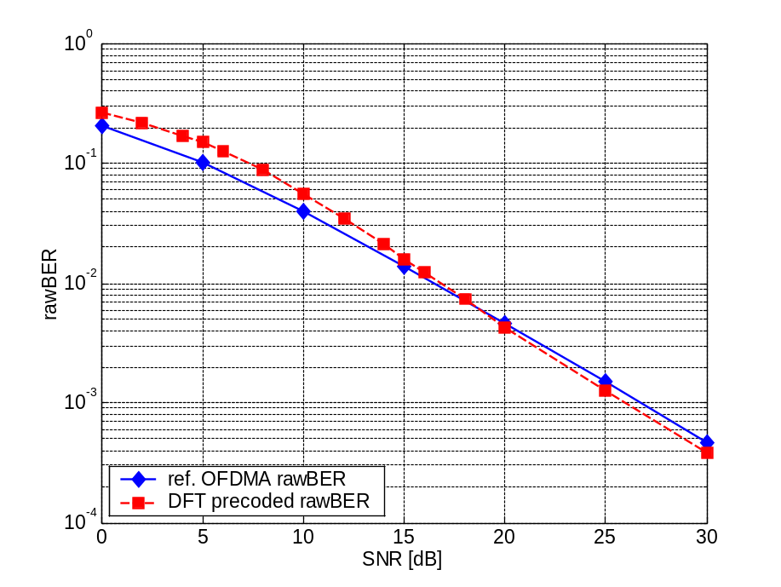
Figure 3-2: rawBER comparison between DFT-OFDMA and OFDMA, block of 32 Sc.
rawBER results from Figure 3-2 do not reveal how the errors are distributed within coding bock, since rawBER can be considered as a relative measure of the error rate from the FEC point of view. In order to see this fact, we evaluated performance of both systems by means of coded BER, i.e. userBER values.
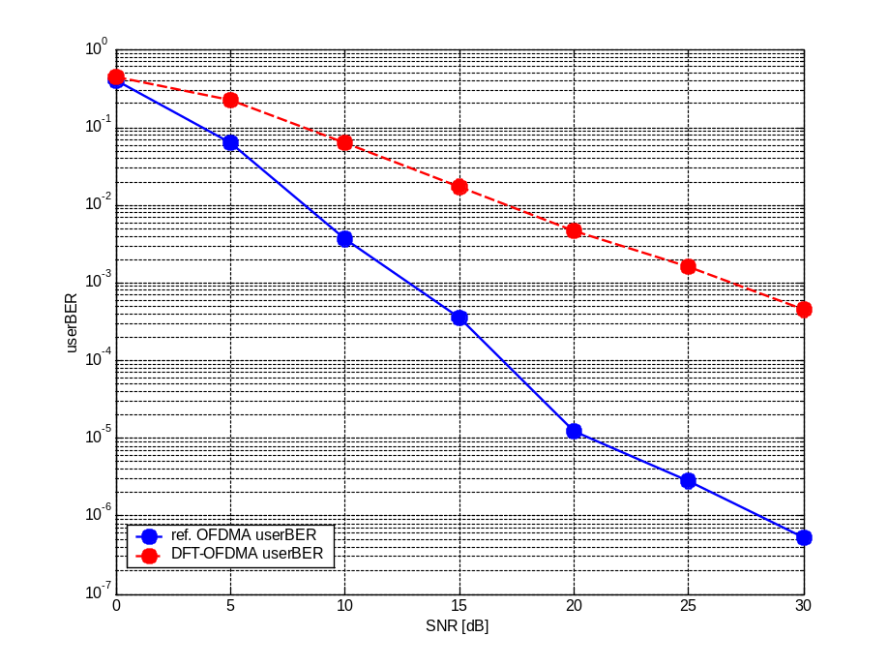
Figure 3-3: userBER comparison between DFT-OFDMA and OFDMA
Figure 3-3 shows that DFT-OFDMA performance, likewise IFDMA [3], worsens in comparison to the reference OFDMA system. This can be explained by the principle and complexity of this modulation technique, which makes DFT-ODFMA (likewise IFDMA) more sensitive to burst errors compared to OFDMA. More detailed information regarding this issue can be found in section Error: Reference source not found of this report.
Figure 3-4 provides a third quality criterion, BLock Error Rate (BLER) waterfall plots.
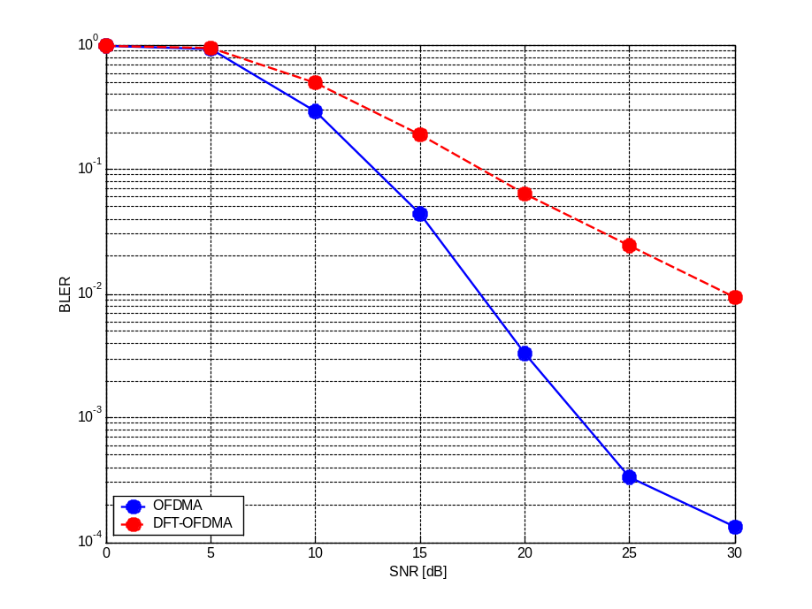
Figure 3-4: BLER comparison between DFT-OFDMA and OFDMA
Since from link level point of view data packet is identical to coding block, we define BLER as a ratio of coding blocks with error to all transferred coding blocks. Likewise in the userBER case, the DFT-OFDMA BLER plot shows apparent performance degradation. (At expected WP of 17 dB, OFDMA reaches BLER = 10^{-1.81} whereas DFT-OFDMA BLER = 10^{-0.91}).

Burst error and error statistics
This section deals with burst error statistics of both investigated concepts. The error statistics are obtained from the simulations over 10.000 OFDMA symbols in environment modeled as WSSUS channel with AWGN. It should be mentioned that defining a proper condition to distinguish a burst error from an ordinary bit error is a crucial point to obtain relevant results. In our simulations the burst error detection is considered as an occurrence of errors in coded data stream where two consecutive errors are distant less than 35 (Constraint Length x 5 = 7 x 5 = 35) bits.
Error: Reference source not foundError: Reference source not found depict the distribution of burst errors and number of bit errors per OFDM symbol, respectively.

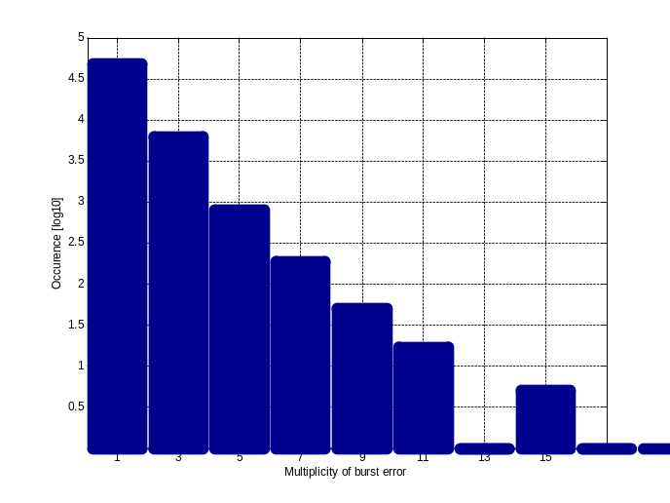  OFDMA | 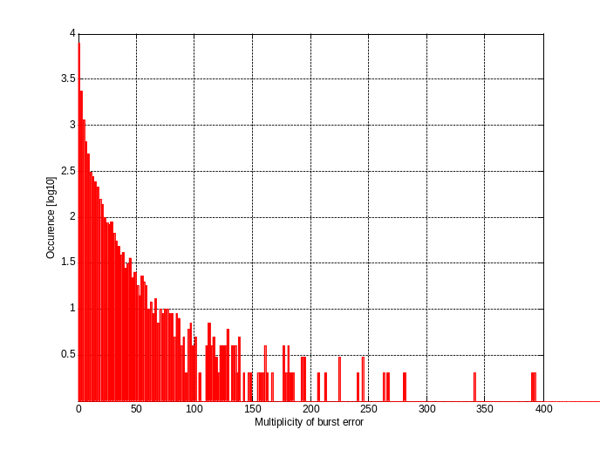  DFT-OFDMA
Figure 3-5: Burst error statistics of DFT-OFDMA and OFDMA – burst error lengths

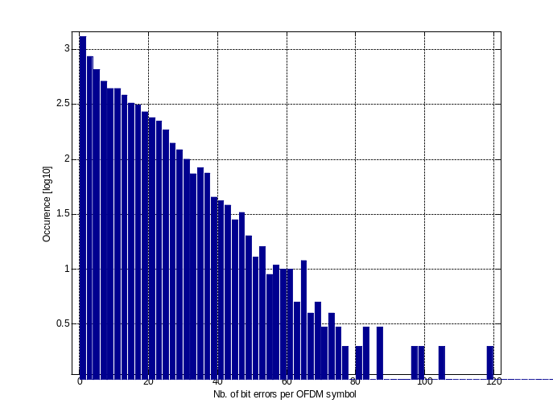  OFDMA | 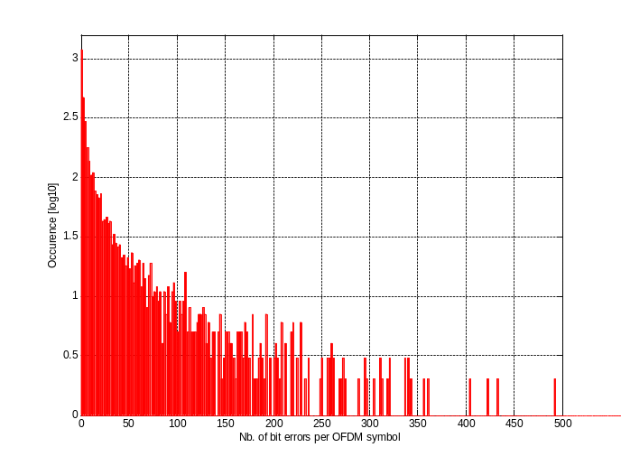  DFT-OFDMA
Figure 3-6: Error per symbol statistics of DFT-OFDMA and OFDMA
It is apparent from both figures that OFDMA system with DFT processor prefixed before the main IFFT becomes more sensitive to channel impairments, particularly to burst errors.

Simulation with adaptive modulation
Simulations with WSSUS channel have revealed that performance of DFT-OFDMA modulation scheme is significantly worse in comparison to a common OFDMA.
One of the possible solutions which can improve the system performance is link adaptation (LA). In single carrier CDMA systems fast power control is used as a preferred method for the LA. In multi-carrier systems like OFDM, similar approach can be used, i.e. fast power control on each sub-carrier. Alternative possibility for the LA is adaptive modulation and coding (AMC). If compared to previous solution based on per sub-carrier fast power control, with AMC the power of the transmitted signal is held constant over a certain period (e.g. several OFDM symbols). However, the modulation and coding scheme is changed to match the current received signal quality or channel conditions.
Considering perfect channel state information in each sub-channel (no measurement errors and delays) performance of the system with AMC will converge to that in AWGN channel. This idealized model is used in the next simulations to compare performances of DFT-OFDMA and OFDMA when AMC is utilized.

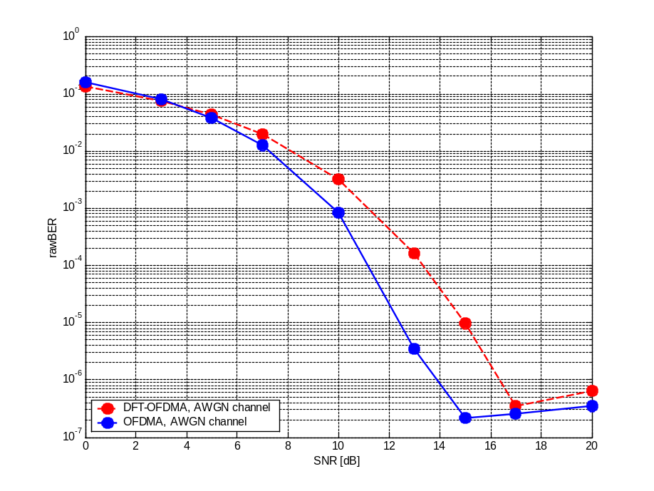
Figure 3-7: rawBER comparison between DFT-OFDMA and OFDMA in AWGN channel, block of 32 Sc.
From the Figure 3-7 we can notice that rawBER curve behavior is still more favorable in OFDMA, than in DFT-OFDMA instance. To quantify the gain, it shows rising trend from 0.276 dB at 10⁻², up to 2.47 dB at rawBER = 10⁻⁶ in favor of OFDMA.

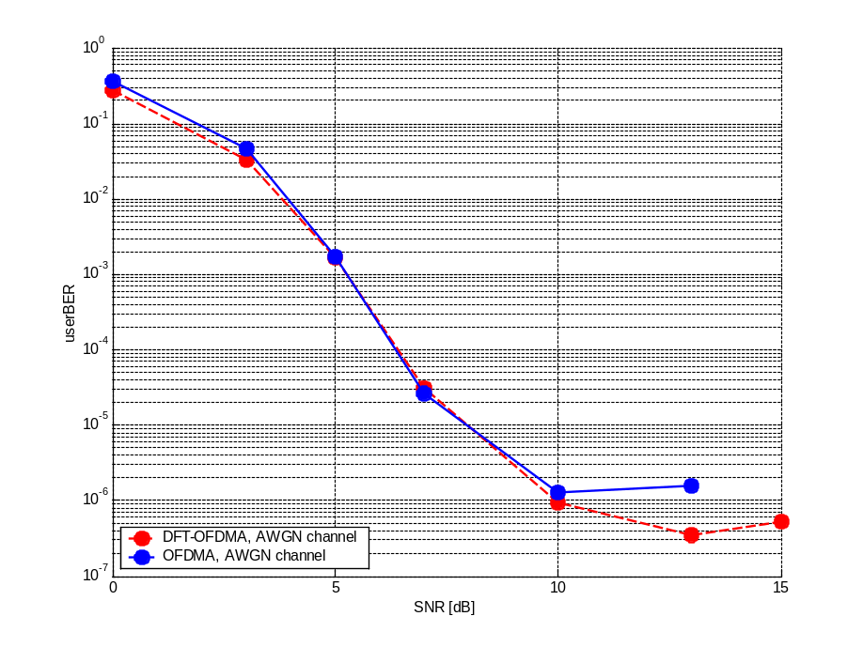
Figure 3-8: userBER comparison between DFT-OFDMA and OFDMA in AWGN channel, block of 32 Sc.
On the contrary, Figure 3-8 suggests different situation than Figure 3-7. Here DFT-OFDMA slightly surpasses OFDMA in the range between 0 – 5 dB SNR. At userBER = 10⁻³ bottssystems show nearly equal performance. While OFDMA curve saturates at 10 dB, DFT-OFDMA saturates later, i.e. at 13 dB.
Compared to the results from sections 4.1 and 4.2, we can see that employing AMC rapidly increases performance of DFT-OFDMA based system.

PAPR simulations

PAPR Complementary Cumulative Distribution Function (CCDF) comparison
The second step of our investigations is targeted at comparison of dynamic range of DFT-OFDMA and OFDMA. For this purpose we used statistical approach based on CCDF. The following sections present results reached under specific parameters.

Results obtained with random input data
The concept of DFT-OFDMA was originally proposed with an objective to reduce dynamic range of general OFDM system. Figure 3-9 presents comparison of PAPR between DFT-OFDMA and OFDMA. As can be seen, DFT-OFDMA concept allows for PAPR reduction gain of approximately 4.8 dB compared to OFDMA. Note that PAPR statistics were collected over 50 millions OFDMA symbols.
In [5] it was shown that the envelope power fluctuations strongly depend on the level of input data correlation. This means that in case the input data exhibits low correlation, i.e. their aperiodic autocorrelation function (AAF) approximates delta function, the energy and thus the envelope power is uniformly distributed.
Therefore, it would be interesting to investigate the proposed concept, however, with a transform which could assure decorrelation of the pre-coded data. It is known from theory of transform coding that DCT can meet above mentioned requirements.
Results of DCT pre-coded OFMDA (DCT-OFDMA) are presented in Figure 3-9. In this case the PAPR reduction gain is comparable to that of DFT-OFDMA. The reason for similar behavior comes from low correlation level of random input data. This issue is further investigated in the next section.
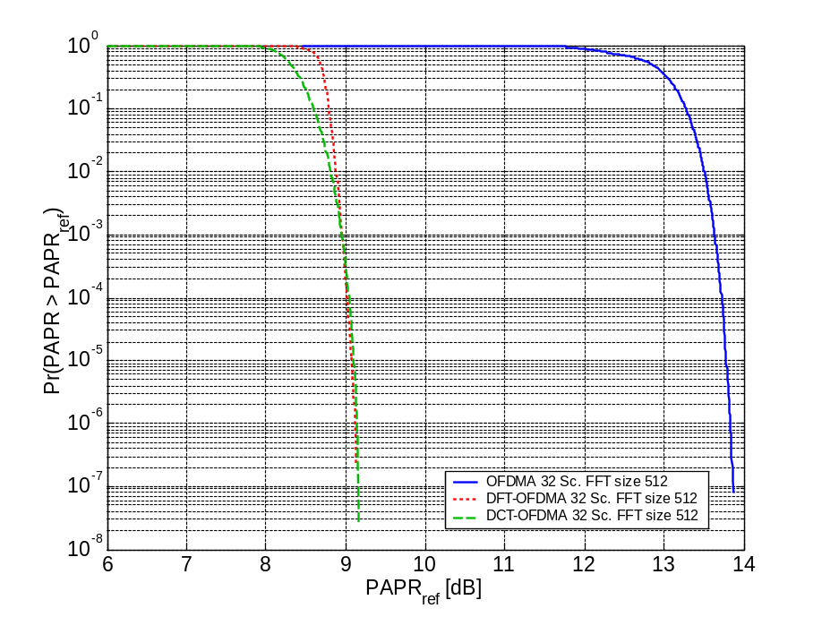
Figure 3-9: CCDF comparison between DFT-OFDMA, DCT-OFDMA and OFDMA

Results obtained by highly correlated input data
In order to see the advantage of DCT-OFDMA, it is necessary to consider some data with a certain level of correlation. In the previous section the comparison was based on data with low level of correlation. Therefore the gain of DCT pre-coding was not significant.
In order to compare the level of correlation for different input data, we generated a random data stream of length 512 symbols and used a windows bitmap file. Their normalized AAF magnitudes are depicted in Figure 3-10.
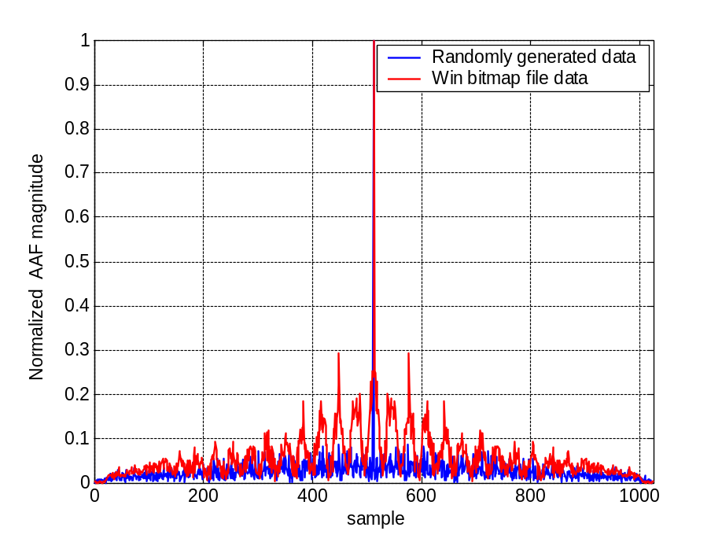
Figure 3-10 Normalized autocorrelation functions of input data streams
As expected, the bitmap data exhibits significantly higher correlation level than randomly generated data. In the following, we compare PAPR reduction for the case of correlated input data stream, when DFT and DCT pre-coding is used.
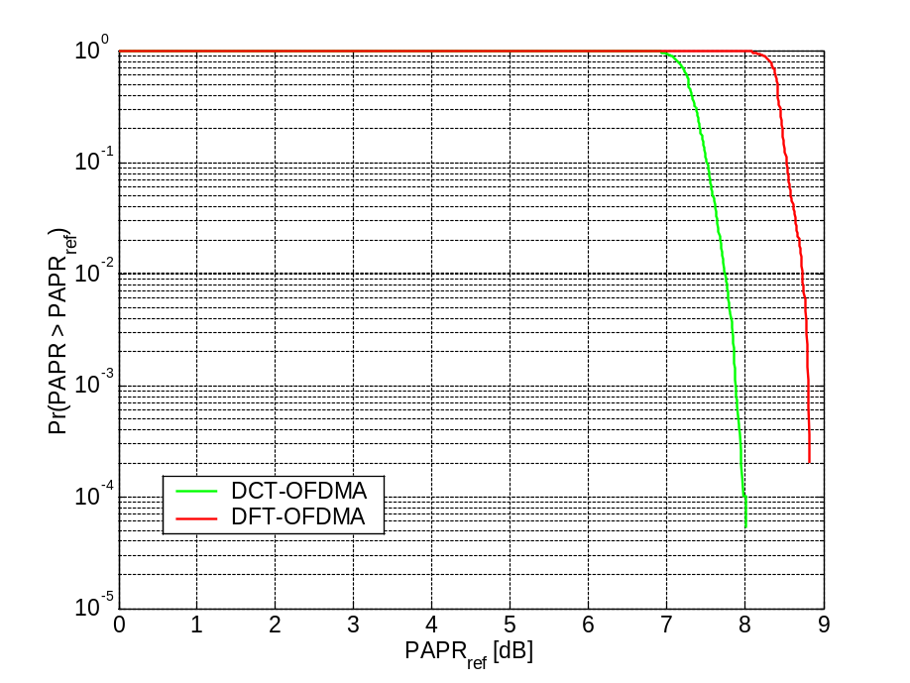
Figure 3-11 CCDF curves for DCT and DFT-OFDMA with highly correlated input data
From Figure 3-11 it can be observed that DCT-OFDMA provides PAPR reduction gain of 1dB compared to DFT-OFDMA. Moreover, from the practical implementation (power consumption, number of operations) point of view, DCT is remarkably more beneficial than DFT.

Results obtained by searching over whole OFDM symbol set
In order to obtain more exact comparison between DCT, DFT pre-coded and OFDMA, PAPR measurement over whole symbol set was carried out. Since there is not enough computational power to perform this investigation in the above mentioned case (i.e. 32 sub-carriers and QAM4 = 2⁶⁴ OFDMA symbols), we have limited OFMDA symbol set to 16 sub-carriers and BPSK (2¹⁶ possible OFDMA symbols). From the Figure 3-12 we can notice that DCT and DFT pre-coding reach both the same maximum PAPR value (8.2 dB). However, plots’ behaviors imply that DCT outperforms DFT pre-coding in the whole displayed range form PAPR reduction point of view.
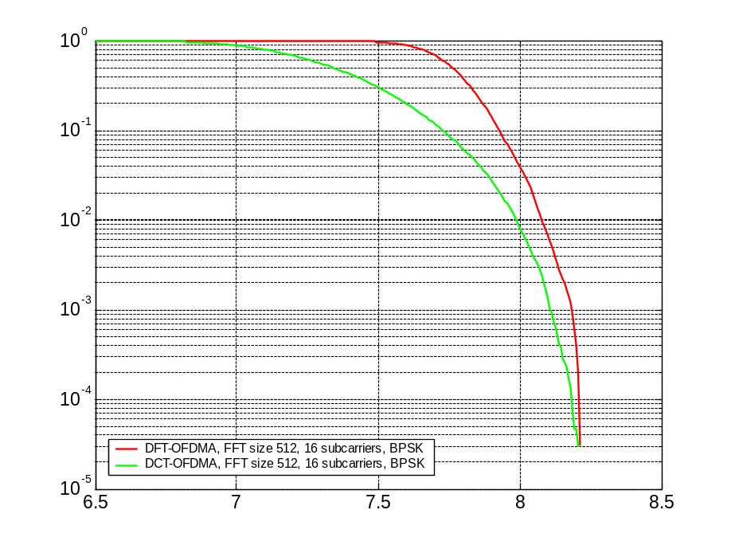
Figure 3-12 CCDF comparison between DFT-OFDMA and DCT-OFDMA, BPSK, 16 sub-carriers

More substantial difference between plots can be observed in the Figure 3-13, where DFT-OFDMA acquires about 4.5 dB lower values of PAPR compared to parallel OFDMA plot, reaching 12.92 dB at its maximum.
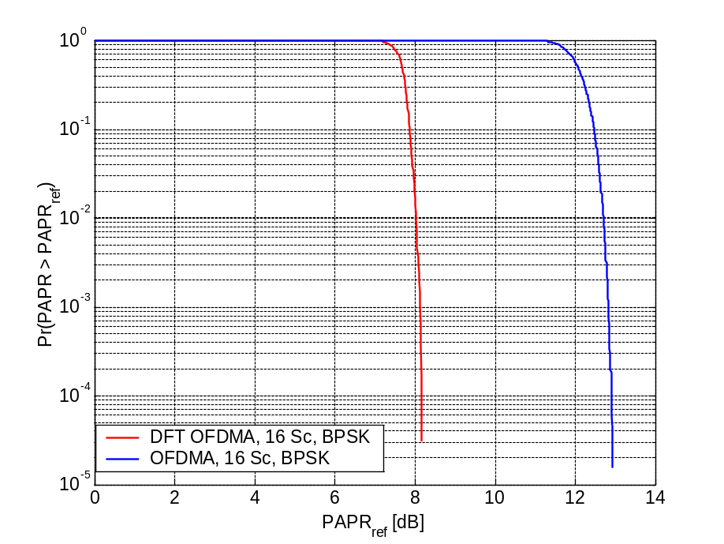
Figure 3-13 CCDF comparison between DFT-OFDMA and OFDMA, BPSK, 16 sub-carriers

Power clipping.
In the following we focus our interest on the performance of OFDMA concept, when we take into account possible peak clipping of the signal envelope by a power amplifier. For our simulation purposes, an ideal power amplifier with limited gain was taken as a model. The gain limit was adjusted to 9.13 dB, which is the dynamic range in case of DFT-OFDMA. According to [4], the Clipping Ratio (CR) is defined as CR = A/σ, where A is the amplitude and σ is the RMS of the OFDMA complex signal. Hence, we can state that the gain limit of 9.13 dB results in CR = 10^{9.13/10} = 8.1846.
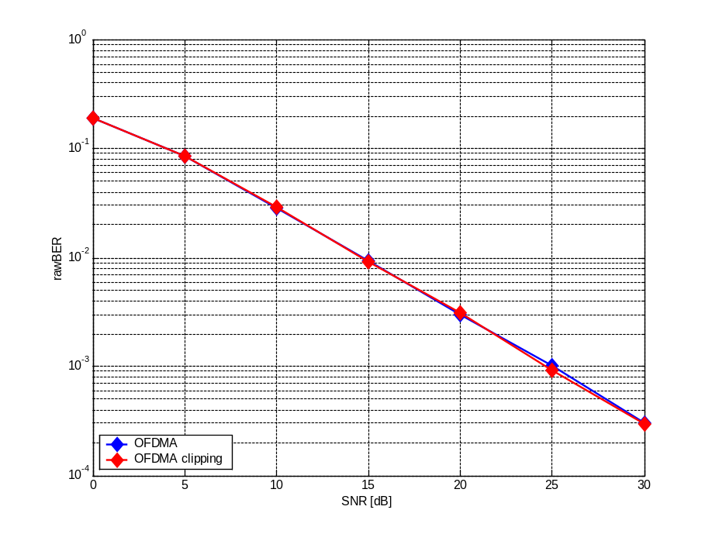
Figure 3-14: Comparison of OFDMA and DFT-OFDMA signal envelope in time domain
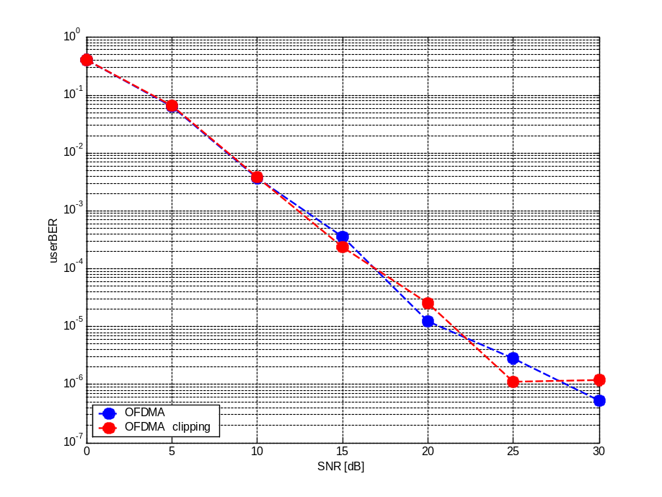
Figure 3-15: Comparison of OFDMA and DFT-OFDMA signal envelope in time domain
Simulation results are presented in Error: Reference source not found and Error: Reference source not found. Since in case of OFDMA clipping curve almost no deviation from OFDMA is observed, one can conclude that under given circumstances (i.e. CR = 8.1846, WSSUS channel) signal envelope clipping has minor or no impact on the system performance.
To investigate and demonstrate the influence of peak clipping on the system performance, we tried to expose the discussed OFDMA modulation scheme to special conditions. We set the simulator to AWGN channel mode and performed 3 simulation in CR = 1.4, 1.2, and 1. Error: Reference source not found depicts corresponding curves, plus theoretical curve in AWGN channel for QAM4.
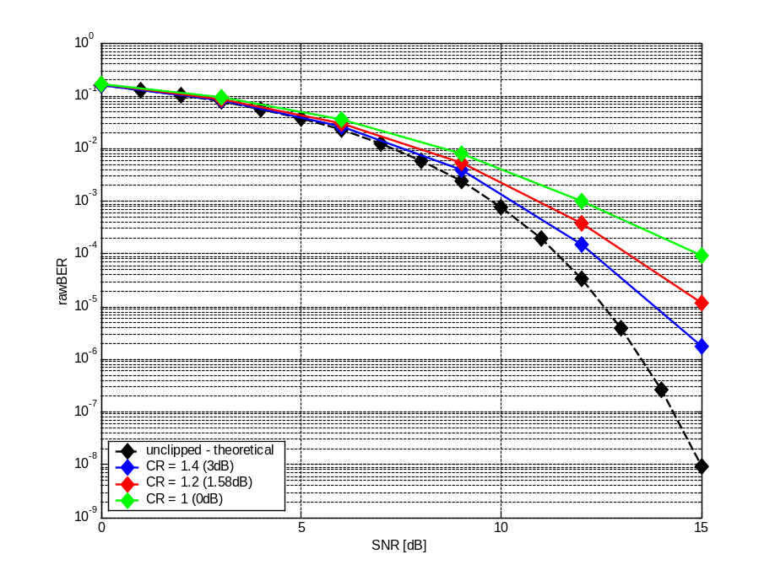
Figure 3-16: Comparison of rawBER curves in AWGN channel, with different values of CR
In the above figure, we recognize much stronger influence of signal envelope clipping. However, this occurs by CR far below CR = 8.1846 (9.13 dB). Therefore we can assume neglectable deviation from the theoretical, unclipped curve.

Conclusion

In this report it has been shown that pre-coding is a promising technique for lowering dynamic range of OFDMA systems. DFT-OFDMA concept excels OFDMA in PAPR CCDF statistics of around 5 dB. On the other hand, DFT-OFDMA itself introduces symbol errors. This is manifested mainly in userBER and burst error statistics which imply that the DFT-OFDMA (likewise IFDMA) tends to group errors to bursts, rather than spreading them over coding block. This drawback can be easily overcome by means of interleaver or more efficient FEC codes. Moreover, as simulation results in section 4.2 have shown that in AWGN channel DFT-OFDMA reaches BER parameters comparable to OFDMA we can anticipate that employing adaptive, soft modulation will near the performance of both technologies. Therefore, combination of DFT pre-coding with an interleaver, adaptive modulation, or other technologies suppressing burst errors is very promising.
From plots provided by section 4.3.1 we can deduce no impact of signal peak clipping in case of OFDMA system with QAM4, assuming CR = 8.1846. Hence, from this point of view we can apprehend both technologies as roughly equal (comparable).
Apart from DFT pre-coding, also DCT pre-coding was investigated. This transform, known for its well de-correlating capabilities proved to be more efficient in terms of PAPR CCDF statistics. This benefit compared to DFT is even more evident from the plots displaying CCDF for the correlated data stream obtained from the bitmap file. Since DCT is known as a special and simpler case of FFT, it is computationally less demanding than FFT. Therefore, it could be better suited for pre-coding in OFDMA modulation scheme. However, userBER and rawBER waterfall curves for DCT-OFDMA have not been investigated but we can expect behavior similar to that of DFT-OFDMA.

G.722.2 AMR-WB | LL simulations |  |  | SL simulations
G.722.2 AMR-WB | uBER | rawBER | CIR [dB] | C_target [dBm] | Users/cell  [%] | Spectral efficiency  [kbps/MHz/cell]
cluster size 3
OFDM -TDMA | 10e-3 | 0.014 | 17.0816 | -57 | << 2.5 | << 1.5
OFDMA | 10e-3 | 0.0010553 | 26.7113 | -57 | <<< 2.5 | <<< 3.93
cluster size 13
OFDM -TDMA | 10e-3 | 0.0141 | 17.0251 | -78 | 11.4696 | 4.13
OFDMA | 10e-3 | 0.0010553 | 26.7113 | -80 | 2.5 | 0.91
cluster size 16
OFDM -TDMA | 10e-3 | 0.01396 | 17.2057 | -81 | 100 | 25.73
OFDMA | 10e-3 | 0.0010553 | 26.7113 | -93 | 8.49585 | 2.5
cluster size 16, code rate: ½
IFDMA | 10e-3 | 0.00080279 | 27.4991 | -79 | 6.5217 | 1.27
cluster size 16, code rate: ½
DFT-OFDMA | 10e-3 | 0.00074131 | 27.2078 | N.S. | N.S. | 1.4344
cluster size 16, code rate: ½
DCT-OFDMA | 10e-3 | 0.0007480 | 28.3357 | N.S. | N.S. | 0.7978

Definitions of terms and abbreviations

AAF Aperiodic Autocorrelation Function
BLER BLock Error Rate
DCT-OFDMA Discrete Cosine Transform pre-coded OFDMA
DFT-OFDMA Discrete Fourier Transform pre-coded OFDMA
PAPR Peak to Average Power Ratio
CCDF Complementary Cumulative Distribution Function
CL Constraint Length of convolution code
CR Clipping Ratio
DSP Digital Signal Processing
RMS Root Mean Square
WP Working Point

Appendix

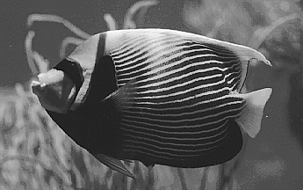
Literature
[1] V. Bochnicka, “Intra and Inter-cell Synchronisation”, Deliverable of the project “OFDM Network Synchronization Simulator”, 06-2004.
[2] P.Hric, P.Svac, P.Slanina, “Optimisation of intercell allocation versus synchronisation requirements for wide area scenario OFDM parameters”, Project report 04-2005
[3] P.Hric, P.Svac, “IFDMA system level simulations – Spectral efficiency determination for SUC threshold 95%” Project report 02-2005
[4] Xiaodong Li and Leonard J. Cimini, Jr., Senior Member, IEEE, “Effects of Clipping and Filtering on the Performance of OFDM”, IEEE COMMUNICATIONS LETTERS, VOL. 2, NO. 5, MAY 1998

[5] P.Svac, O. Hridlicka, “A high Peak To Average Power Ratio reduction in OFDM systems by ideal N/2 - shift apperiodic autocorrelation property”, Invention report, 12-2005
[6] Jihoon Choi, Robert W. Health, Jr., “Interpolation Based Transmit Beamforming for MIMO-OFDM with Limited Feedback”, IEEE transaction on signal processing, http://www.ece.utexas.edu/~rheath/papers/2003/bf_sp/paper.pdf
[7] Encyclopaedia online: http://en.wikipedia.org/wiki/Discrete_cosine_transform

By the definition, convolution code can correct at most fivefold of its constraint length (CL). Since the CL of the used ½ rate convolution code is 7 (see [3], or [2] for details) it will not correct consecutive errors distant less than 7 x 5 = 35 bits. Therefore, we consider a burst error such an occurrence of errors in raw coded data stream, where two consecutive errors are distant not more than 35 bits.
For AMC it is assumed that the coherence time or coherence bandwidth is high enough. Otherwise AMC cannot be used.
With adaptive modulation we would introduce variable bit rate, which must be also considered when evaluating spectral efficiency from the system level point of view.
See appendix
FFT fast algorithms (such as decimation-in-time and decimation-in-frequency) typically require (N/2)*log₂N complex multiplications and N*log₂N complex additions [6]. Since DCT is essentially DFT of real-even data, even specialized algorithms reaching minimum number of arithmetic operations can be designed by eliminating redundant operations from FFT algorithm due to this symmetry. The precise count of arithmetic operations depends on used algorithm, transform definition and transform scaling. For DCT-II definition, typically adduced count of operations is: 2*N*log₂N − N + 2. Two multiplications can be saved if the transform is scaled by an overall √2 factor. Additional multiplications can be saved if the implementation permits the outputs of the transform to be rescaled individually [7].
Not Simulated

