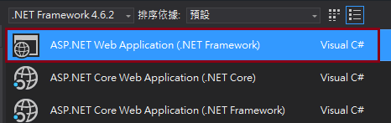

SignalRSite

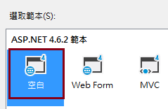

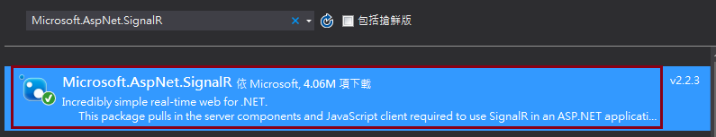

|  |
| --- |
| 新增[ChatHub.cs] |
| using Microsoft.AspNet.SignalR;  namespace SignalRSite  {  public class ChatHub : Hub  {  public void Send(string name, string message)  {  Clients.All.broadcastMessage(name, message);  }  }  } |

|  |
| --- |
| 新增OWIN啟動類別[Startup.cs] |
| using Microsoft.Owin;  using Owin;  [assembly: OwinStartup(typeof(SignalRSite.Startup))]  namespace SignalRSite  {  public class Startup  {  public void Configuration(IAppBuilder app)  {  app.MapSignalR();  }  }  } |

|  |
| --- |
| 新增[index.html] |
| <!DOCTYPE html>  <html>  <head>  <title>SignalR Simple Chat</title>  <style type="text/css">  .container {  background-color: #99CCFF;  border: thick solid #808080;  padding: 20px;  margin: 20px;  }  </style>  </head>  <body>  <div class="container">  <input type="text" id="message" />  <input type="button" id="sendmessage" value="Send" />  <input type="hidden" id="displayname" />  <ul id="discussion"></ul>  </div>  <!--Script references. -->  <!--Reference the jQuery library. -->  <script src="Scripts/jquery-1.6.4.min.js"></script>  <!--Reference the SignalR library. -->  <script src="Scripts/jquery.signalR-2.2.3.min.js"></script>  <!--Reference the autogenerated SignalR hub script. -->  <script src="signalr/hubs"></script>  <!--Add script to update the page and send messages.-->  <script type="text/javascript">  $(function () {  // Declare a proxy to reference the hub.  var chat = $.connection.chatHub;  // Create a function that the hub can call to broadcast messages.  chat.client.broadcastMessage = function (name, message) {  // Html encode display name and message.  var encodedName = $('<div />').text(name).html();  var encodedMsg = $('<div />').text(message).html();  // Add the message to the page.  $('#discussion').append('<li><strong>' + encodedName  + '</strong>:&nbsp;&nbsp;' + encodedMsg + '</li>');  };  // Get the user name and store it to prepend to messages.  $('#displayname').val(prompt('Enter your name:', ''));  // Set initial focus to message input box.  $('#message').focus();  // Start the connection.  $.connection.hub.start().done(function () {  $('#sendmessage').click(function () {  // Call the Send method on the hub.  chat.server.send($('#displayname').val(), $('#message').val());  // Clear text box and reset focus for next comment.  $('#message').val('').focus();  });  });  });  </script>  </body>  </html> |

執行測試

加入CORS

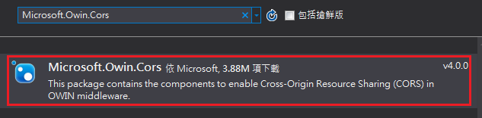

|  |
| --- |
| 修改[Startup.cs] |
| using Microsoft.AspNet.SignalR;  using Microsoft.Owin;  using Microsoft.Owin.Cors;  using Owin;  [assembly: OwinStartup(typeof(SignalRSite.Startup))]  namespace SignalRSite  {  public class Startup  {  public void Configuration(IAppBuilder app)  {  app.Map("/signalr", map =>  {  map.UseCors(CorsOptions.AllowAll);  var hubConfiguration = new HubConfiguration  {  EnableJSONP = true  };  map.RunSignalR(hubConfiguration);  });  }  }  } |

新增Client1目錄, 將index.html及Script目錄複製過來

|  |
| --- |
| 修改[index.html], URL要看你的WebSite |
| <!--<script src="signalr/hubs"></script>-->  <script src="http://localhost:57319/signalr/hubs"></script> |
| <script type="text/javascript">  $(function () {  $.connection.hub.url = "http://localhost:57319/signalr";  // Declare a proxy to reference the hub.  var chat = $.connection.chatHub; |
| $.connection.hub.start({ jsonp: true }).done(function () { |

執行測試

>ng new AngularClient --routing --style=scss