Attached is info on turning off the NBIoT Search for the BG96 Module.

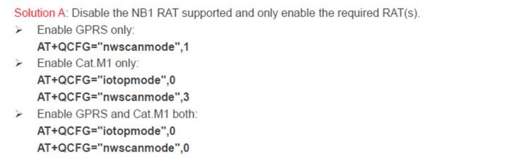

If this is done the connect time for CatM1 Network should improve.

<https://www.dropbox.com/sh/61fsqyy6f7zxzq6/AABRbZI5AcH8QMBPfz57-lN3a?dl=0>