MET CS 555 Assignment 6 – 20 points
SUBMISSION REQUIREMENTS: Please submit a single document (word or PDF) for submission. Your submission should contain a summary of your results (and answers to questions asked on the homework) as well as your R code used to generate your results (please append to the end of your submission). Please use R for the calculations whenever possible. You will lose points if you are not utilizing R. You will also lose 10 points per day for late submissions unless prior arrangements are made with your facilitator.
The data in this document consists of body temperature measurements and heart rate measurements for 65 men and 65 women. Save the data to excel and read the data into R. Use this data to address the following questions.
(1) We are interested in whether the proportion of men and women with body temperatures greater than or equal to 98.6 degrees Fahrenheit are equal. Therefore, we need to dichotomize the body temperature variable. Create a new variable, called “temp_level” in which temp_level = 1 if body temperature >= 98.6 and temp_level=0 if body temperature < 98.6. (2 point)
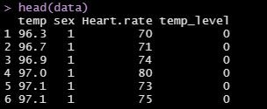
(2) Summarize the data relating to body temperature level by sex. (2 points)
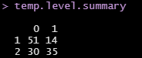
Where (0, 1) are temperature < 98.6 and temperature >= 98.6 respectively and where (1,2) are male and female respectively.
(3) Calculate the risk difference. Formally test (at the alpha=0.05 level) whether the proportion of people with higher body temperatures (greater than or equal to 98.6) is the same across men and women, based on this effect measure. Do females have higher body temperatures than males? (4 points)
Risk difference = -0.323 with female as the reference group.
Proving that the proportion is not the same across men and women
Hypothesis:
H₀: p₁=p₂
H₁: p₁=p₂
α=0.05
Test Statistic:
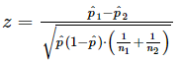
Decision Rule:
Critical Value = 1.960 (α=0.05/2 = 0.025)
Decision Rule: Reject H₀ if |z| > 1.960
Z (test statistic) calculation: 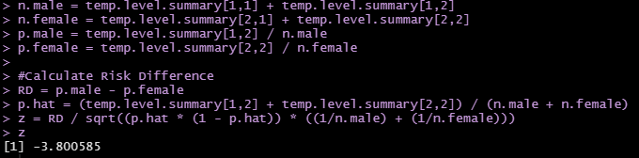
Conclusion:
Reject H₀ since 3.8 is greater that 1.960. We have significant evidence at α=0.05 that the proportion of men with a higher body temp. is not equal to the proportion of women with a higher body temp (p = 7.217752e-05). The negative risk difference value with female as the reference group inditates that females have higher body temperatures than male.

(4) Perform a logistic regression with sex as the only explanatory variable. Formally test (at the alpha=0.05 level) if the odds of having a temperature greater than or equal to 98.6 is the same between males and females. Include the odds ratio for sex and the associated 95% confidence interval based on the model in your summary and interpret this value. What is the c-statistic for this model? (5 points)
Hypothesis:
H0:β1=0 or OR=1 (there is no association between sex and temp. level)
H1:β1≠0 or OR≠1 (there is an association between sex and temp. level)
α=0.05
Test Statistic:
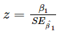
Decision Rule:
Critical Value = 1.960 (α=0.05/2 = 0.025)
Decision Rule: Reject H0 if |z| > 1.960 OR Reject H₀ if p ≤ α
Calculation of z:
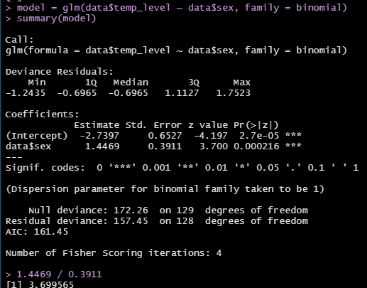
Conclusion: Reject H₀ since 3.70 > 1.960 and 0.000216 ≤ 0.05. There is evidence of an assoiciation between sex and temp. level. The odds ratio = 4.25 implies that the odds of having a high temperature level are 4.25 times higher for females than males. The 95% confidence interval for this odds ratio is 1.975 to 9.147. The c-statistic is 0.672.
(5) Perform a multiple logistic regression predicting body temperature level from sex and heart rate. Summarize briefly the output from this model. Give the odds ratio for sex and heart rate (for a 10 beat increase). What is the c-statistic of this model? (5 points)
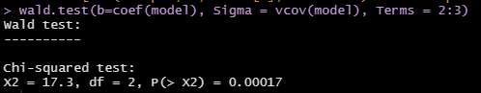

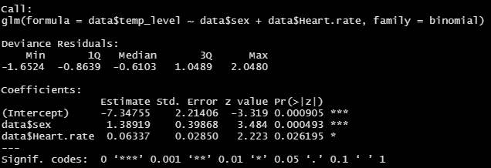
The p-value for the global test was 0.0019 indicating. While an α value was not stated, this is well below 0.05 indicating that at least one of the explanatory variables’ coefficients is not equal to 0.
We also reject the null hypothesis for both sex and heart rate. The p values for both explantory variables are less that 0.05. We have significant evidence that neither coefficient is 0 therefore there is an association between sex and temp_level and between heart rate and temp_level. The OR_{sex}= 4.012 and the OR_{heart.rate}= 1.885 (for a 10 beat increase). The c-statistic is 0.7289.

(6) Which model fit the data better? Support your response with evidence from your output. Present the ROC curve for the model you choose. (2 points)
data$temp_level ~ data$Sex_dummy + data$Heart.rate fits the model better than data$temp_level ~ data$Sex_dummy (note data$Sex_dummy is data$Sex with [0,1] instead of [1,2]. The c-statistic for the former is 0.7289 while the latter is 0.672. Therefore we choose data$Sex_dummy + data$Heart.rate, the model with the higher c-static. Here is the ROC curve:
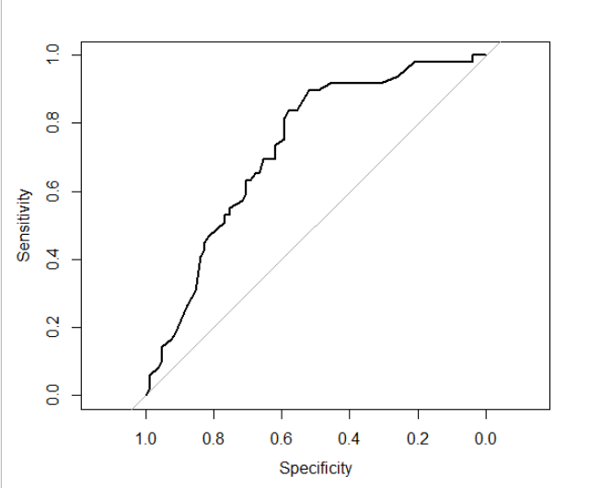

R Code:
#install.packages("pROC")
#install.packages("aod")
library(pROC)
library(aod)

setwd("C:/Users/Peter's Laptop/Documents/CS555F21DataAnalysisR/Assignments")

#Read CSV files
data = read.csv("Assignment6Data.csv", header = TRUE)

#Create binary variable for the body temperature variable
data$temp_level = ifelse(data$temp >= 98.6, 1, 0)

#Summary by sex
temp.level.summary = table(data$sex, data$temp_level)
temp.level.summary
n.male = temp.level.summary[1,1] + temp.level.summary[1,2]
n.female = temp.level.summary[2,1] + temp.level.summary[2,2]
p.male = temp.level.summary[1,2] / n.male
p.female = temp.level.summary[2,2] / n.female

#Calculate Risk Difference
RD = p.male - p.female
p.hat = (temp.level.summary[1,2] + temp.level.summary[2,2]) / (n.male + n.female)
z = RD / sqrt((p.hat * (1 - p.hat)) * ((1/n.male) + (1/n.female)))
z
p = pnorm(z, mean = 0, sd = 1)
p

#Logistic Regression w/ sex as explanatory variable
#Add a dummy variable so that sex is [male = 0, female = 1]
data$Sex_dummy = ifelse(data$sex == 2, 1, 0)

model = glm(data$temp_level ~ data$Sex_dummy, family = binomial)
summary(model)

1.4469 / 0.3911

OR = exp(as.double(model$coefficients[2]))
OR

exp(cbind(OR = coef(model), confint.default(model)))

model.roc = roc(data$temp_level ~ data$Sex_dummy)
print(model.roc)

data$prob = predict(model, type=c("response"))
g.1 = roc(data$temp_level ~ data$prob)
g.1
plot(g.1)

#Logistic Regression w/ sex and heart rate as explanatory variables
model = glm(data$temp_level ~ data$Sex_dummy + data$Heart.rate, family = binomial)
summary(model)

#Global test of signiicance
wald.test(b=coef(model), Sigma = vcov(model), Terms = 2:3)

#Odds Ratios
OR.sex = exp(as.double(model$coefficients[2]))
OR.sex
OR.heart.rate = exp(as.double(model$coefficients[3]*10))
OR.heart.rate

model.roc = roc(data$temp_level ~ data$Sex_dummy + data$Heart.rate)
print(model.roc)

data$prob = predict(model, type=c("response"))
g.2 = roc(data$temp_level ~ data$prob)
g.2
plot(g.2)

Data set for Assignment 6
Data (1=males, 2 =females)
temp | sex | Heart rate
96.3 | 1 | 70
96.7 | 1 | 71
96.9 | 1 | 74
97 | 1 | 80
97.1 | 1 | 73
97.1 | 1 | 75
97.1 | 1 | 82
97.2 | 1 | 64
97.3 | 1 | 69
97.4 | 1 | 70
97.4 | 1 | 68
97.4 | 1 | 72
97.4 | 1 | 78
97.5 | 1 | 70
97.5 | 1 | 75
97.6 | 1 | 74
97.6 | 1 | 69
97.6 | 1 | 73
97.7 | 1 | 77
97.8 | 1 | 58
97.8 | 1 | 73
97.8 | 1 | 65
97.8 | 1 | 74
97.9 | 1 | 76
97.9 | 1 | 72
98 | 1 | 78
98 | 1 | 71
98 | 1 | 74
98 | 1 | 67
98 | 1 | 64
98 | 1 | 78
98.1 | 1 | 73
98.1 | 1 | 67
98.2 | 1 | 66
98.2 | 1 | 64
98.2 | 1 | 71
98.2 | 1 | 72
98.3 | 1 | 86
98.3 | 1 | 72
98.4 | 1 | 68
98.4 | 1 | 70
98.4 | 1 | 82
98.4 | 1 | 84
98.5 | 1 | 68
98.5 | 1 | 71
98.6 | 2 | 77
98.6 | 1 | 78
98.6 | 1 | 83
98.6 | 2 | 66
98.6 | 1 | 70
98.6 | 1 | 82
98.7 | 2 | 73
98.7 | 1 | 78
98.8 | 1 | 78
98.8 | 1 | 81
98.8 | 2 | 78
98.9 | 1 | 80
99 | 2 | 75
99 | 2 | 79
99 | 1 | 81
99.1 | 1 | 71
99.2 | 1 | 83
99.3 | 1 | 63
99.4 | 1 | 70
99.5 | 1 | 75
96.4 | 2 | 69
96.7 | 2 | 62
96.8 | 1 | 75
97.2 | 1 | 66
97.2 | 2 | 68
97.4 | 2 | 57
97.6 | 1 | 61
97.7 | 2 | 84
97.7 | 1 | 61
97.8 | 2 | 77
97.8 | 2 | 62
97.8 | 2 | 71
97.9 | 1 | 68
97.9 | 2 | 69
97.9 | 2 | 79
98 | 2 | 76
98 | 1 | 87
98 | 2 | 78
98 | 2 | 73
98 | 2 | 89
98.1 | 2 | 81
98.2 | 2 | 73
98.2 | 2 | 64
98.2 | 2 | 65
98.2 | 2 | 73
98.2 | 2 | 69
98.2 | 2 | 57
98.3 | 2 | 79
98.3 | 2 | 78
98.3 | 2 | 80
98.4 | 2 | 79
98.4 | 2 | 81
98.4 | 2 | 73
98.4 | 2 | 74
98.4 | 2 | 84
98.5 | 2 | 83
98.6 | 2 | 82
98.6 | 2 | 85
98.6 | 2 | 86
98.6 | 2 | 77
98.7 | 2 | 72
98.7 | 2 | 79
98.7 | 2 | 59
98.7 | 2 | 64
98.7 | 2 | 65
98.7 | 2 | 82
98.8 | 2 | 64
98.8 | 2 | 70
98.8 | 2 | 83
98.8 | 2 | 89
98.8 | 2 | 69
98.8 | 2 | 73
98.8 | 2 | 84
98.9 | 2 | 76
99 | 2 | 79
99 | 2 | 81
99.1 | 2 | 80
99.1 | 2 | 74
99.2 | 2 | 77
99.2 | 2 | 66
99.3 | 2 | 68
99.4 | 2 | 77
99.9 | 2 | 79
100 | 2 | 78
100.8 | 2 | 77

