Hong Kong Metropolitan University

COMP8650SEF
Design And Analysis Of Algorithms

Course Project Report
Applying Graph Algorithms to the Analysis of Small-Molecule Structures

Submission date: 19 April, 2026

I declare that:

(i) All parts of this project, including the proposal, code programs, and this report, are my own original work, except for the source materials that I have clearly acknowledged;
(ii) I have not submitted this project, in whole or in part, for any other purpose without proper declaration;
(iii) I am fully aware of the University’s policy and regulations regarding honesty in academic work, and I understand the serious consequences if I breach them;
(iv) I confirm that I did not use any AI tools, such as ChatGPT, Grok, Gemini or any other generative models, to create this report. The entire report was written by me based on my own coding, analysis and understanding. I know the instructor will check the AI detection rate, and I accept that I will get zero marks for the report if any part is found to be AI-generated;
(v) I understand that I am fully responsible for the content of my submission and may face disciplinary actions, even if I have signed this declaration.

I have carefully read and understood all the project requirements. I am aware that failing to follow them may result in mark deductions.

NAME | SID
LEUNG KAM CHUNG PETER | 11664473

1. Introduction

In this project, we treat small molecules as graphs. Every heavy atom (non-hydrogen) becomes a node with labels like C0, C1, N2, O6, and every chemical bond becomes an edge. Single bonds get weight 1 and double bonds get weight 2.

The two molecules I got from the ChemicalStrings_SIDendWithOddNumber file are:
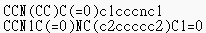

First, I used the provided visualize_mol.py script to draw the 2D structures. After that, I converted each molecule into two NetworkX graphs:
1. an unweighted graph for BFS and DFS
2. a weighted graph for Kruskal’s MST and Dijkstra’s shortest path.

For BFS and DFS, every neighbour list is processed in strict alphabetical order of labels. That means C1 is visited before C2, and C5 is visited before N1, as required by the project.

2. Methodology

I created a script called mol_to_graph.py. It reads the SMILES string with RDKit, then builds two separate graphs.
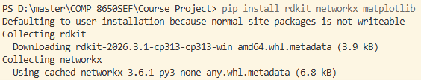

G_unweighted: used for BFS and DFS without edge weights (just a plain nx.Graph())
G_weighted: used for Dijkstra’s and Kruskal’s algorithms (also nx.Graph(), but with weight on every edge)
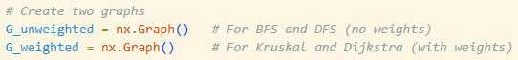

In both graphs, the node names are the atom labels like “C7” or “N2”. Edge weights are assigned according to bond type:
- single bond = 1
- aromatic bond = 1
- double bond = 2
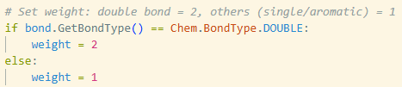

I saved the graphs as pickle files so I wouldn’t have to rebuild them every time:
molecule_1_unweighted.pkl, molecule_1_weighted.pkl,
molecule_2_unweighted.pkl, molecule_2_weighted.pkl.

I wrote four separate Python files for the algorithms.
bfs_from_c7.py, dfs_from_c7.py,
kruskal_mst.py, dijkstra_c0_to_c7.py.

The BFS and DFS scripts load the unweighted graphs and sort neighbours alphabetically before visiting them. The Kruskal and Dijkstra scripts use the weighted graphs and also enforce deterministic ordering for tie-breaking.

3. Results and Discussion

3.1 Breadth-First Search (BFS)
BFS goes level by level using a queue. Even though we have a weighted graph, BFS only uses the unweighted version, so it ignores the bond weights.

Molecule 1 BFS order:
[C7→ C5 → C8 → C12 → N2 → O6 → C9 → N11 → C1 → C3 → C10 → C0 → C4]

Molecule 2 BFS order:
[C7 → C6 → C8 → C12 → C13 → N5 → C9 → C11 → N2 → O14 → C3 → C10 → C1 → O4 → C0]

I noticed the orders are quite different because the two molecules have very different ring structures and functional groups. It really shows how the shape of the molecule changes the way BFS explores it.

I also generated BF-tree diagrams:
- molecule_1_CCN(CC)C(=O)c1cccnc1_bfs_tree.png
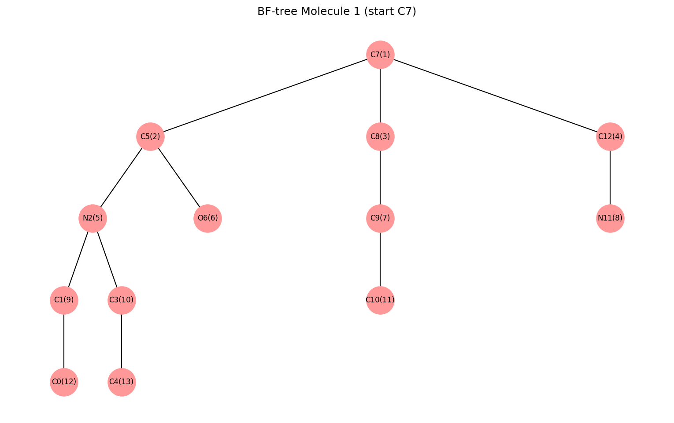

- molecule_2_CCN1C(=O)NC(c2ccccc2)C1=O_bfs_tree.png
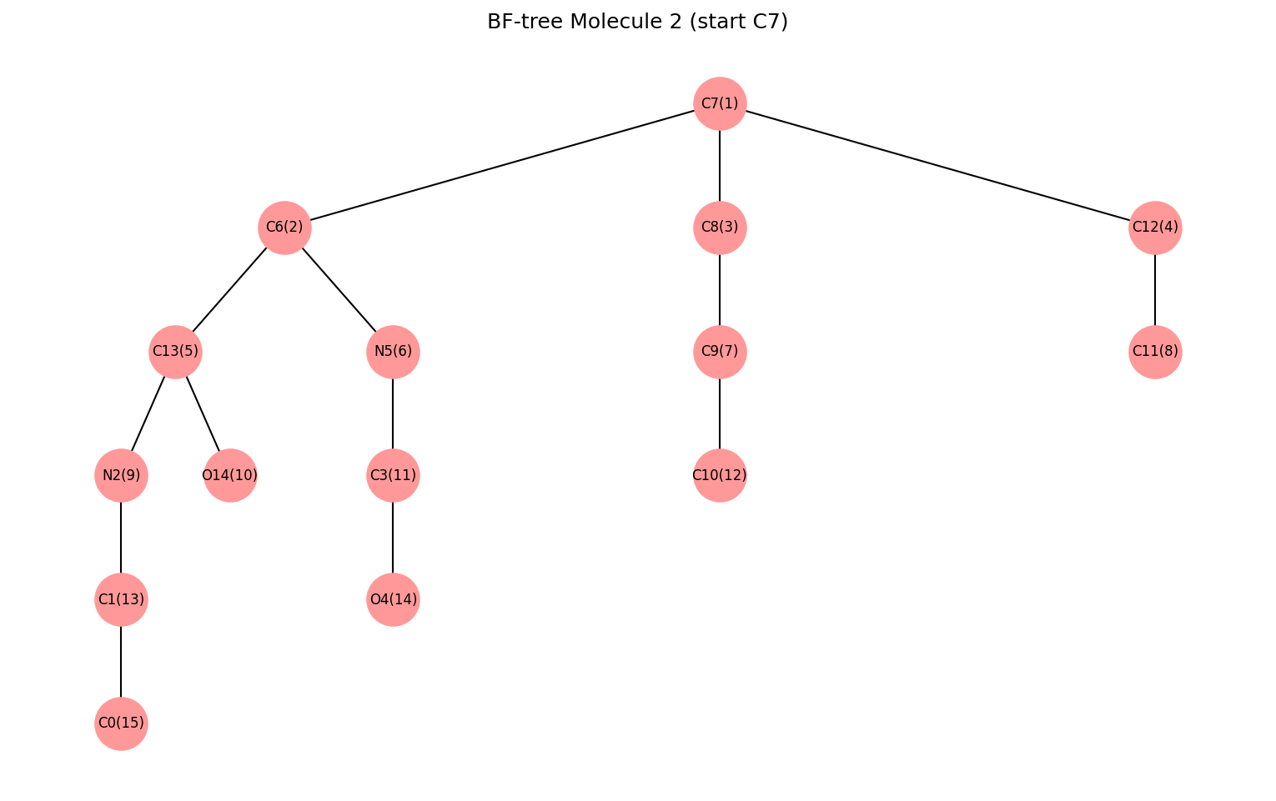

3.2 Depth-First Search (DFS)
DFS goes as deep as possible along one path before backtracking. Like BFS, it works on the unweighted graph and does not care about bond weights.

Molecule 1 DFS order:
[C7 → C5 → N2 → C1 → C0 → C3 → C4 → O6 → C8 → C9 → C10 → N11 → C12]

Molecule 2 DFS order:
[C7 → C6 → C13 → N2 → C1 → C0 → C3 → N5 → O4 → O14 → C8 → C9 → C10 → C11 → C12]

The DFS sequences are very different from BFS even though both start at C7. This clearly illustrates breadth-first versus depth-first traversal behavior.

I also generated DF-tree diagrams:
- molecule_1_CCN(CC)C(=O)c1cccnc1_dfs_tree.png
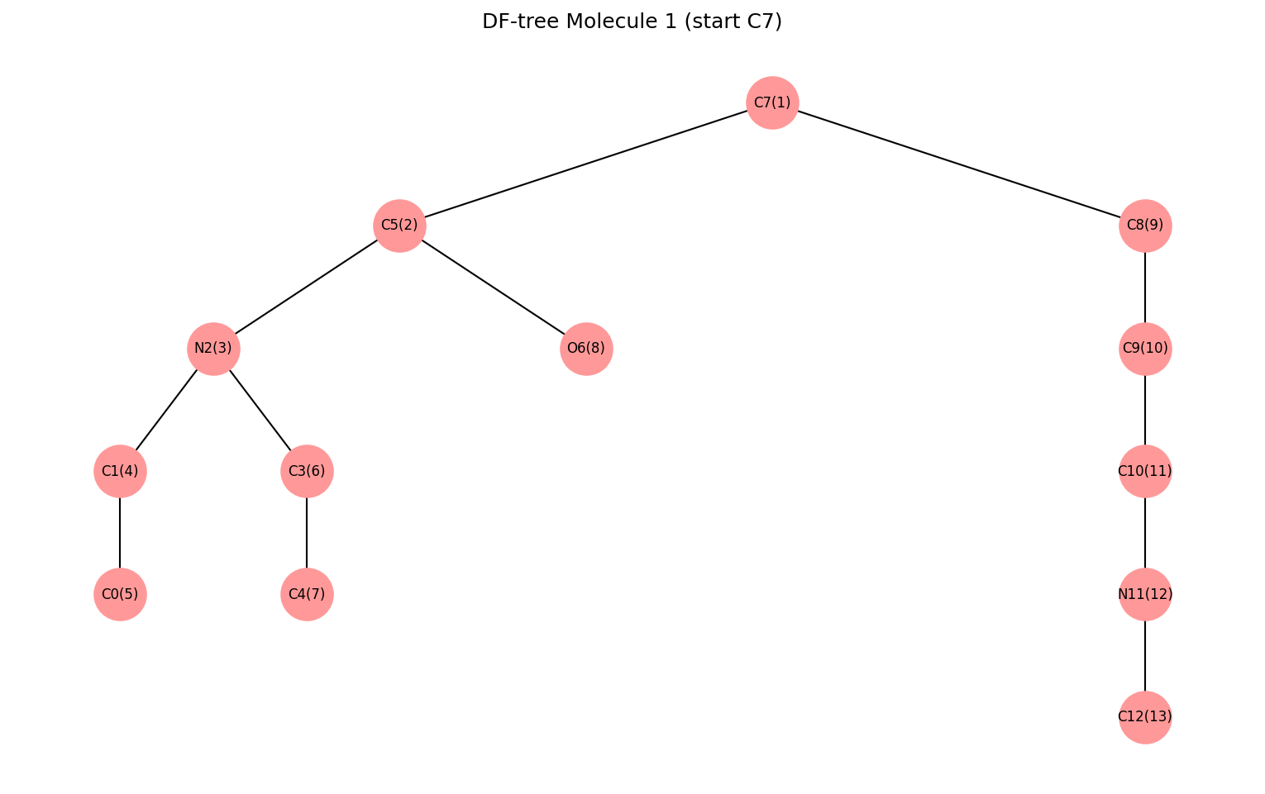

- molecule_2_CCN1C(=O)NC(c2ccccc2)C1=O_dfs_tree.png
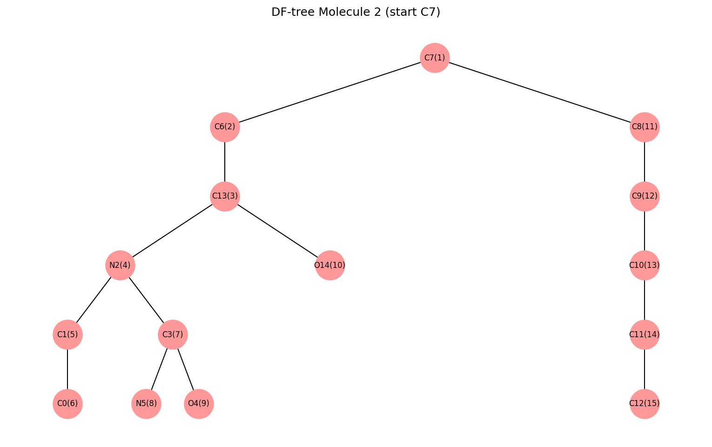

3.3 Dijkstra’s Algorithm
Dijkstra’s algorithm finds the shortest path from C0 to C7 using edge weights.

Molecule 1:
Shortest distance = 4
Path: [C0 → C1 → N2 → C5 → C7]
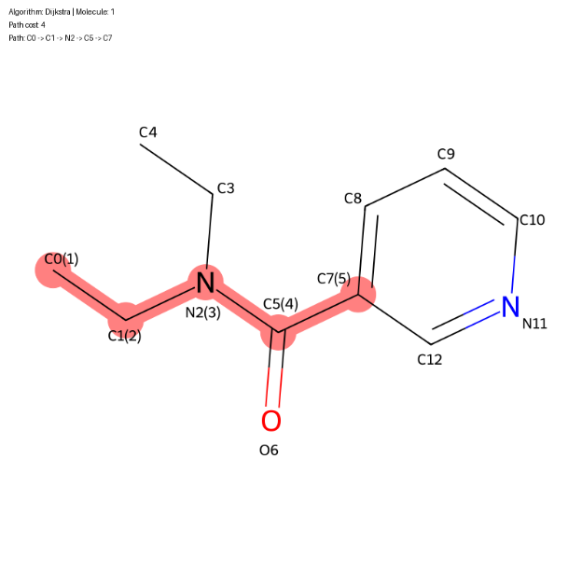

Molecule 2:
Shortest distance = 5
Path: [C0 → C1 → N2 → C13 → C6 → C7]
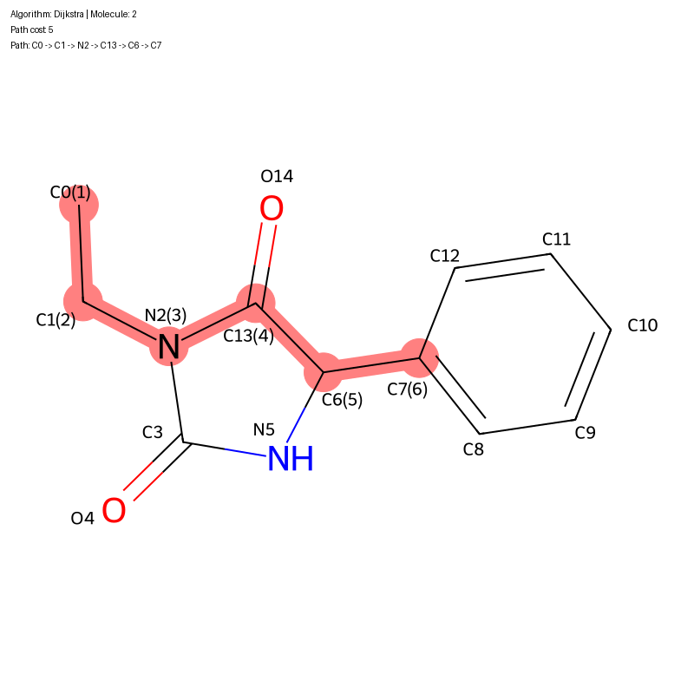

The path in Molecule 2 is longer because of its more complicated ring system between C0 and C7. This result made me realize how double bonds can increase the “cost” of moving through the molecule.

3.4 Kruskal’s Algorithm (Minimum Spanning Tree)

Kruskal’s algorithm finds a minimum spanning tree from the weighted graph.

Molecule 1:
MST total weight = 13
Number of edges = 12
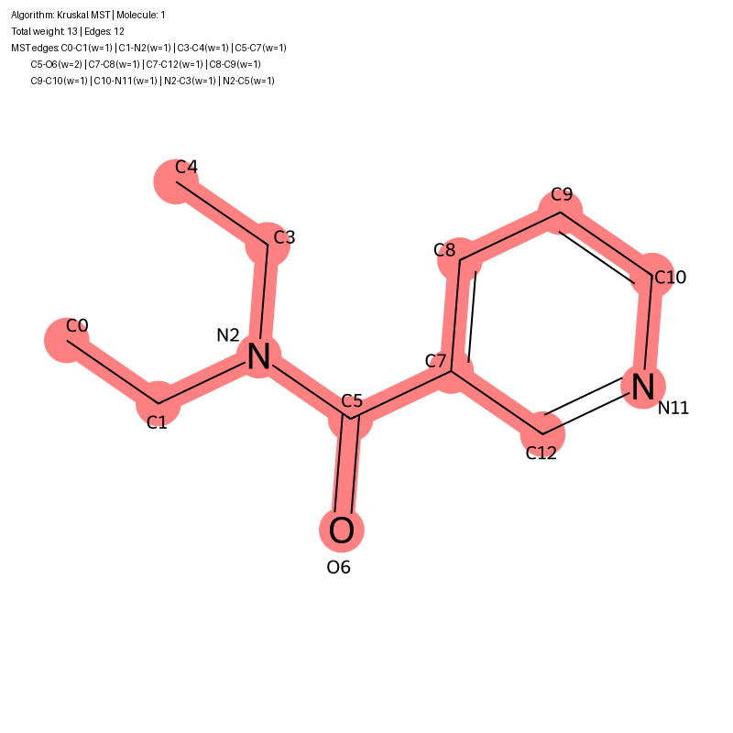

Molecule 2:
MST total weight = 16
Number of edges = 14
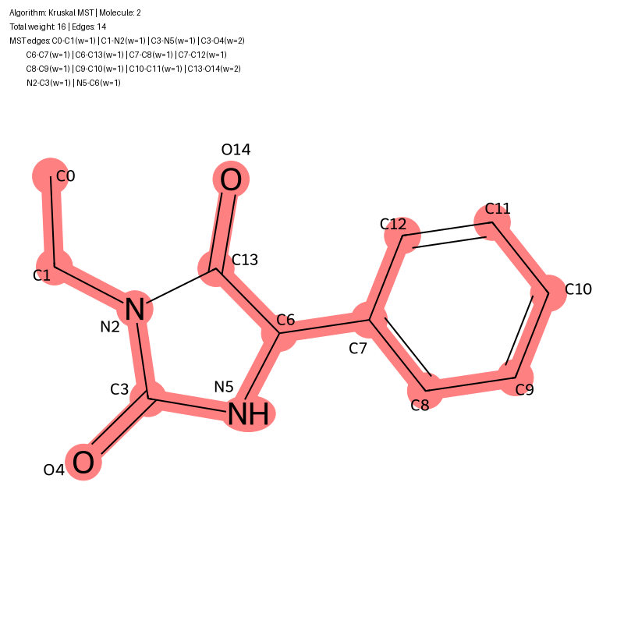

In both MSTs, most edges are single bonds with weight 1. only necessary double bonds with weight 2 are included to keep the graph connected without cycles. The total weight is very close to (number of atoms: 1), which makes sense because any tree with n nodes always has exactly n-1 edges.

4. Time Complexity Analysis

The theoretical time complexity of each algorithm is:
BFS and DFS: O(V + E)
Dijkstra’s algorithm: O((V + E) log V)
Kruskal’s algorithm: O(E log E)

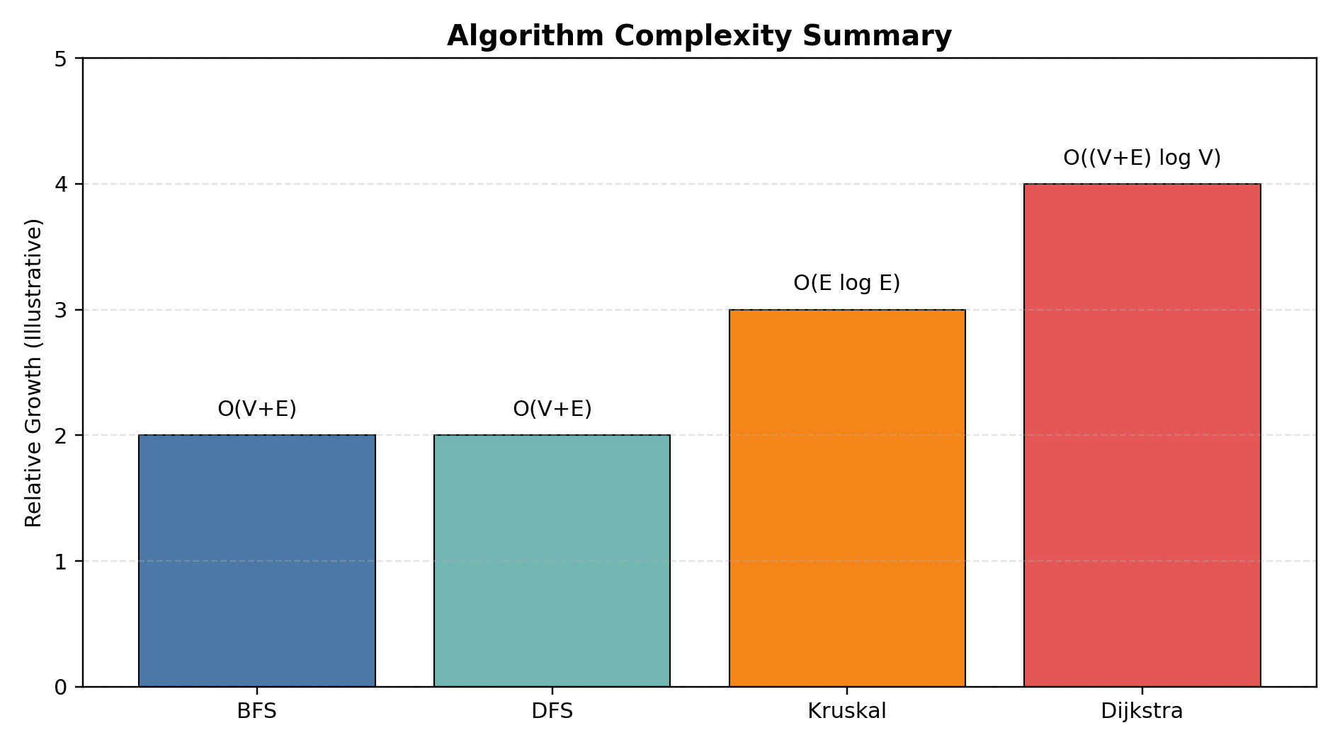

Since our molecules are tiny (only 13 and 15 atoms), everything runs almost instantly. But I can see that when dealing with bigger molecules with hundreds of atoms, choosing the right algorithm and data structures would make a huge difference in speed.

5. Conclusion and Reflection

This project was a good chance for me to connect graph theory with real chemistry problems. I learned how to turn SMILES strings into graphs using RDKit and NetworkX, and then apply the four classic algorithms in a practical way.

From this work, I learned how to:
1. Convert SMILES into graph representations suitable for algorithmic analysis.
2. Separate unweighted and weighted graph models depending on the algorithm being used.
3. Apply BFS, DFS, Dijkstra’s algorithm, and Kruskal’s algorithm to real molecular data.
4. Interpret how molecular structure affects traversal order, shortest paths, and spanning trees.

The biggest challenge for me was getting the alphabetical sorting of neighbors right in every algorithm and making sure I used the correct graph (unweighted or weighted) each time. It took me quite a few debugging sessions, but in the end the results clearly show how the molecule’s structure affects the algorithm outputs.

Overall, I now have a much better understanding of how graph algorithms are used in cheminformatics and bioinformatics. In the future, I would like to try drawing the actual BF-tree and DF-tree visually, or maybe test these methods on larger drug molecules.

This whole experience made me appreciate that graph algorithms are not just abstract theory: they can really help analyze real-world molecular data.

5. Project Flow

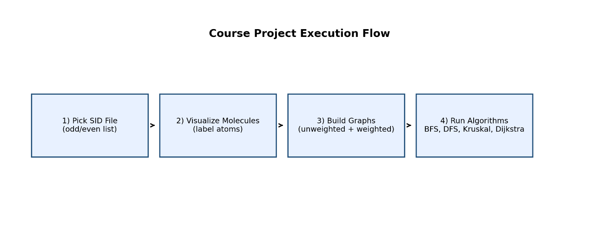

The project was completed in these main stages:
1. Data preparation
- Retrieved the two SMILES strings from ChemicalStrings_SIDendWithOddNumber.txt
- Verified the structures using RDKit

2. Molecule visualization
- Used visualize_mol.py with minor modifications
- Generated 2D drawings for each molecule

3. Graph construction
- Built mol_to_graph.py
- Created two NetworkX graphs per molecule:
G_unweighted for BFS/DFS
G_weighted for Kruskal/Dijkstra

- Converted atoms to node labels like C0, C7, N2, O6
- Assigned edge weights: single/aromatic = 1, double = 2
- Saved graphs as pickle files:
molecule_1_unweighted.pkl
molecule_1_weighted.pkl
molecule_2_unweighted.pkl
molecule_2_weighted.pkl
4. Algorithm implementation
- Implemented bfs_from_c7.py
- Implemented dfs_from_c7.py
- Implemented kruskal_mst.py
- Implemented dijkstra_c0_to_c7.py

5. Alphabetical neighbour ordering
- Ensured all graph traversals sort neighbours alphabetically before visiting
- Verified C1 comes before C2, and C5 comes before N1

6. Result generation
- Produced BFS and DFS traversal orders
- Computed Dijkstra shortest paths from C0 to C7
- Computed MSTs with Kruskal
- Generated visual outputs for molecule structure and traversal trees

Declaration of Contribution
This implementation was developed independently by LEUNGKAMCHUNGPETER as an individual assignment for COMP8090SEF. All code, documentation, and design work was completed solely by the author.

References
- BFS vs DFS in Binary Trees. GeeksforGeeks. https://www.geeksforgeeks.org/dsa/bfs-vs-dfs-binary-tree/
- Breaking Down Breadth-First Search. Medium / BaseCS. https://medium.com/basecs/breaking-down-breadth-first-search-cebe696709d9
- Spanning Tree Notes. Steven Gong. https://stevengong.co/notes/Spanning-Tree
- Shortest Path Algorithms. University of Vermont course notes. https://www.uvm.edu/~cbcafier/cs2240/content/13_graph_algos/01_shortest_path.html
- RDKit Getting Started in Python. RDKit documentation. https://www.rdkit.org/docs/GettingStartedInPython.html
- SMILES strings for structurally similar molecules. ResearchGate figure. https://www.researchgate.net/figure/SMILES-strings-for-structurally-similar-molecules-have-local-differences-red-but-common_fig1_344468708
- 5 Sorting Algorithms Every Python Programmer Must Know. Medium / PythonCLCoding. https://pythonclcoding.medium.com/5-sorting-algorithms-every-python-programmer-must-know-with-code-b284a0856956

