Git Guide – Aleksandra Skarzycka

Git init

Git init initializes a repository in a chosen directory.

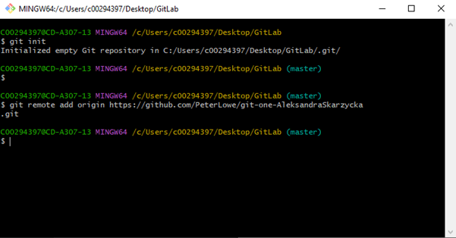 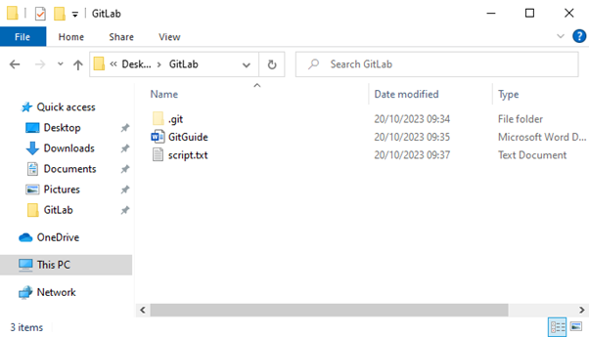

Git status + add

Status shows the files in the branch that are “dirty” or clean, add adds them to the branch which will let them be included in the next commit.

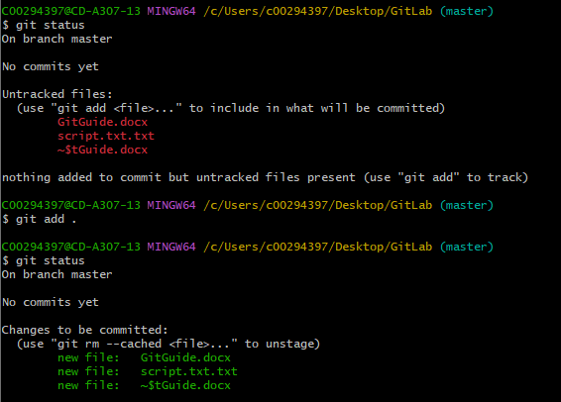

Git commit

Commit creates a snapshot of the staged changes made, saves your changes to a local repository.

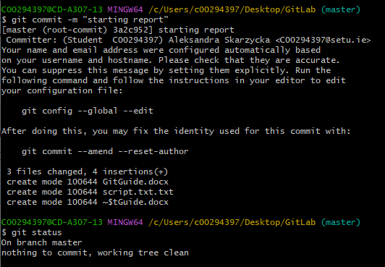

Git remote

Lets you view the remote repositories in a list with a URL

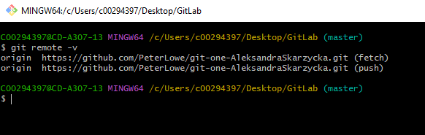

Git push

Push allows you to upload your local repository changes to a remote repository.

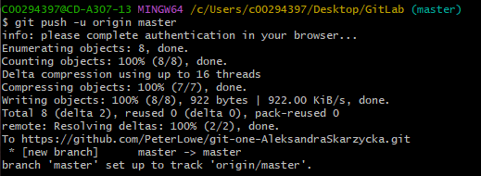

Git branch

Branches are used to keep different features being developed organized and separate.

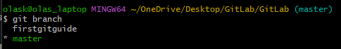

Git checkout

Checkout lets you switch between different branches or commit states.

