Git init:

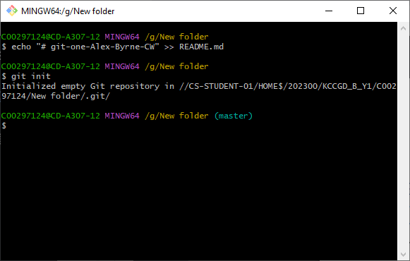It will create a new repository in the folder where git bash was ran

Git add:

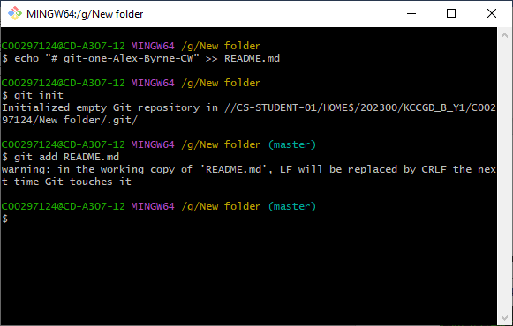 Adds a file to the staging awaiting a commit

Git status:

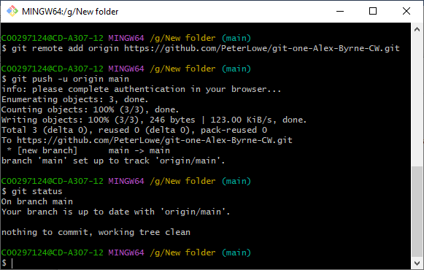gives the currents statues of the current branch being worked on

Git commit:

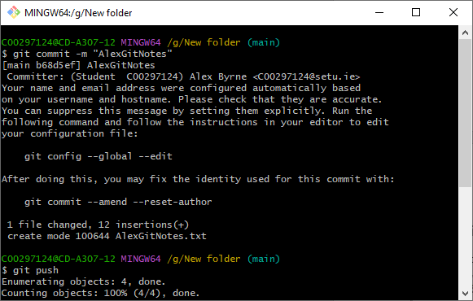The commit command prepares a file to be pushed into the repository

Git Remote:

Creates a link between your computer and the repository on git hub

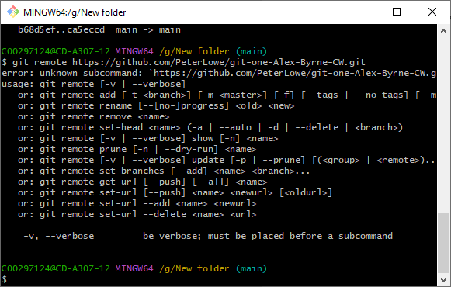

Git push:

Once a file has been added and committed it is ready to be pushed, once the push command is entered the committed files will be sent to the current branch of the repository

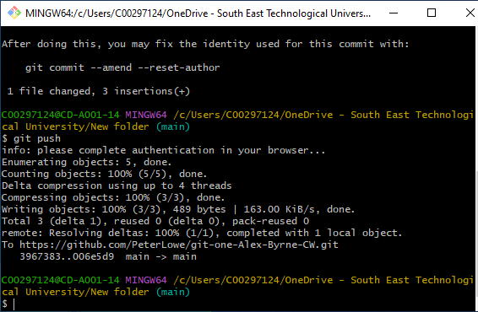

Git Branch:

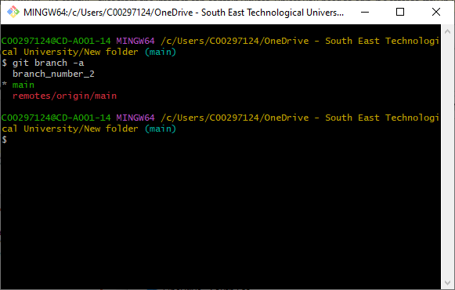A branch is a Linear sequence of commits that are able to be updated once work is done on a branch it can be merged to master or deleted

Git Checkout:

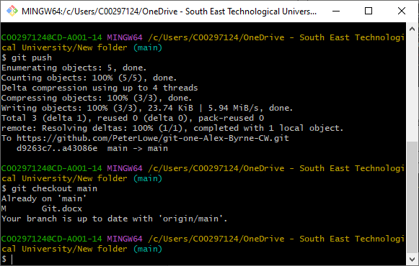Git checkout allows you to make whatever node you are working on to be the head of the branch but this wont work if the files on the node have been modified

Git Merge:

Git merge allows you to merge the head of whatever branch you are working on into master, if there will be a problem with this command git will give you a warning.

