# Git Guide

By Caoimhe O’Brien

## Git rm example

Git rm to remove file(s) from the staging area. #Format git rm filename

Can use wildcards and -r for recursive

Use – cached to remove form staging area

Use -f to use on working directory.

## Init

Definition and usage:

The git init command allows you to create or re-initialise a new repository whether than be locally or on GitHub.

Should be one of the first commands that you use in a new project.

Syntax:

git init

Screenshot:

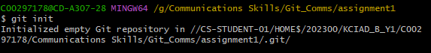

## Add

Definition and usage:

The git add command adds new files to the working directory.

Adds all files except those listed in .gitignore.

Syntax:

git add .

Screenshot:

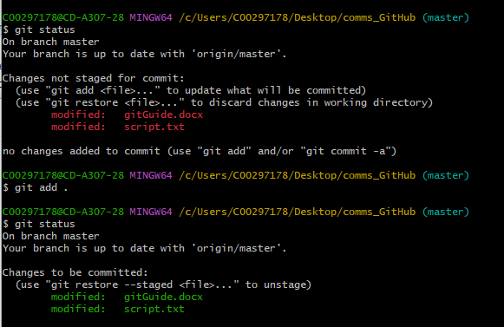

## Status

Definition and usage:

The git status command allows you to view the status of your files in the working directory/ whatever branch you’re currently working on.

Syntax:

git status

Screenshot:



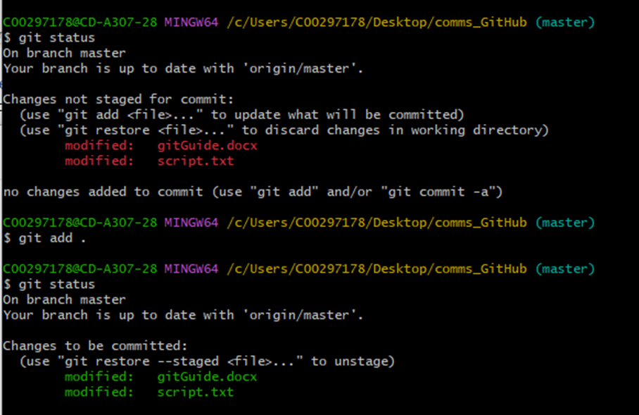

## Commit

Definition and usage:

The commit command allows the user to upload the files in the working directory and uploads them to the previous node.

Will enter editor mode to enter multiline comment.

Will add the label to this specific commit.

Should be useful names, not only for you but for anyone else who might read your code. If you omit a label, git will force you to assign a label and will open an editor.

Syntax:

git commit -m “<Commit name”

Screenshot:

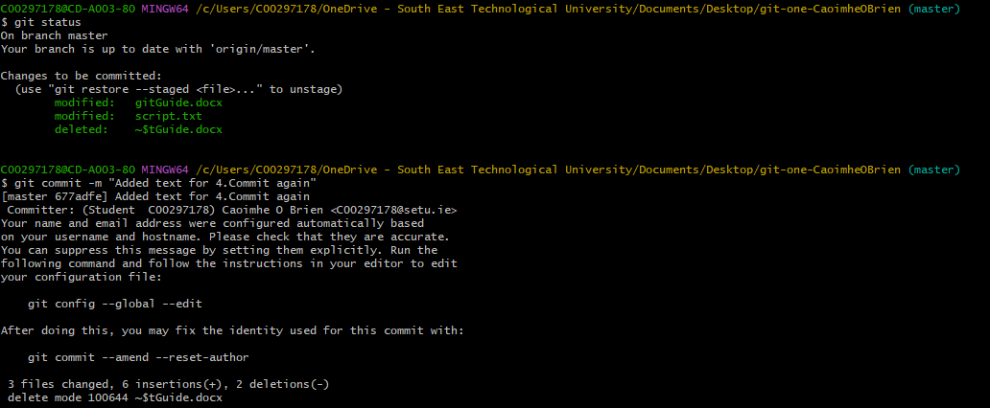

## Remote

Definition and usage:

Lists repositories on remote server and create a new remote repository.

Syntax:

git remote -v

git remote add <name> <url>

Screenshot



## Push

Definition and usage:

Updates the remote node with the current node.

Syntax:

git push -u origin master.

Screenshot:

