Git Lab 1 – Git Commands

git init

Creates a new repository in the folder we created in step one.

Creates a hidden file in the root directory .git which can be brought to view using the view tab and then checking the “Hidden Folders” check box.

This creates a master repository on the machine that the user is sitting at.

Git add

This command prepares a file to the next commit by sending it to the staging area. This staging area is where all the files that you want to include in your next commit need to be added to. Using the git status command you can check what files have and haven’t been added to the staging area.

I have added both my text documents and they are now ready to be committed



git status

Gives us a readout of what files are in the staging area and are ready to be committed.

Files shown in Green have successfully been added using the git add command and are in the staging area now ready to be committed. Files shown in Red have not been added to the staging area and won’t be committed with the next commit.

This is before adding, the file is in red

This is after using the add command to add the file to the staging area

git commit

This command creates a snapshot of the staged files. In other words, a new revision point, a point along the projects timeline where the changes made between commits can easily be viewed.

Putting -m after the commit command allows me to add a comment to the commit, in this example “Third Commit” which allows me to keep track of what has been changed and at what time along the timeline

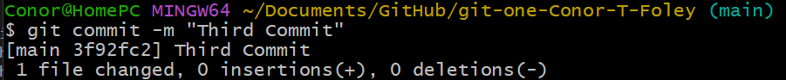

git branch -M master

This command has allowed me to change the name of my main branch to “master”

The git branch command is use for branch management. It can list the branches I have, create a new branch, delete a branch or rename an existing branch.

Note the branch name has switched to master at the end of the second line.

git remote

This command creates a connection between my local repository that I created with git init and the remote repository created by Pete on GitHub.