Git

1)init

Create a new repository in the file

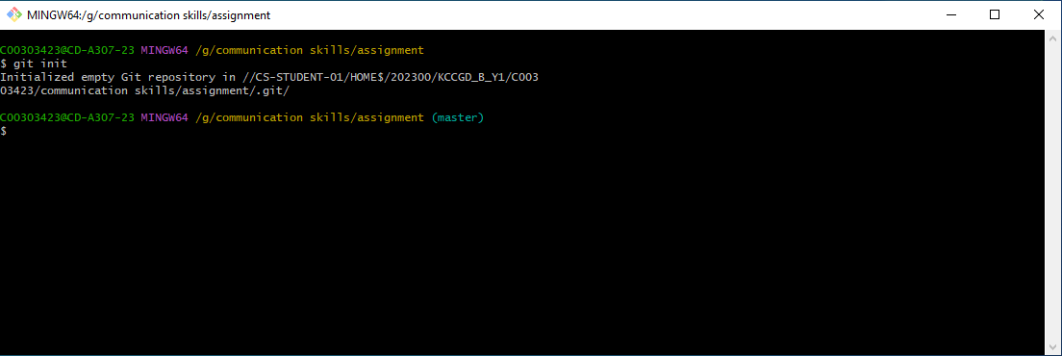

A new folder is created with .git

2)status

It shows which files have been commited or uploaded to repository.

Red means they are not uploaded. They need to be uploaded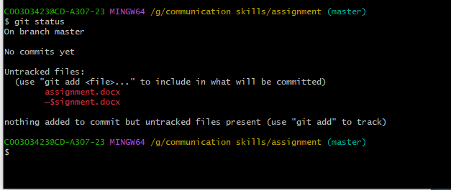

Green means they have been uploaded.

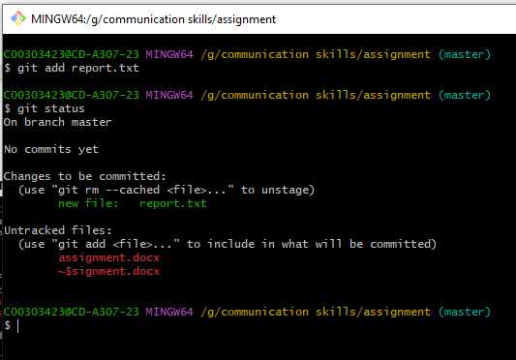

3)add

Add command is used to add or upload the file to the repository which is currently stored on the local system.



4) commit

Commit helps to add a time stamp which tells what are the changes made to the file with securing the previous one.

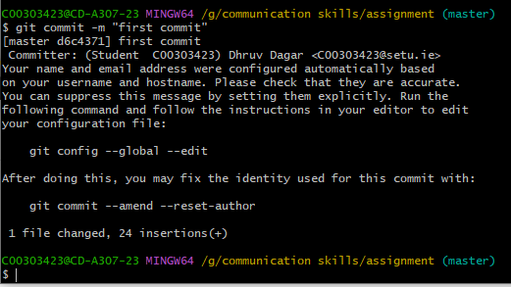

5)push

Push command is generally made after the commit because this is the command which is responsible for uploading the file to the git.which is generally followed by the branch name.

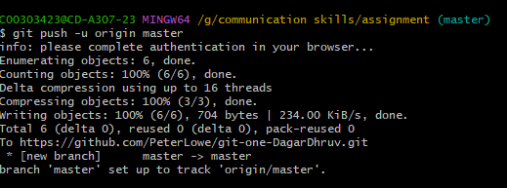

6)remote

It creates a new repository remotely.the command for this is git add remote <name > <url>

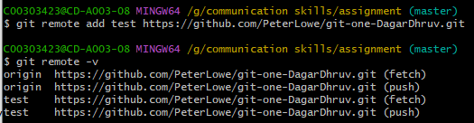

7)log

It gives us the log of the commit history. The command is git log.

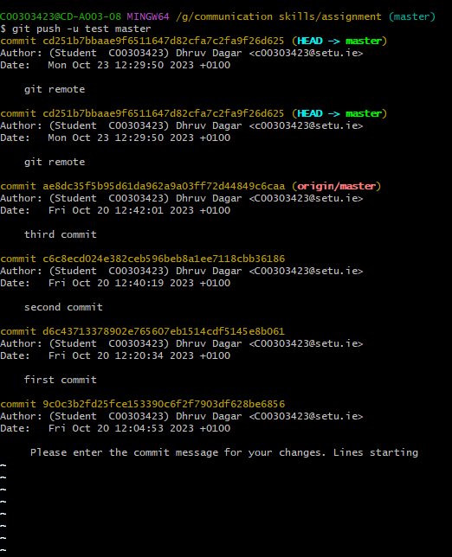

8)clone

It clones or save a copy of a repository to a local computer from the server.

9) rm

It removes the file from the repository. The command is git rm <file name>

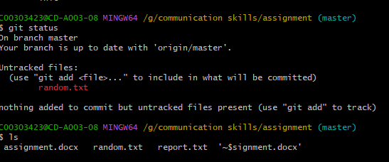

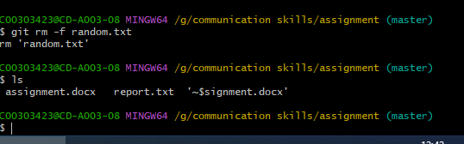

10)branch

it lists all the branches in the repository and can be add and removed by

adding-

git branch <added branch name>

removing

git branch -d <name of branch to be removed>

