Eliza Zimmermann GitOne

1. Init

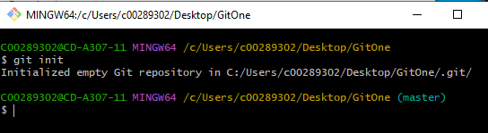

Git init creates an empty repository in chosen folder.

1. Add



Git add adds files to the local branch

1. Status

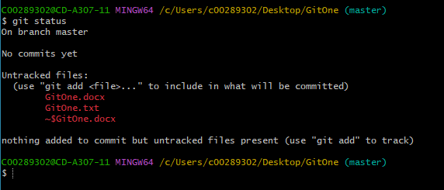

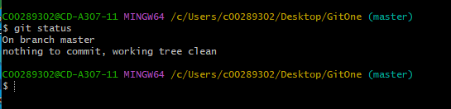

Git status tells us what files are in the folder and if they are pushed to branch or no, also it informs us about what branch we are at and if something new was commited.

1. Commit

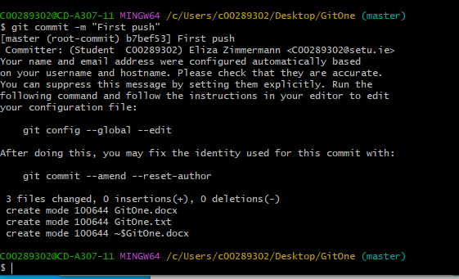

Git commit -m commits all new files and new changes into the local branch.

1. Remote



Git remote add origin https://  adds chosen project and pulls it into the chosen folder.

1. Push

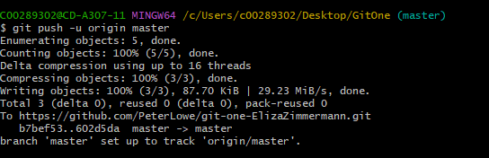

Pushes all commited files to the github.

1. Branch
2. Checkout
3. Merge
4. Log
5. Clone
6. Pull
7. Stash
8. Rm