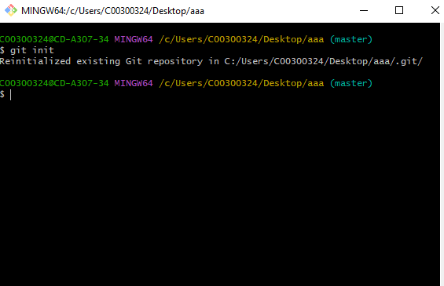

Git init creates a hidden repository file in the folder called .git



Git adds a file to the local repository

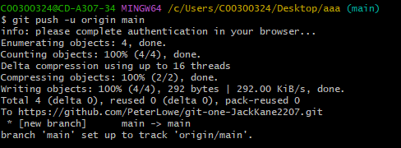

Git push will move the local repository data to a remote repository



Git branch will create a new branch in your repository

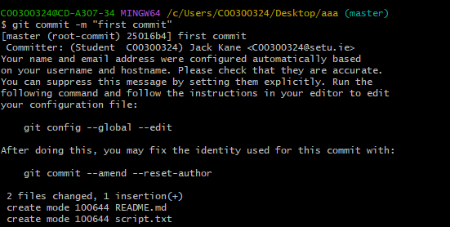

Git commit will wriite the files to the repository

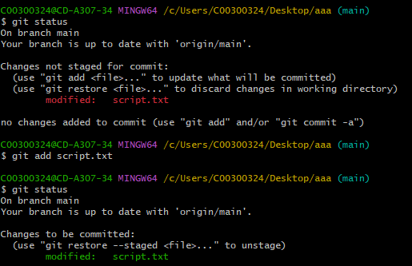

Git status displays the current status of the working area and staging area

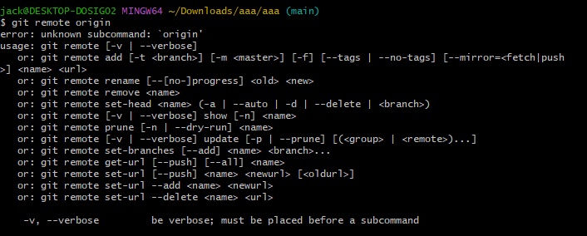

Git remote lets you create, view or delete connections to other repositories

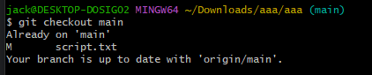

Git checkout will apply chacnges from your branch to main

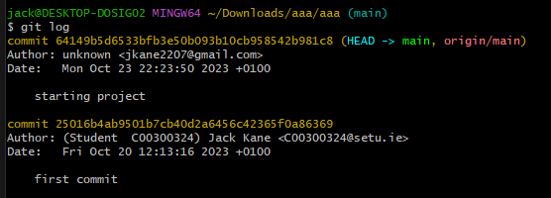

Git log lists the commits made in the repository



Git pull will download content from the remote repository to the local repository