Communications Class  
Jake Kelly’s Lab on Git ☻  
20/10/2023  
  
-git init

This command creates and or reinitializes previous repositories in a certain folder.  
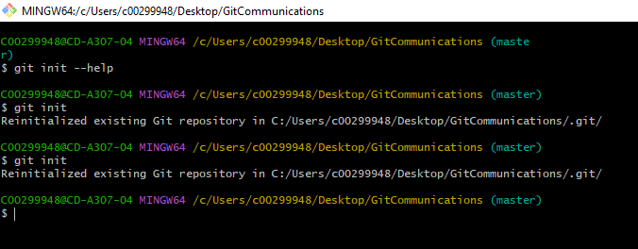  
  
-git add

Adds new files to the next commit, If you wish to modify, re-add.