GIT

# Init

The init code command creates empty repository in my student folder

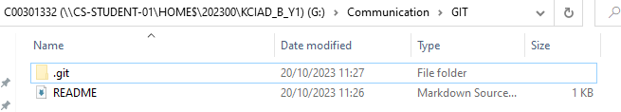We can check this by going the address of the repository and showing hidden files (.git)

# Add

The add code command will add . all the files in the folder, we can check this with status command

The git add . adds all files, if we want to specify we use git add <name of the file>

For example:

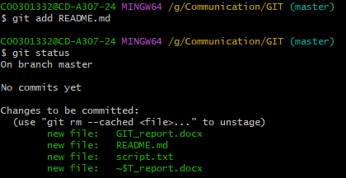

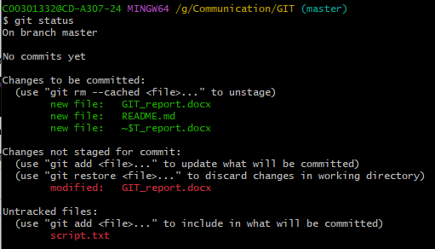Before using the git add . command:

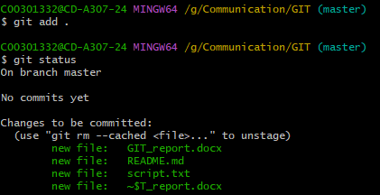After using the git add . command:

# Status

I used status command when showing the add command, but what it does is that it shows the status of the folder in which we are using the git bash

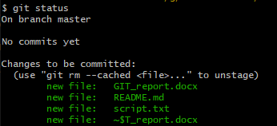

# Commit

The commit command sets “milestones” in the project timeline, something we can come back in later

There is Committer: in this instance me

We can see that the commit name is first_commit, then we have info about committer and we can see that all the files in the folder were changed

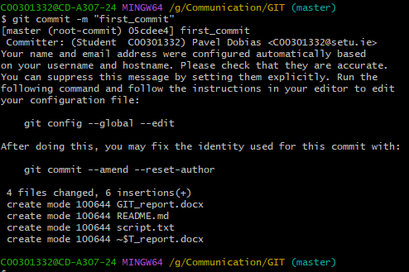

# Remote

The git remote add <name> <url> is used to add remote server to the folder we are using the git bash in

We can check what remote servers we have by using git remote -v

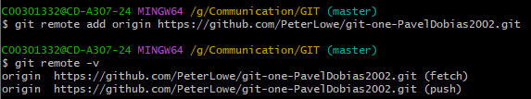

# Push

Git push updates remote node with current node that we are using, we are pushing local nodes to the remote ones

To push we need to complete authentication in browser and needs to be associated remote node

In this instance its: origin main which we created before using git remote add

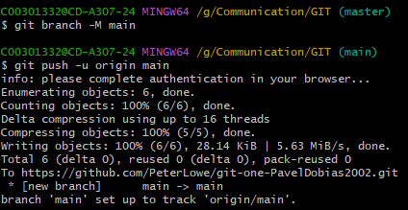

# Branch

We use git branch name_of_the_branch to create sequence of commit points which needs to be merged to main





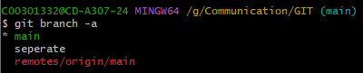We can check all our branches using git branch -a

# Checkout

We use the git checkout branch_name to switch to that branch from current one

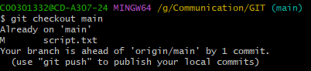I am already on the branch main

I created new branch separate and switched to it using git checkout

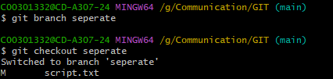

# Merge

We use git merge branch_name to merge branches to main

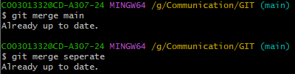

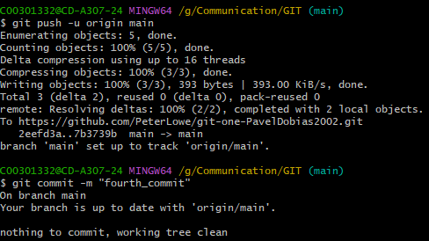We can check everything is merged properly by pushing and committing

# Log

Git log displays commit history

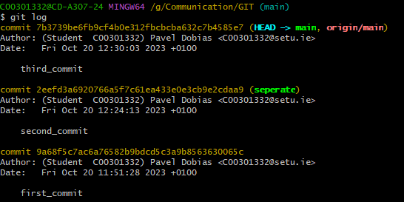Here we can see who did the commit, what was committed and the name of the comit

# Clone

Git clone copies existing repository, creating new copy of it in different folder

to clone we open different folder in it we open git bash and we use the url of the reposiotry we want to copy to that folder

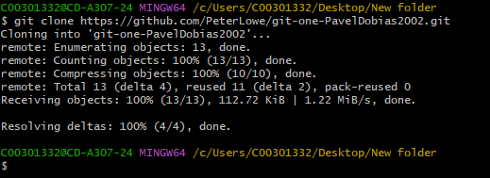



# Pull