Rin Larkin – Git: Assignment One

git init

* creates a new git repository

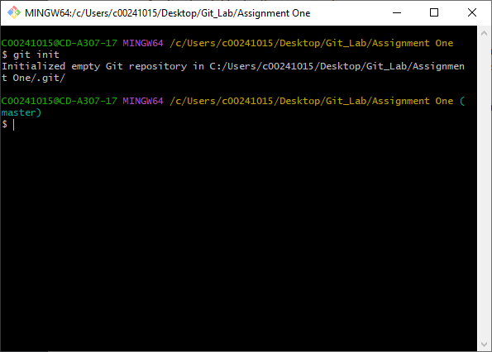

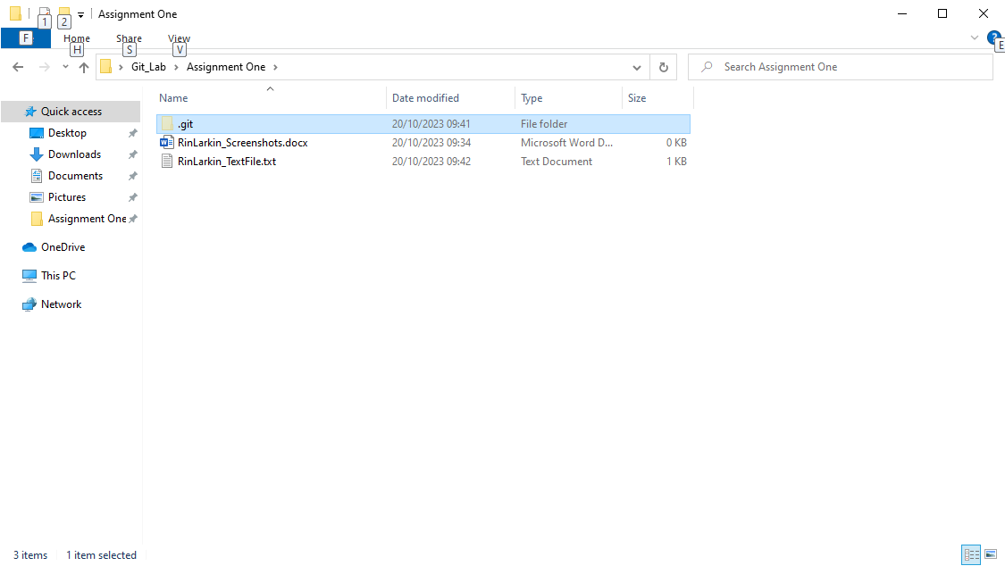

git status

* lists files, such as modified files in the working area, as well as added files in the staging area.

