# Init

git init creates a new repository in the folder that Git Bash is launched in

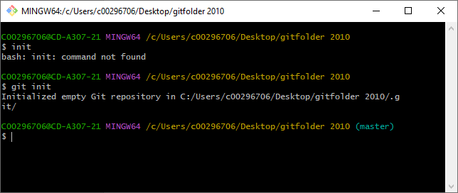

A hidden .git folder is created that contains this repository

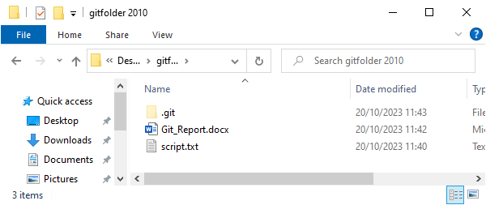

# Add

git add adds files to the directory, I will use git add . to add all the new files, we can see that all the files are added using the “git status” command that I will go over next

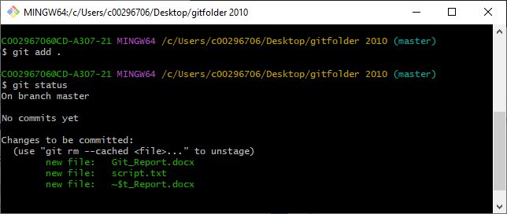

# Status

“git status” will list all the files in the directory, modified files will be red and added files will be green

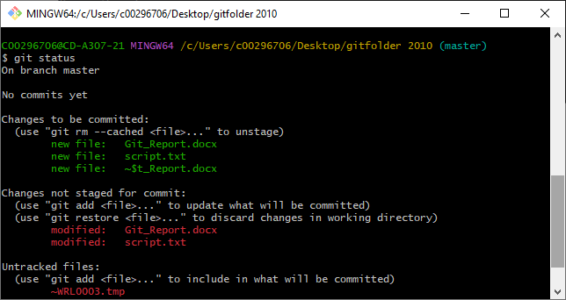

After using git add .

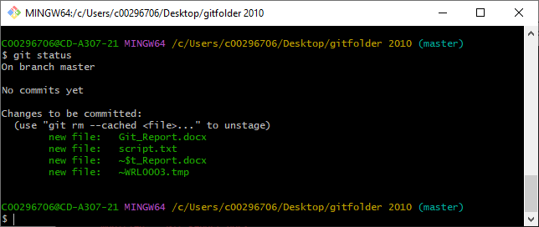

# Commit

git commit creates a new commit, commits are snapshots of the repository at different times, I will use git commit -m “init, add, status, commit written” to create a new commit and leave a suitable comment

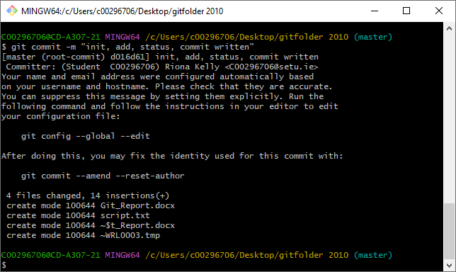

# Remote

git remote add <name> <url> adds a new repository

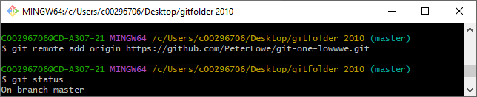

git remote -v lists the remote repositories

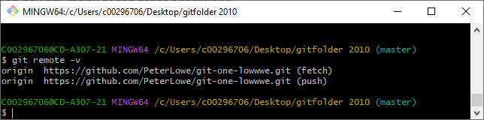

# Push

git push updates the remote node with the current node

# Branch

git branch creates a new branch in the local repository, the term after branch will be the branch name

git branch --list will list all the branches in the repository

# Log

git log displays the entire commit history, you can press <space> for more or <q> to quit

# Log cont.

git log --stat shows the files altered and the lines that have been changed

git log --graph will drawn the branch paths

git log –(n) will only display the last (n) commits

I will put all the screenshots here and smaller because they take up a lot of space but I want to get all the information in

# Stash

git stash makes a local copy of the current working directory

git stash list lists all the previously pushed stashes

git pop retrieves stash {0} (the last stash of the edited files) and copies the files into a working directory, numbers other than {0} can be retrieved with git apply stash {(n)}

# Remove/Rm

git rm deletes files

Here I delete my old pdf file so that it doesn't cause any problems since I’ll have to make a new one later

