# Init

“git init” creates a new repository in the folder that Git Bash is launched in.

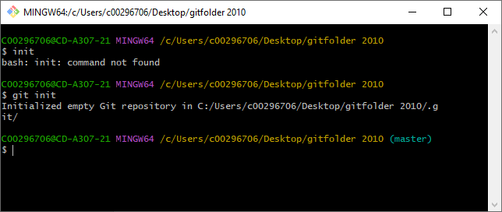

A hidden .git folder is created that contains this repository.

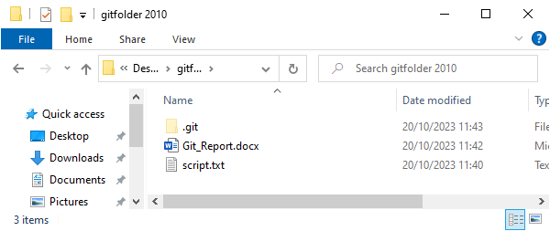

# Add

“git add” adds files to the directory, I will use “git add .” to add all the new files, we can see that all the files are added using the “git status” command that I will go over next.

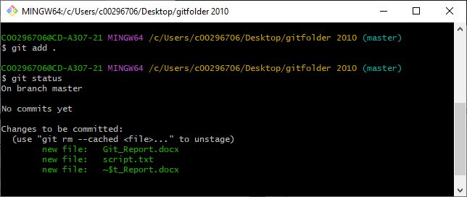

# Status

“git status” will list all the files in the directory, modified files will be red and added files will be green.