Init:

It creates a new repository or a subdirectory

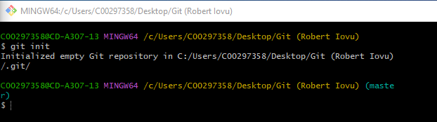

Add . :

Adds a change in the working directory to the staging area

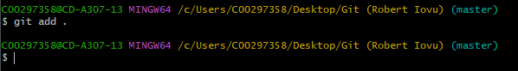

Status:

Shows status of the repository

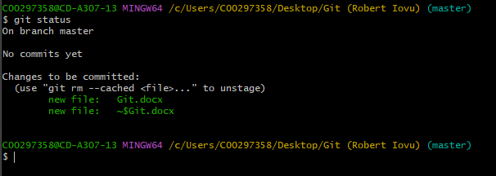

Commit:

Remote:

Creates link between pc and repository

Push:

Uploads local repository content to a remote reposition

