1. Init

The git init command initialises a local repository on my computer and allows me to work on it on my PC. After executing ‘init’, the repo will be in sub folder of where I ran the ‘init’ command. (hidden git folder)

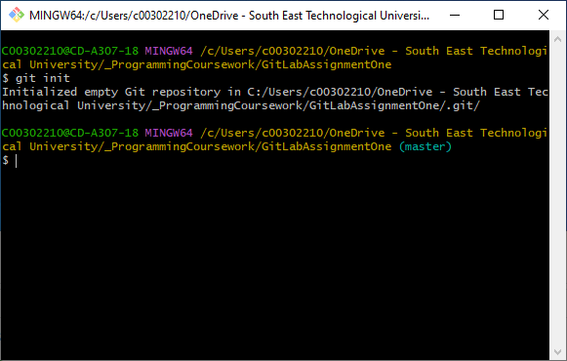

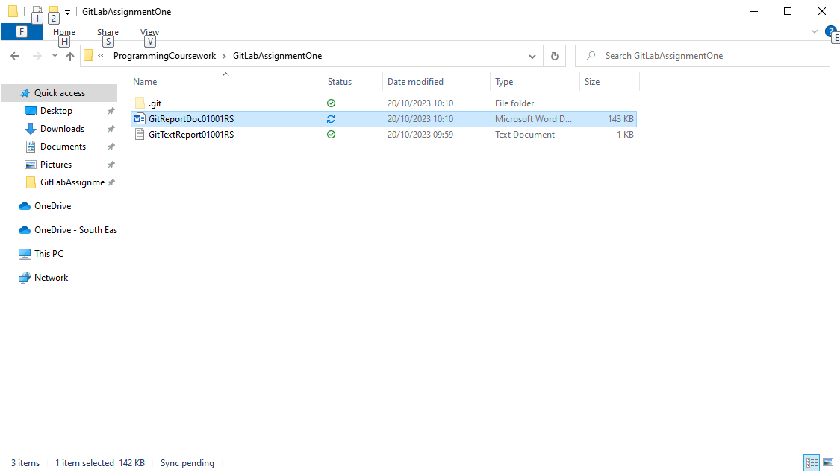

1. Add

The git add command can make files or whole directories staged for committing to repositories.

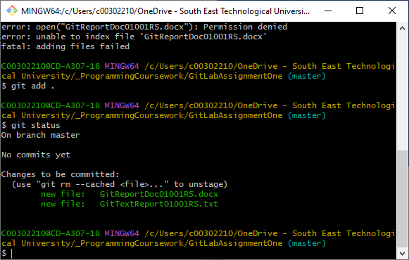

3. Status

Status indicates the current contents of the local repo and their current state (eg. Whether staged, dirty, etc).



1. Commit

Creates a new commit with files that have been staged. The new commit is the child of the head, I think.

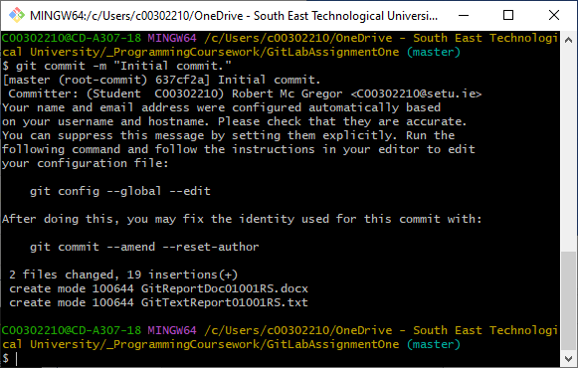

1. Remote

Manages the repos associated with the project, allows you to see what you’re currently attached to (‘master’) – does a lot more stuff!

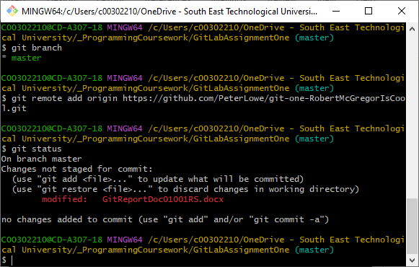

1. Push

Updates the remote node with the current node – sends staged files/commits to remote repo.

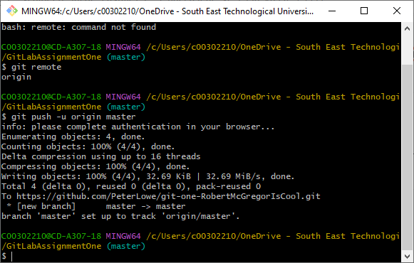

1. Branch

Branch allows the user to list created branches, make a new branch or delete branches. (Doesn’t switch to ‘em?)

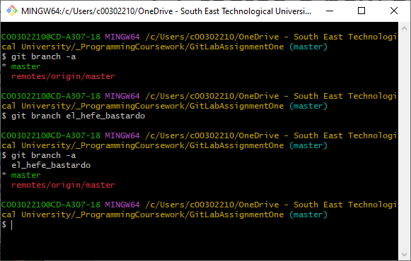

1. Checkout

9. Merge

10. Log

11. Clone

12. Pull

13. Stash

14. Rm