# Git Guide

By Elisabeth Sykorova

## Init

* Creates a new repository locally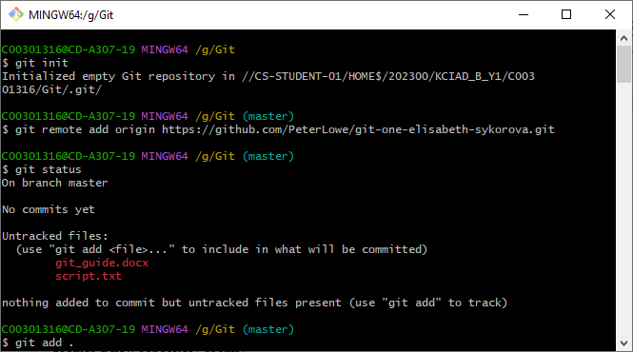
* Format: git init

## Add

* Adds all new files (also edited files)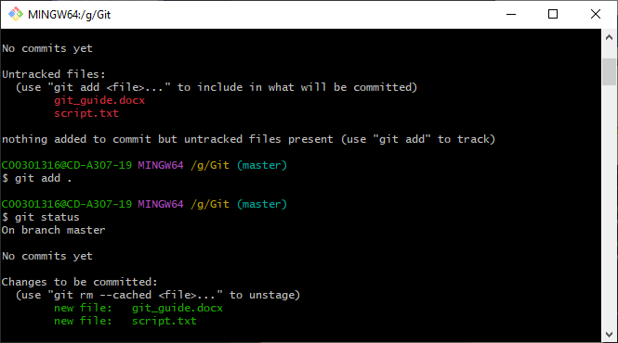
* Format: git add .
* To add specific files -> git add filename/pattern

## Status

* Lists files modified in the working area, added files in staging area and current branch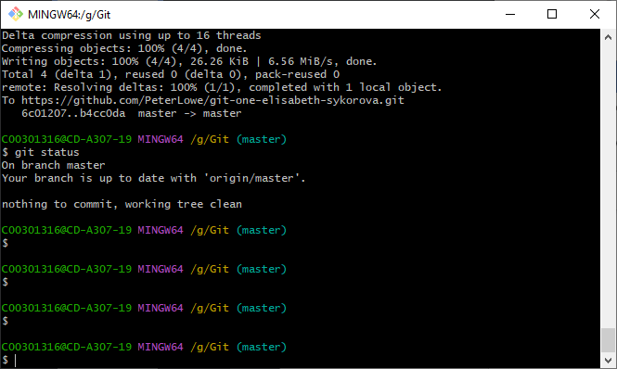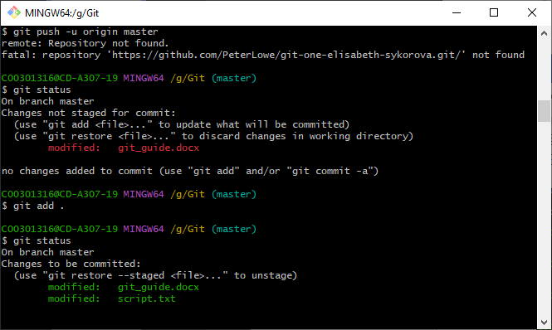
* Format: git status

## Commit

* Records changes to the repository (=snapshot/backup) 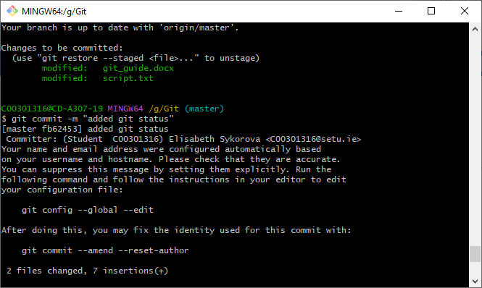
* Format: git commit -m “comment”
* To enter editor mode for multiline comments -> git commit

## Remote

* Manages set of tracked repositories, used to clone repositories

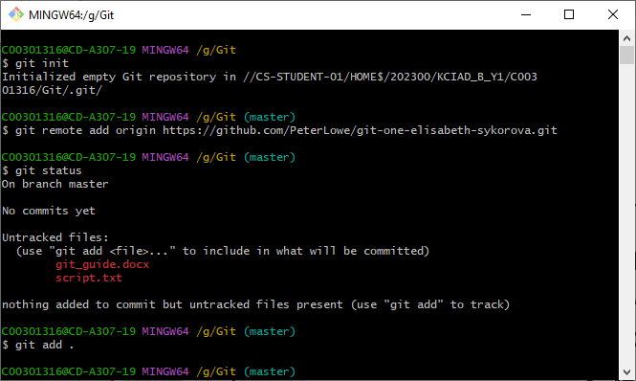

* Format: git remote …
* Different uses -> add, rename, remove,..

## Push

* Used to update remote node with current node

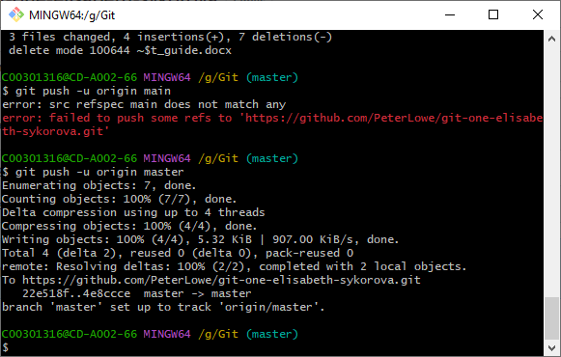

* Format: git push -u origin master (depending on what the branch name changes to)

## Branch

* Used to create a new branch in the local repository that can be worked on separately from the main branch and later merged.

* Format: git branch new_branch_name
* To list all branches in repository: git branch -a/-l/-r

## Checkout

* Makes chosen node the current HEAD

* Format: git checkout branch_name