Peter Mamaev

MGMT-4600 Lab 2 Part 1

* Generate Central Tendency values for AIR_E variable
* Generate Central Tendency values for WATER_E variable

> class(modernepi_data$AIR_E)

[1] "numeric"

> class(modernepi_data$WATER_E)

[1] "numeric"

> mean(modernepi_data$AIR_E, na.rm = TRUE)

[1] 49.46074

> median(modernepi_data$WATER_E, na.rm = TRUE)

[1] 71.17

> mode = mfv(modernepi_data$AIR_E, na_rm = TRUE)

> print(mode)

[1] 44.69 51.96 53.74

> mode = mfv(modernepi_data$WATER_E, na_rm = TRUE)

> print(mode)

[1] 0.00 71.40 73.08

> class(modernepi_data$NOX_pt)

[1] "numeric"

> class(modernepi_data$SO2_pt)

[1] "numeric"

> mean(modernepi_data$NOX_pt, na.rm = TRUE)

[1] 47.50777

> mean(modernepi_data$SO2_pt, na.rm = TRUE)

[1] 53.05288

mode = mfv(modernepi_data$AIR_E, na_rm = TRUE)

> print(mode)

[1] 44.69 51.96 53.74

> class(modernepi_data$CLIMATE)

[1] "numeric"

> class(modernepi_data$AGRICULTURE)

[1] "numeric"

> mean(modernepi_data$CLIMATE, na.rm = TRUE)

[1] 55.33374

> mean(modernepi_data$AGRICULTURE, na.rm = TRUE)

[1] 70.85822

> median(modernepi_data$CLIMATE, na.rm = TRUE)

[1] 55.43

> median(modernepi_data$AGRICULTURE, na.rm = TRUE)

[1] 75.29

> class(modernepi_data$CLIMATE)

[1] "numeric"

> class(modernepi_data$AGRICULTURE)

[1] "numeric"

> mean(modernepi_data$CLIMATE, na.rm = TRUE)

[1] 55.33374

> mean(modernepi_data$AGRICULTURE, na.rm = TRUE)

[1] 70.85822

> median(modernepi_data$CLIMATE, na.rm = TRUE)

[1] 55.43

> median(modernepi_data$AGRICULTURE, na.rm = TRUE)

[1] 75.29

> mode = mfv(modernepi_data$CLIMATE, na_rm = TRUE)

> print(mode)

[1] 35.05 49.85 60.74 64.45 75.40

> mode = mfv(modernepi_data$AGRICULTURE, na_rm = TRUE)

> print(mode)

[1] 54.55

* Generate the Boxplots for AIR_E variable

* Generate the Boxplots for WATER_E variable

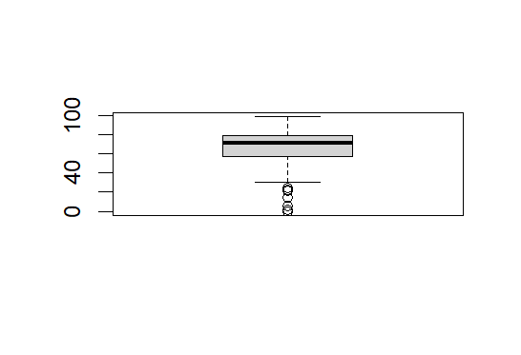

* Generate Central Tendency values for NOX_pt variable
* Generate Central Tendency values for SO2_pt variable

> class(modernepi_data$NOX_pt)

[1] "numeric"

> class(modernepi_data$SO2_pt)

[1] "numeric"

> mean(modernepi_data$NOX_pt, na.rm = TRUE)

[1] 47.50777

> mean(modernepi_data$SO2_pt, na.rm = TRUE)

[1] 53.05288

> median(modernepi_data$NOX_pt, na.rm = TRUE)

[1] 48.03795

> median(modernepi_data$SO2_pt, na.rm = TRUE)

[1] 53.7276

> hist(modernepi_data$NOX_pt)

> hist(modernepi_data$SO2_pt)

> mode = mfv(modernepi_data$AIR_E, na_rm = TRUE)

> print(mode)

[1] 44.69 51.96 53.74

> mode = mfv(modernepi_data$WATER_E, na_rm = TRUE)

> print(mode)

[1] 0.00 71.40 73.08

* Generate the Boxplots for OZONE_pt variable

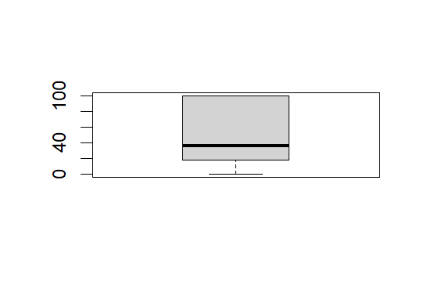

* Generate the Boxplots for WQI_pt variable

* Generate Central Tendency values for CLIMATE variable
* Generate Central Tendency values for AGRICULTURE variable

> # This is done to check the numerical nature of the values

> class(modernepi_data$CLIMATE)

[1] "numeric"

> class(modernepi_data$AGRICULTURE)

[1] "numeric"

> mean(modernepi_data$CLIMATE, na.rm = TRUE)

[1] 55.33374

> mean(modernepi_data$AGRICULTURE, na.rm = TRUE)

[1] 70.85822

> median(modernepi_data$CLIMATE, na.rm = TRUE)

[1] 55.43

> median(modernepi_data$AGRICULTURE, na.rm = TRUE)

[1] 75.29

> hist(modernepi_data$CLIMATE)

> hist(modernepi_data$AGRICULTURE)

> # Multiple modes because a single number can appear multiple times as the mode

> mode = mfv(modernepi_data$CLIMATE, na_rm = TRUE)

> print(mode)

[1] 35.05 49.85 60.74 64.45 75.40

> # Here, on the other hand, using the same method, there is only one most frequent number.

> mode = mfv(modernepi_data$AGRICULTURE, na_rm = TRUE)

> print(mode)

[1] 54.55

* Generate the Boxplots for FISHERIES_pt variable

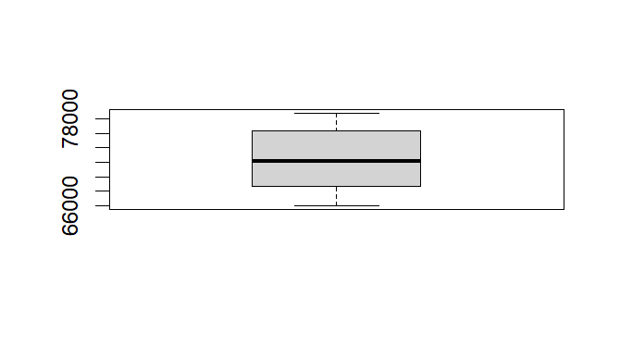

* Generate the Boxplots for NMVOC_pt variable

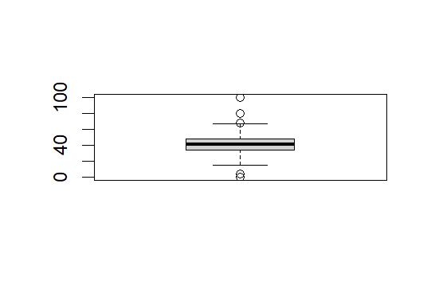

boxplot(ENVHEALTH,ECOSYSTEM)

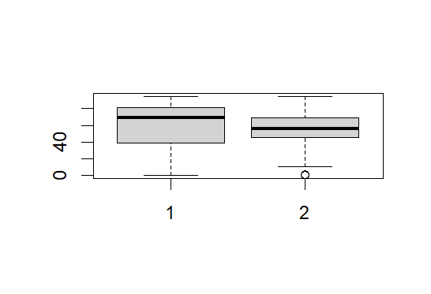

qqplot(ENVHEALTH,ECOSYSTEM

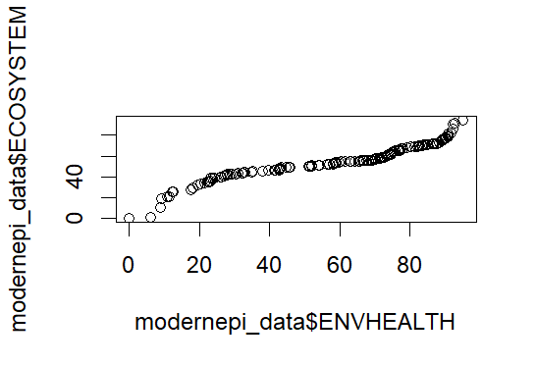

> #SLIDE 12

> boxplot(epi_data$ENVHEALTH, epi_data$DALY, epi_data$AIR_H, epi_data$WATER_H)

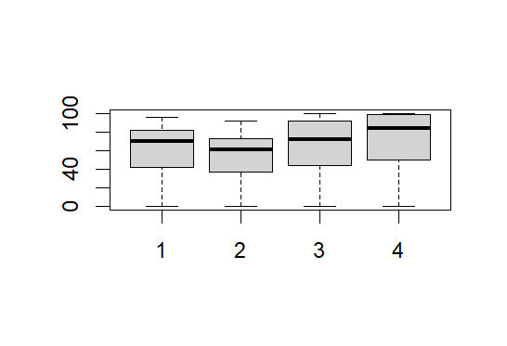

> lmENVH <- lm(epi_data$ENVHEALTH ~ epi_data$DALY + epi_data$AIR_H + epi_data$WATER_H)

> lmENVH

Call:

lm(formula = epi_data$ENVHEALTH ~ epi_data$DALY + epi_data$AIR_H +

epi_data$WATER_H)

Coefficients:

(Intercept) epi_data$DALY epi_data$AIR_H

-2.673e-05 5.000e-01 2.500e-01

epi_data$WATER_H

2.500e-01

> #SLIDE 13

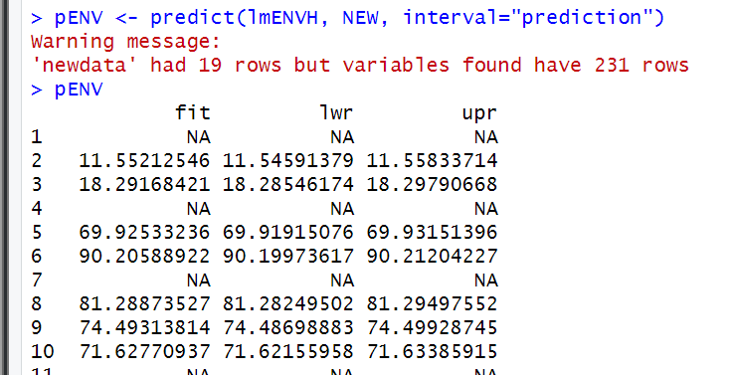

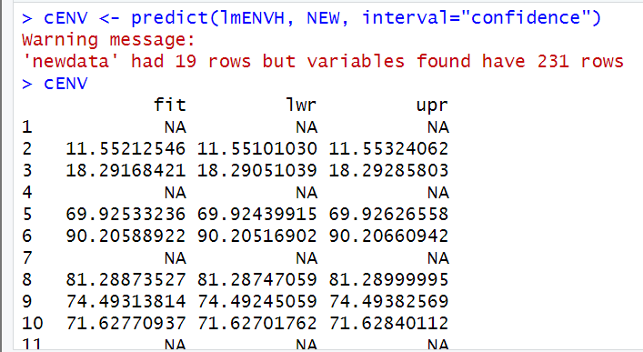

* Boxplot ENVHEALTH, DALY, AIR_H, WATER_H



> lmENVH <- lm(epi_data$ENVHEALTH ~ epi_data$DALY + epi_data$AIR_H + epi_data$WATER_H)

> lmENVH

Call:

lm(formula = epi_data$ENVHEALTH ~ epi_data$DALY + epi_data$AIR_H +

epi_data$WATER_H)

Coefficients:

(Intercept) epi_data$DALY epi_data$AIR_H

-2.673e-05 5.000e-01 2.500e-01

epi_data$WATER_H

2.500e-01

* Using the response variable as: AIR_E and CLIMATE_E
* > boxplot(ENVHEALTH,DALY,AIR_E,WATER_H)
* > boxplot(ENVHEALTH,DALY,CLIMATE,WATER_H)



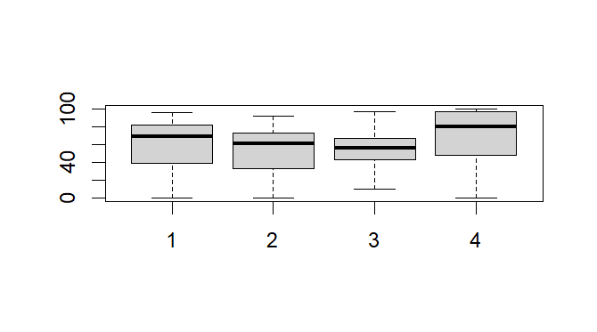

> Model1

Call:

lm(formula = epi_data$AIR_E ~ epi_data$DALY + epi_data$AIR_H +

epi_data$WATER_H)

Coefficients:

(Intercept) epi_data$DALY epi_data$AIR_H

59.2903 -0.1248 0.1686

epi_data$WATER_H

-0.1798

> summary(Model1)

Call:

lm(formula = epi_data$AIR_E ~ epi_data$DALY + epi_data$AIR_H +

epi_data$WATER_H)

Residuals:

Min 1Q Median 3Q Max

-32.708 -7.328 -1.739 8.117 38.182

Coefficients:

Estimate Std. Error t value Pr(>|t|)

(Intercept) 59.29025 2.55759 23.182 < 2e-16 ***

epi_data$DALY -0.12482 0.07707 -1.620 0.10710

epi_data$AIR_H 0.16863 0.05104 3.304 0.00115 **

epi_data$WATER_H -0.17982 0.07021 -2.561 0.01126 *

---

Signif. codes: 0 ‘***’ 0.001 ‘**’ 0.01 ‘*’ 0.05 ‘.’ 0.1 ‘ ’ 1

Residual standard error: 12.42 on 178 degrees of freedom

(49 observations deleted due to missingness)

Multiple R-squared: 0.1803, Adjusted R-squared: 0.1664

F-statistic: 13.05 on 3 and 178 DF, p-value: 9.654e-08

> cModel1 <- coef(Model1)

> AIR_ENEW <- c(seq(5, 95, 5))

> help(seq)

> NEW_AIRE <- data.frame(DALYNEW, AIR_ENEW, WATER_HNEW)

> pENV <- predict(Model1, NEW_AIRE, interval = "prediction")

Warning message:

'newdata' had 19 rows but variables found have 231 rows

> pENV

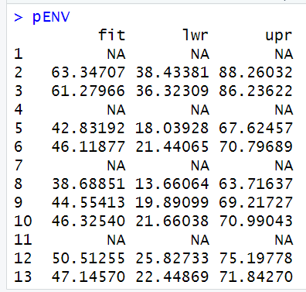

> cENV <- predict(Model1, NEW_AIRE, interval = "confidence")

Warning message:

'newdata' had 19 rows but variables found have 231 rows

> cENV



> Model2

> Model2 <- lm(epi_data$CLIMATE ~ epi_data$DALY + epi_data$AIR_H + epi_data$WATER_H)

Call:

lm(formula = epi_data$CLIMATE ~ epi_data$DALY + epi_data$AIR_H +

epi_data$WATER_H)

Coefficients:

(Intercept) epi_data$DALY epi_data$AIR_H

75.3487 -0.1732 0.0181

epi_data$WATER_H

-0.1538

> summary(Model2)

Call:

lm(formula = epi_data$CLIMATE ~ epi_data$DALY + epi_data$AIR_H +

epi_data$WATER_H)

Residuals:

Min 1Q Median 3Q Max

-37.578 -9.768 1.165 9.164 44.434

Coefficients:

Estimate Std. Error t value Pr(>|t|)

(Intercept) 75.34874 3.01412 24.999 <2e-16 ***

epi_data$DALY -0.17323 0.09050 -1.914 0.0573 .

epi_data$AIR_H 0.01810 0.05919 0.306 0.7602

epi_data$WATER_H -0.15385 0.08161 -1.885 0.0611 .

---

Signif. codes: 0 ‘***’ 0.001 ‘**’ 0.01 ‘*’ 0.05 ‘.’ 0.1 ‘ ’ 1

Residual standard error: 14.15 on 168 degrees of freedom

(59 observations deleted due to missingness)

Multiple R-squared: 0.255, Adjusted R-squared: 0.2417

F-statistic: 19.17 on 3 and 168 DF, p-value: 9.704e-11

> cModel2 <- coef(Model2)

> CLIMATE_NEW <- c(seq(5, 95, 5))

> cModel2 <- coef(Model2)

> CLIMATE_NEW <- c(seq(5, 95, 5))

> NEW_CLIMATE <- data.frame(DALYNEW, CLIMATE_NEW, WATER_HNEW)

> pENV <- predict(Model2, NEW_CLIMATE, interval = "prediction")

Warning message:

'newdata' had 19 rows but variables found have 231 rows

> pENV

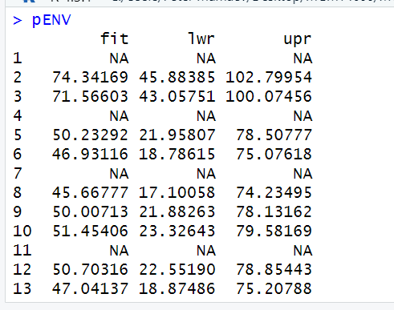

> cENV <- predict(Model2, NEW_CLIMATE, interval = "confidence")

Warning message:

'newdata' had 19 rows but variables found have 231 rows

> cENV

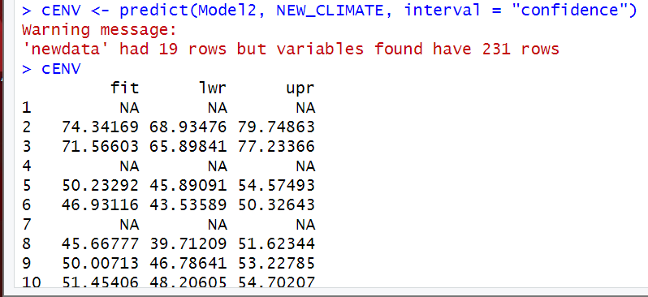

> # While the Shapiro-Wilks test is possible, the number of rows for

> # 2010 EPI data (referred to here as modernepi_data) is too high.

> # As such we wouldn't receive a good assessment for its values.

> # The dataset for epi_data is within acceptable size to do Shapiro-Wilks test on.

> nrow(epi_data)

[1] 231

> library(dplyr)

> # data_sl <- sample(modernepi_data))

> data_sl <- na.omit(modernepi_data$ENVHEALTH)

> shapiro.test(data_sl)

Shapiro-Wilk normality test

data: data_sl

W = 0.92019, p-value = 8.178e-08

> data_sl2 <- na.omit(modernepi_data$ECOSYSTEM)

> shapiro.test(data_sl2)

Shapiro-Wilk normality test

data: data_sl2

W = 0.98129, p-value = 0.02654

> shapiro.test(epi_data$ENVHEALTH)

Shapiro-Wilk normality test

data: epi_data$ENVHEALTH

W = 0.91613, p-value = 1.083e-08

> shapiro.test(epi_data$ECOSYSTEM)

Shapiro-Wilk normality test

data: epi_data$ECOSYSTEM

W = 0.98129, p-value = 0.02654

> modernepi_data <- read.csv("2010EPI_data.csv", skip=1)

> nrow(modernepi_data)

[1] 65467

> modernepi_data <- filter(modernepi_data, !is.na(EPI))

> nrow(modernepi_data)

[1] 163

> shapiro.test(modernepi_data$ENVHEALTH)

Shapiro-Wilk normality test

data: modernepi_data$ENVHEALTH

W = 0.92019, p-value = 8.178e-08