**Queries**

Note Test data does not necessarily match website data

**Use Case: Generate the data visible on a hotel “card” on the website after using main search form**

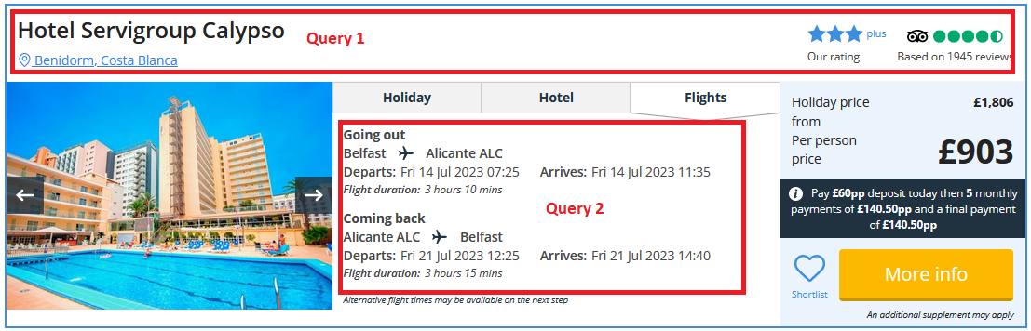

**Queries - 1:**

SET @HotelName = 'Spanish Hotel 1';

SELECT

  hotel.hotel_name AS HotelName,

    region.region_name AS RegionName,

    resort.resort_name AS ResortName,

    star_rating.star_rating AS OurRating,

    star_rating.star_rating_plus AS OurRatingPlusFlag,

    CAST(SUM(review_rating.review_rating) / COUNT(review.review_id) AS DEC(2,1)) AS ReviewScore,

    COUNT(DISTINCT review.review_id) AS NumberOfReviews

FROM hotel

INNER JOIN resort ON resort.resort_id = hotel.hotel_resort_id

INNER JOIN region ON region.region_id = resort.resort_id

INNER JOIN star_rating ON star_rating.star_rating_id = hotel.hotel_star_rating_id

INNER JOIN room_type ON room_type.room_type_hotel_id = hotel.hotel_id

INNER JOIN room_booking ON room_booking.room_booking_room_type_id = room_type.room_type_id

INNER JOIN booking ON booking.booking_id = room_booking.room_booking_booking_id

INNER JOIN booking_contact ON booking_contact.booking_contact_id = booking.booking_contact_id

INNER JOIN review ON review.reviewer_id = booking_contact.booking_contact_id

INNER JOIN review_rating ON review_rating.review_rating_id = review.review_rating_id

WHERE hotel.hotel_name = @HotelName

GROUP BY hotel.hotel_id;

**Results - 1:**

**Queries - 2:**

-- parameters gathered from jet2Holidays main search feature form

SET @OutboundDate = '2023-01-01';

SET @Duration = 2;

SET @HomeAirportId = 5; -- Belfast Internation Airport ID

-- parameter from website card shown above, changes for each card

SET @HotelId = 11; -- 'Spanish Hotel 1' Id

-- get route ids & compute return date

SET @AwayAirportId = (SELECT hotel.hotel_serving_airport_id FROM hotel WHERE hotel.hotel_id = @HotelId);

SET @OutboundRouteId = (SELECT route.route_id FROM route WHERE route.departure_airport_id = @HomeAirportId AND route.arrival_airport_id = @AwayAirportId);

SET @ReturnRouteId = (SELECT route.route_id FROM route WHERE route.departure_airport_id = @AwayAirportId AND route.arrival_airport_id = @HomeAirportId);

SET @ReturnDate = DATE_ADD(@OutboundDate, INTERVAL @Duration DAY);

-- outbound flight info query

SELECT

  dep_airport.airport_name AS DepartureAirport,

    dep_airport.airport_iata_code AS DepartureAirportCode,

    arr_airport.airport_name AS ArrivalAirport,

    arr_airport.airport_iata_code AS ArrivalAirportCode,

    flight.departure_utc_datetime AS DepartureTime,

    flight.arrival_utc_datetime AS ArrivalTime,

    TIMEDIFF(flight.arrival_utc_datetime, flight.departure_utc_datetime) AS Duration

FROM flight

INNER JOIN route ON route.route_id = flight.route_id

INNER JOIN airport AS dep_airport ON dep_airport.airport_id = route.departure_airport_id

INNER JOIN airport AS arr_airport ON arr_airport.airport_id = route.arrival_airport_id

WHERE flight.route_id = @OutboundRouteId LIMIT 1;

-- return flight info query

SELECT

  dep_airport.airport_name AS DepartureAirport,

    dep_airport.airport_iata_code AS DepartureAirportCode,

    arr_airport.airport_name AS ArrivalAirport,

    arr_airport.airport_iata_code AS ArrivalAirportCode,

    flight.departure_utc_datetime AS DepartureTime,

    flight.arrival_utc_datetime AS ArrivalTime,

    TIMEDIFF(flight.arrival_utc_datetime, flight.departure_utc_datetime) AS Duration

FROM flight

INNER JOIN route ON route.route_id = flight.route_id

INNER JOIN airport AS dep_airport ON dep_airport.airport_id = route.departure_airport_id

INNER JOIN airport AS arr_airport ON arr_airport.airport_id = route.arrival_airport_id

WHERE flight.route_id = @ReturnRouteId LIMIT 1;

**Results - 2:**



