# Moods and Triggers

I used a modified version [1] of Russell’s Circumplex Model of Affect [2] as the mood model for my project. I considered several other models.

Figure 1 Russell's Circumplex Model of Affect (Modified)

The Valence-Arousal-Dominance model [2] (also proposed by Russell) was a front runner, but it’s third dimension (dominance) added an unnecessary complexity that I felt would not add enough value to the project to warrant handling the its extra complexity.

Another strong contender was the Ekman's Basic Emotions Model [3] which attempts to enumerate the discrete emotional states categories, i.e. anger, disgust, fear, happiness, sadness, and surprise. This would fit well within the constraints of this project, but it seemed reductive from a user’s perspective.

Russell’s Circumplex Model of Affect was particularly attractive as it allowed 2 axes (valence and arousal) with which to classify each “mood” - see Figure 1. This would be useful during visualization of mood logs, as it attaches data potentially useful to the user to each emotion. I used a modified version of this model which classified 12 separate moods, 2 valences and 2 arousal levels.

For mood triggers/ context I used *activities* the user engaged in – those that prompted the mood – and a free-text *notes* field. These activity triggers are sub divided into groups. Each user account, upon creation, is seeded with an Activity Group named *Default*, in which are nested two Activities – *Work* & *Exercise*. This will be demonstrated in the video report. User’s may add and remove activities themselves via the main menu to customize their experience.

This allows the user’s to associate their day to day activities as triggers for certain moods. As the user creates more and more logs, my visualization charts (Activity/ Mood relationship chart especially) will allow users to spot these trends over time.

To visualise the moods, I used the Chart.js library [4], which is included via a script tag’s src attribute in visual.ejs. I created a set of uniquely authorized routes on my API (in the visualRouter.ts). These routes are authorized not by API keys like the other API routes, but instead via the user’s login token JWT cookie set in the Authorization header of the request. This was done so that the visualization client-side JavaScript scripts can call each chart’s end-point as and when it requires the data (in an ajax-like fashion), instead of doing a potentially wasteful large query to gather all charts data in one go. I had to authorize these requests originating on the client-side without exposing API keys so I chose this method. All of the of the visualization route’s derive the user’s ID from the JWT token’s encrypted payload, ensuring a logged in user can only use these visualize endpoints to get their *own* data.

For the actual statistics rendered in the charts I decided on the following:

**(1)** Raw mood frequency bar chart. The frequency of each mood in that user’s log history is shown. A quick glance can show the user what their most common moods are!

**(2 + 3)** arousal and valence pie charts. These give an indication of how common each valence / arousal [2] in mood logs. This gives the user an immediately accounting of whether their moods are mostly positive or negative, and weather they are of low or high arousal.

**(4)** Summary line graph. This that displays the most common mod logged on each day that has at least a single log. This shows the most common daily mood over the entire time span the user has been logging their moods. Positive/ Negative valence moods are denoted with a green or red colouring respectively to make it obvious immediately which days were broadly positive, and which were negative.

**(5)** Activity/ mood relationships. That is a set of charts that relate the contextual activities the user recorded with the mood logged. When the main relationship tab is selected the user is shown a chart that shows the most common mood/activity relationships. This helps the user pinpoint what activities may be triggering specific moods regularly. This tab nests several sub-charts equal to the number of activities that user has on their account. Newly registered users will have only two sub-charts (for default Work and Exercise activities), but my *testuser1* demo account has eight charts under this tab, as there is currently 8 activities associated with that account.

There is also an Introduction tab, that briefly explains the concept of Russells’ Circumplex model, links to the original paper, and gives a plain English description of what that means for the user.

# Functional and System Requirements

**User Registration:** User registration is done via a registration form that has both client and server side validation. The form is clean and easy to read, and the client side validation uses input border/ background colouring and validation messages in absolutely positioned div elements. The form requires the user to confirm their password to ensure it is what they expect, and allows the user to click a checkbox to show the password if they wish. If a logged in user navigates to the register page (at /user/register) accidentally, eg via the browsers back button, the registration form is not displayed, as to not confuse the user.

If user registration is successful, the second route controller middleware method is called which seamlessly logs that user in.

Upon reflection, it would have been better if I had a confirm email field, and required the user to verify their submitted email address is under their control.

**Loggin In:** As discussed in the video, a user is considered successfully logged in if their client has a cookie named token containing a JWT signed with the MOODR_TOKEN_SECRET encryption key from environment variables. Even if a user attempts to create a fraudulent login cookie, they cannot sign the JWT with the same encryption key available server-side, making their fraudulent JWT invalid as the authorize middleware will fail to verify (decrypt and decode) the JWT. Thus only the web application/ API can create/sign and verify/decrypt these JWTs payloads.

I chose to render the login form via a modal, accessible via the hamburger button. This means that if the user navigates to an page accessible to non-logged in users, they can access the login form no matter where they are. If the user is logged in, then this modal instead shows the username and avatar of the user, with options to navigate to the account details page or to log out. The navigation menu is also displayed when the user is logged in, so that if the user is using the website via a device with a smaller viewport where the CSS breakpoints will hide the navigation menu on the main body of the page, they can still access it via the hamburger button.

**Mood Logging:** The user can access the mood logging form via the /user/new or /user/<entryId> routes. The form is dual purpose and depending on which of these two routes the form is accessed via, will allow the user to create a new log entry, or edit an existing log entry. The form allows the user to select from a series of positive and negative moods, as defined by Russell’s Circumplex Model of Affect [2]. This makes the appropriate mood easier to find and makes the UI more intuitive for a user. Optionally, the user may leave some free-text notes and select the activity they were undertaking that triggered the mood. These *notes* and *activities* are discussed in the *Moods and Triggers* section above.

**Mood List:** The moods list page is accessible via the /mood/list route. This page renders all the user’s mood logged. The data is processed on the server and sorted by day. Each day’s entries are then sorted chronologically to make navigating the list intuitive for the user. Here the user can easily *Edit* and *Delete* each entry by selecting the relevant button on that entry.

**Edit Mood:** When a user selects the *Edit* button on the mood list page, the add/edit entry form (at ./app/views/components/mood-entry-form.ejs, embedded into the ./app/views/mood-entry-edit.ejs template) is displayed. This form will not allow a user to change the mood value or timestamp of the entry as per specification, but it does allow the user to edit the *notes* and *activities* mood triggers/ context data as they wish.

**Delete Mood:** When a user selects the Delete button on the mood list page, the web application send a DELETE request to the /api/mood/<userId>/<entryId> route, and simply renders the mood list page once complete (reusing the controllers getEntryList method, which is used to get the data for and display the mood list page). Upon reflection, it would have been better if some sort of success or failure message was displayed on the mood list (e,g, cannot find that entry to delete, internal server error).

**Mood Summary:** The user can navigate to the /mood/visual route, to access mood summary charts. They are initially greeted with the abstract from Russell’s paper [2], with a link to the paper online and a very small paragraph that attempts to explain the relevance of this model in plain English. The user can then click buttons along the top that will render the individual charts. The data from the charts, as already shown in the video, is requested directly from the API via client side JavaScript scripts, via a unique router that is authorized via the users JWT token cookie.

This unique authorization method was employed so that the server need not request all visualization data in one giant query but may make smaller requests are needed for a specific charts data. Although this is an educational project, this was done as a nod to the needs of scaling such a web site up to potentially many users who have a great number of mood logs recorded.

**Delete Account:** A logged in user may click the hamburger button, and then the Accounts button on the displayed modal to access their account details page. I have not demonstrated username/ email changes as they are excess to requirements, although I did demonstrate the password change route as a successfully implemented PATCH request.

The account deletion process was demonstrated already in the video report. The reason I chose to require the user to type in their username to confirm account deletion was to make deletion itself a deliberate act, that cannot be executed by an errant misclick. I cannot imagine a scenario that would destroy a user’s motivation to log their mood more than accidentally deleting their account and ALL data on it with a single accidental click.

**Logout:** A logged in user can click the hamburger button then the Logout button displayed on the modal. This route simply deletes the token cookie off the user’s client (and sets the authed ExpressJS locals variable to false – this variable is used by the web applications authorize middleware, and is set to false as a safety precaution).

I placed this logout button the hamburger buttons menu modal, as it seemed prudent to allow a used quick and easy access to the logout functionality, no matter where on the website they were.

# Authorization & Security

There are currently 3 main methods of authorization used in my project.

1. **Web application:** The user’s session is authorized on login restricted routes via the authorize and restrictedArea middleware functions from ./app/middleware/ (that authorize the user and requires user to be authorized to access any routes that use this middleware respectively). Authorize attempts to retrieve the user’s login JWT token cookie from the browser, and then attempts to decrypt it using the MOODR_TOKEN_SECRET from environment variables. If the JWT is not valid (current time surpasses expiration time, or it was signed with a different secret), the authed ExpressJS locals variable is set to false. If it is valid, it is set to true. The restrictedArea middleware simple checks this authed locals variable is set to true for that request/ response cycle. If it is set to false the user is redirected to the /forbidden route which displays a polite message informing the user they must be logged in. If authed is set to true, the next() Express method is called which calls the next middleware for that route. Note middleware functions can be mounted for the entire router/ application via .use(), or per route via the appropriate ExpressJS HTTP verb method (e.g., .get, .post) [5].
2. **API:** All requests from the web application to the API are authorized via API keys. The web application reads the current in-use key from environment variables. The dotenv [6] node module/ library is used to inject key/value pairs (including the active API key amongst others) from the ./.env file into environment variables. This .env file would not be committed to a repository as to not expose the API keys. The environment variables and their values in the real world would be added to the server machine when the application is deployed to a production environment, likely by CI/CD tooling. The keys are stored in the tbl_key table in the database and can easily be disabled by changing the active bit(1) attribute to 0 on a specific key. These keys are passed in the Authorization header of the HTTP request. The API checks the key both exists in the database, and has its active bit set to 1, otherwise it rejects the key and does not authorize the request. This authorization method is enacted by the ./api/middleware/authorizeByRequestSource.ts middleware.
3. **API:** Requests from client-side scripts to the API’s visualizeRouter GET routes are authorized via the user’s login cookie named token. It is placed into the Authorization header of the request. The API reads this token, verifies & decrypts it, and the user’s ID is read from the JWT’s payload. The user id from the payload is then embedded into SQL queries. In this manner the client-side scripts can only successfully GET resources for an account they have the login details for.

I chose API keys to authorize requests from the web app to the API, as it is a well defined industry standard process, that has stood the test of time. My implementation allows immediately disabling of any keys which are compromised.

I chose JWT’s to authenticate user’s as they are also a well defined industry practice. It allows me to store information in the login cookie, ie, the user’d id, username, email and an expiry property. The expiry property is important as it means that a valid JWT has a limited lifespan, so even if a user has their JWT lifted off their machine, it will be invalidated automatically after 30 minutes.

This is a somewhat naïve implementation of handling expiry of tokens, as even if a user is logged in and operating the website, they will have to login every 30 minutes. I could solve this limitation in a number of ways, e.g. implementing a check that would automatically delete the cookie if the IP address using the token changed.

Figure 2 API keys stored in tbl_key

# User Input Validation & Sanitization

As discussed already, user input is validated server side to ensure there are no characters in the user input that can be used to inject code into the website. This is accomplished via regular expressions that only allow safe characters past validation, and so if input passes the regex check it is therefore sanitized. These regular expressions are accessible throughout the server-side portion of the project via a configuration class named Config that reads data from JSON configuration files (Config and JSON files are viewable in ./common/config/). The Config class stores the data in private fields and exposes it via getter methods, which stops the config data from being changed in the config object.

This Config class is imported in various files throughout the app/ API (and passed to client-side by passing the config data into ExpressJS locals variable, where they are assigned the required config data to client-side JavaScript variables when rendering the template – viewable in ./app/views/partials/top.ejs lines 14-21, and the middleware ./app/middleware/injectConfig.ts). This allows the client-side to access validation data for input fields such as minLength, maxLength, validation regex and a description containing a validation error message. Thus, to change all input validation throughout the app (or other config data such as the ExpressJS listening port), one must only change the data contained in the appropriate configuration file at ./common/config/*.json. The validation regex is simple, it enforces a 8-20 character limit, and allowable characters of a-z A-Z and 0-9 on usernames; a 8-20 character limit, and allowable characters of a-z A-Z, 0-9, _, -, ?, ! and * on passwords; and emails simply have to be in the format example@website.topleveldomain (containing only a-z, A-Z and 0-9). In reality these regular expressions would need some further development.

# REST API Implementation

All database operations performed by the web application are done so through via RESTful API which, like the web application, is also an ExpressJS application. Technically my API is mounted as An ExpressJS Router in the main web application but it could easily be deployed as its own ExpressJS application. The API is divided into 3 ExpressJS Routers - *authRouter, moodRouter* and *visualizeRouter*, to maintain separation of concerns. These 3 routers are mounted in the ./api/api.ts ExpressJS Router, which it itself mounted in ./app/app.ts ExpressJS application. I already described Request Authorization in the Security section.

All database operations executed by the API are housed in my two database access objects (DAOs) in ./api/database/. The *format* function, provided by the mysql2 node module/ library, allows us to prepare SQL statement with escaped parameters, to prevent SQL injection attacks. In concert with validation and sanitization of user inputs discussed above, this is an additional layer of protection against SQL injection and XSS attacks.

The RESTful API I developed for this project was in the form of an NodeJS/ExpressJS application wrapping a MySQL database running on an Apache Server, managed via XAMPP. For the purposes of a university project the API is mounted via the main web application’s app.ts as an ExpressJS Router, although it could easily be deployed as a separate Express application.

This Router is defined in./api/api.ts. Its routes are divided into 3 groups, /user, /mood and /visual, which are themselves ExpressJS Routers, each with its own area of concern. Authorization was discussed in its own section above, but the former two are authorized via API keys and the latter via a JWT.

## Endpoints

A list of all API endpoints follows. All endpoints accept only application/x-www-form-urlencoded content type in request bodies. All endpoints use the building express Response method .json() [7] to convert from TypeScript response objects to JSON via JSON.stringify(). These response objects, discussed below, are stored in the ./common/response/ folder. Most of them extend SuccessResponse, barring some specific use case response objects such as EntryDataResponse.ts.

./api/routes/userRouter.ts

**POST /api/user/login**

Expects a POST body containing username & password key/ value pairs, and returns a response modelled by LoginResponse.ts. If post body is missing data, or if the passed username / password fail their regex tests from Config as discussed above, returns a 400 with appropriate message(s). If username and password are correct a 200 is returned with a login JWT. If the username and password combination is incorrect a 401 is returned.

**POST /api/user/register**

Valid POST body to contain username, email and password key/ value pairs, and returns a response modelled by RegistrationResponse.ts. If post body invalid, or if the data from the POST body fail their Config regex tests, returns a 400 with appropriate message(s). The database is queried to check if the username or email has already been used, and if so returns a 409 Conflict with appropriate message(s). If all inputs pass validation and the user was created successfully, a 200 is returned.

**DELETE /api/user/<userId>**

Requires no body. The user ID is read directly from route parameters and calls a stored procedure named usp_delete_account(userId)that deletes in specific order (due to foreign key constraints), log entry activities, log entry images, log entries, context activities, activity groups and finally the user data. Returns a 200 if deleted successfully, a 400 if the userID request parameter is non-numeric and 404 if that user is not in the database.

**GET /api/user/<userId>**

This route is used for populating the form data in the Account Details page accessible via the hamburger menu. If the userID parameter is a valid user ID, a 200 is returned with a JSON body modelled by AccountDetailsGetResponse.ts. If the userID parameter is non-numeric a 404 is returned and if the userID does not exist in the database a 400 is returned. These latter two have response modelled by the SuccessResponse.ts class.

**PATCH /api/user/<userId>**

This endpoint is used to partially update a user resource (hence PATCH not PUT [8]), that is, it updates the username and email, but does NOT update the user’s password. Returns a 200 if the user ID is numeric, and is a valid users ID. Returns a 404 if the user ID is not found in the database. Both responses return a JSON body modelled by AccountDetailsGetResponse.ts. Returns a 400 if username or email are absent from the request body or fail their regex check, or if userID is a non-numeric value, with a response body modelled by SuccessResponse.

**PATCH /api/user/<userId>/password**

GET /api/mood/**<userId>**/new

POST /api/mood/**<userId>**/new

GET /api/mood/**<userId>**/list

GET /api/mood/**<userId>/<entryId>**

PUT /api/mood/**<userId>/<entryId>**

DELETE /api/mood/**<userId>/<entryId>**

GET /api/visualize/moodFrequency

GET /api/visualize/arousal

GET /api/visualize/valence

GET /api/visualize/relationship

GET /api/visualize/summary

# Database

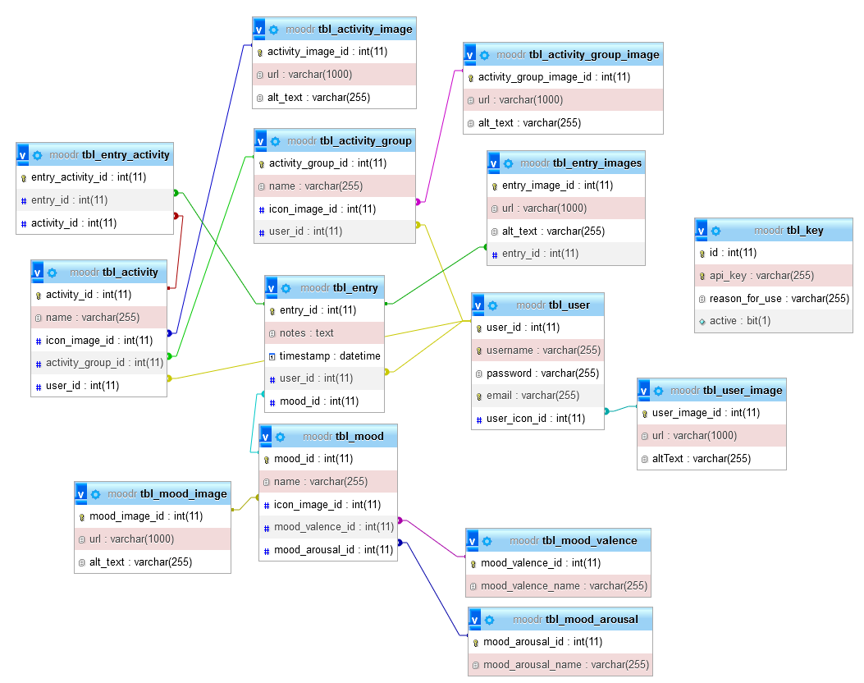

I made significant modification to the provided database layout. I tried to incorporate the lessons from the Database module about normalising data, reducing data redundancy, and attempting to reduce opportunity for data anomalies/ corruption.

The table *tbl_entry* is my implementation of the table *moods* from the design in the specification. I normalised out the *value* attribute from the specification into its own table (*tbl_mood*), as to introduce the 12 moods identified in my modified version of Russell’s Circumplex Model of Affect. To expand the number of moods available for users, as some versions of Russell’s model have significantly more than 12 moods, more can simply by inserted into *tbl_mood,* and so will be immediately available for use by all users. The *tbl_mood_arousal*, and *tbl_mood_valence* lookup tables exist only normalise out the valences and arousals out of *tbl_mood*, and contain only two records apiece. *tbl_mood_image* exists only to hold the URLs for the mood’s icons (the emoticon-like images associated with each mood).

The *context* attribute from the provided design has been splint into 2 pieces of information: *notes*, which is analogous to the *context* field, and activities. Activities have a many-to-many relationship with mood entries and so a linking table named *tbl_entry_activity* was created to allow this linking of *tbl_entry* and *tbl_activity*.

*tbl_entry_images* was implemented to allow a user to attach a number of images to a mood log entry, and which I have demonstrated an entry that has images attached, I did not implement the functionality to allow a user to do this. Nevertheless, the basic functionality is in place, and our API returns these images if they are present in the database. With more time and foresight, I would have implemented this to allow a user to attach images themselves, and extra context for an entry.

*tbl_user_image*, in the same way, is the basis for functionality that allows a user to set a personal avatar image for their account. Currently when a user registers, a default silhouette avatar URL is assigned to their account. The avatar image *img* tag’s *src* attribute is populated from the URL stored in tbl_user_image and can be updated with an insert to tbl_user_image, and an update to *tbl_user*’s *user_icon_id* attribute. However, currently a user cannot access this functionality themselves.

All the image tables in the database have an *alt_text* attribute, which is set to the associate img HTML tag’s *alt* attribute.

The API storage table *tbl_key* has already been discussed, but it seemed appropriate not only to store the key, but its reason for creation, and the *bit(1)* active attribute was added to allow quick disabling of keys without deleting their record from the database.

# Appendix - References

|  |  |
| --- | --- |
| [1] | Unknown, “Modifier Russell's Circumplex Model of Affect,” [Online]. Available: https://ascelibrary.org/cms/asset/4f61d617-0684-42de-9120-1cb8d15e3734/figure1.jpg. |
| [2] | “The circumplex model of affect: An integrative approach to affective neuroscience, cognitive development, and psychopathology,” [Online]. Available: https://www.ncbi.nlm.nih.gov/pmc/articles/PMC2367156/. [Accessed 01 February 2023]. |
| [3] | P. Ekman, “Universals And Cultural Differences In Facial Expressions,” in *Nebraska Symposium on Motivation*, 1971. |
| [4] | Chart.js, “Chart.js homepage,” Chart.js, [Online]. Available: https://www.chartjs.org/. [Accessed 15 02 2023]. |
| [5] | ExpressJS, “Using Express middleware,” ExpressJS, [Online]. Available: https://expressjs.com/en/guide/using-middleware.html. [Accessed 22 March 2023]. |
| [6] | dotenv, “dotenv - npm,” [Online]. Available: https://www.npmjs.com/package/dotenv. [Accessed 3 January 2023]. |
| [7] | ExpressJS, “Express 4.x - API Reference - res.json(),” [Online]. Available: https://expressjs.com/en/4x/api.html#res.json. [Accessed 19 March 2023]. |
| [8] | Mozilla Developer Network, “HTTP request methods - HTTP | MDN,” Mozilla, [Online]. Available: https://developer.mozilla.org/en-US/docs/Web/HTTP/Methods. [Accessed 1 February 2023]. |
| [9] | ExpressJS, “ExpressJS Locals,” ExpressJS, [Online]. Available: https://expressjs.com/en/4x/api.html#res.locals. [Accessed 19 March 2023]. |
| [10] | Wikipedia, “Hamburger button,” Wikipedia, [Online]. Available: https://en.wikipedia.org/wiki/Hamburger_button. [Accessed 03 March 2023]. |
| [11] | P. Leach, M. Mealling and R. Salz, “RFC 4122 - A Universally Unique IDentifier (UUID) URN Namespace,” Internet Engineering Task Force, 17 January 2017. [Online]. Available: https://datatracker.ietf.org/doc/html/rfc4122. [Accessed 19 March 2023]. |