COMP20240 Assignment 2: Peter Murphy 16440004

**Q1:**

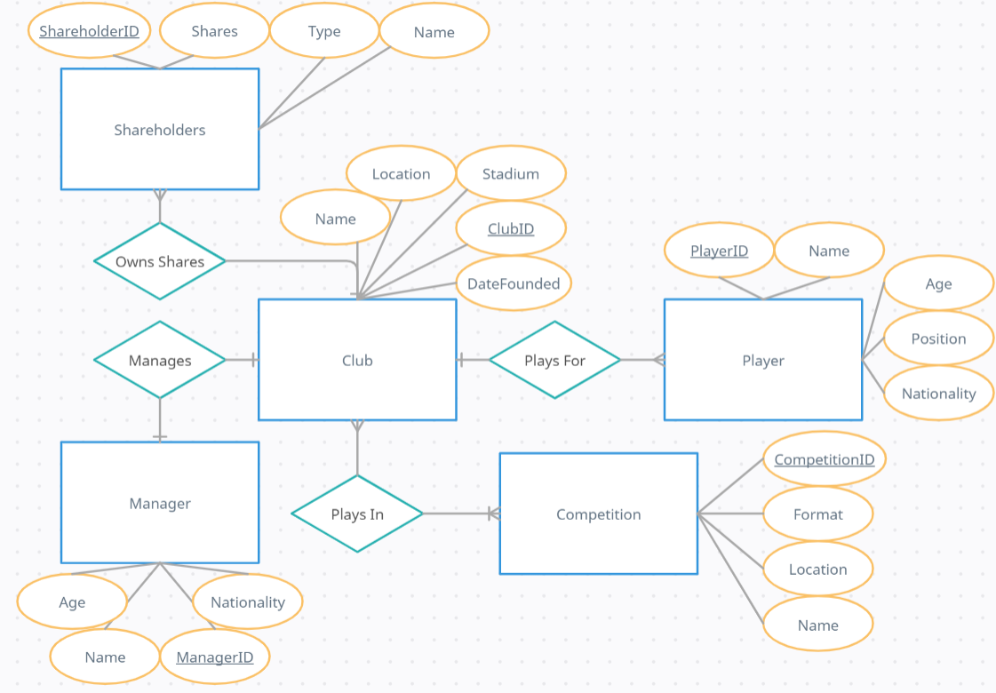

**Q2:**

* My diagram represents a sports club, some of it’s staff and the competitions it plays in.
* The 5 entities are Competition, Club, Player, Manager and Shareholders.
* A player plays for 1 club, and a club has many players (one-to-many).
* A manager manages 1 club, and a club has 1 manager (one-to-one).
* A shareholder has shares in 1 club, and a club has many shareholders (one-to-many).

I assumed a shareholder can only have shares in one club.

* A club can play in many competitions, and a competition has many clubs (many to many).

A club must play in at least 1 competition.

**Q3:**

**CLUB**(ClubID, Name, Location , DateFounded, Stadium) **PLAYER**(PlayerID, Name, Age, Position, Nationality, ClubID) **MANAGER**(ManagerID, Name, Age, Nationality, ClubID) **SHAREHOLDERS**(ShareholderID, Name, Shares, Type, ClubID) **COMPETITION**(CompetitionID, Name, Location, Format) **PLAYS_IN**(ClubID, CompetitionID)

Note: The first attribute is the primary key in all tables, except the PLAYS_IN table. The ‘Plays for’, ‘Manages’ and ‘Owns Shares’ relationships are translated using ClubID as a foreign key in the PLAYER, MANAGER and SHAREHOLDERS tables referencing ClubID in the CLUB table. The ‘Plays In’ relationship is translated using the PLAYS_IN table, which has ClubID and CompetitionID as foreign keys referencing ClubID in the CLUB table and CompetitionID in the COMPETITION table, splitting the many-to-many relationship into 2 one-to-many relationships.

**Q4:**

Given a competition name, list all teams in that competition.

Given a club name, list all players that play for that club.

**Q5:**

SELECT CLUB.Name FROM CLUB INNER JOIN PLAYS_IN ON PLAYS_IN.ClubID = CLUB.ClubID INNER JOIN COMPETITION ON PLAYS_IN.CompetitionID = COMPETITION.CompetitionID WHERE COMPETITION.Name = “given name”

SELECT PLAYER.Name FROM PLAYER INNER JOIN CLUB ON PLAYER.ClubID = CLUB.ClubID WHERE CLUB.Name = “given name”