**Project Charter**

* **Project name:**CRC (Car Remote Control).
* **Project sponsor:**  
  (Porsche company” Porsche@gmail.com”)  
  (Ford company “Ford@gmail.com”)
* **Project manager:**  
  Eng. \ Gorg Hosny [gorghosny010@gmail.com](mailto:gorghosny010@gmail.com).
* **Purpose of the project:**  
  Ease of daily use of the car without problems or risks.
* **Business case:**  
  After looking at many statistics, we noticed some negative numbers that cost insurance companies and car companies billions, many people neglect their cars by forgetting to do the periodic maintenance of cars and the increase in the breakdowns that occur on public roads with the large increase in the number of deaths resulting from road accidents and a decrease in the lifespan of cars due to neglect in cars for long periods without going to the technician and the increase in car theft cases in many countries, due to forgetting car keys in public places, and all this causes great losses to many international companies.
* **Key deliverables of the project:**  
  application (android & IOS & Windows & Linux)
* **Project milestones (Timeline of the project):**  
  - At first, it will take a group of automotive engineers 1 months to collect data on most cars.  
  - It will take about 2 months for technicians to install  
  the required devices, to develop the cars’ computers.  
  - For 5 months, a team of engineers will make the mobile application and the software system of the cars’ computers.  
  - The application will be tested for a month.
* **Project resources:**1- A team of automotive engineers.  
  2- A team of software and hardware engineers.  
  3- Budget: 440,000$ to the first stage of the project.
* **Constraints:**1- The project must take time less than 11 months as a worst case.  
  2- The cost of the project of the project must not exceed 440,000$.
* **Risks:**1- One of the risks that the work team will face is the lack of experience of programmers, and this will affect the project significantly and may delay its operation. 2- He also mentioned that we need some parts that will be installed in cars, and one of the potential risks is the lack of supplying some parts from companies.  
  3- Another risk is the weakness of the available financial resources, and this represents a major challenge.

4- the lack of expert technicians to install parts in cars of different types.

5- Finally, Different operating systems for different cars represent the biggest risks.

* **How to deal with risks?**

1. Hiring programmers with enough experience and constantly testing the program.
2. Training technicians to install on different types of cars.
3. On the financial side, we are trying to persuade investors and sponsors to pay larger sums of money in order to complete the project.

**Project Scope**

* **Product Scope Description:**1- Easy accessibility between the user and her/his car.  
  2- To make the user connected to his/her car, we will develop an application that provides many services to the user that make him/her deal with his/her car easily.  
  3- The application will be directly connected to the user’s car computer.  
  4- The application will be available for use on mobiles powered by Android & IOS (OS) and laptops powered by Windows & Linux & Macintosh (OS).  
  5- All modern features that exist in modern cars will be added to the application.  
  6- The application will be able to check what features are available on the user’s car, to introduce the most appropriate services.  
  7- The application will be highly secured to sure that only the car’s user can control it by the application.  
  8- The initial features of the application are (locate the car, lock & open the car, sending warnings, sending car’s information).
* **Product Acceptance Criteria:  
  The application should be able to do the following: -**1- Locate the car and send the location to the user.  
  2- Provides the user the ability to lock and open the car.  
  3- Shows the status of all functions the car provides.4- Finds out if there are any malfunctions in the car and sends a warning to the user to inform him/her about it.  
  5- Sends location and emergency message to the nearest hospital and the police station if there is serious damage on the car that refers to an accident that happened.
* **Project Deliverables:**1- Develop cars’ computers to have the ability to be connected to every part of the car and the internet at the same time.  
  2- Modern hardware and technologies will be added to cars and to cars’ computers.  
  3- Develop a software system for cars’ computers that provides many options such that (connection to the internet, giving permission to phone to control the car, securing the car from hacking, etc.…).  
  4- Create a database belonging to the car that stores cars’ information.  
  5- Create a GUI for the car’s software system and for the application.
* **Project Exclusions:**  
  In the first stage of the project, we will focus on simple services that the project will introduce to the user, these simple services are in the **Product Acceptance Criteria**, any other ideas will be added in the next stage of the project.
* **Project Constraints:  
  1- Time: -**The first stage will be finished in 5 to 11 months of work.  
  **2- Budget: -**  
  A 440,000$ to start the first stage of the project.  
  **3- Resources: -**- Human resource: 50 efficient persons with a high level of experience.  
  - Cars Resource: 2 cars with different high Brands.  
  - 2 support companies to provide devices and other resources.

**Work Breakdown Structure (WBS) of The Project**

**2.2**

**Create Database**

**4.1**

**Test The Application**

**4.2**

**Pushing app on**

**Google store**

**And**

**App store**

**3.1**

**Make secure Access**

**CRC**

**4  
Finishing**

**2.1**

**Create**

**Application**

**3  
Access**

**2  
Application Develop**

**1.2.1**

**Installing sensor**

**1.2**

**Computer Hardware Development**

**1.2.2**

**Network (WAN)**

**1.1**

**Computer Software System Development**

**1  
Car Develop**

**WBS Dictionary of The Project**

|  |  |
| --- | --- |
| **Description** | **Develop software systems of cars’ computers to support internet connection and other required options** |
| **Responsibility Owner** | **Group of software systems engineers** |
| **Resources** | **(30 – 50) experienced engineers in developing software systems** |
| **Cost** | **40,000$ - 50,000$** |
| **Acceptance** | **Cars’ Computer support internet connection and other required options** |
| **TimeLine** | **(1 – 2) months to end this task** |

|  |  |
| --- | --- |
| **Description** | **Develop hardware component of cars’ computers to support internet connection and GPS technology** |
| **Responsibility Owner** | **Group of automotive and IT engineers** |
| **Resources** | **1- (30– 50) automotive and IT engineers**  **2- (10) GPS devices 3- (10) internet devices** |

**1- Car Develop: -**- 1.1 Computer Software System Development:  
- 1.2 Computer Hardware Development:

|  |  |
| --- | --- |
| **Cost** | **80,000$ - 100,000$** |
| **Acceptance** | **Cars’ Computer support internet connection and other required options** |
| **TimeLine** | **(1 – 2) months to end this task** |

1. **Application Develop: -**

|  |  |
| --- | --- |
| **Description** | **Design application GUI and Programing and writing the application codes (coding)** |
| **Responsibility Owner** | **Group GUI designers and Group of programmers and problem solvers** |
| **Resources** | **(30– 50) GUI designers and developer** |
| **Cost** | **70,000$ - 80,000$** |
| **Acceptance** | **High quality and simple Interface** |
| **TimeLine** | **(2 – 3) months to end this task ,Efficiency (speed and small)** |

2.1 Create Application:

|  |  |
| --- | --- |
| **Description** | **Create application database** |
| **Responsibility Owner** | **Group of database engineers** |
| **Resources** | **(30 – 50) experienced database engineers** |
| **Cost** | **15,000$ - 25,000$** |
| **Acceptance** | **Efficiency (simple relationships)** |
| **TimeLine** | **(1 – 2) months to end this task** |

|  |  |
| --- | --- |
| **Description** | **Make Secure Access between application and car’s computer** |
| **Responsibility Owner** | **All work crew** |
| **Resources** | **All work crew other required things** |
| **Cost** | **15,000$ - 20,000$** |
| **Acceptance** | **Secure and good connection between application and car’s computer** |
| **TimeLine** | **(1 ) month to end this task** |

- 2.2 Create Database: **3- Access : -**

**4. Finishing The Project:**

- 4.1 Test the Application:

|  |  |
| --- | --- |
| **Description** | **Test the application** |
| **Responsibility Owner** | **Group of testers** |
| **Resources** | **(30 - 50) experienced testers** |
| **Cost** | **50,000$ - 60,000$** |
| **Acceptance** | **There are no problems in the applications** |
| **TimeLine** | **(1-2) months to end the test** |

-4.2. Pushing app on Google store And App store

|  |  |
| --- | --- |
| **Description** | **Pushing App on google store and app store and Making advertising** |
| **Responsibility Owner** | **Group of experts** |
| **Resources** | **(30 - 50) experienced testers** |
| **Cost** | **50,000$-60,000$** |
| **Acceptance** | **There are no problems in the applications** |
| **TimeLine** | **1 month to end pushing and making advertising** |

**Responsibility Matrix**

|  |  |  |  |  |  |  |  |
| --- | --- | --- | --- | --- | --- | --- | --- |
|  | **Manager** | **Software Systems Engineers** | **Automotive and IT engineers** | **GUI designers** | **Database engineers** | **Testers** | **programmers and problem solvers** |
| **Collect Data** | **A** | **P & C** | **P** |  |  | **R** |  |
| **Software System** | **A** | **P** | **P** |  |  | **R** |  |
| **Hardware System** | **A** |  |  | **C & P** |  | **R** | **R** |
| **Application Develop** | **R** | **R** | **R** | **R** |  | **R** | **C & P** |
| **Make Secure Access** | **R** |  |  |  | **C & P** | **R** | **R** |
| **Test** | **A** | **P** | **P** | **P** | **P** |  |  |
| **Finishing** | **R** | **R** | **R** | **R** | **R** | **P** | **R** |

**A = Approves**

**R = Reviews**

**P = Participant**

**C = Creator**

**Network:**

|  |  |  |  |
| --- | --- | --- | --- |
| Id | Activity | Duration | Preceding Activity |
| A | Collect Data | 4 | None |
| B | Software System | 6 | A |
| C | Hardware System | 6 | B |
| D | Application Develop | 10 | C |
| E | Make Secure Access | 4 | D |
| F | Test | 6 | E |
| G | Finishing | 4 | F |

Network:

|  |  |  |
| --- | --- | --- |
| 4 | B | 10 |
| 0 | 50P | 10 |
| 4 | 6 | 10 |

|  |  |  |
| --- | --- | --- |
| 0 | A | 4 |
| 0 | 30P | 0 |
| 0 | 4 | 4 |

|  |  |  |
| --- | --- | --- |
| 10 | C | 16 |
| 0 | 30P | 0 |
| 10 | 6 | 16 |

|  |  |  |
| --- | --- | --- |
| 16 | D | 26 |
| 0 | 50P | 0 |
| 16 | 10 | 26 |

|  |  |  |
| --- | --- | --- |
| 26 | E | 30 |
| 0 | 50P | 0 |
| 26 | 4 | 30 |

|  |  |  |
| --- | --- | --- |
| 30 | F | 36 |
| 0 | 50P | 0 |
| 30 | 6 | 36 |

|  |  |  |
| --- | --- | --- |
| 36 | G | 40 |
| 0 | 30P | 0 |
| 36 | 4 | 40 |

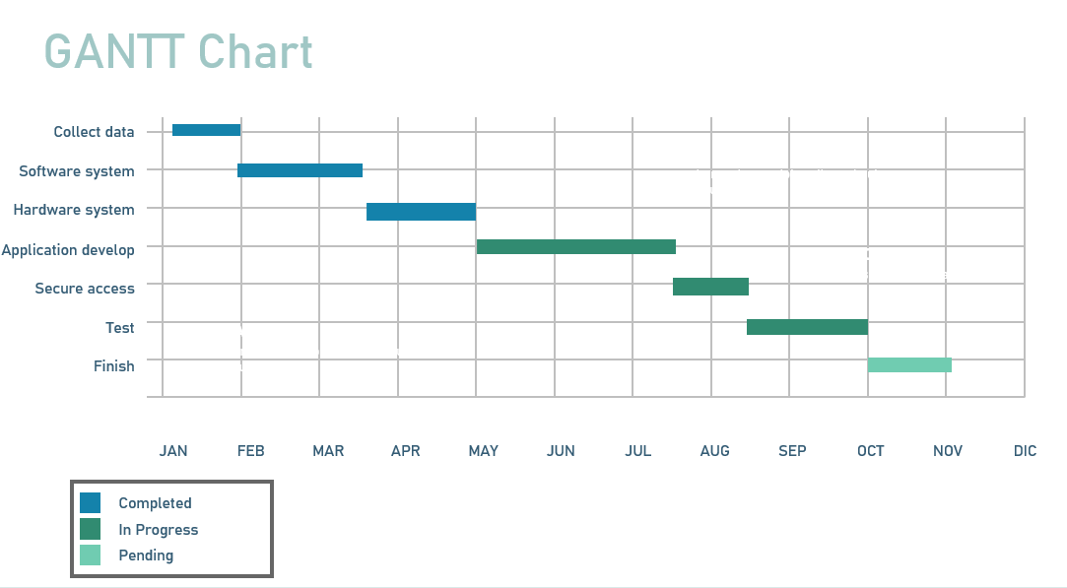

**Resource Constrained:**

|  |  |  |  |  |  |  |  |  |  |  |  |  |  |  |  |  |  |  |  |  |  |  |  |  |  |
| --- | --- | --- | --- | --- | --- | --- | --- | --- | --- | --- | --- | --- | --- | --- | --- | --- | --- | --- | --- | --- | --- | --- | --- | --- | --- |
| Id RES DUR ES LF SL 0 2 4 6 8 10 12 14 16 18 20 22 24 26 28 30 32 34 36 38 40 | | | | | | | | | | | | | | | | | | | | | | | | | |
| A | 30P | 4 | 0 | 4 | 0 | 30 | 30 |  |  |  |  |  |  |  |  |  |  |  |  |  |  |  |  |  |  |
| B | 50P | 6 | 4 | 10 | 0 |  |  | 50 | 50 | 50 |  |  |  |  |  |  |  |  |  |  |  |  |  |  |  |
| C | 30P | 10 | 6 | 16 | 0 |  |  |  |  |  | 30 | 30 | 30 |  |  |  |  |  |  |  |  |  |  |  |  |
| D | 50P | 16 | 10 | 26 | 0 |  |  |  |  |  |  |  |  | 50 | 50 | 50 | 50 | 50 |  |  |  |  |  |  |  |
| E | 50P | 26 | 4 | 30 | 0 |  |  |  |  |  |  |  |  |  |  |  |  |  | 50 | 50 |  |  |  |  |  |
| F | 50P | 30 | 6 | 36 | 0 |  |  |  |  |  |  |  |  |  |  |  |  |  |  |  | 50 | 50 | 50 |  |  |
| G | 30P | 36 | 4 | 40 | 0 |  |  |  |  |  |  |  |  |  |  |  |  |  |  |  |  |  |  | 30 | 30 |
| Total Resource Loud | | | | | | 30 | 30 | 50 | 50 | 50 | 30 | 30 | 30 | 30 | 50 | 50 | 50 | 50 | 50 | 50 | 50 | 50 | 50 | 50 | 30 |
|  | | | | | |  |  |  |  |  |  |  |  |  |  |  |  |  |  |  |  |  |  |  |  |

**__________________________________________**

**Budget Baseline:**

0 2 4 6 8 10 12 14 16 18 20 22 24 26 28 30 32 34 36 38 40 42

|  |  |  |  |  |  |  |  |  |  |  |  |  |  |  |  |  |  |  |  |  |  |
| --- | --- | --- | --- | --- | --- | --- | --- | --- | --- | --- | --- | --- | --- | --- | --- | --- | --- | --- | --- | --- | --- |
| ID |  |  |  |  |  |  |  |  |  |  |  |  |  |  |  |  |  |  |  |  |  |
| A | 10k | 10k |  |  |  |  |  |  |  |  |  |  |  |  |  |  |  |  |  |  |  |
| B |  |  | 15k | 20k | 20k |  |  |  |  |  |  |  |  |  |  |  |  |  |  |  |  |
| C |  |  |  |  |  | 30k | 35k | 30k |  |  |  |  |  |  |  |  |  |  |  |  |  |
| D |  |  |  |  |  |  |  |  | 10k | 10k | 15k | 20k | 20k |  |  |  |  |  |  |  |  |
| E |  |  |  |  |  |  |  |  |  |  |  |  |  | 10k | 10k |  |  |  |  |  |  |
| F |  |  |  |  |  |  |  |  |  |  |  |  |  |  |  | 20k | 20k | 20k |  |  |  |
| G |  |  |  |  |  |  |  |  |  |  |  |  |  |  |  |  |  |  | 20k | 20k | 20k |

**أسماء المجموعة:-**

**1-جورج حسني**

**2-جوزيف اشرف**

**3-باسم بشاي**

**4-أيمن محمد عباس**

**5-راحيل رأفت**

**6-بيتر نصرت**