# „QA Fundamentals” Course’s Exam SRS - 11.11.2018

Congratulations On Making It This Far! After long and hard interviews with your employer you have finally got hired. At the Quality Assurance Engineer position in company’s most important project for an international client and well known car shop - “**Best Cars”** Inc. In this project, the company needs to compare all car models’ fuel consumption. So, after that, they can target even better clients by providing this real information to them.

# Project Team

The Development lead is **Batman**, the lead of Design and Art is **Cat Woman**, and the Project Manager is **Robin**. They have gathered a highly motivated and skilled team to complete the project in time, you are there to help them do it in the proper manner.

# Software Requirements

1. Introduction
   1. Purpose

The purpose of this document is to present a detailed description of Fuel and Cost Calculator application (hereinafter called Calculator, Just Monitor or simply Project). It will explain some of the key features at very high level.

* 1. Scope

The document will cover the basic functionality on a high level, regarding the Just Monitor. The user-management system, which is over there to add some more features for registered users. The filter section for selecting car model. The details page for each specific car model that is part of our database.

1. Overall description
   1. System environment

The Project has two active actors, normal user and registered user. All of them are accessing their parts from the internet. The Unregistered user can access the basic functionality of the project. He/she can view products, categories and pictures rate and compare products as well. The Registered user can access some of the basic CRUD operations over the orders. It can add new car models, edit current models, add and remove details from it.

* 1. Design
     1. **Pages** should contain Header and Footer, which need to be equal for each page.
* Header should contain Register and Login links, which navigate to a new page, where users can complete these operations. It also needs to have About link, which redirects user to a new page, where he can find information about Project.
* Footer should say that all rights for this site are reserved by our company. Also, it has to contain link, which redirects to page with information about creators of the Just Monitor.
  + 1. **Home page** should have short description of the Project and its main functionalities. Possibility for simple selection for car brand selection or even for specific car. Body also has to have 4 links for getting top 30 car models in some categories for most economic vehicles (diesel, gasoline, LPG, CNG)

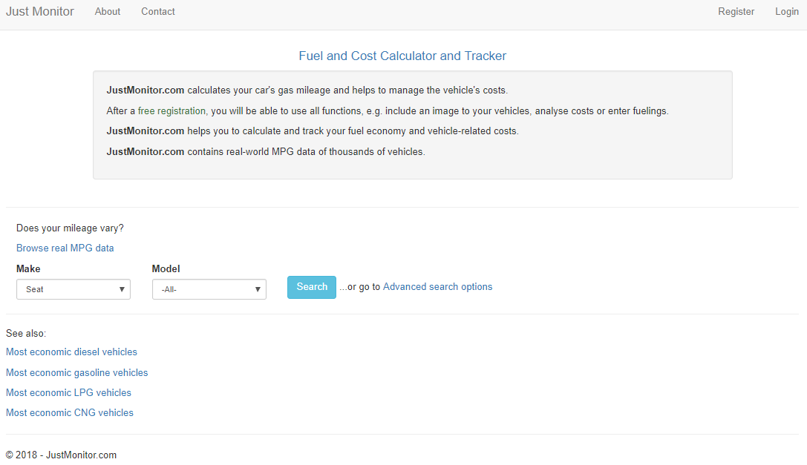

* + 1. **Register/Login pages.** Both pages need to be very simple and provide basic functionalities.
* Register page must have button for registration, which to be active after user adds some information in all 4 necessary fields:

1. 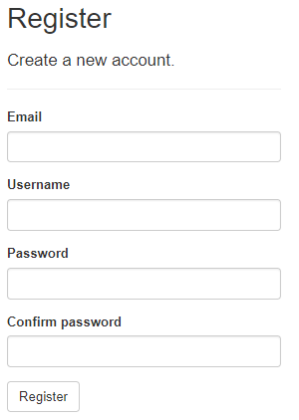Email
2. Username
3. Password
4. Confirm password

* **Login page** should have basic functionality for Login by providing user name and password. We need to integrate our site with Facebook and Google APIs, so we can provide possibility for our users to log in with their Facebook or Google account. There should be buttons, which redirect to right platform to login in it.

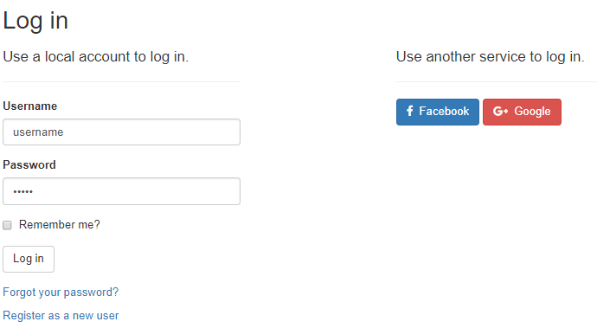

* + 1. **Search page** should provide a lot of criteria for filtering brands and models of cars. All filters should be placed on the left part of the page and on the right the right part have to be shown all results of filtering. Most of search criteria should be displayed only for registered users.
    - Make
    - Model
    - Exact Model Name – registered user only
    - Vehicle Type – registered user only
    - Gearing Type – registered user only
    - Fuel Type – registered user only
    - Year from – registered user only
    - Year to – registered user only
    - Power from – registered user only
    - Power to – registered user only
    - Minimum Kilometers – registered user only

Each time when Search button is clicked, on the right side must be shown all models that have these properties. All results should have 5 different properties:

* + - Image
    - Vehicle – link navigates to Vehicle Page
    - Consumption
    - Owner – link navigates to Owner page
    - Actions – link navigates to Details page

Search section will be peggable, so if there are many results on the bottom of the page should be displayed buttons for First page, Prev. page, Number of page, Next page, Last page. This section should be displayed only if there are:

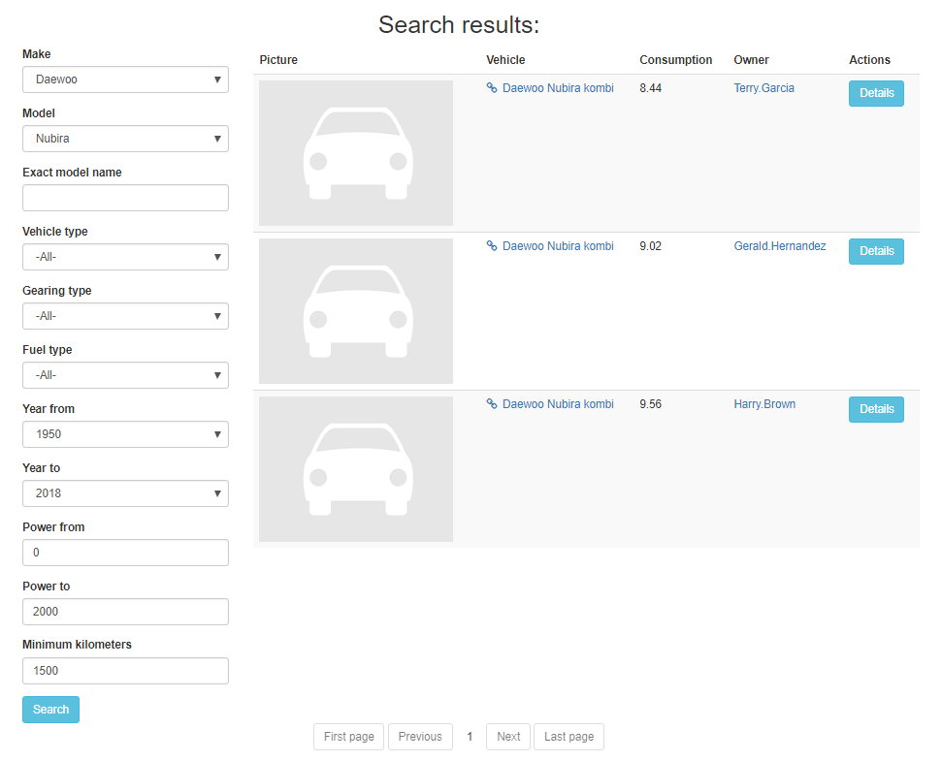

* + 1. **Details page.** The first section on the Details page contains 3 diagrams, which are visual of representation of data for the car. First one is Route profile, where users can check types where car is driven. Second chart shows Distribution of vehicle cost. Here the user can easily check how are separated money for maintenance. Last chart should be Consumption histogram, which is specially generated for each car.

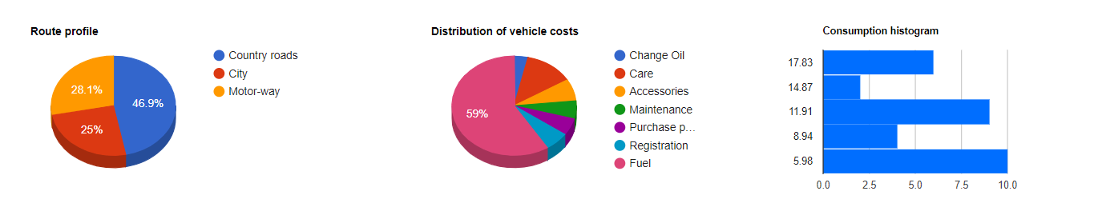

Below we have to see section with statistics:

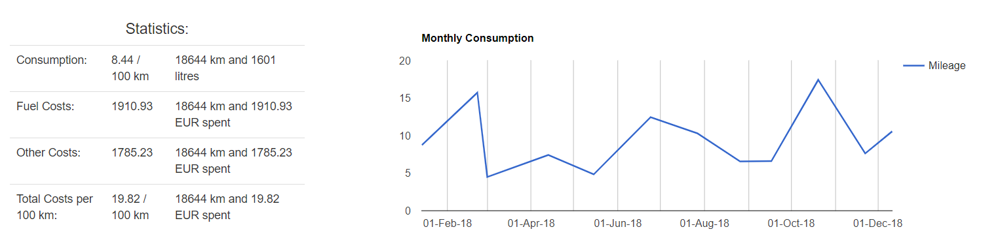

For the registered user there is one more section, where the current user can see all Entries of his colleague with his car. Each entry has 9 properties:

* + - Date
    - Odometer
    - Trip Odometer
    - Quantity
    - Fuel
    - Price (USD)
    - Average
    - Type
    - Options
    1. **Top cars page** should have section with all top 30 ordered car models by their stats. Below this section, user can find a link, which downloads excel file with all top 30 ordered car models.
    2. **Vehicle page** should display manufacturer information for each car. It needs to have some properties:
* Exact model name
* Fuel type
* Year of manufacture
* Horse power
* Gearing type
* Official fuels consumption

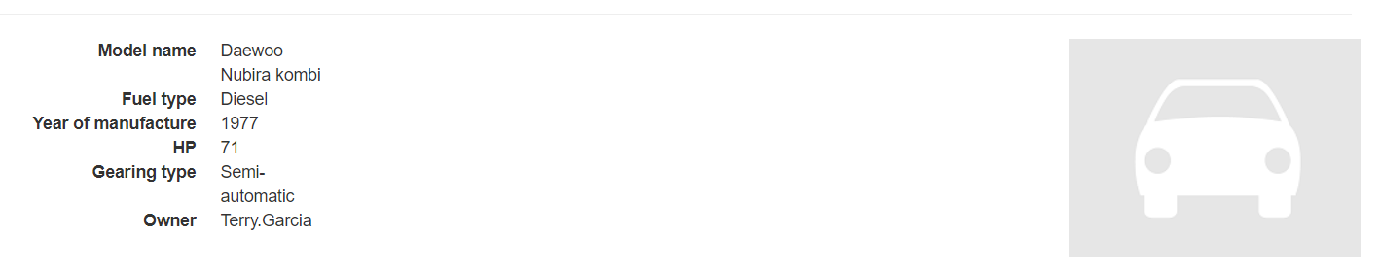

* + 1. **Owner page** is shown only for registered users and shows all cars own by selected user.

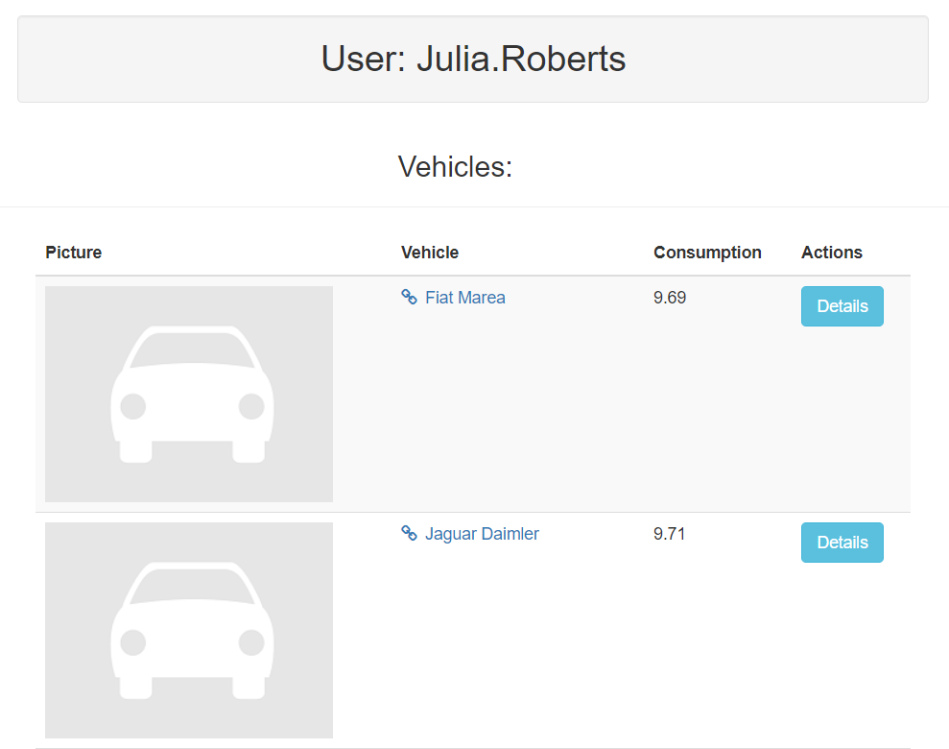

* 1. Functional requirement specification

* + 1. Use Case 1 (Accessing the system)

The system is accessed through the internet from its initial URL. It loads header, navigation bar and a home page.

* + 1. Use Case 2 (Navigation bar)

The navigation bar has navigational hyperlinks to the Register and Login pages. When the user is successfully logged in, this link has to change to {username} page (My Account page).

* + - 1. Navigation bar - Login with username

When the user fills a valid username and password, he/she should be logged in the system. After successful logging in, the user has to be redirected to Home page.

* + - 1. Navigation bar - Login with third-party API

When user clicks on third-party icons (Facebook and Google), new windows need to pop-up, where connection with third-party API is confirmed.

* + - 1. Navigation bar - Register

When the visitor is unregistered, this hyperlink navigates to the Register page. After filling the right data in every field, user should be informed that he/she receives mail in his/her mailbox for confirmation of registration. This link has to navigate to Home page, where the user is automatically logged in for the first time.

* + - 1. Navigation bar - About

When the user clicks on “About” link, a new page should be loaded, where the user can see basic description of project

* + 1. Use Case 3 (Home page)

User can do some actions on Home page. He can do a simple search by providing brand and model of the car. After clicking "Search" button, user should be redirected to Search page.  
If user is logged in, he can see links for top 30 for some categories of cars.

* + 1. Use Case 4 (Search page)

On this page, user can see results of his search on the right side. On the left, user can see all criteria for searching in Just Monitor. User can change his/her search at any time by setting new values in any or all criteria from the left bar. There will be 11 criteria:

* + - 1. **Make** criteria should contain all of brands that we will support in Just Monitor
      2. **Model** criteria should show all models for a selected brand
      3. **Exact Model Name** will be input field, where user can fill text and look for concrete model, if he/she knows the exact model name
      4. **Vehicle type -** dropdown with all supported types of vehicle
* Car
* Motors
* Bus
* Truck
* Other
  + - 1. **Gearing Type** **-** dropdown with all supported gearing types for vehicles
* Automatic
* Manual
* Continuously variable
* Direct shift gearbox
* Semi-automatic
  + - 1. **Fuel type** **-** dropdown with all supported fuel types for vehicles
* CNG
* Diesel
* Electricity
* LPG
  + - 1. **Year from / Year to** **-** dropdown with all years after 1950
      2. **Power from / Power to** - field boxes for only positive values of vehicles horse power
      3. **Minimum Kilometers -** fieldbox for only positive numbers, which represent current vehicle driven distance
    1. Use Case 5 (Details page)

Only registered users can access this page.

First section should contain details for the car (Model name, Fuel type, Year of manufacture, Horse Power, Gearing type, Owner) and a picture of the car.

Second section is a chart section, where the user can find Route profile and Consumption histogram.

Third section is statistics, where we can find information about (Consumption, Fuel Costs, Other Costs, Total Costs per 100 km). Also the user has to see Monthly Consumption for a selected year. This Monthly Consumption will be visualizing in form of chart. On top of chart, user can select one of all possible years, for which our system has statistics.

Forth section has to have entries for each vehicle in our system. Here user can find info for every single time when current car is driven. Every car can have **many** entries, so this section needs to be peggable and needs to show only 20 entries by page. On the bottom of the section we can find current loaded page and buttons for first page, previous page, next page, last page. This section is shown only for registered users.

* + 1. Use Case 6 (Top cars page)

Reached only by registered user, which clicks on Home page links. On this page, user can see top cars in a selected category. There will be 4 ranking:

* Most economic diesel vehicles
* Most economic gasoline vehicles
* Most economic LPG vehicles
* Most economic CNG vehicles
  + 1. Use case 7 (Vehicle page)

User can reach this page from some different places. On the Search page should have a link, which navigates to a Vehicle page. On “Details” page also should have a link, which navigates to this page. And the last one - the Owner page should have a link for every car, owned by user.

* + 1. Use case 8 (Owner page)

The Owner page can be accessed only by a registered user. User can check all cars, owned by current user and, of course, he/she can check details for each car there.