- SOA to OIC

Sizing with BeeBa
12.2.1.4
SOA/OSB
---- DB Adapter, SOA, REST, FTP File
OSB
REST/SOAP/SFTP/Outlook/SMTP-Notifications

--- SOA OSB Internal/External

Straightforward
OSB -> Microsoft Dynamics CRM – o Data/Rest

SOA -> APEX/DB – REST API
EBS -> Fusion

- Pulling the data from multiple tables
Postgres Adapter
900 – integrations

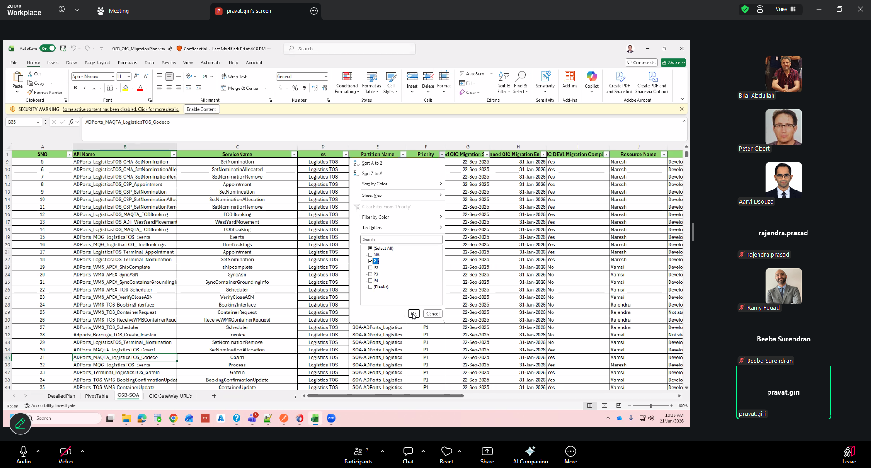

P1

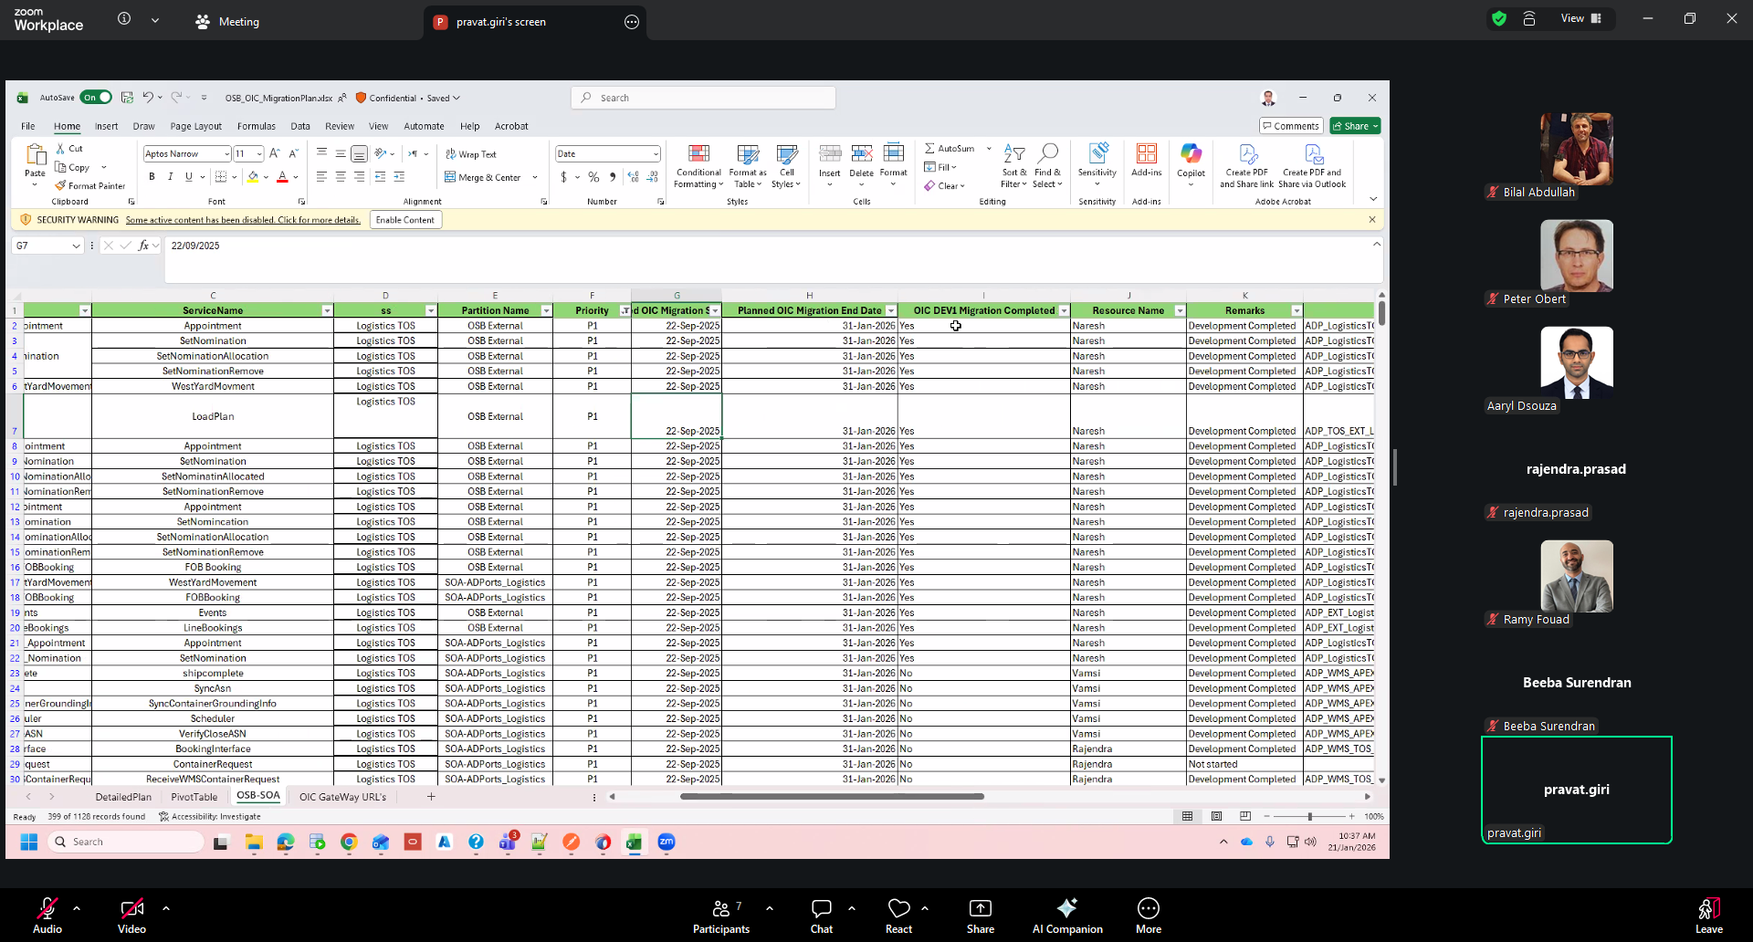

60 – P1 remaining integrations

