Abstract

Introduction

Autism
Autism, or autistic spectrum disorder is considered a syndrome, meaning that symptoms can vary from mild to severe and the child does not need to have all the associated signs that defines autism [JJ, KK]. There are two standard ways to diagnose autism, DSM-IV is mostly used in the United States and ICD-10 is mostly used in Europe [KK]. Even though sensory processing deficits are no longer a criteria in either of the two diagnostic tools, many authors and researchers discuss the unusual responses to sensory stimuli that some children with autism exhibit [DD, JJ, LL m.fl]. The most commonly observed aspect of sensory processing in autistic children is their difficulty to register meaningful sensory input [JJ]. For example one child may react defensively to touch and shows it by disliking tooth brushing, hair washing and combing. Another child may not notice light touch at all, which can trigger the child to seek that stimuli and try to touch everything around him.
Evaluating a child with autism can be very difficult [U & Cook 1991] due to its distractibility and difficulties to maintain focus. A lot of practitioners and researchers consider observations in natural settings and informal interviews gives a better picture of these children than standardized testing does. But still, to be able to meet today’s changing requirements of practice, the need of valid and reliable assessment instruments is growing [H]. Occupational therapists do not have a specific assessment tools for children with autism, but in America they do have both standardized and nonstandardized instruments for evaluating sensory integrative dysfunction [U]. An American study [V] of current practice for children with autism shows that 87% of the occupational therapists that work with autistic children use some form of Sensory history questionnaire frequently or always as part of their evaluation of the autistic child.

Sensory history questionnaires
Sensory history questionnaires are clinical assessment tools that are traditionally used in American occupational therapy to assess children with known or suspected sensory integration problems [L]. They are used as screening tools and can provide information about a child’s sensory processing skills [H, N, U].
The questionnaires play an important role in assisting the therapist to gather valuable information about how a child responds to sensory information in the home or other natural environment. There are several different questionnaires developed to meet specific areas in sensory processing or different ages, but unfortunately many of them are informally devised with no knowledge of validity or reliability [AA]. Though there are exceptions: probably the most known and similar to the ESP in content as well as intended population is the Sensory Profile [T]. The Sensory Profile consists of 125 items which are also categorized according to sensory system, but also emotional and fine motor behavior is included [AA, W].

Evaluation of Sensory Processing (ESP)
The term "sensory processing" in the name of the instrument refers to the brain's handling of sensory information for the purpose of engagement in occupations. This is synonymous with what Ayres (1979) called "sensory integration": the brain's coordination of various forms of sensory information in order to participate in daily life activities [L].
LaCroix [L] initiated the development of the ESP, the instrument translated in the present study.
ESP's advantages before other existing SHQ(??)
According to Werner & Campbell (1970) and Brislin's [Q] suggested rules, ESP is well suited for translation. (??)

Purpose
- The purpose of this study is to generate a valid translation the Evaluation of Sensory Processing (ESP) into Swedish. Specifically the goals are to translate the assessment tool and to revalidate the Swedish version by comparing a group of autistic children in Sweden with a group of autistic children in the States, using the ESP.
- The purpose is also to describe the sensory processing in children with autistic spectrum disorder with the help of this questionnaire.
This study is part of a long-term project at University of Southern California involving development of the ESP.

Method
The translation followed an established forward-backward translation procedure [Q].
Two occupational therapists with Sensory integration training (E.O & M.H.) separately translated the ESP version 3 into Swedish and then compared the two versions in order to generate the first working version 1. This version was back translated into English by one authorized translator and one bilingual person, independent of each other. One back translated version was generated and sent back to one of the developer of the original ESP: Diane Parham. She arranged for a comparison between the original version and the back translated version.
Two expert group discussion sessions were held, with two occupational therapists in each group. The authors (E.O. & M.H.) conducted both discussions.
The occupational therapists included in the group discussions have several years of working experience in pediatrics and have 10 credits or more in sensory integration theory.
The questionnaire was sent to the therapists approximately one week in advance to give them time to review it. (for discussion: therapists did not have time to review it anyway). Each question was read and difficulties and cultural differences was brought up when found. After the review the therapists came up with suggestions for cultural supplements. The group discussion took about 2,5 hours and had a low degree of standardization but were well structured(Trotz).

During the work with the translation, the original version of the ESP 3 was reduced from 185 items to 75 items and became ESP version 4. A few of the items were altered, and these items went through the back translation procedure again. After some discussion and minor alterations, an agreement with the developer of the ESP was reached, six cultural supplements were added and the Swedish version: “Utvärdering av Sensoriska Processer” (USP 1) was ready.

Pilot study 1
Five parents with normally developed children were given the USP version 1 (81 items) with instructions to look at comprehension, relevance and grammar. The children's ages were 3,5; 4; 7; 9 and 10 years old, and it was two boys and three girls. Four of the following interviews were conducted by telephone and one in person. All of the interviews took about 30 minutes and they were semi structured, the questions are enclosed in the appendix.

Pilot study 2

Participants
Twenty-five parents of children with high functioning autism or Asperger´s Disorder participated. The age of the children ranged from four to twelve years and there were twenty-two boys and three girls. One criterion for inclusion was that they did not have any developmental delays or a diagnosis of physical dysfunction like cerebral palsy , another was that at least one of the parents had Swedish as his/her first language. The families were recruited through Habiliteringen Göteborg och Södra Bohuslän and Habiliteringen Borås.
Information about the subject criteria was given to all the included occupational therapists. The OT`s then distributed the USP version 2, information letter and a stamped envelope to appropriate families.
The parents that chose to participate signed an informed consent, sent the completed questionnaire back, and where then telephoned by the researcher who obtained possible missing data.
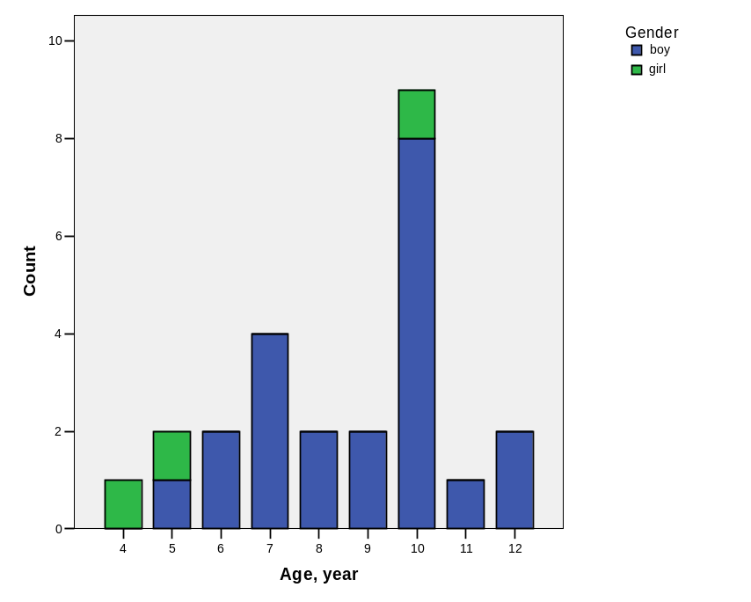

Procedure
Of 58 questionnaires distributed, 28 were returned. One was excluded because the child’s age were not within the parameters of the inclusion criteria, one because it had another diagnosis as well and one were the parents had not filled in the child’s age or phone number for a follow up. Most of the participants received a follow up phone call from the researcher to obtain missing data and to offer explanations since sensory integration is not well known in Sweden.
All the questionnaires were decoded and the responses were recoded.

Results

Group discussions with therapists
In Sweden it is very common to give a lot of different questionnaires to parents in the process of evaluating their child. Thus it is important to give them a questionnaire that is short and precise or else the parents can be reluctant to participate. The therapists felt that too many of the questions in the first working version (185 items) were repeated and would benefit by being reduced.
During the discussion it was implicated that a cultural characteristic is that the Swedish people like all kind of literature short and concise.
The therapists in group discussion 1 felt that the questionnaire lacked space for writing comments, since it is easy to misinterpret answers if there are no comments. In the second group the therapists did not share this opinion, since their experience was that parents could elaborate more than necessary.
Questions where the parent is supposed to compare the child with other children might be difficult and will be dependent upon the parent's background and experiences with other children.

The therapists general impression of the first working version was positive and they felt that the questions had a good relevance in Swedish occupational therapy. The therapists in the first group was of the opinion that it should be reduced to 50 questions to be practicable in their work. In the second group they gave a maximum of 100 questions as realistic.

The therapists in group discussion 2 are specialized in visual habilitation, and they had reflections about some of the questions in the visual system. They were questioning if item 4, 7, 8, 11 and 13 in the visual system was SI-related. In the American ESP version 4, all of these items except item 11 were excluded.

Pilot study 1
All of the five parents agreed that the general impression of the questionnaire was that it was easy to understand, just the right length and felt carefully prepared. There were some pointers they all had in common. Some of the items were perceived as yes/no questions. This resulted in a pretext where an explanation was written that if you feel like the answer is yes, you can answer always, and if you feel the answer is no, you answer never.
Other items created a problem when their child had to be compared to other children or "normality" as in item 8, vestibular system: “Does your child seem not to get dizzy when others usually do?”. This was not considered a big problem though.
Item 9, tactile system, created an ethical dilemma and since the researchers believed this was caused by the translation it was eliminated.
With the help of these interviews USP version 2 with 80 items was ready.

Pilot study 2

Methodology discussion

Translating
According to Streiner et al [A], translating an instrument can be done, but it is as time consuming as developing a new tool. Further, both similarities and differences in results must be interpreted with extreme caution. Once the translation is done, however, there is little assurance that the psycometric properies of the scale (i.e. reliability and validity) have remained constant. It is therefor necessary to revalidate the instrument, as if it were a new one[A].
One of the common and recommended procedures for verifying the translation of an instrument is backtranslation[Q]. This means that after a translation is made, another bilingual person translates the instrument back to the original language, and then a third party will examine the original language versions to see if the meaning has been lost or altered. If that is the case, that part of the instrument will go through the process again[P].
Bullinger et al. (1993) suggested that one forward and one backward translation and a pretest are the minimal requirements for translating an instrument.
This does not guarantee that the new language questionnaire is as valid as the parent instrument. The translators are likely to find questions that do not translate well. The instrument may include items from the original which are less important in the new language or lack items that are crucial in the new settings[O].
G.H. Guyatt [O] dictates a new philosophy in the translations of questionnaires where he suggests more unconventional strategies. For example he recommends the investigators to use an initial translation as the basis for focus group discussions where the items are analyzed in the context of the new culture. It is however necessary with rigorous testing of the construct validity of the new language questionnaires[O, Q, P].
Svårigheter i kulturella skillnader[A, F].

Result discussion

Conclusion

Acknowledgement

