Abstract

Table of contents
Introduction 2
Autism 2
Sensory history questionnaires 2
Evaluation of Sensory Processing (ESP) 2
Purpose 3
Method 4
Translation 4
Pilot study 1 4
Pilot study 2 4
Instrument 4
Participants 5
Procedure 5
Data Analysis 6
Results 6
Group discussions with therapists 6
Pilot study 1 6
Pilot study 2 7
Methodology discussion 7
Translation 7
Result discussion 7
Conclusion 7
Acknowledgement 7

Introduction

Autism
Autism, or autistic spectrum disorder is considered a syndrome, meaning that symptoms can vary from mild to severe and the autistic child does not need to have all the associated signs that defines autism [JJ, KK]. There are two standard tools to diagnose autism, DSM-IV is mostly used in the United States and ICD-10 is mostly used in Europe [KK]. Even though sensory processing deficits are no longer a criterion in either of the two diagnostic tools, many authors and researchers discuss the unusual responses to sensory stimuli that some children with autism exhibit [DD, JJ, LL m.fl]. The most commonly observed aspect of sensory processing in autistic children is their difficulty to register meaningful sensory input [JJ]. For example one child may react defensively to touch and shows it by disliking tooth brushing, hair washing and combing. Another child may not notice light touch at all, which can trigger the child to seek that stimuli and try to touch everything around him. The capacity to process sensory information affects how people are able to interact with their environments and thus their performance in daily activities.
Evaluating a child with autism can be very difficult [U & Cook 1991] due to its distractibility and difficulties to maintain focus. A lot of practitioners and researchers consider observations in natural settings and informal interviews can tell more about these children than standardized tests do. But still, to be able to meet today’s changing requirements of practice, the need of valid and reliable assessment instruments is growing [H]. Occupational therapists do not have specific assessment tools for children with autism, but in America they do have both standardized and non-standardized instruments for evaluating sensory integrative dysfunction [U]. An American study [V] of current practice for children with autism shows that 87% of the occupational therapists that work with autistic children use some form of sensory history questionnaire frequently or always as part of their evaluation of the autistic child.

Sensory history questionnaires
Sensory history questionnaires are clinical assessment tools that are traditionally used in American occupational therapy to assess children with known or suspected sensory integration problems [L]. They are used as screening tools and can provide information about a child’s sensory processing skills [H, N, U].
The questionnaires are important in assisting the therapist to gather valuable information about how a child responds to sensory information in the home or in other natural environments. There are several different questionnaires developed to meet specific areas in sensory processing or different ages, but unfortunately many of them are informally created, with no knowledge of validity or reliability [AA]. Though there are exceptions; probably the most known and similar to the ESP in content as well as intended population is the Sensory Profile [T]. The Sensory Profile consists of 125 items which are also categorized according to sensory system, but also emotional and fine motor behavior are included [AA, W].

Evaluation of Sensory Processing (ESP)
The ESP version 4 is a parent questionnaire consisting of 73 items for 2-5 year olds and three more items for 6-12 year olds. The answers are made in a five-point Likert-scale format ranging from never to always. It is intended to be used as an initial screening tool [N] and help the therapist to screen out those children that would benefit from sensory integration treatment.
Even though the two instruments may seem much alike, ESP differs from the Sensory Profile by its strong content validity [M]. This ensures that all the items in the ESP are specific to the sensory domain they fall under, thus helps the therapist that is using the questionnaire to know which sensory systems are most affected, and consequently offer a more appropriate and focused intervention.
The instrument has undergone rigorous development in an attempt to provide a valid and reliable tool. LaCroix [1993, M] initiated the development and started out with 679 items collected from literature, parents and therapists. After a content validity process there were 200 items chosen for the first pilot study. Following this there has been research on construct validity, qualitative evaluation, criterion validity, internal consistency, more content validity and inter-rater reliability [X]. The results of these studies have lead to further exclusion of items and finally to the ESP version 4, which, as can be read above, contains of 76 items.
Most of the research on the ESP are still unpublished, but the criterion validity study has been published [N] in the American Journal of Occupational Therapy. Although the ESP is in the early stages of development, these reports indicate that it is a valid and reliable tool [A] and hopefully following research will confirm this further. The ESP has also been translated to Japanese and Mandarin Chinese, and is currently being translated into Spanish [X].
To compute a total score on the ESP, each item (except for two items, as noted below) is scored as follows: a parent rating of always is given a score of 1, often is given a 2, sometimes is given a 3, rarely is given a 4, and never is given a 5.
The two items that are scored differently are items 3 and 5 under the Vestibular System. These items are: Does your child have good balance? (item 3) and Does your child like fast spinning carnival rides, such as merry-go-rounds? (item 5). These two items are scored in reverse order because ratings of never are strongly associated with sensory processing problems. For these two items, a parent rating of Always is scored as 5, Often is scored as 4, sometimes is 3, rarely is 2, and never is 1.
All the items, except for the last three visual items (Visual: 11, 12, and 13), are to be added up for the total score. For the 73 items, a total score that falls below the cut point score of 277 indicates that a sensory processing difficulty is likely to be present.
The cut point was determined through a secondary analysis of data from two studies that utilized the ESP: Chang (1999) and VerMaas-Lee (1999).

Purpose
- The purpose of this study is to generate a valid translation of the Evaluation of Sensory Processing (ESP) into Swedish. Specifically the goals are to translate the assessment tool and to revalidate the Swedish version by comparing a group of autistic children in Sweden with a group of autistic children in the States, using the ESP.
- The purpose is also to describe the sensory processing in children with autistic spectrum disorder with the help of this questionnaire.
This study is part of a long-term project at University of Southern California involving the development of the ESP.

Method
This study was approved by the Ethical Committee.

Translation
The translation followed an established forward-backward translation procedure [Q].
Two occupational therapists with Sensory integration training (E.O & M.H.) separately translated the ESP version 3 into Swedish and then compared the two versions in order to generate the first working version 1. This version was back translated into English by one authorized translator and one bilingual person, independent of each other. One back translated version was generated and sent back to one of the developer of the original ESP: Diane Parham. She arranged for a comparison between the original version and the back translated version.
Two expert group discussion sessions were held, with two occupational therapists in each group. The authors (E.O. & M.H.) conducted both discussions.
The occupational therapists included in the group discussions have several years of working experience in pediatrics and have 10 university credits or more in sensory integration theory.
The questionnaire was sent to the therapists approximately one week in advance to give them time to review it. Each question was read and difficulties and cultural differences were brought up when found. After the review the therapists came up with suggestions for cultural supplements. The group discussion took about 2½ hours and had a low degree of standardization but were well structured(Trotz).
During the work with the translation, the original version of the ESP 3 was reduced from 185 items to 76 items and became ESP version 4. A few of the items were altered, and these items went through the back translation procedure again. After some discussion and minor alterations, an agreement with the developer of the ESP was reached, six cultural supplements were added and the Swedish version: Utvärdering av Sensoriska Processer (USP 1) was ready.

Pilot study 1
Five parents with normally developed children were given the USP version 1 (80 items) with instructions to look at comprehension, relevance and grammar. The children's ages were 3½; 4; 7; 9 and 10 years old, and it was two boys and three girls. Four of the following interviews were conducted by telephone and one in person. All of the interviews took about 30 minutes and they were semi structured, the questions are enclosed in the appendix.

Pilot study 2

Instrument
The sensory history questionnaire utilized was the USP (Utvärdering av Sensoriska Processer) version 2 (see appendix). It contains 79 items, grouped into six sensory systems: 10 items in Auditory, 5 items in Gustatory/Olfactory, 13 items in Proprioception, 22 items in Tactile, 16 items in Vestibulary and 13 items in the Visual system. The answer alternatives are always, often, sometimes, rarely and never.

Participants
In the Swedish group, twenty-five parents of children with high functioning autism or Asperger´s Disorder participated. The age of the children ranged from four to twelve years with a mean of 8.52, and there were twenty-two boys and three girls (see Table 1). One criterion for inclusion was that they did not have any developmental delays or a diagnosis of physical dysfunction like cerebral palsy , another was that at least one of the parents had Swedish as his/her first language. The families were recruited through Habiliteringen Göteborg och Södra Bohuslän and Habiliteringen Borås.
Information about the subject criteria was given to all the included occupational therapists. The OT’s then distributed the questionnaires, information letters and stamped envelopes to appropriate families.
The parents that chose to participate signed an informed consent, sent the completed questionnaire back, and were then telephoned by the researcher who obtained possible missing data.

Age, year * Gender Crosstabulation

Count
 |  | Gender |  | Total
 |  | boy | girl | Total
Age, year | 4 | 0 | 1 | 1
Age, year | 5 | 1 | 1 | 2
Age, year | 6 | 2 | 0 | 2
Age, year | 7 | 4 | 0 | 4
Age, year | 8 | 2 | 0 | 2
Age, year | 9 | 2 | 0 | 2
Age, year | 10 | 8 | 1 | 9
Age, year | 11 | 1 | 0 | 1
Age, year | 12 | 2 | 0 | 2
Total |  | 22 | 3 | 25

Table 1 Age and gender distribution of participating children.

A group of American children where imported from another study by Vermaas [W]. This group included 41 autistic children with various degrees of developmental delays and Aspergers disorder, the ages ranged from 2.17 to 11.08 with a mean of 4.58, and the group contained of 34 boys and 7 girls.

Procedure
Of 58 questionnaires distributed, 28 were returned. One was excluded because the child’s age were not within the parameters of the inclusion criteria, one because it had another diagnosis as well and one where the parents had not filled in the child’s age or phone number for a follow up. Most of the participants received a follow up phone call from the researcher to obtain missing data and to offer explanations since sensory integration is not well known in Sweden.
All the questionnaires were decoded and the responses were recoded.
In the American study, the ESP version 3 was used, therefore, only the items that matched the ESP version 4 was collected and compared with the Swedish data.

Data Analysis
The responses of the parents in the Swedish group of autistic children where compared with the American group by using… to determine if the two groups responded similarly to the Swedish versus the American questionnaire items.

Results

Group discussions with therapists
In Sweden it is very common to give a lot of different questionnaires to parents in the process of evaluating their child. Thus it is important to give them a questionnaire that is short and precise or else the parents can be reluctant to participate. The therapists felt that too many of the questions in the first working version (185 items) were repeated and would benefit by being reduced.
During the discussion it was implicated that a cultural characteristic is that the Swedish people like all kind of literature short and concise.
The therapists in group discussion 1 felt that the questionnaire lacked space for writing comments, since it is easy to misinterpret answers if there are no comments. In the second group the therapists did not share this opinion, since their experience was that parents could elaborate more than necessary.
Questions where the parent is supposed to compare the child with other children might be difficult and will be dependent upon the parent's background and experiences with other children.
The therapist’s general impression of the first working version was positive and they felt that the questions had a good relevance in Swedish occupational therapy. The therapists in the first group was of the opinion that it should be reduced to 50 questions to be practicable in their work. In the second group they gave a maximum of 100 questions as realistic.
The therapists in group discussion 2 are specialized in visual habilitation, and they had reflections about some of the questions in the visual system. They were questioning if item 4, 7, 8, 11 and 13 in the visual system was SI-related. In the American ESP version 4, all of these items except item 11 were excluded.

Pilot study 1
All of the five parents agreed that the general impression of the questionnaire was that it was easy to understand, just the right length and felt carefully prepared. There were some pointers they all had in common. Some of the items were perceived as yes/no questions. This resulted in a pretext where an explanation was written that if you feel like the answer is yes, you can answer always, and if you feel the answer is no, you answer never.
Other items created a problem when their child had to be compared to other children or "normality" as in item 8, vestibular system: Does your child seem not to get dizzy when others usually do? This was not considered a big problem though.
Item 9, tactile system, created an ethical dilemma and since the researchers believed this was caused by the translation it was eliminated.

Pilot study 2
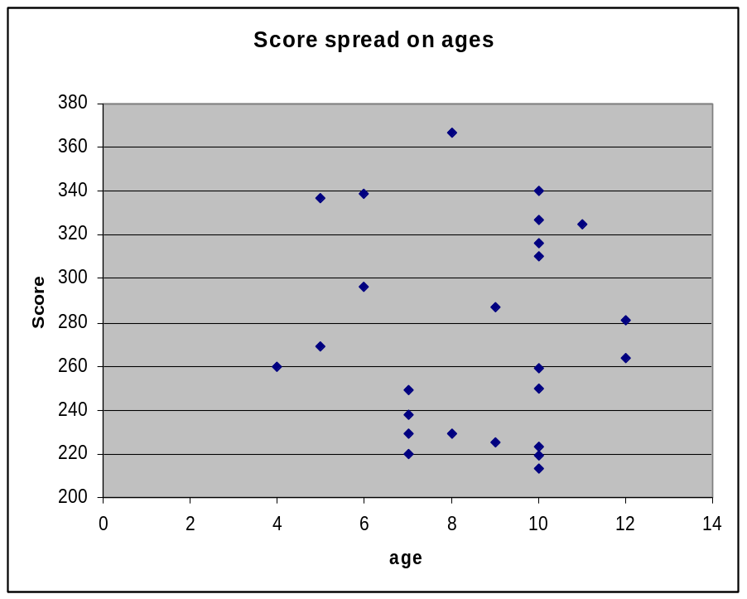

Methodology discussion

Translation
According to Streiner et al [A], translating an instrument can be done, but it is as time consuming as developing a new tool. Further, both similarities and differences in results must be interpreted with extreme caution, and once the translation is done, there is still little assurance that the reliability and validity have remained constant. It is therefore necessary to revalidate the instrument, as if it were a new one [A].
In this study, the back-translation procedure was used since it is one of the most common and recommended procedures for verifying the translation of an instrument [Q]. This means that after a translation is made, another bilingual person translates the instrument back to the original language, and then a third party will examine the original language versions to see if the meaning has been lost or altered. If that is the case, that part of the instrument will go through the process again [P]. In this case, the third party was people involved in the development of the original instrument, which I believe would validate the translation even further, since they are well suited to determine if the meaning of the questions had been altered.
The review by the group of occupational therapists would have been more beneficial if it had been the fourth version they reviewed, as it was now, much time was spent on items that later was taken from the ESP anyway.
As Guyatt [O] points out, the translators are likely to find questions that do not translate well, which also was true in this particular case, though all but one of those items were excluded in the ESP version 4, partly due to translation problems in another study [I]. The one item left were excluded after pointers from several of the five parents that were interviewed as a first pilot study.
Guyatt also mentions that a translated instrument may include items from the original which are less important in the new language or lack items that are crucial in the new settings [O]. Since the ESP was developed in Southern California, there were no aspects of sensory reactions to winter clothing or activities in the snow. Together with the expert group of occupational therapists four new items were developed for that purpose.

Result discussion

Conclusion

Acknowledgement

