Translation and validation of the Evaluation of Sensory Processing, a Sensory History Questionnaire
Abstract
Introduction: Many clinicians and researchers discuss the unusual responses to sensory stimuli that many children with autism or Asperger’s syndrome (AS) exhibit. The most commonly observed aspect of sensory processing in children with autism is their difficulty to register meaningful sensory input in an appropriate way. One way to evaluate these problems in a child with autism or AS is to use sensory history questionnaires. Evaluation of Sensory Processing (ESP) is an American questionnaire still in the process of development but the studies already made, shows promising psychometric properties.
Purpose: The purpose of the study was to generate a valid Swedish translation of the ESP. Specifically the goals were 1) to translate the assessment tool 2) to revalidate the Swedish version by comparing parent ratings from two groups of children with autism/AS one from USA and one group from Sweden 3) to describe the sensory processing in a group of Swedish children with high-functioning autism and AS.
Method: 1) A forward-backward translation procedure has been used, and both an expert and a non-expert panel reviewed the Swedish version of the ESP to establish face validity. 2) Parent ratings from a group of 25 Swedish children with autism or AS was collected with the Swedish version of the ESP and compared with the parent ratings from 41 children with the same diagnosis, taken from an American study of the original ESP. When comparing parent ratings from the Swedish and the American groups of children, Pearson’s chi-square test was conducted. The median of every item was calculated for each group and compared. 3) The median of every item was calculated for the Swedish group as well as the total score for each child.
Result: 1) With the addition of four culturally developed items and the exclusion of one item that did not translate well, the Swedish version of the ESP: Utvärdering av Sensoriska Processer (USP) was developed and face validity was established. 2) Pearson’s chi-square test demonstrates that 14 of the compared 75 items showed a significant difference and several of these may be explained by the heterogeneity of the two groups of children. The answers on 81% of the items has equivalence in the two groups and though the small sample of the Swedish group prevent general conclusions to be drawn, the results of this study is still promising. 3) According to the USP, 60% of the children in the Swedish group showed signs of sensory integration dysfunction.

Keywords: sensory integration, Autism, Aspergers Syndrome, back translation
Abstrakt
Introduktion: Många forskare och kliniker diskuterar de ovanliga reaktioner på sensoriska stimuli som många barn med autism och Aspergers syndrom (AS) visar. Den vanligast observerade problem inom sensorisk integration hos barn med autism, är svårigheten att på ett ändamålsenligt sätt registrera meningsfulla sensoriska intryck. Ett sätt att bedöma dessa svårigheter hos barn med autism eller AS är att använda sig av frågeformulär med inriktning på barnets sensoriska bakgrund. Evaluation of Sensory Processing (ESP) är ett amerikanskt frågeformulär som fortfarande är under utveckling men där de studier som redan gjorts visar lovande resultat vad gäller reliabilitet och validitet.
Syfte: Syftet med studien var att åstadkomma en valid svensk översättning av ESP. Specifikt var målet att 1) översätta formuläret till svenska 2) validitetstesta den svenska översättningen genom att jämföra föräldrarsvar från två grupper av barn med autism/AS, en från USA och en från Sverige samt 3) beskriva en grupp av svenska barn med högfungerande autism och AS.
Metod: 1) En Backtranslation-procedur användes vid översättningen och både en expertgrupp och en icke-expertgrupp granskade översättningen för att kunna fastställa face validity. 2) Föräldrarsvar från en grupp på 25 svenska barn med autism/AS samlades med hjälp av den svenska översättningen in och jämfördes med föräldrarsvaren från 41 barn med samma diagnos, lånade från en amerikansk studie kring ESP. Pearsons chi-två test användes på varje item, för att jämföra de två gruppernas svar. Medianen för varje item räknades också ut för båda grupperna och jämfördes. 3) Medianen för varje item i formuläret räknades ut för den svenska gruppen, samt varje barns totala poäng.
Resultat: 1) Med ett tillägg av fyra kulturellt anpassade frågor och uteslutande av en fråga som inte kunde översättas på ett tillfredsställande sätt, utarbetades en svensk översättning av ESP: Utvärdering av Sensoriska Processer (USP) och face validitet kunde fastställas. 2) Pearsons chi-två test klarlägger att 14 av de 75 jämförda frågorna visade en signifikant skillnad i proportionerna och flera av dessa skillnader kan förklaras med olikheter i de jämförda grupperna. Svaren på 81% av frågorna i formuläret påvisar en överensstämmelse i de båda grupperna vilket är ett lovande resultat som, trots det lilla urvalet i den svenska gruppen, uppmanar till vidare studier och utveckling av USP. 3) Enligt USP visar 60% av barnen i den svenska gruppen upp tecken på svårigheter inom sensorisk integration.

Sökord: Sensory integration, autism, Aspergers syndrom, back translation
Table of contents
Introduction 3
Autism 3
Sensory history questionnaires 3
Evaluation of Sensory Processing (ESP) 4
To compute a total score 4
Purpose 5
Method 5
Translation process 5
Comparison between two groups – a pilot study 7
Instrument 7
Participants 7
Procedure 8
Data Analysis 8
Describing the group of Swedish children with autism 8
Ethical considerations 8
Results 8
Translation process 8
Face validity 9
Comparison between two groups 11
Describing the Swedish group of children with autism 17
Methodology discussion 19
Translation process 19
Comparison between two groups 20
Describing the Swedish group of children with autism 20
Result discussion 20
Comparison between two groups 20
Describing the Swedish group of children with autism 22
Clinical relevance 23
Limitations 23
Conclusion 23
Acknowledgement 24
References 25
Böcker 25
Artiklar 26

Introduction

Autism
Autism, or autistic spectrum disorder is considered a syndrome, meaning that symptoms can vary from mild to severe and the autistic child does not need to have all the associated signs that defines autism [JJ, KK]. Some of the most common signs seen in these children are poor social skills, poor verbal and/or non-verbal communication, repetitive and stereotyped behaviors and inflexibility [PP, RR]. Children belonging to the group of so-called high-functioning autism are the ones with normal or just below normal intelligence. Aspergers Syndrome (AS) is often considered a milder form of autism, and it is characterized by the same deviant behaviors. The most important difference is that children with AS does not show any significant delays in early language skills. This does not exclude the possibility, even probability, that these children have difficulties with non-verbal communication [PP, RR].
There are two standard tools to diagnose autism and AS, DSM-IV (Diagnostic and statistical manual of mental disorders) [RR] is mostly used in the United States and ICD-10 (International statistical classification of diseases and related health problems) [PP] is mostly used in Europe. Even though sensory processing deficits are no longer a criterion in either of the two diagnostic tools, most authors and researchers acknowledges the unusual responses to sensory stimuli that many children with autism exhibit [DD, JJ, LL, QQ]. The most commonly observed aspect of sensory processing in autistic children is their difficulty to register meaningful sensory input (sensory modulation) [JJ]. For example one child may react defensively to touch and shows it by disliking tooth brushing, hair washing and combing. Another child may not notice light touch at all, which can trigger the child to seek that stimuli and try to touch everything around him. The capacity to process sensory information affects how people are able to interact with their environments and thus their performance in daily activities such as grooming, education and play. If the occupational therapist can influence the child’s ability to process sensory information, maybe he/she can influence the child’s performance in daily activities [AA, BB, DD, W].
To be able to make the most of intervention, the therapist must, among other things, have a plan for what areas need to be addressed [MM], but evaluating a child with autism can be very difficult due to its distractibility and difficulties to maintain focus [U]. Many practitioners and researchers consider observations in natural settings and informal interviews tell more about these children than standardized tests do. But still, to be able to meet today’s changing requirements of practice the need of valid and reliable assessment instruments is growing [H]. Occupational therapists do not have specific assessment tools for children with autism, but in North America they do have both standardized and non-standardized instruments for evaluating sensory integrative dysfunction [U]. An American study [V] of current practice for children with autism shows that 87% of the occupational therapists that work with autistic children use some form of sensory history questionnaire frequently or always as part of their evaluation of the autistic child.

Sensory history questionnaires
Sensory history questionnaires are clinical assessment tools, most commonly parent rated, that are traditionally used in North American occupational therapy to assess children with known or suspected sensory integration problems [L]. They are used as initial screening tools and can provide information about a child’s sensory processing skills and deficits [H, N, U].
The questionnaires are considered important in assisting the therapist to gather valuable information about how a child responds to sensory information in the home or in other natural environments [AA, GG]. There are several different questionnaires developed to meet specific areas in sensory processing or different ages, but unfortunately many of them are informally created, with no knowledge of validity or reliability [AA]. Though there are some exceptions; The Sensory Profile consists of 125 items which are categorized according to sensory system, but also emotional and fine motor behavior are included [AA, W] and the Touch Inventory for Elementary School-aged Children (TIE) contains 26 questions referring to sensory defensiveness [AA, BX]. The Evaluation of Sensory Processing (ESP) is still in the early stages of development, but is according to the first studies showing psychometric promise.

Evaluation of Sensory Processing (ESP)
The ESP version 4 is a self administered parent questionnaire consisting of 76 items. Seventy-three of them are for 2-5 year olds and all the items for 6-12 year olds. The answers are made in a five-point Likert-scale format ranging from never to always. It is intended to be used as an initial screening tool and help the therapist to screen out those children in need of further evaluation within the sensory integration area [N].
Even though the ESP may seem much alike the Sensory Profile, ESP differs from the Sensory Profile by its strong content validity [M]. This ensures that all the items in the ESP are specific to the sensory domain they fall under, thus helps the therapist that is using the questionnaire to know which sensory systems are most affected, and consequently offer a more appropriate and focused intervention.
The instrument has undergone rigorous psychometric testing in an attempt to provide a valid and reliable tool. LaCroix [B, M] initiated the development in 1993 and started out with 679 items collected from literature, parents and therapists (figure 1). After a content validity process there were 200 items chosen for the first working version 1 and a pilot study. Following this there has been research on construct validity, qualitative evaluation, criterion validity, internal consistency, more content validity and inter-rater reliability [X]. The results of these studies have lead to further exclusion of items and finally to the ESP version 4, which, as can be read above, containing 76 items.
Most of the research on the ESP are still unpublished, but the criterion validity study has been published [N] in the American Journal of Occupational Therapy. Although the ESP is in the early stages of development, these reports indicate that it is a valid and reliable tool [A] and hopefully following research will confirm this further. The ESP has also been translated to Japanese and Mandarin Chinese, and is currently being translated into Spanish [X].

To compute a total score
According to the manual, [SS] each item (except for two items, as noted below) is scored as follows: a parent rating of always is given a score of 1, often is given a 2, sometimes a 3, rarely a 4, and never a 5. The two items that are scored differently are Vestibular items 3 and 5:
Does your child have good balance?
Does your child like fast spinning carnival rides, such as merry-go-rounds?
These two items are scored in reverse order because ratings of never are strongly associated with sensory processing problems. For these two items, a parent rating of Always is scored as 5, often is scored as 4, sometimes is 3, rarely is 2, and never is 1.
All the items, except for the last three visual items (Visual: 11, 12, and 13), are to be added up for the total score. For the 73 items, a total score that falls below the cut point score of 277 indicates that a sensory processing difficulty is likely to be present and further evaluation is recommended. The maximum total score obtainable is 365.

Purpose
The purpose of this study was to generate a valid translation of the Evaluation of Sensory Processing (ESP) into Swedish. Specifically the goals were to:
- translate the assessment tool.
- revalidate the Swedish version by comparing parent ratings from a group of autistic children in Sweden with a group of autistic children in the USA, using the ESP. The hypothesis in the pilot study is that there is no significant difference in the proportions of the items in the Swedish versus the American questionnaire.
- describe the sensory processing in Swedish children with high-functioning autism and Asperger’s Syndrome with the help of this questionnaire.
This study is part of a long-term project at University of Southern California involving the development of the ESP.

Method

Translation process
The translation followed an established forward-backward translation procedure [Q] (figure 1). Two occupational therapists with Sensory integration training, one being the author of this study, separately translated the ESP version 3 into Swedish and then compared the two versions in order to generate the first working version 1. This version was back translated into English by one authorized translator and one bilingual person, independent of each other. One back translated version was generated and sent back to one of the developer of the original ESP: Diane Parham. She arranged for a comparison between the original version and the back translated version.
As a second part of the translation process, face validity should be established [OO, Z]. Two expert group discussion sessions were held, with two occupational therapists in each group. The translators conducted both discussions. The occupational therapists included in the group discussions have several years of working experience in pediatrics and have 10 university credits or more in sensory integration theory.
The questionnaire was sent to the therapists approximately one week in advance to give them time to review it. Each item was read and sensory integration aspects, difficulties and cultural differences were brought up when found. After the review the therapists came up with suggestions for cultural supplements. The group discussions took about 2½ hours each, and had a low degree of standardization but were well structured.
During the work with the translation, the original version of the ESP 3 was reduced from 185 items to 76 items and became ESP version 4. The USP and the new source language version were revised without altering any items and sent back to America for reviewing. After some discussion and minor alterations, an agreement with the developer of the ESP was reached, four cultural supplements were added, with suggestions from the expert panel, and the Swedish version: Utvärdering av Sensoriska Processer (USP version 1) was ready.
Five parents with normally developed children were given the USP version 1 (figure 1) with instructions to look at comprehension, relevance, grammar and ethics. The children's ages were 3½; 4; 7; 9 and 10 years old, and it was two boys and three girls. Four of the following interviews were conducted by telephone and one in person. The interviews took about 30 minutes and they were semi structured (see appendix 1). This resulted in USP version 2, with 79 items.
5a) ESP version 4
76 items

4b) USP workversion
185 items
4a) ESP version 3
185 items
5b) USP version 1
80 items
Face validity
Non-expert
Swedish group
Translation
and back-translation
face validity
Swedish expertpanel
6) USP version 2
79 items
Backtranslation of 10 items
& addition of four cultural items

Interviews with parents to children with SI dysfunctions
3) ESP version 2
192 items
2) ESP version 1
200 items
Comparative study
Comparative studies
1) ESP 679 items
Content validity analyze with 21 experts
Figure 1: The flowchart show the development of the ESP and the translation process of the USP. The earliest version of ESP was created in 1993 by LaCroix.

Comparison between two groups – a pilot study
To evaluate if the ESP (Evaluation of Sensory Processing) and the USP (Utvärdering av Sensoriska Processer) has psychometric equivalence [S], parent ratings on the ESP from a group of American children were compared with parent ratings on the USP from a group of Swedish children, both groups containing children diagnosed with autism or AS.

Instrument
The sensory history questionnaire utilized was the USP version 2 (see appendix 2). It contains 79 items, grouped into six sensory systems: 10 items in Auditory, 5 items in Gustatory/Olfactory, 13 items in Proprioception, 22 items in Tactile, 16 items in Vestibular and 13 items in the Visual system. The answer alternatives are always, often, sometimes, rarely and never. Four of the items were created specifically for the Swedish questionnaire and were therefore not included in the comparison of the two groups.
The instrument used in the American study [W], was ESP (Evaluation of Sensory Processing) version 3. That questionnaire contained 185 items, grouped into the same six systems as USP although there where one more answer alternative: not applicable. This alternative was induced to the never alternative in the data analysis.

Participants
In the Swedish group, twenty-five parents of children with high functioning autism or Asperger´s Syndrome (AS) participated (n=25). The age of the children ranged from four to twelve years with a mean of 8.52, a median of 9, and there were twenty-two boys and three girls (table 1). One criterion for inclusion was that they did not have any developmental delays or a diagnosis of physical dysfunction like cerebral palsy , another was that at least one of the parents had Swedish as his/her first language. The families were recruited through Habiliteringen Göteborg och Södra Bohuslän and Habiliteringen Borås.
Information about the subject criteria was given to all the included occupational therapists. The OT’s then distributed the questionnaires, information letters and stamped envelopes to appropriate families.
Table 1: Age and gender distribution of the Swedish group of children with autism/AS

 |  | Gender |  | Total
 |  | boy | girl | Total
Age, year | 4 | 0 | 1 | 1
Age, year | 5 | 1 | 1 | 2
Age, year | 6 | 2 | 0 | 2
Age, year | 7 | 4 | 0 | 4
Age, year | 8 | 2 | 0 | 2
Age, year | 9 | 2 | 0 | 2
Age, year | 10 | 8 | 1 | 9
Age, year | 11 | 1 | 0 | 1
Age, year | 12 | 2 | 0 | 2
Total |  | 22 | 3 | 25
Parent ratings from a group of American children where imported from another study by Vermaas Lee [W]. This group included 41 children with autism (n=41) with various degrees of developmental delays and Aspergers disorder, the ages ranged from 2 to 11 with a mean of 4.58 and the group contained 34 boys and 7 girls. It was not possible to calculate the median age from the American study.

Procedure
Of 58 questionnaires distributed, 28 (48%) were returned. Three questionnaires where excluded, one because the child’s age were not within the parameters of the inclusion criteria, another because it had another diagnosis as well and in the third, the parents had not filled in the child’s age or their phone number for a follow up. Most of the participants received a follow up phone call from the researcher to obtain missing data and to offer explanations since sensory integration is not well known in Sweden.
All the questionnaires were decoded and the responses were recoded.
In the American study, the ESP version 3 was used, therefore, only the items that matched the ESP version 4 was collected and compared with the Swedish data.

Data Analysis
The data from the American study [W] had to be calculated from valid percent of each item to gain the frequency of the responses. Then it was, together with the Swedish data, computerized into SPSS. The median of each item was calculated in both groups and compared. Because of the small sample in the Swedish group and because the questionnaire is an ordinal scale, all the answers were dichotomized [NN, UU] before Pearson’s chi-square test or Fisher’s exact test was performed: one group with the answers always, often and sometimes; and one with the answers rarely and never. Pearson’s Chi-square or Fisher’s exact test was performed on each item in order to test the hypothesis by determining if the proportions of the two groups significantly differ. In this study the significance value is p< 0.05.

Describing the group of Swedish children with autism
In order to describe the Swedish group of children with autism/AS, all items in each questionnaire were added up for a total score of every child, according to the manual made in the States [SS], with the addition of points to compensate for the cultural items and the exclusion of one item. The maximum total score of the Swedish questionnaire is 380 to compare with maximum total score of the ESP that is 365 and the cut score of the USP is 286 while the cut score on the ESP is 277. Also, the median score from each item for the whole Swedish group was calculated to be able to present the median profile of the USP (appendix).

Ethical considerations
All of the invited participants were informed about the study in a written letter and the parents that chose to participate signed an informed consent. The Research Ethical Committee at University of Göteborg provided approval for this study.

Results

Translation process
Two people (one being the author) separately translated the ESP version 3 from English to Swedish and then compared the two target language versions [HH eller II] in order to develop one final version to back-translate. Most items differed only slightly in the two versions and were easy to modify to both translators satisfaction. On the items that differed more, a third person was consulted and one version was created. The final version was sent to two independent translators, one being an authorized translator to British English and one being a bilingual American English person, for back-translation. The two versions were compared and one back-translated version was developed. This new source language version was sent to the USA for analyzing. When receiving the news of ESP version 4 (figure 1) the translators revised the USP and the new source language version [HH eller II] without altering any items and sent it back for analyzing again.
Ten items were in need of alterations. The translators made the new Swedish version of these items together, sent them for a new back-translation and then to the USA a second time. The translators and the developer of the ESP came to a satisfactory result and the USP version 1 (figure 1) was approved.

Face validity
While the new source language version of the ESP was analyzed in the USA, the work with USP continued with group discussions with an expert panel of occupational therapists.
In Sweden it is very common to give a lot of different questionnaires to parents in the process of evaluating their child. Thus it is important to give them a questionnaire that is short and precise or else the parents can be reluctant to participate. The therapists felt that too many of the questions in the first working version (figure 1, square 4b) were repeated and the questionnaire would benefit by being reduced. The therapists in the first group was of the opinion that it should be reduced to 50 items to be practicable in their work. In the second group they gave a maximum of 100 items as realistic. Except for the length of the questionnaire, their general impression of the first working version was positive and they felt that the questions had good relevance in Swedish occupational therapy.
The therapists in group discussion 1 felt that the questionnaire lacked space for writing comments, since it is easy to misinterpret answers if there are no comments. In the second group the therapists did not share this opinion, since their experience was that parents could elaborate more than necessary.
Questions where the parent is supposed to compare the child with other children might be difficult and will be dependent upon the parent's background and experiences with other children.
The therapists in group discussion 2 were specialized in visual habilitation, and they had reflections about some of the questions in the visual system. They were questioning if item no 4, 7, 8, 11 and 13 in the visual system was SI-related.
The expert panel of occupational therapists helped to establish face validity, many of their opinions automatically resulted in changes by the development of ESP version 4. The items were reduced to 76, one item out of the five that were questioned remained. Since the two groups disagreed concerning space for comments, the decision was to keep it as it was and recommend that the therapist follow up the questionnaire with an interview. The expert panel came with suggestions concerning cultural differences, and four items were added to cover sensory input received during wintertime:
Tycker ditt barn om att dra kompisar i pulka?
English translation: Does your child like to pull friends on a little sledge?
Vägrar ditt barn att ha på sig vantar och mössa trots att det är kallt?
English translation: Does your child refuse to ware mittens and a cap despite cold whether?
Föredrar ditt barn att ha på sig tumvantar framför fingervantar?
English translation: Does your child prefer mittens instead of gloves?
Undviker ditt barn att åka pulka?
English translation: Does your child avoid going downhill on a sledge?

The five parents that were given the USP version 1 (figure 1 square 5b), all agreed that the general impression of the questionnaire was that it was easy to understand, just the right length and felt carefully prepared. There were a few pointers all parents had in common. Some of the items were perceived as yes/no questions. This resulted in a pretext where an explanation was written that if you feel like the answer is yes, you can answer always, and if you feel the answer is no, you answer never.
Other items created a problem when their child had to be compared to other children or "normality" as in Vestibular item no 8:
Does your child seem not to get dizzy when others usually do?
Swedish translation: Verkar ditt barn bli mindre yr än vad andra barn brukar bli?
This was not considered a big problem though and therefore no change was made. Tactile item no 9:
Does your child struggle against being held?
created an ethical dilemma and since the researchers believed this was caused by the translation, and difficult to translate in another way, it was eliminated.

Comparison between two groups
Parent ratings from an American group of 41 children with various degrees of autism or Aspergers Syndrome (AS) were compared with the parent ratings from a Swedish group of 25 children with high-functioning autism or AS, to find out if the translated sensory history questionnaire, Utvärdering av Sensoriska Processer, has psychometric equivalence with its American original.
Seventy-five of the 79 items in the USP were compared, since four items only exist in the Swedish version. When looking at the median (see appendix 3), 39 items (52%) were congruent, while eight items (11%) were separated with more than one step. Tactile item no 7:
Does your child refuse to wear hats, sunglasses, or other accessories?
Swedish translation: Vägrar ditt barn att bära hatt, solglasögon eller andra accessoarer?
is the only item where the median separates more than two steps, that is, the median for the American group was often, while the median in the Swedish group was never. However, more research must be done before considering excluding this item.
When dichotomizing the data, and using Pearson’s chi-square test, or Fisher’s exact test when necessary, 81% (61/75 items) showed no significant difference between the proportions (table 2). This should mean that the American and the Swedish questionnaires have psychometric equivalence on these 61 items.
Table 2: Proportions of the dichotomized American and Swedish parent ratings in percent and P-value calculated with Pearsons chi-square test. A=always, o=often, s=sometimes, r=rarely, n=never. Items showing a significant difference are marked with bold type.
 | Hörselsinnet | a,o,s Am % | a,o,s Swe % | n,r Am % | n,r Swe % | P- value
1 | Har ditt barn svårigheter att förstå innebörden i ett samtal med andra människor? | 85.0 | 88.0 | 15.0 | 12.0 | 0.520
2 | Störs ditt barn av ljud i hushållet eller andra normalt förekommande ljud så som dammsugaren, hårtorken eller en toalett som spolar? | 53.7 | 60.0 | 46.3 | 40.0 | 0.615
3 | Reagerar ditt barn negativt på höga ljud, t ex genom att springa iväg, gråta eller hålla för öronen? | 43.9 | 64.0 | 56.1 | 46.0 | 0.113
4 | Finns det vissa ljud som ditt barn inte verkar höra? | 52.5 | 32.0 | 47.5 | 68.0 | 0.106
5 | Distraheras ditt barn av ljud som andra människor oftast inte lägger märke till? | 52.5 | 56.0 | 47.5 | 44.0 | 0.783
6 | Skräms ditt barn av ljud som vanligtvis inte väcker rädsla hos andra barn i samma ålder? | 37.5 | 48.0 | 62.5 | 52.0 | 0.403
7 | Verkar ditt barn reagera mindre än förväntat på höga ljud? | 39.0 | 28.0 | 61.0 | 72.0 | 0.362
8 | Har ditt barn svårt att tolka betydelsen av enkla eller vanliga ord? | 70.0 | 68.0 | 30.0 | 32.0 | 0.865
9 | Distraheras ditt barn av irrelevanta ljud, t ex en gräsklippare utomhus, barn som pratar längst bak i klassrummet, prasslande papper, luftkonditionering, kylskåp eller lysrör? | 46.3 | 80.0 | 53.7 | 20.0 | 0.007
10 | Verkar ditt barn överkänsligt för ljud? | 37.5 | 64.0 | 62.5 | 36.0 | 0.037
 | Smak- och luktsinnet | a,o,s Am % | a,o,s Swe % | n,r Am % | n,r Swe % | P- value
1 | Får ditt barn kväljningar, börjar kräkas eller klagar på illamående när han/hon känner lukten av t ex tvål, parfym eller rengöringsmedel? | 12.2 | 20.0 | 87.8 | 80.0 | 0.303
2 | Klagar ditt barn på att mat är för smaklös, eller vägrar han/hon att äta smaklös mat? | 27.5 | 24.0 | 72.5 | 76.0 | 0.755
3 | Föredrar ditt barn välsaltad mat? | 52.5 | 44.0 | 47.5 | 56.0 | 0.505
4 | Tycker ditt barn om att smaka på sådant som är oätligt, exempelvis lim eller färg? | 19.5 | 8.0 | 80.5 | 92.0 | 0.183
5 | Får ditt barn kväljningar när han/hon förväntar sig mindre tilltalande mat, exempelvis kokt spenat? | 25.0 | 48.0 | 75.0 | 52.0 | 0.057
Proprioception (led- & muskelsinnet) |  | a,o,s Am % | a,o,s Swe % | n,r Am % | n,r Swe % | P- value
1 | Håller ditt barn saker så hårt att de blir svåra att använda? | 41.0 | 20.0 | 59.0 | 80.0 | 0.080
2 | Gnisslar ditt barn tänder? | 52.5 | 24.0 | 47.5 | 76.0 | 0.023
3 | Verkar ditt barn söka sig till aktiviteter som att knuffa, dra, släpa, lyfta och hoppa? | 77.5 | 44.0 | 22.5 | 56.0 | 0.006
4 | Verkar ditt barn osäker på hur stor rörelse som krävs när han/hon ska sätta sig eller ta ett steg över något? | 39.0 | 44.0 | 61.0 | 56.0 | 0.690
5 | Greppar ditt barn saker så löst att de blir svåra att använda? | 25.6 | 16.0 | 74.4 | 84.0 | 0.363
6 | Verkar ditt barn använda för mycket kraft för uppgiften, som att gå tungt, slå i dörrar eller trycka för hårt när pennor och kritor används? | 56.1 | 44.0 | 43.9 | 56.0 | 0.340
7 | Hoppar ditt barn mycket? | 73.2 | 52.0 | 26.8 | 48.0 | 0.080
8 | Har ditt barn svårt att på ett lämpligt sätt leka med husdjur, t ex klappar dem för hårt? | 48.8 | 32.0 | 51.2 | 68.0 | 0.181
9 | Har ditt barn svårt att sätta sig tillrätta på en stol? | 39.0 | 56.0 | 61.0 | 44.0 | 0.179
10 | Törnar eller stöter ditt barn emot andra barn? | 41.5 | 40.0 | 58.5 | 60.0 | 0.907
11 | Verkar ditt barn vara allmänt svag i kroppen? | 20.0 | 28.0 | 80.0 | 72.0 | 0.456
12 | Tuggar ditt barn oftare på leksaker, kläder eller annat, jämfört med andra barn? | 43.9 | 44.0 | 56.1 | 56.0 | 0.994
Taktila sinnet (känseln) |  | a,o,s Am % | a,o,s Swe % | n,r Am % | n,r Swe % | P- value
1 | Drar sig ditt barn undan från lätt beröring? | 46.3 | 48.0 | 53.7 | 52.0 | 0.896
2 | Verkar ditt barn sakna den normala medvetenheten om att känna beröring? | 26.8 | 32.0 | 73.2 | 68.0 | 0.653
3 | Reagerar ditt barn negativt på känslan av nya kläder? | 34.1 | 64.0 | 65.9 | 39.0 | 0.018
4 | Visar ditt barn en ovanlig motvilja mot att få håret kammat, borstat eller ”stylat”? | 65.0 | 48.0 | 35.0 | 52.0 | 0.176
5 | Föredrar ditt barn att beröra snarare än att bli berörd? | 57.5 | 40.0 | 42.5 | 60.0 | 0.170
6 | Verkar ditt barn ha ett stort behov av att vidröra material med olika karaktär? | 48.8 | 48.0 | 51.2 | 52.0 | 0.951
7 | Vägrar ditt barn att bära hatt, solglasögon eller andra accessoarer? | 87.8 | 32.0 | 12.2 | 68.0 | 0.000
8 | Störs ditt barn av att få sina finger- eller tånaglar klippta? | 68.3 | 52.0 | 31.7 | 48.0 | 0.186
9 | Har ditt barn en tendens att hela tiden röra vid saker? | 60.0 | 68.0 | 40.0 | 32.0 | 0.516
10 | Undviker eller ogillar ditt barn att leka med sand och liknande material? | 42.5 | 16.0 | 57.5 | 84.0 | 0.026
11 | Föredrar ditt barn kläder i något visst material eller särskilda tyger? | 41.5 | 48.0 | 58.5 | 52.0 | 0.604
12 | Störs ditt barn av att någon vidrör hans/hennes ansikte? | 53.7 | 32.0 | 46.3 | 68.0 | 0.086
13 | Störs ditt barn av att bli tvättad i ansiktet? | 75.0 | 72.0 | 25.0 | 28.0 | 0.789
14 | Motsätter sig eller ogillar ditt barn att bära kortärmat eller shorts? | 7.3 | 24.0 | 92.7 | 76.0 | 0.063
15 | Ogillar ditt barn att äta kladdig mat med händerna? | 50.0 | 52.0 | 50.0 | 48.0 | 0.875
16 | Verkar ditt barn ovilligt att äta viss mat på grund av dess konsistens? | 58.5 | 64.0 | 41.5 | 36.0 | 0.659
17 | Undviker ditt barn att stoppa sina händer i fingerfärg, klister, sand, lera, jord, lim eller andra kladdiga saker? | 46.3 | 44.0 | 53.7 | 56.0 | 0.853
18 | Störs ditt barn av att få sitt hår klippt? | 78.0 | 60.0 | 22.0 | 40.0 | 0.116
19 | Överreagerar ditt barn på mindre skador? | 29.3 | 52.0 | 70.7 | 48.0 | 0.065
20 | Har ditt barn en ovanligt hög smärttröskel? | 47.5 | 48.0 | 52.5 | 52.0 | 0.969
Vestibulära sinnet (balansen) |  | a,o,s Am % | a,o,s Swe % | n,r Am % | n,r Swe % | P- value
1 | Verkar ditt barn överdrivet ängslig vid rörelse/läges-förändringar, som att gå upp och ner för trappor, gunga på en gunga eller gungbräda, åka rutschkana eller använda andra redskap på lekplatser? | 26.8 | 32.0 | 73.2 | 68.0 | 0.653
2 | Oroas ditt barn när han/hon blir förflyttad eller sitter på redskap som är i rörelse? | 34.1 | 32.0 | 65.9 | 68.0 | 0.858
3 | Har ditt barn bra balans? | 34.1 | 40.0 | 65.9 | 60.0 | 0.632
4 | Undviker ditt barn aktiviteter som utmanar balansen, t ex gå på trottoarkanter eller på ojämn mark? | 22.0 | 36.0 | 78.0 | 64.0 | 0.214
5 | Tycker ditt barn om snabbt snurrande åkattraktioner som exempelvis karuseller? | 60.0 | 36.0 | 40.0 | 64.0 | 0.060
6 | Faller ditt barn av stolen när han/hon ändrar ställning? | 17.5 | 24.0 | 82.5 | 76.0 | 0.524
7 | Är ditt barn oförmöget att ta emot sig när han/hon ramlar? | 43.6 | 36.0 | 56.4 | 64.0 | 0.546
8 | Verkar ditt barn bli mindre yr än vad andra barn brukar bli? | 61.5 | 20.0 | 38.5 | 80.0 | 0.001
9 | Verkar ditt barn vara allmänt svag i kroppen? | 24.4 | 24.0 | 75.6 | 76.0 | 0.971
10 | Snurrar ditt barn runt mer än andra barn? | 46.3 | 48.0 | 53.7 | 52.0 | 0.896
11 | Vaggar ditt barn fram och tillbaka när han/hon är stressad? | 17.1 | 32.0 | 82.9 | 68.0 | 0.160
12 | Tycker ditt barn om att bli upp- och nervänd eller njuter han/hon av aktiviteter där man t ex hänger upp- och nerpå eller slår kullerbyttor? | 80.0 | 32.0 | 20.0 | 68.0 | 0.000
13 | Var ditt barn rädd för att gunga eller hoppa som riktigt liten? | 26.8 | 20.0 | 73.2 | 80.0 | 0.530
14 | Jämfört med andra barn i samma ålder, verkar ditt barn åka längre och mer intensivt på vissa av lekplatsens redskap, exempelvis gungor och karuseller? | 61.0 | 32.0 | 39.0 | 68.0 | 0.022
15 | Stressas ditt barn av att ha huvudet i en annan position än upprätt, som att luta huvudet bakåt eller vara upp-och-ner? | 15.0 | 24.0 | 85.0 | 76.0 | 0.278
Visuella sinnet (synen) |  | a,o,s Am % | a,o,s Swe % | n,r Am % | n,r Swe % | P- value
1 | Har ditt barn svårt att skilja på likartade tecken, som t ex ”b” och ”p” eller ”+” och ”x”? | 15.0 | 32.0 | 85.0 | 68.0 | 0.105
2 | Är ditt barn känsligt eller besvärat av ljus, speciellt av skarpt ljus (blinkar, kisar, gråter eller blundar etc)? | 51.2 | 64.0 | 48.8 | 36.0 | 0.310
3 | När ditt barn tittar på bilder, fokuserar han/hon då på mönster eller detaljer istället för att se helheten? | 67.5 | 84.0 | 32.5 | 16.0 | 0.141
4 | Har ditt barn svårt att hålla ögonen på en aktuell uppgift eller aktivitet? | 70.7 | 72.0 | 29.3 | 28.0 | 0.912
5 | Distraheras ditt barn lätt av synintryck? | 86.5 | 72.0 | 13.5 | 28.0 | 0.139
6 | Har ditt barn svårt att hitta något som det ligger bland flera andra saker? | 43.6 | 84.0 | 56.4 | 16.0 | 0.001
7 | Blundar ditt barn med ena ögat eller lutar huvudet bakåt när han/hon tittar på något eller någon? | 33.3 | 20.0 | 66.7 | 80.0 | 0.247
8 | Har ditt barn svårt för ovanliga visuella miljöer, som ett färgstarkt rum eller ett svagt upplyst rum? | 23.7 | 32.0 | 76.3 | 68.0 | 0.467
9 | Har ditt barn svårt att kontrollera ögonrörelserna när han/hon ska följa t ex en boll med ögonen? | 34.2 | 32.0 | 65.8 | 68.0 | 0.856
10 | Har ditt barn svårt att namnge, skilja på eller para ihop färger, former eller storlekar? | 34.1 | 24.0 | 65.9 | 76.0 | 0.384
 | Om ditt barn är 6 år eller äldre, svara även på följande tre frågor.
11 | Vände ditt barn på ord eller bokstäver, eller läste ord baklänges (t ex läste ”lam” istället för ”mal”) efter första klass? | 7.3 | 27.3 | 92.7 | 72.7 | 0.040
12 | Tappar ditt barn bort sig på sidan när han/hon läser, skriver av, löser problem eller följer skrivna instruktioner? | 14.6 | 61.9 | 85.4 | 38.1 | 0.000
13 | Har ditt barn svårt att i skolan flytta blicken från ”svarta tavlan” till papperet när han/hon ska skriva av en text? | 9.8 | 50.0 | 90.2 | 50.0 | 0.001

The 14 items that significantly differentiated in the proportions (bold type in table 2) were distributed along the whole questionnaire with two items in the auditory domain, two in the proprioceptive domain, three in the tactile domain, three in the vestibular domain and four in the visual domain. Because of the small sample in the Swedish group and the differences of the two groups, none of these items were considered to be excluded. Item 11-13 in the visual domain were classified as items only answered by parents to children older than six already in the American ESP version 4 as a result of other studies made in the States.
Tactile item no 7, vestibular item no 8 and visual items no 6, 12 and 13 showed a difference in median score (appendix 3) as well as they differentiated significantly in proportions (table 2).
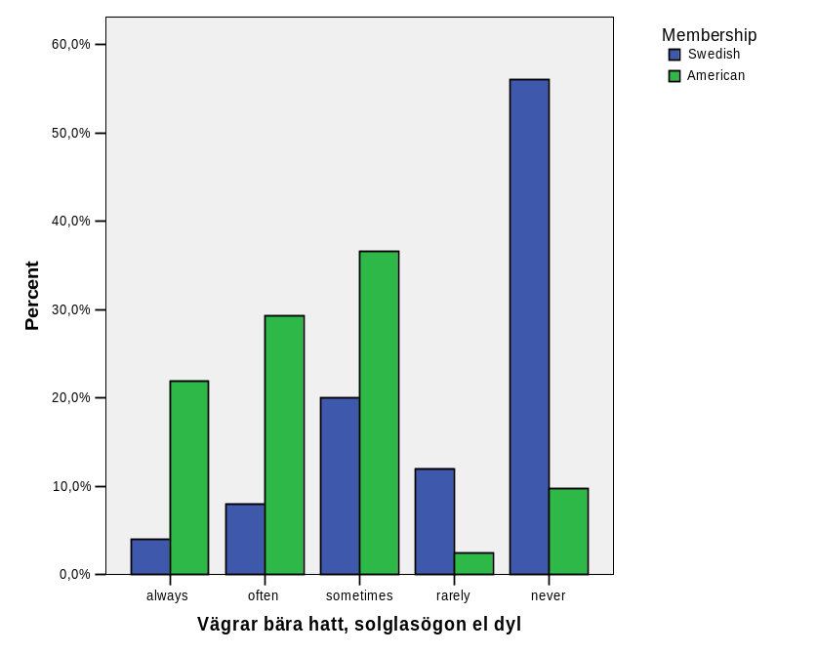
Figur 2: Score distributions in percentage of Tactile no item 7. The parent ratings in Swedish group are highly skewed toward never while the ratings in the American group are more evenly distributed. The Swedish median is 5/never, the American median is 2/often.

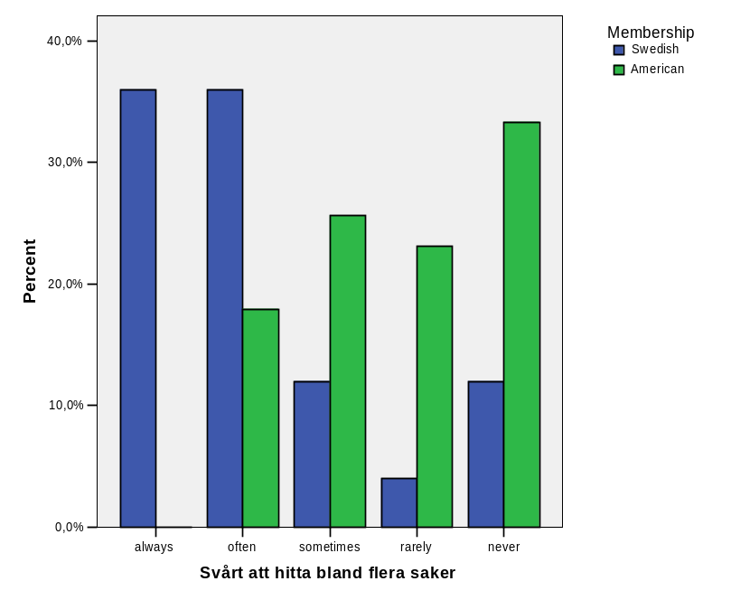
Figur 3: Score distributions in percentage of Visual item 6. The parent ratings are skewed toward always while the ratings in the American group are skewed toward never. The Swedish median is 2/often, the American median is 4/rarely.

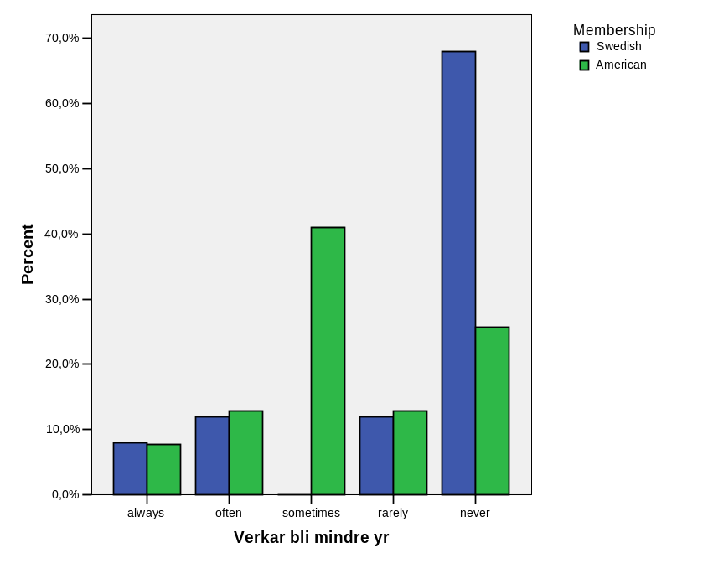
Figur 4: Score distributions in percentage of Vestibular item 8. Parent ratings in Swedish group are highly skewed toward never while the ratings in the American group are more evenly distributed. The Swedish median is 5/never, the American median is 3/sometimes.

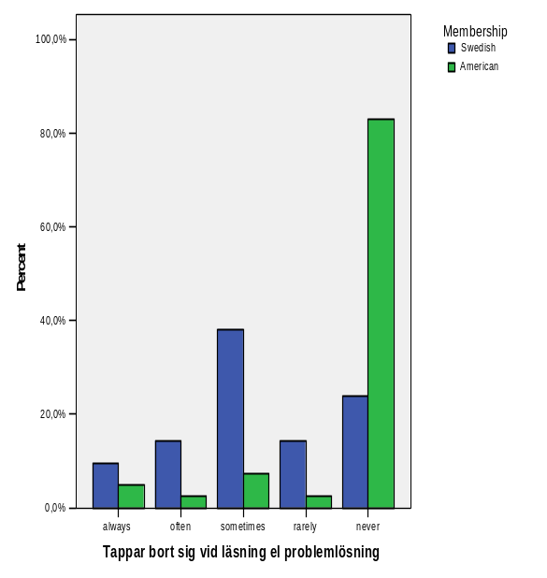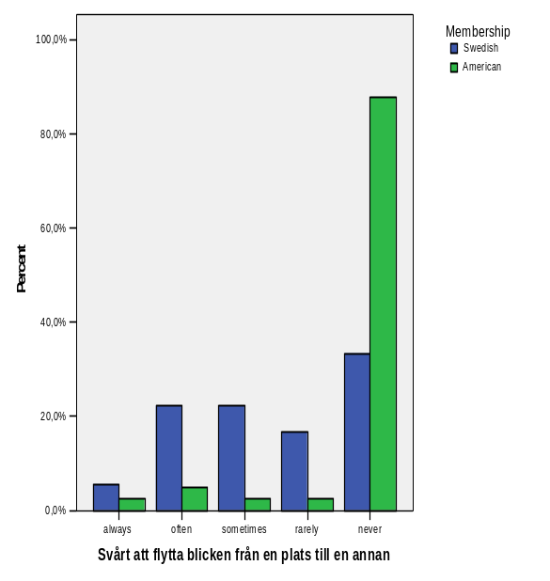
Figur 5: Score distributions in percentage of Visual item 12 and 13. The parent ratings in the Swedish group are evenly distributed while the American ratings are highly skewed toward never. The Swedish median is 3/sometimes on both items, the American median is 5/never.

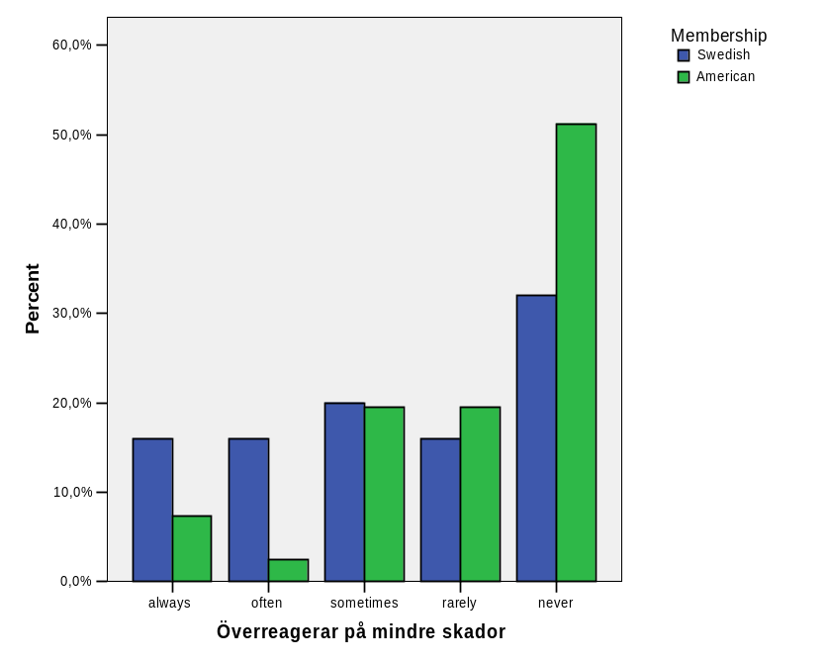
Figur 6: Score distributions in percentage of Tactile item 19. Parent ratings did not significantly differ between the two groups, still, the Swedish median is 3/sometimes, while the American median is 5/never.

Describing the Swedish group of children with autism
The highest possible total score obtainable on the USP questionnaire is 380. This is obtained if the answer is never on all items except Vestibular item 3 and 5, which then should be answered always. Visual items 11-13 are excluded from the count in agreement to the American manual [SS]. As can be seen in figure 7, there is a wide distribution in the total scoring of the USP in the children with autism. The total score range is 213 - 367. The red line indicates the cut score: 286, calculated according to the manual and modified to the number of Swedish items. Below the cut score are those children with probable sensory integration dysfunction. Above are those children that presumably don’t suffer any sensory integration dysfunction. 60% of the children with autism show signs of sensory integration dysfunction according to the USP questionnaire. It is of great importance though, to remember that the cut score is not something absolute, it is as important to follow up the questionnaire with an interview with the parents to children just above the cut score as it is with the children below. Still, the result suggests that even though this is a homogenic group as far as diagnosis: only children with high functioning autism or Asperger’s syndrome are included, it is a heterogenic group when it comes to how these children are able to process their sensory inputs.
The figure also indicates that age (between 4 and 12) may not affect the total score of the USP. For example the 10-year olds are distributed throughout the whole range, from the lowest score to one of the highest, however, it must be interpreted with caution due to the small sample.

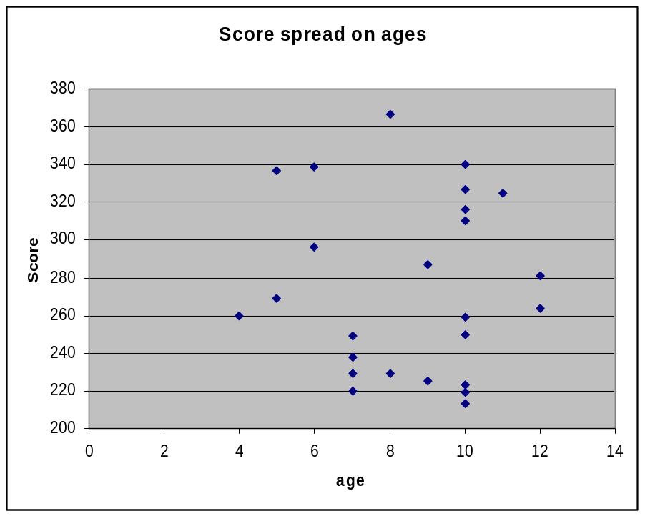
Figure 7: Total score of the USP, distributed on age. The red line indicates the cut score 286, below are the ones that indicate a Sensory integrative disorder.

Table 2 shows that 24 of the 75 items, half of the Swedish parents or more responded with always/often/sometimes, with the highest percentage of 88% (22 parents) on Auditory item no 1:
Does your child have trouble understanding what other people mean when they say something?
Swedish translation: Har ditt barn svårigheter att förstå innebörden i ett samtal med andra människor.
This means that 22 of the Swedish children with autism or AS has trouble understanding what other people mean, and on ytterligare 23 items, half of the children or more has trouble interpreting the sensory input demanded in the presented situation.
Eight of the 75 items in table 2 had 80% or more that responded never/rarely with 23 parents rating never/rarely on Gustatory item no 2:
Does your child complain that foods are too bland or refuse to eat bland foods?
Swedish translation: Klagar ditt barn på att mat är för smaklös, eller vägrar han/hon att äta smaklös mat?
One of the added Swedish items had XX the parents responding never/rarely.
When looking at the median of each item in the Swedish group (see appendix 3), this shows that 30% of the items indicate a problem, that is, answers are either always, often or sometimes. However, it is very important not to look at one item alone, since it is the cluster of answer that may indicate if a child has difficulties to process sensory input.
Table 3 shows the total score of each domain as well as for the whole questionnaire, calculated for each child. There have not been any calculations for a cut score of each domain in the American version yet, but it can still be of use to look at each domain separately. Table 3 also shows the mean and median score of each domain and the mean and median of the whole questionnaire. As can be seen, the mean of the total score of the USP is 274.88, just below the cut score indicating a problem with processing sensory input, the median score is somewhat lower: 264.
Table 3: Every participants total score of the USP to the right and the total score of each domain, also the mean, median, minimum and maximum of the total score.
n=25 | Auditory (max 50) | Gustatory (max 25) | Proprio (max 65) | Tactile (max 110) | Vestibular (max 80) | Visual (max 50) | Total (max 380)
1 | 25 | 21 | 34 | 69 | 43 | 21 | 213
2 | 19 | 23 | 30 | 72 | 46 | 29 | 219
3 | 31 | 20 | 47 | 58 | 40 | 24 | 220
4 | 26 | 23 | 49 | 45 | 56 | 24 | 223
5 | 27 | 12 | 48 | 60 | 51 | 27 | 225
6 | 24 | 17 | 33 | 62 | 59 | 34 | 229
7 | 25 | 16 | 40 | 58 | 62 | 28 | 229
8 | 26 | 18 | 54 | 56 | 52 | 32 | 238
9 | 29 | 15 | 38 | 74 | 59 | 34 | 249
10 | 26 | 19 | 38 | 74 | 65 | 28 | 250
11 | 29 | 21 | 43 | 70 | 65 | 31 | 259
12 | 27 | 13 | 44 | 74 | 68 | 34 | 260
13 | 27 | 19 | 53 | 78 | 61 | 26 | 264
14 | 25 | 23 | 53 | 71 | 65 | 32 | 269
15 | 37 | 24 | 51 | 83 | 52 | 34 | 281
16 | 39 | 14 | 60 | 76 | 64 | 34 | 287
17 | 48 | 20 | 38 | 77 | 67 | 46 | 296
18 | 39 | 22 | 56 | 84 | 74 | 35 | 310
19 | 38 | 20 | 64 | 74 | 79 | 41 | 316
20 | 41 | 25 | 51 | 99 | 72 | 37 | 325
21 | 45 | 25 | 52 | 95 | 73 | 37 | 327
22 | 46 | 23 | 58 | 85 | 80 | 45 | 337
23 | 40 | 25 | 55 | 107 | 74 | 38 | 339
24 | 44 | 25 | 61 | 104 | 71 | 35 | 340
25 | 48 | 23 | 64 | 106 | 77 | 49 | 367
Total | 831 | 506 | 1214 | 1911 | 1575 | 835 | 6872
Mean | 33,24 | 20,24 | 48,56 | 76,44 | 63 | 33,4 | 274,88
Median | 29 | 21 | 51 | 74 | 65 | 34 | 264
Min | 19 | 12 | 30 | 45 | 40 | 21 | 213
Max | 48 | 25 | 64 | 107 | 80 | 49 | 367

Methodology discussion

Translation process
According to Streiner et al [OO], translating an instrument can be done, but it is as time consuming as developing a new tool. Further, both similarities and differences in results must be interpreted with extreme caution, and once the translation is done, there is still little assurance that the reliability and validity have remained constant. It is therefore necessary to revalidate the instrument, as if it were a new one [OO].
In this study, the back-translation procedure was used since it is one of the most common and recommended procedures for verifying the translation of an instrument [Q]. This means that after a translation is made, another bilingual person translates the instrument back to the original language, and then a third party will examine the original language versions to see if the meaning has been lost or altered. If that is the case, that part of the instrument will go through the process again [P]. In this case, the third party was people involved in the development of the original instrument, which I believe would validate the translation even further, since they are well suited to determine if the meaning of the questions had been altered.
The review by the group of occupational therapists would have been more beneficial if it had been the fourth version they reviewed, as it was now, much time was spent on items that later was taken from the ESP anyway.
As Guyatt [O] points out, the translators are likely to find questions that do not translate well, which also was true in this particular case, though all but one of those items were excluded in the ESP version 4, partly due to translation problems in another study [I]. The one item left were excluded after pointers from several of the five parents that were interviewed to further establish face validity.
Guyatt also mentions that a translated instrument may include items from the original which are less important in the new language or lack items that are crucial in the new settings [O]. Since the ESP was developed in Southern California, there were no aspects of sensory reactions to winter clothing or activities in the snow. Together with the expert group of occupational therapists four new items were developed for that purpose.

Comparison between two groups
To import data from another study was proven more difficult than expected. There was no raw data, only valid percent of the answers and total number of answers on each item and from this, frequency could be obtained and then the comparison with the Swedish data could be done item by item. No individual description could be made of the American children, only item based comparison with the Swedish group, but that was also the intention with this study.
When comparing the parent ratings from the American group (n=41) of children with the Swedish group (n=25), two different methods were used. First, the median of each item in both groups were calculated and compared. Second, Pearson’s chi-square test was performed after the five responses were dichotomized into two groups: one with always, often and sometimes; and one group with the answers rarely and never. The reason for dichotomize, was that the small sample in the Swedish group did not fulfill the conditions for the chi-square test [NN, CX] and the results from Odéus study with normally developed children [?] which indicates that these parent ratings predominantly were rarely and never determined where to make the cut. Many researchers consider 30 to be the lowest number of participants when using Pearson´s chi-square test, but some agree that as few as 20 is enough [CX]. Only eight items did not fulfill the conditions even after dichotomizing the answers and there the Fisher’s Exact Test was used.

Describing the Swedish group of children with autism

Result discussion

Comparison between two groups
In the development and testing of the American ESP, [L,M,W] the results have shown good reliability and validity. So far, the studies have been made on ESP version 3 which generated the ESP version 4, translated into USP in this study.
Judging from the expert panel of occupational therapists reviewing the questionnaire, the items shows good face validity, that is, it appears to measure what it is supposed to measure and it is likely to be used by therapists working with sensory integration methods [OO].
Many of the questions that arose during the two group discussions were automatically solved when the new and shorter version of the ESP came. For example the opinion that the questionnaire had to many items, and items that were too similar. Also four of the five items that were judged not sensory integrative related were excluded in ESP version 4 and of course in the Swedish USP as well.
Some authors disagree whether the face validity should be decided by an expert panel or a non-expert panel [Z]. Therefore, five parents were asked to complete the questionnaire, and later interviewed, in order to collect parent’s point of view concerning all the items. This was a good addition to the expert panel, and contributed with important opinions, for example, one item was found compelling to answer, and since the translators could not find a better translation, it was removed from the questionnaire. Thus, the result of the expert and non-expert group was similar, and the judgment that the face validity of the items in the questionnaire is good, still stands.
When comparing the two groups of children with autism, Pearson’s chi-square test showed a significant difference of proportions in a minority of items.
The probable cause of the difference of Visual items 11,12 and 13 is that these questions were not age limited in the ESP version 3 that were used in the American study, therefore all of the parents gave a response, even for the children under the age of six. In ESP version 3 there were also a response alternative called Not applicable, which in the data analysis were recoded as never. In my opinion, this must have had a faulty effect on these three items. In the ESP version 4 and therefore in the Swedish USP, only parents with children six years or older answers these questions, whereas these items has a better chance to distinguish between problem or no problem.
The age difference of the two groups can be the cause of the significant difference of many of the items. As, for example, Auditory items nine:
Is your child easily distracted by irrelevant noises such as a lawn mower outside, children talking in the back of the room, crinkling paper, an air conditioner, a refrigerator, or floursescent lights?
Swedish translation: Distraheras ditt barn av irrelevanta ljud, t ex en gräsklippare utomhus, barn som pratar längst bak i klassrummet, prasslande papper, luftkonditionering, kylskåp eller lysrör?
and ten:
Does your child seem too sensitive to sounds?
Swedish translation: Verkar ditt barn överkänsligt för ljud?
may be questions that are easier for parents with older children to be aware of a problem. These are items that the parent ratings showed more problems in the Swedish group, where the children generally were older.
Other items, as in Proprioceptive item three:
Does your child seem driven to seek activities such as pushing, pulling, dragging, lifting and jumping?
Swedish translation: Verkar ditt barn söka sig till aktiviteter som att knuffa, dra, släpa, lyfta och hoppa?
and seven:
Does your child jump a lot?
Swedish translation: Hoppar ditt barn mycket?
Vestibular item 12:
Does your child like to be inverted or tipped upside down, or enjoy doing activities that involve inversion, such as hanging upside down or doing somersaults?
Swedish translation: Tycker ditt barn om att bli upp- och nervänd eller njuter han/hon av aktiviteter där man t ex hänger upp- och nerpå eller slår kullerbyttor?
are problem areas more easily observed in younger children. This has to be taken into consideration when the questionnaire is interpreted and the score is calculated. Still, when looking at figure 7, the results indicates that the USP has no age relevance, the ages of the children below the cut score ranges from four to twelve years, and the ages of children above ranges from five to eleven years. This must mean that the questionnaire is suitable at least for the whole age range tested in this study. The instrument is intended to suite children as young as two years old, but since there, to my knowledge, are very few two-year-old children diagnosed with high-functioning autism in Sweden, I chose not to include them in this study.
Considering 81% of the items showed no significant difference between the American group of children and the Swedish group of children, and several of the remaining items that did show a significant difference can be explained with the differences of the two groups, I believe that it can be established that the two questionnaires has psychometric equivalence.
Many of the American and the Swedish items have a high degree of skewness in the rating distribution, often toward rarely/never. This may be perceived as a bad result, but in the American study [W] the parent ratings of the autistic group were compared with a group of normally developed children, and those responses were even more highly skewed and most of the items showed a significant difference between those two groups. The skewness in rating distribution is probably due to the variability in the scores of children with autism and AS and this is consistent with sensory integration theory [AA, DD, JJ]. Those autistic children that do show signs of sensory integration dysfunction are still a heterogeneous group with different problems in their sensory systems. One child may seek desperately for vestibular or proprioceptive input, while another child completely tries to avoid it.

Describing the Swedish group of children with autism
When using the USP on the Swedish group of children with autism, the results showed that 60% of the children are probably having some form of sensory integration dysfunction. Even though summing up data from an ordinal rating scale is considered inappropriate [Y] I feel that it in this case shows more than only a Median score of each item shows. Most of the participants have a distinct position in table 2, far from the cut score, either far above or far below, clearly indicating either no problem or multiple problems. This can be compared with the initial results of another study by Odéus [?] where a group of normally developed children showed no indication of sensory integration dysfunction, according to the USP. Those children’s total score range from 322 – 379.
This is a promising result for the questionnaire’s ability to discriminate between children with and without sensory integration dysfunction. On the other hand it does not support the earlier indications that it can discriminate between children with and without autism [AA]. Because of these two subgroups (above and below the cut score), almost equal in size, the groups median profile shows almost no indication of problem areas in the field of sensory integration. This shows once again the importance of looking at the individuals. You can not assume that a child with autism also is having sensory integration dysfunction, but it is a possibility. Also, children with sensory integrative dysfunction do not present it in the same way or in the same sensory domains and this is why there is such a high degree of variability in the scores of the children in this group.

Clinical relevance
The USP will fill a gap in Swedish occupational therapy. Canadian Occupational Performance Measure (COPM) and Assessment of Motor and Process Skills (AMPS) are two examples of instruments used by Occupational therapists when looking at children with Asperger’s Syndrome [AX]. Before now, there have not been any formaly translated questionnaires considering sensory integration dysfunction. Even though there are not that many occupational therapists in Sweden with SI-knowledge, those that do use this theory and those interested in using it have not had any valid instrument to back up their work. In order to widen the interest for sensory integration, we need valid and reliable instruments and translating a screening tool as the Evaluation of Sensory Processing is an important step, and to test the Swedish version in different ways is yet another important step toward proving sensory integration treatment to be efficient and crucial to children with these problems.

Limitations
What would have been interesting, and maybe vital to the study, is to know whether or not the children were medicated at the time the parent was completing the questionnaire, this because medication, in some cases, affects the children’s capacity to process sensory input.
Another limitation is the small sample of participants in the Swedish group, but as a first step in validating the questionnaire I chose homogeneity above multiplicity.
The homogeneity of the Swedish group and the heterogeneity of the American group, both regarding severity of autism and age is also something to take in consideration when interpret the results. On the other hand, Kientz and Dunn [U] found that there was no difference between the perceptions of parents of children with severe autism and the parents of children with mild/moderate autism on the behaviors listed on the Sensory Profile, a similar questionnaire.
The difference in size of the two groups may affect the results somewhat, even though Pearson’s chi-square test takes that into account.

Conclusion
This study alone is by far, not enough to draw any general conclusions, the USP must undergo further psychometric testing before anything can be said about the instruments validity and reliability. The plan is to compare this study’s group of children with autism with a group of normally developed children to establish discriminant validity. There is also currently a study involving the USP used on children with Fragile X. Collecting normative data for different diagnoses, in order to compare median, is an important step. It also feels necessary to evaluate the effect of age on USP ratings.
Although, I dare say that the results of this study is promising, and shows that it is worth while to continue to work with it, both scientifically and in clinical work in a small scale by occupational therapists with Sensory integration knowledge. I agree with previous studies, saying the USP is a screening instrument, either to exclude the probability of a sensory integration dysfunction interfering with everyday activities, or to help focus the attention on the domain/domains where the child shows having a problem. It should be followed by an interview with the parents and, if found necessary, further evaluation to determine the child’s needs.
Summing up the total score of the instrument should be done with great caution, if at all [DX]. There is not enough testing made to ensure a reliable cut score, and the questionnaire is an ordinal scale which means the alternative responses are not tradable with numbers. However, in the USA, the work continues to establish cut scores, both for the total test and for each domain, and summing up can be a hint in the right direction as long as the total score is not the only thing determining further action. The important thing to remember is that the individual score of a child’s performance on the questionnaire can not be compared in any absolute way, not with other children and not with itself after treatment.

Acknowledgement

References

Böcker
AA Bundy A, Lane S, Murray E. Sensory integration: theory and practice. 2nd ed. Philadelphia: F.A. Davis company; 2002.
BB Ayres A J. Sensory integration and learning disorders. Los Angeles: Western Psychological Services; 1972.
CC Ayres A J. Sensory integration and praxis tests. Los Angeles: Western Psychological Services; 1989.
DD Ayres A J. Sensory integration and the child. Los Angeles: Western Psychological Services; 1979.
EE Patel R, Davidson B. Forskningsmetodikens grunder. Andra upplagan. Lund: Studentlitteratur; 1994.
FF Kielhofner G. A model of human occupation: theory and application. 2nd ed. Baltimore: Williams & Wilkins; 1995.
GG Parham L D, Mallioux Z. Sensory integration. In: Case-Smith J, Allen A S, Pratt N P, editors. Occupational therapy for children. St. Louis: Mosby; 1996. p. 307-56.
HH Brislin RW, Lonner WJ, Thorndike RM. Cross-cultural research methods, comparative studies in behavioral science. New York: John Wiley & Sons; 1973.
II Brislin RW. Introduction. In: Brislin RW, editor. Translation, applications and research. New York: John Wiley & Sons; 1976.
JJ Smith Roley S, Blanche EI, Schaaf RC. Understanding the nature of sensory integration with diverse populations.
KK Siegel B. The world of the autistic child. Oxford: Oxford university press; 1996.
LL Yack E, Aquilla O, Sutton S. Building bridges through sensory integration. 2nd ed.
MM Play and the sensory integration approach. Mailloux Z, Posatery Burke J. In: Parham D, Fazio L, editors. Play in occupational therapy for children. St. Louis: Mosby-year book inc; 1997.
NN Eljertsson G. Statistik för hälsovetenskaperna. Lund: Studentlitteratur;2003.
OO Streiner D L, Norman G R. Health measurement scales: a practical guide to their development and use. 2nd ed. Oxford: Oxford medical publications; 1995.
PP World Health Organisation. International statistical classification of diseases and related health problems, ICD10. Geneva; 1993.
QQ Gillberg C. Autism och autismliknande tillstånd hon barn, ungdomar och vuxna. Stockholm: Natur och Kultur; 1992
RR American psychiatric association. Diagnostic and statistical manual of mental disorders, 4th ed, text revision. Washington DC: American psychiatric association; 2000.
SS Parham D. Scoring the ESP version 4. Unpublished material.
TT Pearson’s chi-square test. http://en.wikipedia.org/wiki/Pearson's_chi-square_test
UU Wahlgren L. SPSS steg för steg. Lund: Studentlitteratur;2005.

Artiklar
[B] LaCroix J E. A study of content validity using the sensory history questionnaire. Unpublished Master’s thesis, University of Southern California, Los Angeles, 1993.
[C] Hachey R, Jumoorty J, Mercier C. Methodology for validating the translation of test measurements applied to occupational therapy. Occupational Therapy International 1995;(2):190-203.
[D] Bernspång B, Fischer AG. Validation of the assessment of motor and process skills for use in Sweden. Scand J Occup Ther 1995;(2):3-9.
[E] Case-Smith J. Clinical interpretation of factor analysis on the sensory profile from a national sample of children without disabilities. Am J Occup Ther: 1997; 51: 496-499.
[F] Jones E. Translation of quantitatative measures for use in cross-cultural research. Nursing reasearch 1987; 36:324-6.
[G] Haglund L, Karlsson G, Kielhofner G, Shei Lai J. Validity of the swedish version of the worker role interview. Scand J Occup Ther 1997; (4):23-9.
[H] Spitzer S, Smith Roley S, Clark F, Parham D. Sensory integration: current trends in the united states. Scand J Occup Ther 1996; 3:123-38.
[I] Su C T. Translation of the evaluation of sensory processing into mandarin chinese for use in Taiwan. Unpublished master thesis. University of Southern California, Los Angeles; 1998.
[J] Benson J, Clark F. A guide for instrument development and validation. Am J Occup Ther: 1982;36:789-800.
[K] Merbitz C, Morris J, Grip JC. Ordinal scales and foundations of misinference. Arch Phys Med Rehabil 1989;(70): 308-312.
[L] Johnson-Ecker CL, Parham LD. The evaluation of sensory processing (ESP): a validity study using contrasting groups. Am J Occup Ther:
[M] LaCroix J, Johnsom C, Parham L D. The development of a new sensory history, the evaluation of sensory processing. Sensory Integration Special Interest…
[N] Parham LD. Evaluation of praxis in preschoolers. Occup Ther Health Care 1987; 4(2): 23-35.
[O] Guyatt GH. The philosophy of health-related quality of life translation. Quality of life research 1993; 2: 461-465.
[P] Sechrest L, Fay T L, Zaidi S [2] H. Problems of translation in cross-cultural research. Journal of Cross-Cultural Psychology 1972;(3):44-56.
[Q] Brislin RW. Back-translation for cross-cultural research. Journal of Cross-cultural psychology 1970; 1(3): 185-216.
[R] Lomi C. Evaluation of a Swedish version of the arthritis self-efficacy scale. Scand J Caring Sci 1992; 6(3): 131-138.
[S] Hulin CL. A psychometric theory of evaluations of items and scale translations, fidelity across languages. Journal of Cross-cultural psychology 1987; 18 (2): 115-142.
[T] Dunn W W. Performance of typical children on the sensory profile: an item analysis. Am J Occup Ther: 1994;48:967-974.
[U] Kientz M A, Dunn W. A comparison of the performance of children with and without autism on the sensory profile. Am J Occup Ther: 1997;51:530-537.
[V] Watling R, et al. Current practice of occupational therapy for children with autism. Am J Occup Ther: 1999;53:498-505.
[W] Veermaas Lee J. Unpublished master thesis.
[X] Summary of research on ESP
[Y] Svensson E. Guidelines to statistical evaluation of data from rating scales and questionnaires. Journal of Rehab Med: 2001; 33:47-48.
[Z] Roberts D M. Face validity: is there a place for this in measurements. www.jalt.org/test/rob_1.htm
[BX] Royeen C B, Fortune J C. TIE: Touch inventory for school aged children. Am J Occup Ther: 1990;44:165-170.
[AX] Nylander L, Holmqvist M, Zettervall K. Utredning av barnneuropsykiatriska tillstånd hos vuxna ofta önskvärd. Läkartidningen: 2002;99:1692-1699.
[CX] Statistics solutions, inc. Chi-square significance test. www.statisticssolutions.com/chi_square_test.htm
[DX] Jakobsson U. Statistical presentation and analysis of ordinal data in nursing research. Scand J Caring Sci;2004; 18, 437-440.

