哈尔滨工业大学

<<算法设计与分析>>
实验报告之一

(2015年度秋季学期)

姓名： | 张琦
学号： | 15S003055
学院： | 计算机学院
教师： | 骆吉洲

实验一 分治算法

实验目的
1、掌握分治算法的设计思想与方法，
2、熟练使用高级编程语言实现分治算法，
3、通过对比简单算法以及不同的分治求解思想，体验分治算法。

实验内容
求解凸包问题：输入是平面上n个点的集合Q，凸包问题是要输出一个Q的凸包。其中，Q的凸包是一个凸多边形P，Q中的点或者在P上或者在P中。
使用三个算法，分别为枚举方法、Graham-Scan、分治算法。
本人使用的是python语言，枚举算法使用四层循环，时间复杂度是O(n⁴)，效率低耗时长，当运行3000个点的时候平均需要了4分钟左右，远远超过于其他两种算法的运行时间，故枚举算法的图最多只考虑到3000个点。其他两种算法时间复杂度是O(nlogn)，效率高，实验时运行100000个点也不会耗时过长。

实验过程及结果
3.1 辅助函数：
Pi = 3.14159265358979323846264338327
ZERO = 1e-11
def equal_zero(float_num):#判断浮点数是否可视为0
if -ZERO<float_num<ZERO:
return True
else:
return False

def random_points(length):#随机生成length数目的点
points = []
for i in range(length):
x = random.uniform(0, 100)
y = random.uniform(0, 100)
the_point = (x,y)
points.append(the_point)

return points

def line_equation(point_A, point_B):#求直线方程
line_coefficient = {"A":0, "B":0, "C":0}
line_coefficient["A"] = point_B[1]-point_A[1]
line_coefficient["B"] = point_A[0]-point_B[0]
line_coefficient["C"] = -line_coefficient["A"]*point_A[0]-line_coefficient["B"]*point_A[1]

return line_coefficient

def is_line2(point_A, point_B, point_C):#判断点C对于直线AB的位置
AB = line_equation(point_A, point_B)
return AB["A"]*point_C[0] + AB["B"]*point_C[1] + AB["C"]

def is_line(line_coefficient, point_C):#判断点C对于直线的位置
return line_coefficient["A"]*point_C[0] + line_coefficient["B"]*point_C[1] + line_coefficient["C"]

def sortANDprint(points):#将得到的凸包顶点集合按照逆时针方向排序并输出
num = len(points)
if num <= 2:
for i in range(num):
print points[i]
return
min_x = points[0]
max_x = points[0]
for i in range(1, num):
if points[i][0]<min_x[0]:
min_x = points[i]
if points[i][0]>max_x[0]:
max_x = points[i]

AB = line_equation(min_x, max_x)
SL = []#AB下方的点集
SU = []#AB上方的点集
if AB["B"]>0:
for i in range(0, num):
if is_line(AB, points[i])>0:
SU.append(points[i])
else:
SL.append(points[i])
else:
for i in range(0, num):
if is_line(AB, points[i])<0:
SU.append(points[i])
else:
SL.append(points[i])
SL = sorted(SL, key=lambda p:p[0])
SU = sorted(SU, key=lambda p:p[0], reverse=True)
for i in SL:
print i
for j in SU:
print j

def sGrahamScan(points):#无需极角排序的Graham-Scan算法
result_points = []
num = len(points)
if num <=3:
return points
result_points.append(points[0])
result_points.append(points[1])
result_points.append(points[2])
for i in range(3, num):
while True:
tmp_line = line_equation(points[i], result_points[-2])
if len(result_points)<=2:
break
if is_line(tmp_line, points[0])*is_line(tmp_line, result_points[-1])>0:
result_points.pop()
else:
break
result_points.append(points[i])
return result_points

def angle_sort(points):#将点按照极角排序，极点是纵坐标最小的点，极轴平行于x轴
min_y_P = 0
num = len(points)
if (num == 1):
return points
for i in range(1, num):
if points[i][1]<points[min_y_P][1]:
min_y_P = i
points2 = []
for i in range(0, num):
if i == min_y_P:
points2.append([i, -4])
continue
if points[i][0] == points[min_y_P][0]:
points2.append([i, Pi/2])
continue
if points[i][1] == points[min_y_P][1]:
if points[i][0]>points[min_y_P][0]:
points2.append([i, 0])
else:
points2.append([i, Pi])
continue
iP = line_equation(points[i], points[min_y_P])
angle = math.atan(float(-iP["A"])/iP["B"])
if angle < 0:
angle += Pi
points2.append([i, angle])
points2 = sorted(points2, key=lambda p:p[1])
sorted_points = []
last_point_angle = points2[0][1]
last_point = points[points2[0][0]]

for i in range(1, num):
if points2[i][1] != last_point_angle:#极角不同的顶点则可以插入
sorted_points.append(last_point)
last_point_angle = points2[i][1]
last_point = points[points2[i][0]]
else:
x_compare = math.fabs(points[points2[i][0]][0] - points[points2[0][0]][0]) - math.fabs(last_point[0] - points[points2[0][0]][0])>0
y_compare = math.fabs(points[points2[i][0]][1] - points[points2[0][0]][1]) - math.fabs(last_point[1] - points[points2[0][0]][1])>0
if x_compare or y_compare:#极角相同的该点比上一个节点要更远
last_point = points[points2[i][0]]
sorted_points.append(last_point)
return sorted_points

def find_k_point_X(points, k):#找到点集中横坐标第k小的点
key = points[random.randint(0, len(points)-1)][0]
num = len(points)
a_points = []
b_points = []
for i_point in points:
if i_point[0]<=key:
a_points.append(i_point)
else:
b_points.append(i_point)
if len(a_points)==k:
return [key, a_points, b_points]
elif len(a_points)>k:
get_mid = find_k_point_X(a_points, k)
return [get_mid[0], get_mid[1], get_mid[2]+b_points]
else:
get_mid = find_k_point_X(b_points, k-len(a_points))
return [get_mid[0], a_points+get_mid[1], get_mid[2]]
3.2 枚举算法
num = len(points)
if num == 3:
sortANDprint(points)
return points
lines = [[0 for j in range(num)] for i in range(num)]
for i in range(num):
for j in range(i):
lines[i][j] = line_equation(points[i], points[j])
lines[j][i] = lines[i][j]
convexHullIndexs = range(num)
for i in range(num):
for j in range(num):
if convexHullIndexs[j] == -1 or j == i:
continue
for p in range(num):
if convexHullIndexs[p] == -1 or p == j or p == i:
continue
for q in range(num):
if convexHullIndexs[q] == -1 or q == p or q == j or q == i:
continue
ij_line = lines[i][j]
a_line = is_line(ij_line, points[p])
if equal_zero(a_line):#ijp三点成线
if equal_zero(is_line(ij_line, points[q])):#四点成线
if not(points[q][0]>points[i][0] and points[q][0]>points[j][0] and points[q][0]>points[p][0]):
if not(points[q][0]<points[i][0] and points[q][0]<points[j][0] and points[q][0]<points[p][0]):
if points[q][0]==points[i][0]:#成一条垂直于x轴的线
if not(points[q][1]>points[i][1] and points[q][1]>points[j][1] and points[q][1]>points[p][1]):
if not(points[q][1]<points[i][1] and points[q][1]<points[j][1] and points[q][1]<points[p][1]):
convexHullIndexs[q] = -1#删除该点
else:
convexHullIndexs[q] = -1#删除该点
continue
#ijp三点不成线
if is_line(ij_line, points[q])*is_line(ij_line, points[p])>=0:
ip_line = lines[i][p]
if is_line(ip_line, points[q])*is_line(ip_line, points[j])>=0:
jp_line = lines[j][p]
if is_line(jp_line, points[q])*is_line(jp_line, points[i])>=0:
convexHullIndexs[q] = -1#在ijp三角形内部或之上，删除该点
convexHull = []
for i in range(num):
if (convexHullIndexs[i]>=0):
convexHull.append(points[i])
return sortANDprint(convexHull)
3.3 GrahamScan算法
def GrahamScan(points):#Graham-Scan算法
points = angle_sort(points)
result_points = []
num = len(points)
if num <=3:
for i in points:
print i
return points
result_points.append(points[0])
result_points.append(points[1])
result_points.append(points[2])
for i in range(3, num):
while True:
tmp_line = line_equation(points[i], result_points[-2])
if len(result_points)<=2:
break
if is_line(tmp_line, points[0])*is_line(tmp_line, result_points[-1])>0:
#print points[i], result_points[-2], result_points[-1], points[0]
result_points.pop()
#print len(result_points)
else:
break
result_points.append(points[i])
for i in range(0, len(result_points)):
print result_points[i]
return result_points
3.4 分治算法
def DivideConvexHull(points):#分治算法
num = len(points)
if num == 3:
return angle_sort(points)
if num == 2:
if points[0][1]>points[1][1]:
exPoints = [points[1], points[0]]
return exPoints
return points
if num <= 1:
return points
get_mid = find_k_point_X(points, num/2)
a_points = get_mid[1]
b_points = get_mid[2]
QL = DivideConvexHull(a_points)
QR = DivideConvexHull(b_points)
exflag = False
if QL[0][1]<QR[0][1]:
a_points = QL
b_points = QR
else:
a_points = QR
b_points = QL
exflag = True
a_points_angles = []
b_points_angles = []
b_points_angles1 = []
b_points_angles2 = []
for i in range(1, len(a_points)):
if a_points[i][0] == a_points[0][0]:
a_points_angles.append([i, Pi/2])
continue
if a_points[i][1] == a_points[0][1]:
if a_points[i][0]>a_points[0][0]:
a_points_angles.append([i, 0])
else:
a_points_angles.append([i, Pi])
continue
iP = line_equation(a_points[i], a_points[0])
angle = math.atan(float(-iP["A"])/iP["B"])
if angle < 0:
angle += Pi
a_points_angles.append([i, angle])
b_min_p = 0
b_max_p = 0
b_num = len(b_points)
for i in range(0, b_num):
tmp_angle = 0
if b_points[i][1]!=a_points[0][1]:
iP = line_equation(b_points[i], a_points[0])
tmp_angle = math.atan(float(-iP["A"])/iP["B"])
if exflag:
tmp_angle += Pi
b_points_angles.append(tmp_angle)
if tmp_angle < b_points_angles[b_min_p]:
b_min_p = i
if tmp_angle > b_points_angles[b_max_p]:
b_max_p = i
if b_max_p < b_min_p:
b_max_p += b_num

for j in range(0, b_max_p - b_min_p+1):
i = (j + b_min_p) % b_num
b_points_angles1.append([i, b_points_angles[i]])
for i in range((b_max_p+1)% b_num, b_min_p):
b_points_angles2.append([i, b_points_angles[i]])#逆序
final_points = [a_points[0]]
i = 0
j = 0
k = 0
i_max = len(a_points_angles)
j_max = len(b_points_angles1)
k_max = len(b_points_angles2)
while True:
if i>=i_max and j>=j_max and k >= k_max:
break
A = []
if i<i_max:
A.append([0, a_points_angles[i]])
if j<j_max:
A.append([1, b_points_angles1[j]])
if k<k_max:
A.append([2, b_points_angles2[-1-k]])
tmp_p = [3, [-1, 4]]
for p in A:
if p[1][1]<tmp_p[1][1]:
tmp_p = p
if tmp_p[0] == 0:
final_points.append(a_points[tmp_p[1][0]])
i += 1
elif tmp_p[0] == 1:
final_points.append(b_points[tmp_p[1][0]])
j += 1
elif tmp_p[0] == 2:
final_points.append(b_points[tmp_p[1][0]])
k += 1
else:
return False
return sGrahamScan(final_points)

def printDivideResult(points):#打印分治算法的输出
fP = DivideConvexHull(points)
for i in fP:
print i
3.5 程序运行截图
- 20个点
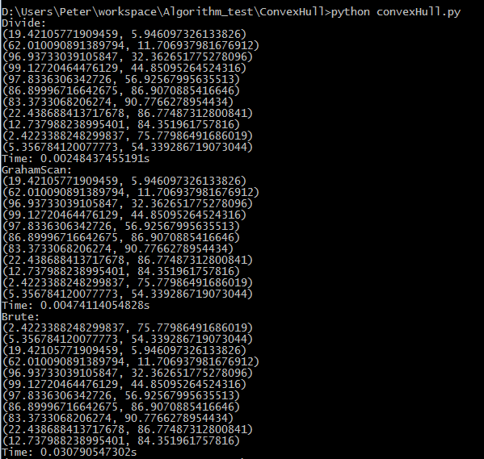
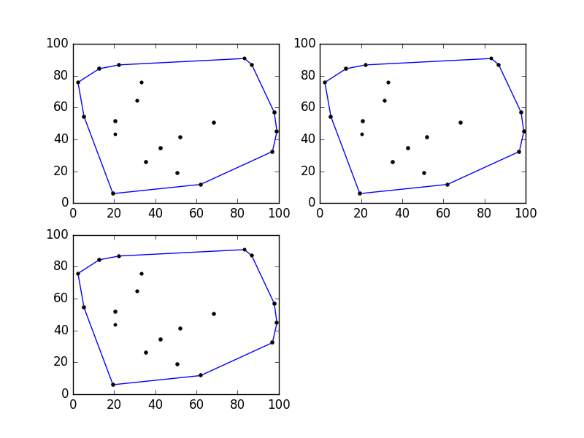
- 30个点
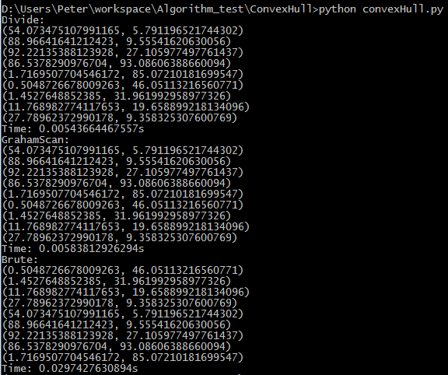
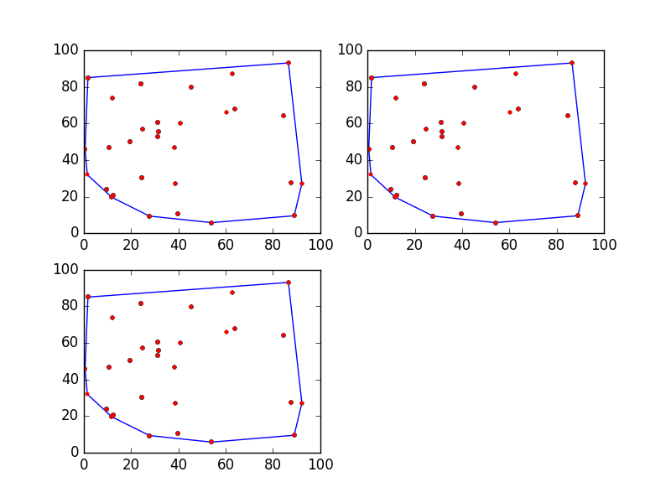

- 200个点
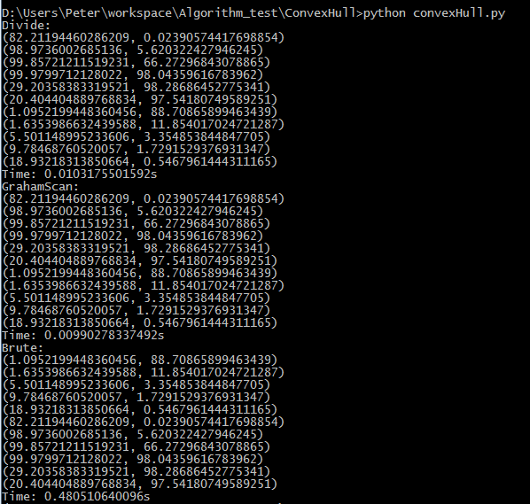
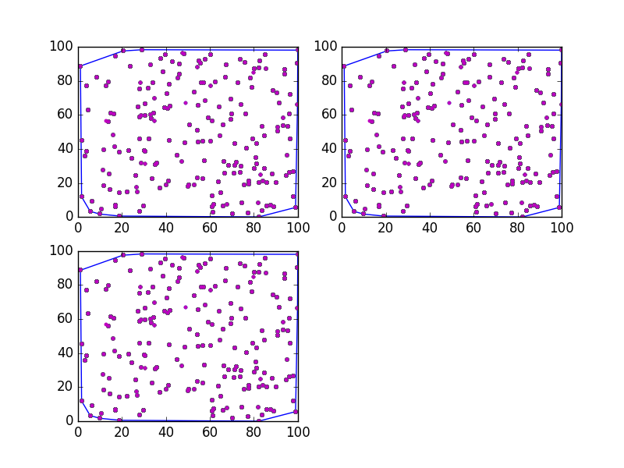

- 500个点
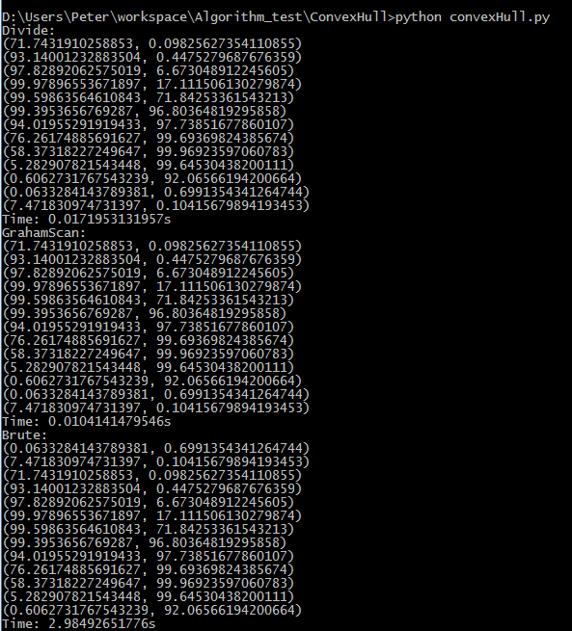
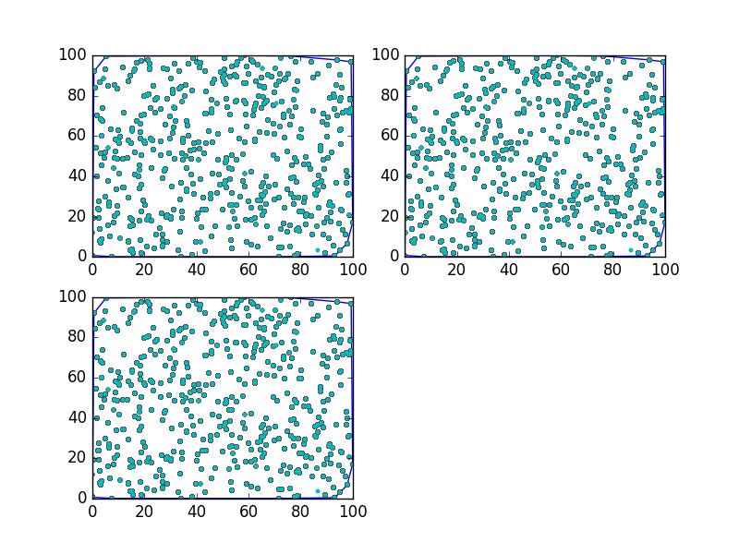
5）1000个点
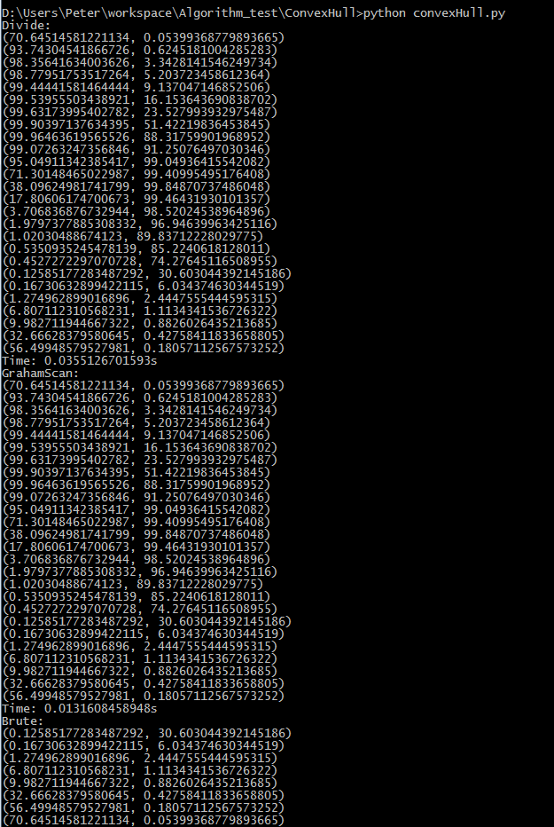
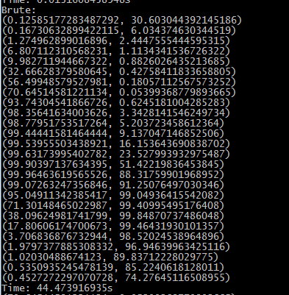
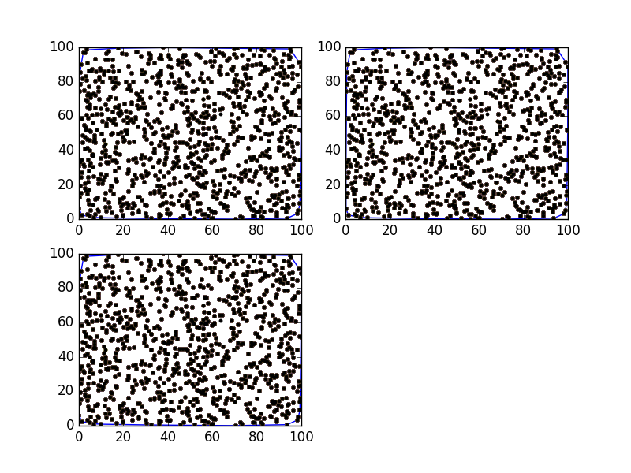
6）总结
运行结果中控制台得到的为每一种算法得到的凸包点集以及运行时间，凸包图为三种算法各自得到的凸包线以及所有初始点，可以看出三个算法得出的点集结果一致且正确，但是分治和GrahamScan算法运行时间要远远小于枚举算法的时间。
3.6 算法性能曲线
Y轴为耗时长度，单位s；X轴为点的数目，单位（个）
1）枚举算法：
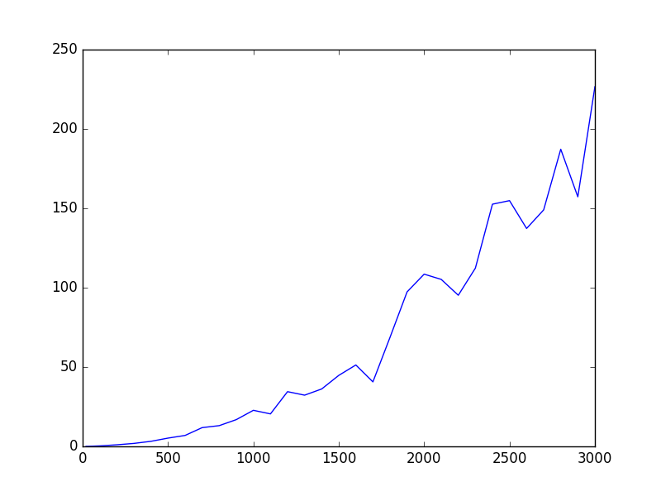
枚举算法近似耗时过长，和另外两种算法时间不是一个数量级的，故其性能曲线单独列出，观察图可知其在3000个点的时候耗时约220秒，整体曲线大致呈抛物线状，因为根据图的不同而运行结果不稳定，实则为n⁴曲线。
2）分治算法和GrahamScan算法
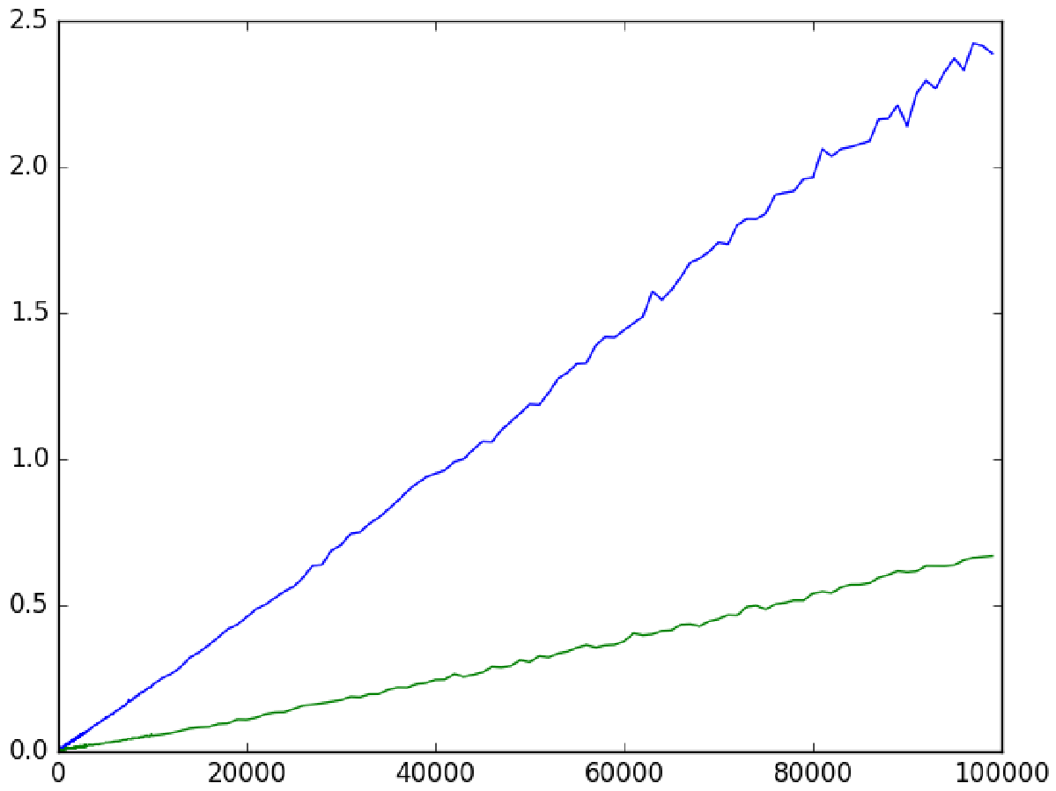
上图中，蓝线是分治算法的性能曲线；绿线是GrahamScan算法的曲线，可以看出两种算法的时间复杂度都近似O(nlogn)，用时很短，在100000点数集时仍然可以在2.5秒以内运行出结果。

实验心得
做完本实验可以看出一个算法的优劣对于解决问题的重要性，劣质的算法耗时时间过长会甚至可能导致问题看起来不可解，而优秀的算法可以把看起来很复杂的问题利用计算机的优势运行出结果。在程序设计的时候算法的重要性不言而喻。

