哈尔滨工业大学

<<算法设计与分析>>
实验报告之二

(2015年度秋季学期)

姓名： | 张琦
学号： | 15S003055
学院： | 计算机学院
教师： | 骆吉洲

实验二 搜索算法

实验目的
1、掌握搜索算法的基本设计思想与方法，
2、掌握分支界限搜索策略的设计思想与方法，
3、熟练使用高级编程语言实现搜索算法，
4、利用实验测试给出的搜索算法的性能。

二、实验内容
2.1 实验问题
（1）哈密顿环问题：输入是一个无向连通图G=(V,E)；如果G中存在哈密顿环则输出该环，否则输出“否”。
（2）最小哈密顿环问题：输入是一个无向连通图G=(V,E)，每个节点都没有到自身的边，每对节点间都有一条非负加权边；输出一个权值代价和最小的哈密顿环。注意：事实上输入图是一个完全图，因此哈密顿环是一定存在的。
2.2 实现哈密顿环搜索算法
（1）哈密顿环问题：(a)实现基于树的基本搜索算法(BFS,DFS) (b)利用爬山法的思想，考虑在搜索过程中如何选择节点进行展开搜索，设计并实现搜索的“个性化”优化策略。
（2）最小哈密顿环问题：(a)实现求解最小哈密顿环问题的分支界限算法。

三、实验过程及结果
3.1 辅助函数
def random_figure(num, full = False):#随机生成图，full为True时生成有权值的完全图，full为False时生成无权值的非完全图
figure = [[0 for i in range(num)]for j in range(num)]
if full:
for i in range(num):
figure[i][i] = -1
for j in range(i):
figure[i][j] = random.randint(1, longest_distance)
#figure[j][i] = random.randint(1, longest_distance)
figure[j][i] = figure[i][j]
else:
for i in range(num):
figure[i][i] = -1
for j in range(i):
figure[i][j] = random.randint(0, 1)
figure[j][i] = figure[i][j]
return figure

def adjacent(figure):#求邻接点集合
num = len(figure)
adj = []
for i in range(num):
adj.append([])
for j in range(num):
if figure[i][j]>0:
adj[i].append(j)
for i in range(num):
adj.append([])
adj[num].append(len(adj[i]))
return adj
def figure_change(figure):#更新矩阵
num = len(figure)
changed_figure = figure
zero_points = []
limit = 0
for i in range(num):
change_flag = False
row_min = longest_distance*num
for j in range(num):
if figure[i][j]<0:
continue
if figure[i][j]==0:
row_min = 0
zero_points.append((i,j))
continue
if figure[i][j]<row_min:
change_flag = True
row_min = figure[i][j]
if row_min>0 and change_flag:
limit += row_min
for j in range(num):
changed_figure[i][j] -= row_min
if changed_figure[i][j]==0:
zero_points.append((i, j))
for j in range(num):
col_min = longest_distance*num
change_flag = False
for i in range(num):
if changed_figure[i][j]<0:
continue
if changed_figure[i][j]<col_min:
col_min = changed_figure[i][j]
change_flag = True
if col_min>0 and change_flag:
limit += col_min
for i in range(num):
changed_figure[i][j] -= col_min
if changed_figure[i][j] == 0:
zero_points.append((i, j))
return [limit, changed_figure, zero_points]

def exist_path(figure_E):#返回不能使用的边集合
num = len(figure_E)
next = [-1 for i in range(num)]
last = [-1 for i in range(num)]
not_path = []
for i in range(num):
for j in range(i):
if figure_E[i][1]==figure_E[j][0]:
next[i] = j
last[j] = i
continue
if figure_E[i][0]==figure_E[j][1]:
next[j] = i
last[i] = j
for i in range(num):
if last[i]==-1:
it = i
while next[it]!=-1:
it = next[it]
not_path.append((figure_E[it][1], figure_E[i][0]))
return not_path
def sbranch_cut(figure):#分支限界法，找解用DFS
h = []
num = len(figure)
cf = figure_change(figure)
h.append(cf+[[]])#每一个节点，0表示路径下界，1表示其邻接矩阵，2表示为0的节点集合，3表示已有路径集合
Hamiltonian = longest_distance*num
Hamiltonian_path = -1
while len(h)>0:
top = h.pop()
if top[0]>=Hamiltonian:
continue

if len(top[2])==0:
continue
f = []
for point in top[2]:
row_min = longest_distance*num
col_min = longest_distance*num
for i in range(num):
if top[1][point[0]][i]>=0 and i != point[1]:
if top[1][point[0]][i]<row_min:
row_min = top[1][point[0]][i]
if top[1][i][point[1]]>=0 and i != point[0]:
if top[1][i][point[1]]<col_min:
col_min = top[1][i][point[1]]
f.append((point, row_min+col_min))
max_point = 0

for i in range(1, len(f)):
if f[i][1]>f[max_point][1]:
max_point = i

chosen_line = f[max_point][0]#下次扩展该节点
if len(top[3])+1 == num:#找到一个解
if top[0]+top[1][chosen_line[0]][chosen_line[1]]<Hamiltonian:
Hamiltonian = top[0]+top[1][chosen_line[0]][chosen_line[1]]
Hamiltonian_path = top[3]+[chosen_line]
continue
leftnode_figure = copy.deepcopy(top[1])
rightnode_figure = copy.deepcopy(top[1])

if len(top[3])+2 != num:#防止出现非哈密顿环
not_path = exist_path(top[3]+[chosen_line])
for i in not_path:
leftnode_figure[i[0]][i[1]] = -1

for i in range(num):
leftnode_figure[chosen_line[0]][i] = -1
leftnode_figure[i][chosen_line[1]] = -1
tmp_cf = figure_change(leftnode_figure)
lp = top[3] + [chosen_line]
leftnode = [tmp_cf[0]+top[0], tmp_cf[1], tmp_cf[2], lp]

rightnode_figure[chosen_line[0]][chosen_line[1]] = -1
tmp_cf2 = figure_change(rightnode_figure)
rightnode = [tmp_cf2[0]+top[0], tmp_cf2[1], tmp_cf2[2], top[3]]
h.append(leftnode)
h.append(rightnode)
return Hamiltonian_path, Hamiltonian
def print_path(path_A):#打印分支限界法的输出
path = path_A[0]
print "length:"+str(path_A[1])
num = len(path)
next = [-1 for i in range(num)]
last = [-1 for i in range(num)]
for i in range(num):
for j in range(i):
if path[i][1]==path[j][0]:
next[i] = j
last[j] = i
continue
if path[i][0]==path[j][1]:
next[j] = i
last[i] = j
it = 0
print "path:"+str(path[it][0]),
while next[it]!=0:
it = next[it]
print path[it][0],
print path[it][1]

def logToDB(log):#运行时间存入数据库
import MySQLdb
con = 0
cur = 0
try:
con = MySQLdb.connect(host = "localhost", user = "algorithm_user", passwd = "123456", db = "algorithm")
cur = con.cursor()
except MySQLdb.Error,e:
print "Mysql Error %d: %s" % (e.args[0], e.args[1])
query = 'INSERT INTO `search` (`num`, `time`, `algorithm_id`) VALUES (%s, %s, %s)'
cur.execute(query, log)
con.commit()
cur.close()
con.close()
3.2 BFS
def BFS(figure, adj = []):
num = len(figure)
Hamiltonian = False
l = Queue.Queue(math.factorial(num))
top = 0
if len(adj)==0:
adj = adjacent(figure)
for i in adj[0]:
l.put([i])
while not l.empty():
top = l.get()
if len(top)==num and top[-1] == 0:
Hamiltonian = True
break
if len(top)==num or top[-1] == 0:
continue
for i in adj[top[-1]]:
if i not in top:
next_path = top+[i]
l.put(next_path)
if Hamiltonian:
print 0,
for i in top:
print i,
print
return True
else:
print "not exist"
return False
3.3 DFS
def DFS(figure, adj = []):
num = len(figure)
Hamiltonian = False
l = []
top = 0
if len(adj)==0:
adj = adjacent(figure)
for i in adj[0]:
l.append([i])
while len(l)>0:
top = l.pop()
if len(top)==num and top[-1] == 0:
Hamiltonian = True
break
if len(top)==num or top[-1] == 0:
continue
for i in adj[top[-1]]:
if i not in top:
next_path = top+[i]
l.append(next_path)
if Hamiltonian:
print 0,
for i in top:
print i,
print
return True
else:
print "not exist"
return False
3.4 sBFS
爬山法是求出每个点的度，每一次将度数小的点先入队，也就是先扩展度数小的点，这样更容易先找到解，但是每次将子节点的度数排序又浪费了一些时间，很多时候优化效果不明显。
def sBFS(figure, adj = []):#爬山法
num = len(figure)
Hamiltonian = False
l = Queue.Queue(math.factorial(num))
top = 0
if len(adj)==0:
adj = adjacent(figure)
adj_nums = adj[num]
for i in adj[0]:
l.put([i])
while not l.empty():
top = l.get()
if len(top)==num and top[-1] == 0:
Hamiltonian = True
break
if len(top)==num or top[-1] == 0:
continue
next_points = []
for i in adj[top[-1]]:
if i not in top:
next_points.append(i)
next_points = sorted(next_points, key = lambda x:adj_nums[x])
for i in next_points:
next_path = top+[i]
l.put(next_path)
if Hamiltonian:
print 0,
for i in top:
print i,
print
return True
else:
print "not exist"
return False
3.5 sDFS
爬山法是求出每个点的度，每一次将度数大的点先压入栈，也就是先扩展度数小的点，这样更容易先找到解，但是每次将子节点的度数排序又浪费了一些时间，很多时候优化效果不明显。
def sDFS(figure, adj = []):#爬山法
num = len(figure)
Hamiltonian = False
l = []
top = 0
if len(adj)==0:
adj = adjacent(figure)
adj_nums = adj[num]
for i in adj[0]:
l.append([i])
while len(l)>0:
top = l.pop()
if len(top)==num and top[-1] == 0:
Hamiltonian = True
break
if len(top)==num or top[-1] == 0:
continue
next_points = []
for i in adj[top[-1]]:
if i not in top:
next_points.append(i)
next_points = sorted(next_points, key = lambda x:adj_nums[x], reverse = True)
for i in next_points:
next_path = top+[i]
l.append(next_path)
if Hamiltonian:
print 0,
for i in top:
print i,
print
return True
else:
print "not exist"
return False
3.6 分支限界法
def branch_cut(figure):#分支限界法
h = []
num = len(figure)
cf = figure_change(figure)
heappush(h, cf+[[]])#每一个节点，0表示路径下界，1表示其邻接矩阵，2表示为0的节点集合，3表示已有路径集合
Hamiltonian = longest_distance*num
Hamiltonian_path = -1
while len(h)>0:
top = heappop(h)
if top[0]>=Hamiltonian:
continue

if len(top[2])==0:
continue
f = []
for point in top[2]:
row_min = longest_distance*num
col_min = longest_distance*num
for i in range(num):
if top[1][point[0]][i]>=0 and i != point[1]:
if top[1][point[0]][i]<row_min:
row_min = top[1][point[0]][i]
if top[1][i][point[1]]>=0 and i != point[0]:
if top[1][i][point[1]]<col_min:
col_min = top[1][i][point[1]]
f.append((point, row_min+col_min))
max_point = 0

for i in range(1, len(f)):
if f[i][1]>f[max_point][1]:
max_point = i

chosen_line = f[max_point][0]#下次扩展该节点
if len(top[3])+1 == num:#找到一个解
if top[0]+top[1][chosen_line[0]][chosen_line[1]]<Hamiltonian:
Hamiltonian = top[0]+top[1][chosen_line[0]][chosen_line[1]]
Hamiltonian_path = top[3]+[chosen_line]
continue
leftnode_figure = copy.deepcopy(top[1])
rightnode_figure = copy.deepcopy(top[1])

if len(top[3])+2 != num:#防止出现非哈密顿环
not_path = exist_path(top[3]+[chosen_line])
for i in not_path:
leftnode_figure[i[0]][i[1]] = -1

for i in range(num):
leftnode_figure[chosen_line[0]][i] = -1
leftnode_figure[i][chosen_line[1]] = -1
tmp_cf = figure_change(leftnode_figure)
lp = top[3] + [chosen_line]
leftnode = [tmp_cf[0]+top[0], tmp_cf[1], tmp_cf[2], lp]

rightnode_figure[chosen_line[0]][chosen_line[1]] = -1
tmp_cf2 = figure_change(rightnode_figure)
rightnode = [tmp_cf2[0]+top[0], tmp_cf2[1], tmp_cf2[2], top[3]]
heappush(h, leftnode)
heappush(h, rightnode)
return Hamiltonian_path, Hamiltonian
3.7 程序运行截图
3.7.1 寻找哈密顿环问题
1）8个点
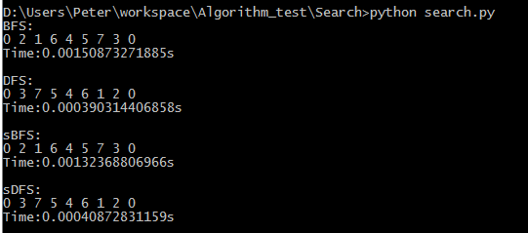
2）10个点
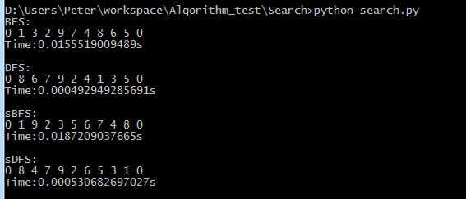
3）12个点
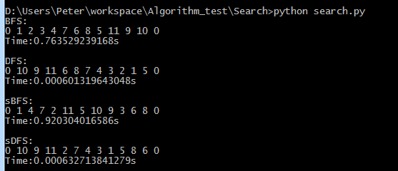
4）14个点
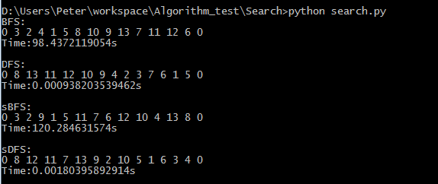
5）16个点
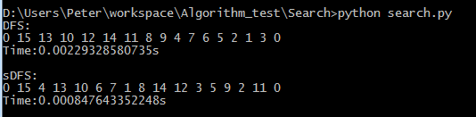
6）18个点
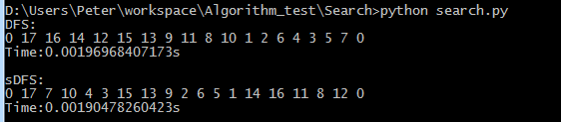
7）20个点
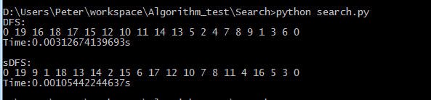
8）10个点不存在哈密顿环
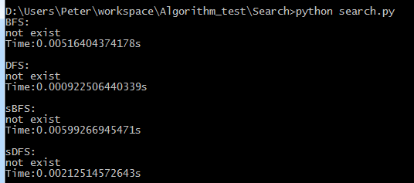
9）总结
BFS普遍比DFS要慢一些，因为倘若存在哈密顿环且图接近完全图，BFS几乎要把所有情况都遍历一遍才能找到解，在运行16个点的时候已经会把16G的内存挤满而无法运行出结果。
3.7.2 最小哈密顿环问题
1）8个点
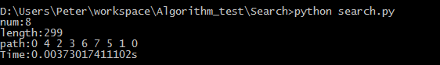
2）10个点
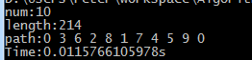
3）12个点
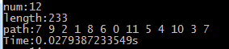
4）14个点
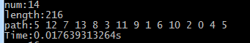
5）16个点
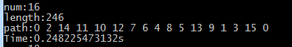
6）18个点
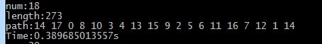
7）20个点
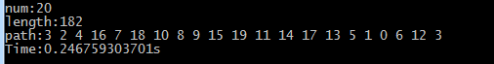
8）总结
分支限界法的时间取决于是否能尽快找到优化解，找到优化解即可尽快剪枝，而其优越性使得在点集为20的时候运行时间都很短，可以运行点数更大的点集。
3.8 性能曲线
3.8.1 寻找哈密顿环问题
1）DFS和sDFS
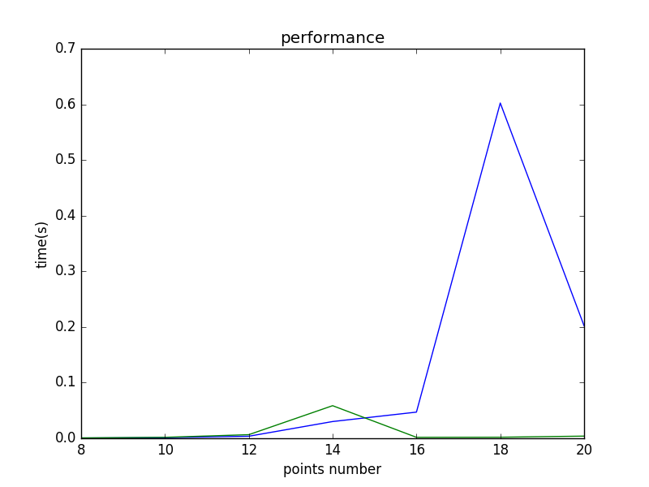
图中是DFS和sDFS每一种点数运行100次得到的运行时间平均值曲线，绿线是爬山法sDFS的性能曲线，蓝线是普通DFS的性能曲线，可以发现爬山法对于16个点及以上时优化效果更佳。而图像也是点集越大很快找到哈密顿环的概率越大，故两个曲线会出现凸起。
2）BFS和sBFS
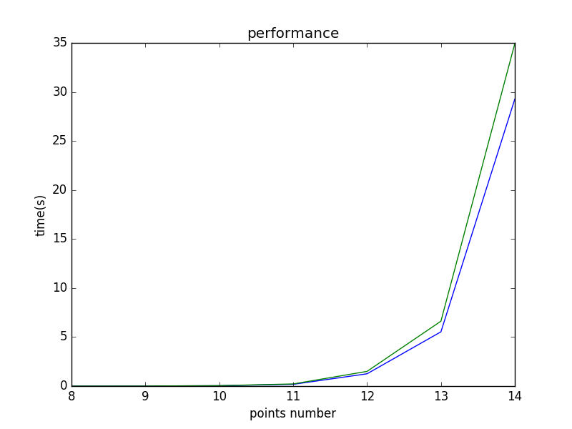
图中是BFS和sBFS在[8-10]个点集运行140次，在[11-14]个点集运行40次得到的运行时间平均值曲线，绿线是爬山法sBFS的性能曲线，蓝线是普通BFS的性能曲线，可以发现爬山法BFS并没有起到优化作用，其每一次对于点数的排序反而浪费了时间。整个图像时间随点数的增大增长极快，几乎呈指数级增长，这是因为BFS要遍历几乎每一种情况，所有情况是点数num的阶乘，故曲线也会与num的阶乘几乎同阶。
3.8.2 最小哈密顿环
分支限界法：
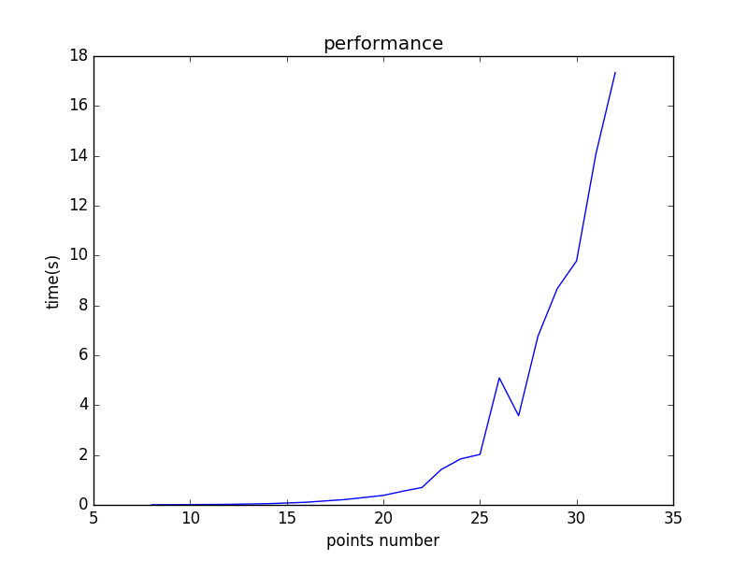
图为分支限界法在随机完全图中找到最小哈密顿环的平均时间曲线，分支限界法是性能较优越的算法，在点数为32的时候依旧可以在18秒以内找到最小哈密顿环。然而曲线依旧接近与点数的阶乘同阶。

四、实验心得
本实验证明了性能优越的算法可以解决范围很大的问题，且只使用很短的时间和很小的空间。而像BFS在找解的时候有时会很低效，把每一个点存入队列而不删除也会有可能使空间复杂度很大，所以以后在使用BFS还是DFS时，要根据问题来选择更优越的算法。

