Medical Image Computing (MT-M-3-ILV-IM2)

Exercise 01

Start Date: 03.11.2022

Due Date: 17.11.2022

Authors: Peter Rott, Markus Wernard, Filip Slatkovic

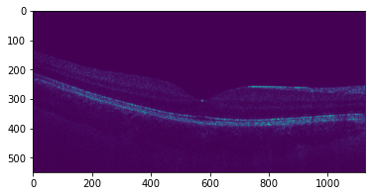

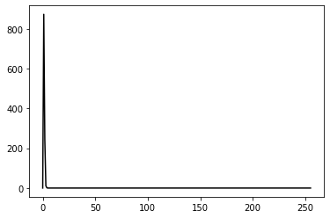

There is 873 pixels with the intensity of 1, 243 pixels with the intensity of 243, 11pixels are 3 and finally only 1 pixel has the intensity of 4. Hard to be shown here in the graph, and as a result we are not getting the best quality picture, histogram needs to be normalized.

How edge detection should look like