### **Data sources and defining variables**

Two key datasets were used, the first to measure and track lockdown stringency, the independent variable, and the second to measure and track political violence events, the dependent variable.

1. **Independent Variable: Oxford Coronavirus Government Response Tracker (OxCGRT)**

The OxCGRT tracks government responses to COVID-19 by containment, economic and health policies. For this study, the OxGCRT ‘Stringency Index’[1] was used, which aggregates the indicators in table 1 to give a score of overall lockdown strictness. The Stringency Index gives a score for almost every country on a daily timescale (updated twice weekly) enabling comparative timeseries analysis. Stringency Index scores were used as the independent variable.

|  |  |
| --- | --- |
| **ID** | **Description** |
| C1 | School closing |
| C2 | Workplace closing |
| C3 | Cancel public events |
| C4 | Restrictions on gathering size |
| C5 | Close public transport |
| C6 | Stay at home requirements |
| C7 | Restrictions on internal movement |
| C8 | Restrictions on international travel |
| H1 | Public information campaign |

*Table 1: OxCGRT Stringency Index composition*

1. **Dependent Variables: ACLED - Armed Conflict Location and Event Data**

ACLED produces political violence event data with near-global coverage. Each data point is a specific political violence event, with date, time, location, actors involved, actor definition, estimated fatalities and type of violence (e.g. protests, battles, remote violence). Two dependent variables were operationalised from ACLED data for each of the hypotheses.

**Use of actor and event definitions**

ACLED categorises eight types of actors (see Table 2), including state forces, several types of NSAGs, rioters, peaceful protestors, civilians, and external forces (such as foreign state actors). ACLED also provides definitions of ‘event type’, for example violence against civilians, remote violence or battles.

To explore H1several definitions were combined to operationalise a new definition of ‘Non-State Armed Groups’ (NSAGs). Similar actors were sometimes in different categories: Islamist insurgents in Cabo Delgado (Mozambique) were defined as actor 3,but Islamic State of West Africa as actor 2**.** Thus, actor definitions 2-4 were used, and this study defines NSGAs as ‘organised non-state groups engaging in violence with a political goal’, with their organised nature differentiating them from e.g. rioters. For H1, all event types were considered.

To explore H2,ACLED the ACLED classifications of the State Forces actor and ‘violence against civilians’ event type were used.

|  |  |  |
| --- | --- | --- |
| Actor ID | Actor | Definition |
| **1** | State Forces | “Collective actors that are recognised to perform government functions, including military and police, over a given territory”. |
| **2** | Rebel Groups | “Political organizations whose goal is to counter an established national governing regime by violent acts”. |
| **3** | Political Militias | “A more diverse set of violent actors, who are often created for a specific purpose or during a specific time period (i.e. Janjaweed largely active in Sudan) and for the furtherance of a political purpose by violence”. |
| **4** | Identity Militias | “Armed and violent groups organized around a collective, common feature including community, ethnicity, region, religion or, in exceptional cases, livelihood”. |
| **5** | Rioters | “Individuals or ‘mobs’ who either engage in violence during demonstrations or in spontaneous acts of disorganised violence”. |
| **6** | Protesters | “Peaceful, unarmed demonstrators”. |
| **7** | Civilians | “Victims of violent acts within ACLED as they are, by definition, unarmed and, hence, vulnerable”. |
| **8** | External/Other Forces | “International organisations, state forces active outside of their main country of operation, private security firms and their armed employees, and hired mercenaries acting independently”. |

*Table 2: ACLED actor types, all definitions taken from ACLED Codebook.[2]*

**Event counts**

From ACLED data we can use several indicators, the two most well-used are (i) number of events and (ii) number of fatalities. Fatalities data is less reliable than event, as multiple sources commonly quote different fatality numbers[3]. Thus, for this study, number of events (event count) was used as the dependent variable, with count of political violence events involving NSAGs for H1 and count of events involving SVAC for H2.

**Weekly/monthly data points**

ACLED provides event dates, enabling time-series analysis of these variables to a daily resolution. Over longer time series however, daily data points can create ‘data noise’ of too many data points, disabling trend analysis. To reduce ‘data noise’, weekly data points were used for statistical analysis over 2020, and monthly data points for data visualisation over the past five years (to allow for visual comparability to previous years).

**Deasonalised data**

Political violence can be seasonal in nature, following a distinct pattern over a year.[4] The data was deseasonalised, locating and removing seasonal patterns to reveal significant changes (see figure 1).

This process yielded a dependent variable for each hypothesis:

H1. *The stringency of lockdowns is related to violence involving non-state armed groups*:

**Deseasonalised number of events of political violence involving NSAGs per week/month**

H2. *The stringency of lockdowns is related to state violence against civilians.*

**Deseasonalised number of events of violence against civilians involving State Forces per week/month**

Figure 1. Nigeria NSAG violence seasonal event pattern located using multiplicative decomposition 2016-2020

**Observed Pattern**

**Trend**

**Seasonal Pattern**

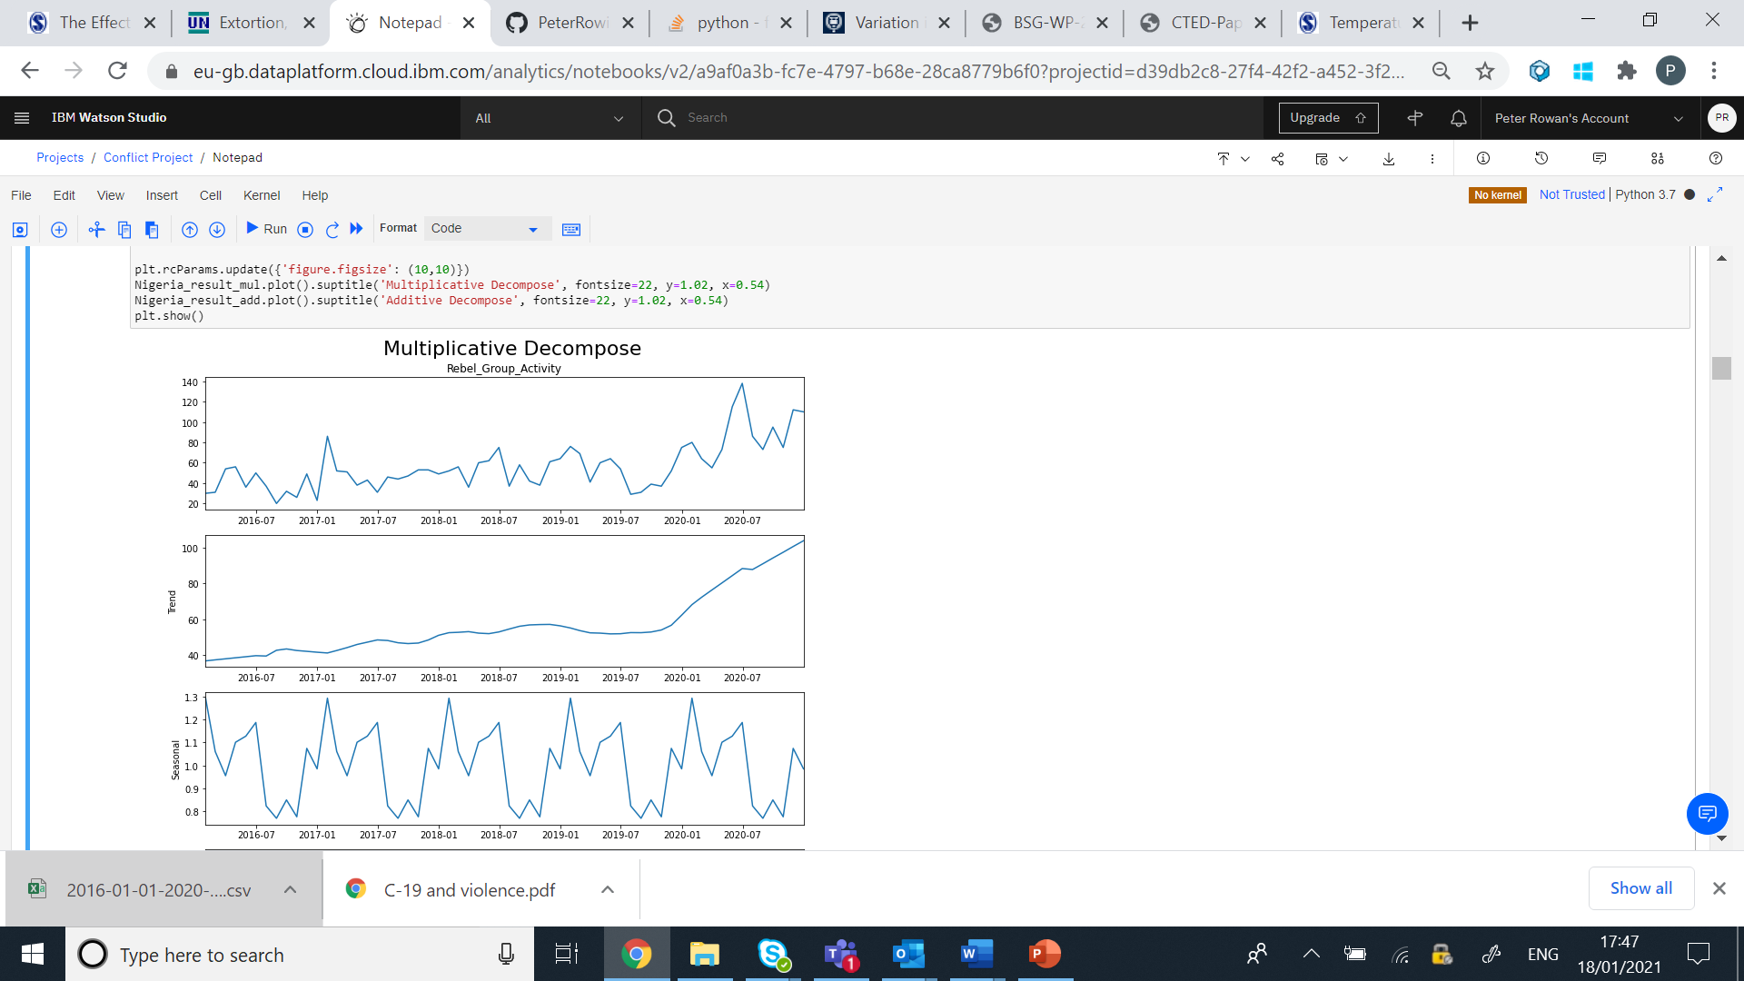

1. OxCGRT (2021) ‘Methodology for calculating indices’, [online], (Available at: <https://github.com/OxCGRT/covid-policy-tracker/blob/master/documentation/index_methodology.md>, *(Last accessed: 01/02/2021).*
2. ACLED (no date) ‘Armed Conflict Location & Event Data Project (ACLED) Codebook’, [online], (Available at: <https://acleddata.com/acleddatanew/wp-content/uploads/dlm_uploads/2019/04/ACLED_Codebook_2019FINAL_pbl.pdf>), *(Last accessed: 01/02/2021).*
3. ACLED (no date) ‘Armed Conflict Location & Event Data Project (ACLED) Codebook’, [online], (Available at: <https://acleddata.com/acleddatanew/wp-content/uploads/dlm_uploads/2019/04/ACLED_Codebook_2019FINAL_pbl.pdf>), *(Last accessed: 01/02/2021).*
4. Guardado, J. Pennings, S. (2016) ‘The Seasonality of Conflict’, *World Bank,*  [online], (Available at: <http://pubdocs.worldbank.org/en/550371467251931899/The-Seasonality-Conflict-Steven-Pennings.pdf>), *(Last accessed: 01/02/2021).*