1/5/2021

Ali Abdel Razik, Peter Sabry, Maha Ibrahim and Howida Samir

**Nile university**

**Scientific Computing**

Coursework 1 Report

**Scientific Computing**

**January 5, 2021**

|  |  |
| --- | --- |
| *ID* | Name |
|  | Ali Abdel Razik |
| *18270045* | Peter Sabry |
| *1910273* | Maha Ibrahim Abdel Aleem |
| *1910298* | Howida Samir Mohamed |

Contents

**Solution Structure** 3

**Classes** 3

**Functions:** 3

**Running the Application:** 5

**1.** **Doing 1-D Regression (with second order polynomial *m = 2*) / Gauss Elimination** 5

**1.1** **Plotting for First Dataset** 7

**1.2** **Plotting for Second Dataset** 7

**2.** **Doing 1-D Regression (with third order polynomial *m = 3*)** 8

**2.1** **Plotting for First Dataset** 10

**2.2** **Plotting for Second Dataset** 10

**3.** **Doing 1-D Regression (with second order polynomial *m = 2*) / Gauss-Siedel** 11

**3.1** **Testing on First Dataset** 11

**3.2** **Testing on Second Dataset** 12

**4.** **Performing 2D Polynomial Linear Regression (Fitting a Plane)** 13

**4.1** **Using Bedrooms & Bathrooms** 14

**4.2** **Using Bedrooms & Stories** 15

**4.3** **Using Bedrooms & Lotsize** 16

**4.4** **Using Bathrooms & Stories** 17

**4.5** **Using Bathrooms & Lotsize** 18

**4.6** **Using Stories & Lotsize** 19

**5.** **Performing Interpolation** 20

**5.1** **Newton Interpolation** 20

# **Solution Structure**

Environment Used: Visual Studio 2019 – C++ Project

Source Code: <https://github.com/PeterSabry84/Numerical_Solver.git>

## **Classes**

|  |  |
| --- | --- |
| *Class Name* | Main Purpose |
| *Linear_system* | Solving linear equations  (Using Gauss Scaled Elimination or/ Gauss-Siedel Iterations) |
| *univar_regressor* | Doing 1-D linear regression (Line Fitting or/ Curve Fitting) |
| *multivar_regressor* | Doing 2-D linear regression (Plane Fitting) |
| *Matrix* | Facilitate using 2D arrays |
| *Newton_interpolator* | Performing Newton Interpolation |
| *Spline_Interpolator* | Performing Spline Interpolation |

## **Functions:**

|  |  |  |
| --- | --- | --- |
| *Class Name* | Function Name | Main Purpose |
| *Linear_system* | Constructor:  Linear_system(Matrix A, Matrix b) |  |
| Solve() | * Solve linear equations using Gauss Scaled Elimination * Uses two variables of type Matrix: A, b, both are forming an augmented matrix that is used to fined the solution |
| solve_iteratively(double initials[], const int& n_iter) | * Solve linear equations using Gauss-Siedel iterations, it accepts initial values and number of iterations |
|  |  |
| bool is_valid_solution() | * Returns a Boolean reflecting the ill-condition state of the system of equations |
| *univar_regressor* | Constructor  univar_regressor(const double x[], const double y[], const int m, const int s) | Accepts X, Y as array data points  *m* is the desired polynomial degree  *s* is an option to use gauss elimination or gauss-siedel iterations |
| fit() | Does the regression task on the points x, y   * Computes the Augmented Matrix (A| b) * Calls the Linear_system.solve() or Linear_system.solve_iteratively() to get solution * Returns the solution |
| predict(const double xi, const Matrix coeff, const int m) | Makes a single prediction for a point x  Called within a loop to predict multiple points |
| *multivar_regressor* | multivar_regressor(const Matrix x, const double y[], const int n, const int m) | Almost the same as univar_regressor except for the input X is of type matrix to accommodate for x[n, 2] input |
| fit() | Same as in univar_regressor, difference in the way the coefficients matrix is computed |
| predict(const double xi[], const Matrix coeff, const int m) | Same as in univar_regressor |
| *Newton_interpolator* | Constructor  Newton_interpolator(double* x, double* y, int size) |  |
| finite_difference(const int& first, const int& last) | Computes finite differences |
| fit() | Uses finite_difference to fit a polynomial |
| interpolate(const double& x_new) | Interpolates a point |
|  |  |  |
| *Spline_Interpolator* | Constructor  Spline_interpolator(double* x, double* y, int size) |  |
| fit() |  |
| interpolate(const double& x_new) |  |

# **Running the Application:**

## **Doing 1-D Regression (with second order polynomial *m = 2*) / Gauss Elimination**

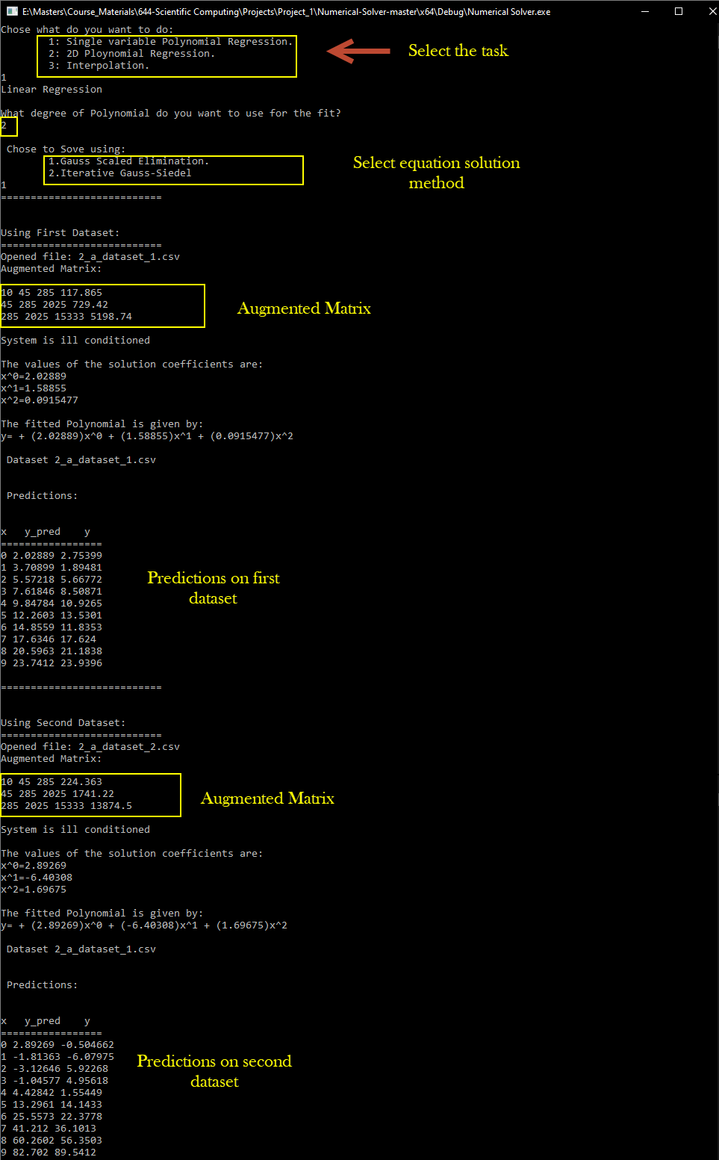



### **Plotting for First Dataset**

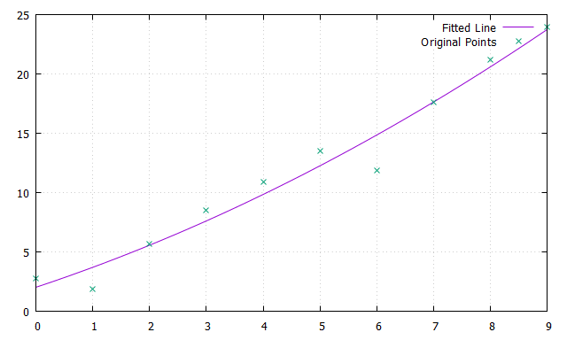

### **Plotting for Second Dataset**

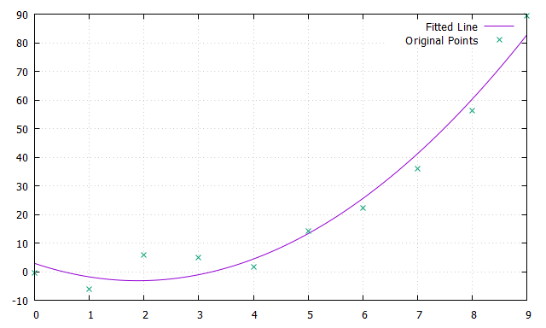

## **Doing 1-D Regression (with third order polynomial *m = 3*)**

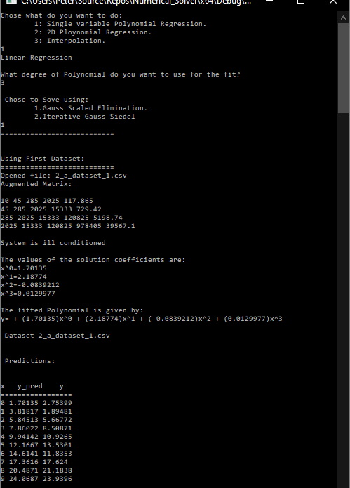

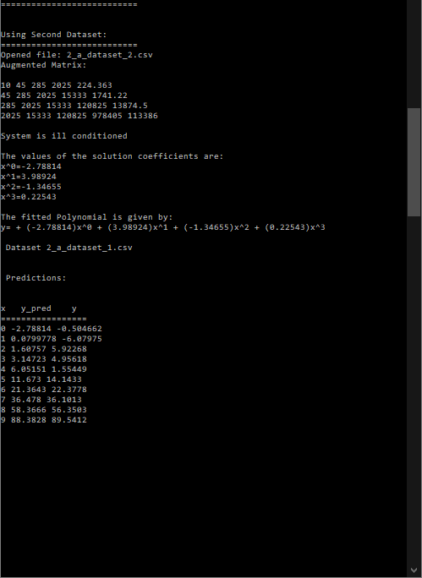

### **Plotting for First Dataset**

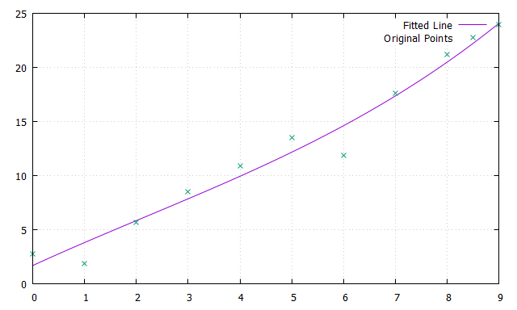

### **Plotting for Second Dataset**

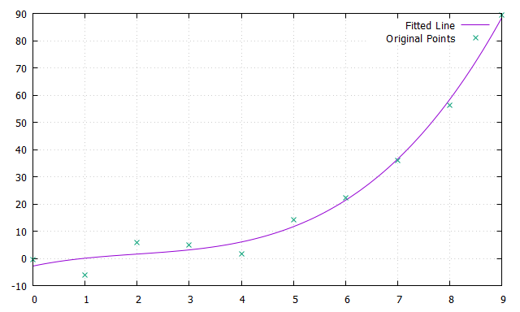

**It is clear that a third order polynomial fits better than a second order**

## **Doing 1-D Regression (with second order polynomial *m = 2*) / Gauss-Siedel**

### **Testing on First Dataset**

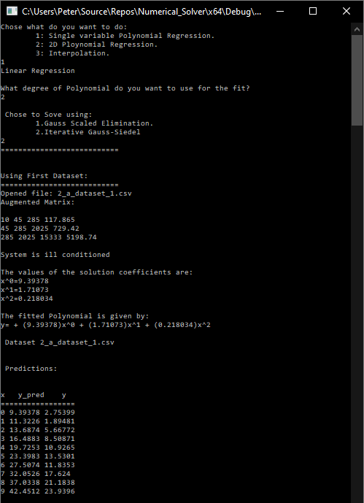

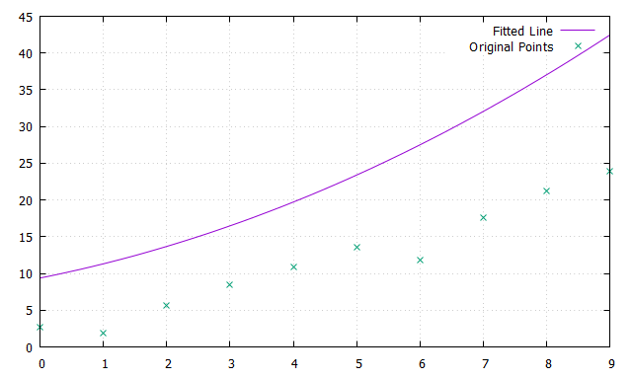

### **Testing on Second Dataset**

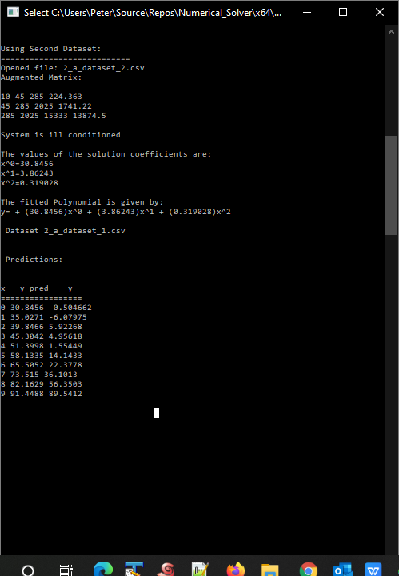

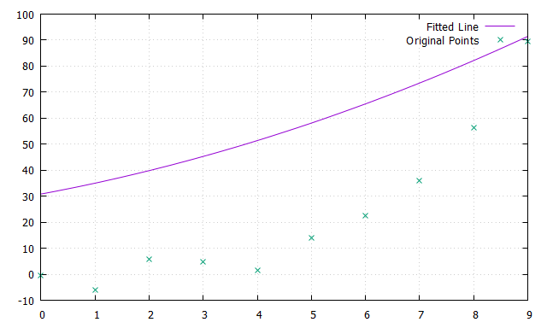

## **Performing 2D Polynomial Linear Regression (Fitting a Plane)**

**Notes/ Assumptions:**

* The Housing.csv file was edited by removing the un-needed columns and keeping only the following:

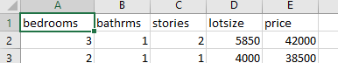

* All columns are in different scales, normalizing was used according to the following simple form: normalized_value = (original_value – min_value) / (max_value – min_value)
* Mean Square Error was calculated based on normalized values
* It was noticed that MSE is the lowest when using "**bathrooms**" and "**lotsize**" features as per the following summary table

|  |  |
| --- | --- |
| **Fearures** | **MSE** |
| Using "bedrooms" and "bathrooms" | 0.01825 |
| Using "bedrooms" and "stories" | 0.020317 |
| Using "bedrooms" and "lotsize" | 0.016463 |
| Using "bathrooms" and "stories" | 0.017282 |
| Using "bathrooms" and "lotsize" | 0.014007 |
| Using "stories" and "lotsize" | 0.014909 |

### **Using Bedrooms & Bathrooms**

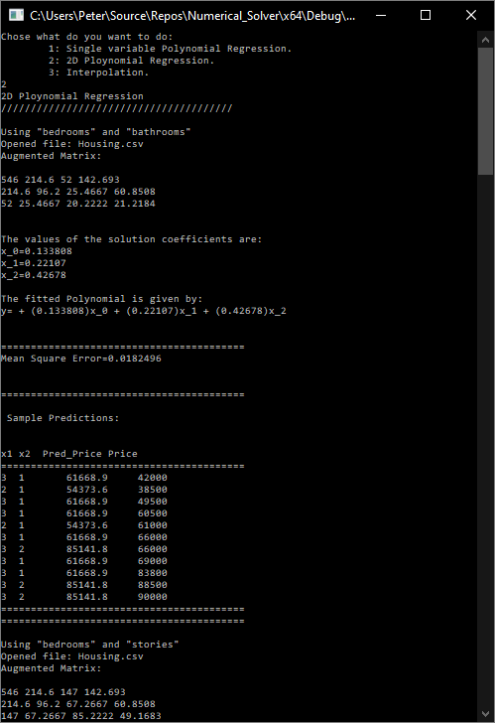

### **Using Bedrooms & Stories**

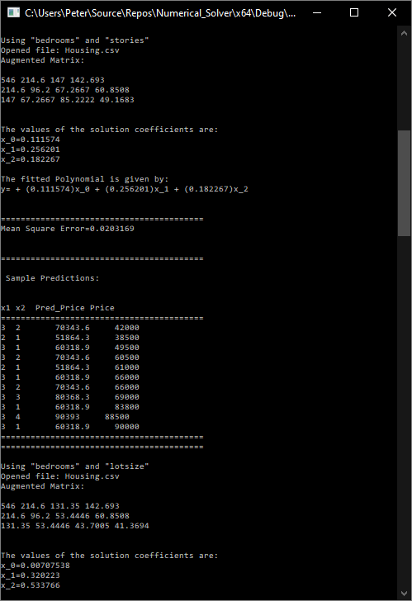

### **Using Bedrooms & Lotsize**

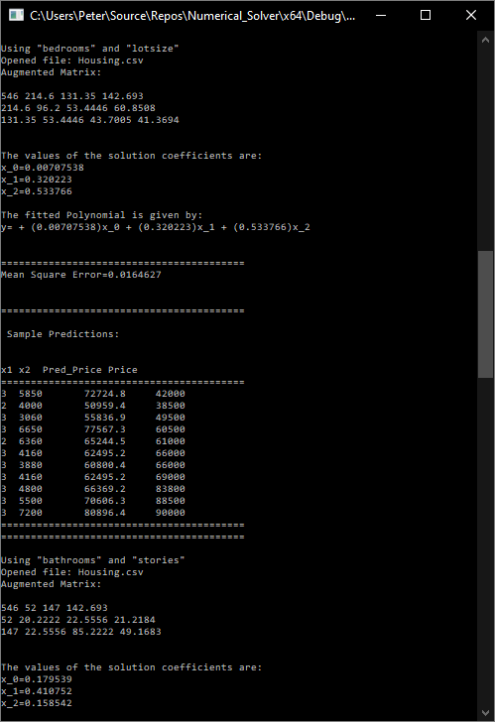

### **Using Bathrooms & Stories**

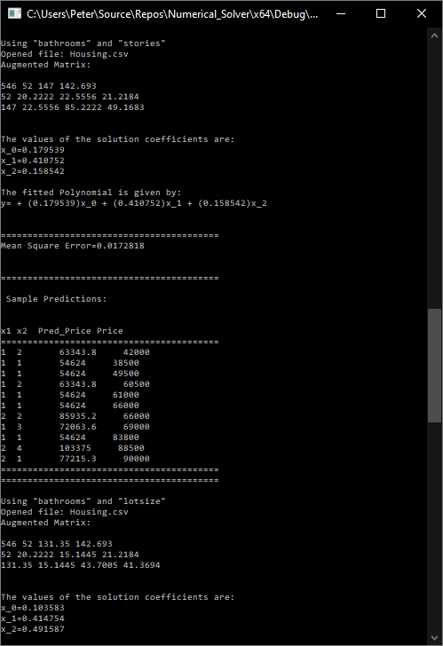

### **Using Bathrooms & Lotsize**

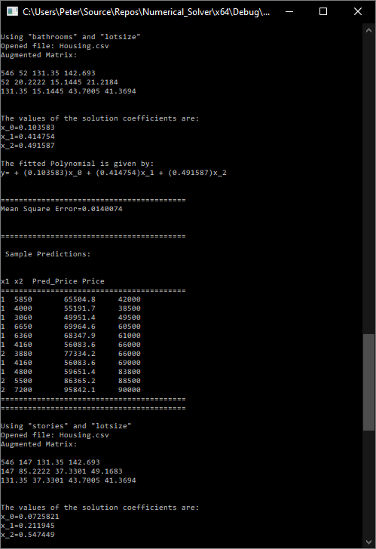

### **Using Stories & Lotsize**

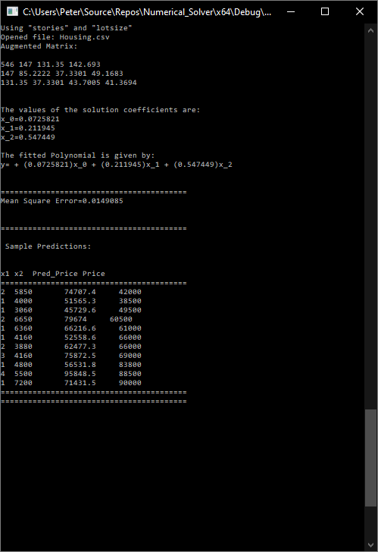

## **Performing Interpolation**

### **Newton Interpolation**

Coefficients file: coeff_3_dataset_1.csv, coeff_3_dataset_2.csv

