# Digression – Variables & Data Structures

## Variables

Almost everyone will have used a spreadsheet at some time or other. We are familiar with the grid layout and our ability to enter values directly into cells and perform calculations on them.

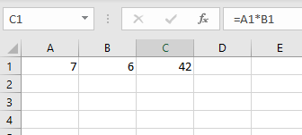

In the image above, the value of 7 has been place in cell A1, the value of 6 has been placed in cell B1 and in cell C1 is the result of multiplying the value od cell A1 by the value of cell B1.

In a spreadsheet the variables you use are predefined (although you can create new names for them) In programming languages like Python, you create new variables as you need them, but you use them in a very similar way.

In Python we would write:

A1 = 6

B1 = 7

C1 = A1*B1

Exercise: put these three lines of code into a single cell of a Notebook and run the cell. What output do you get?

If we want to see the value of C1 we can either just add a line with C1 in it

A1 = 6

B1 = 7

C1 = A1*B1

C1

Or a better option is to use the print statement

A1 = 6

B1 = 7

C1 = A1*B1

print(C1)

If you don’t use ‘print’ and try to output more than one variable, you will only see the last one. If you do use ‘print’ then you will see all of the ones you output

## Data Structures

In addition to using the default cell names like ‘A1’ in Excel, you can rename (or more accurately add an additional name or alias) a cell.

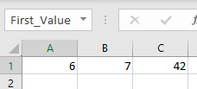

Here the A1 cell has been given the name ‘First_Value’.

You can use the names in formulae

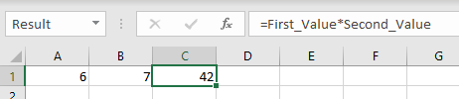

This can aid readability in spreadsheets and is similar to what we would write in Python

Result = First_Value * Second_Value

We are not restricted to renaming single cells. We can rename whole groups of cells together.

Excel provides the facility to ‘convert’ a group of cells into a Table. You can give the whole table a name.

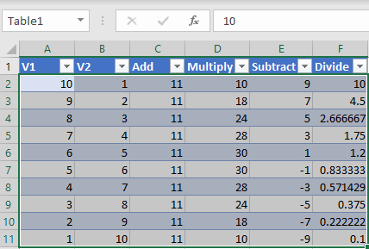

The table is a data structure, you can think of it a whole; Table1 or a collection of cells; A1 to F11, or as a set of columns; V1, V2 etc. depending on how you want to use the data.

The table structure of Rows and Columns is by far the most common data structure we use in Data Analysis