CP1406 A2 Barrier Reef Orchestra improved website

Goals: The goals of the improved website are to improve the functionality and simplicity of the website so BRO can outreach to the Townsville community to try and get them involved. This includes improving attendance to orchestras by an unspecified number of attendees.

Success Evaluation: The success of the website will be evaluated by the increase in attendees to the concerts, the increase of community interaction and member registration by an unspecified amount.

Target Audience: The target audience for the website is essentially anyone interested in the genre although, BRO wishes to attract younger people to Orchestra.

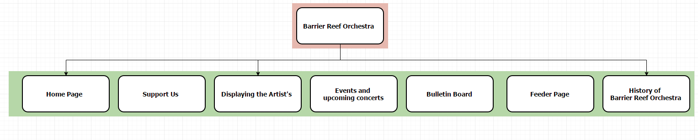Site Flowchart:

Content and design: