Project title: Video Game: Dead Man’s Volley
__________________________________________________________________________________
Report Name Game Design
Author (User Id) Peter Hodgkinson (Peh19)
Supervisor David Hunter (Dah56)
Module CS39440
Degree Scheme G450 (Computer Graphics, Vision and Games)
Date Feb 7th, 2019
Revision v0.1
Status Draft

- Game Overview
  - Game Concept
The concept for this game is to take the common gameplay mechanic known in pop culture as ‘dead man’s volley’ or ‘the tennis boss’ and to focus and expand on it.

  - Genre
The planned game most closely resembles a top-down action-adventure shooter, though the player never creates a projectile.

  - Target Audience
The target audience for this game would most likely be somewhere between the casual market and people who like a bit of a challenge.

  - Game Flow Summary – How does the player move through the game. Both through framing interface and the game itself.
The game will have simple stylized menus designed to be consistent with the games visual style. Options will be displayed in a vertical layout aligned to the left,

  - Look and Feel – What is the basic look and feel of the game? What is the visual style?
Most of the game’s assets will be simple geometric shapes designed to look like they are made from neon strips with a black or dark coloured background. This is to convey a futuristic feel and make all important objects and details standout.

- Gameplay and Mechanics
  - Gameplay
    - Game Progression
Players progress through a series of premade level. Each connected by a narrated story.

    - Mission/challenge Structure
‘Missions’ primarily consist of the player reaching a goal at the end of the level. A variety of enemies and puzzles will be in the players way. Sometimes the goal will be replaced with a boss enemy that the player must defeat.

    - Puzzle Structure
Puzzles would mostly consist of guiding one or many projectiles to a corresponding switch, making use of other objects in the environment to do so. Combat can also be considered a puzzle, as the player must consider how to hit the enemies with their own projectiles.

    - Objectives – What are the objectives of the game?
The objective of the game is to complete all the levels by navigating each one from beginning to end. Each level is filled with puzzles, enemies and traps to hinder the players progress.

    - Play Flow – How does the game flow for the game player?
In the early levels of the game, combat will be against simple enemies that don’t have much health and use simple behavior patterns that don’t try to avoid projectiles. Puzzles at this time will be kept simple to introduce the player to the primary mechanics of the game. Later levels will have more enemies with more health and more complex behavior patterns that include dodging and reflecting projectiles. Puzzles at that point will utilize multiple mechanics and may include a time limit or have combat occur midway through solving them.

  - Mechanics – What are the rules to the game, both implicit and explicit. This is the model of the universe that the game works under. Think of it as a simulation of a world, how do all the pieces interact?
    - Physics – How does the physical universe work?
The game is limited to a top-down perspective with no changes in altitude within the levels, so there is no need for gravity to be a factor. The primary physics mechanic to consider is how objects (primarily the projectile) collide with each other.

    - Movement in the game
As players are restricted to a top-down view, movement is limited to walking around a single plane. The player orientation should be controllable separately from the movement direction so that the players can aim without moving around.

    - Objects – How to pick them up and move them?
The important objects to be included are:
The projectile – The projectile is constantly moving, and persists until it hits either the player, an enemy or a switch. Hitting a player or enemy removes a unit of health from the effected, while hitting a switch might activate it dependent on the colour of both the projectile and the switch. When hitting a wall or similar object, the ball should bounce of at a mirrored angle unless doing so risks causes issues.
Switches – Switches are used to activate or deactivate different obstacles in the environment. Some switches can be interacted with using just the bat, while most others require a projectile, sometimes of a particular colour to be interacted with. After being used once, some switches will become inoperable, while other can still be used, either to repeat the effect or undo it.
Moving walls – Moving wall are the same as normal walls but with a velocity. This velocity can either be a linear direction or an angular direction. Players, enemies and projectiles cannot pass through them. Some switches can be used to control if a wall is moving or not.
Electrified floors – Simple floor tiles that damages both the player and enemies. They do not affect the ball in any way. They can either be on, off or in a state where they periodically switch between being on or off. Some switches can be used to change their state.
‘Creators’ – Aptly named as this object acts as a spawn point for other entities, such as enemies, projectiles and moving walls. These objects cannot be passed through, like a wall. They can be activated or deactivated by interacting with a corresponding switch.
‘Destroyers’ – This object will destroy any entity that interacts with it, aside from ‘creators’ and stationary walls. These can also have a velocity and bounce off walls. They can be activated or deactivated by interacting with a corresponding switch.
Goal – The objective the player must reach in almost every level. The level ends when the player hits the goal with the bat. No other entity can interact with this object.

    - Actions – Including whatever switches and buttons are used, interacting with objects, and what means of communication are used.
The player can move around, turn-around separately from their velocity and swing their bat. If the bat hits an entity while being swung, the object is giving a new velocity in the case of the ball, or it is activated in the case of some switches.

    - Combat – If there is combat or even conflict, how is this specifically modeled?
The player cannot just run up to an enemy and hit them with the bat. All this does is push the enemy back a bit without damaging them. To damage and defeat an enemy, the player must use the bat to launch a projectile into the enemy. As the player does not have the ability to create projectiles, they must either redirect the ones the enemies create, or find them in the environment.

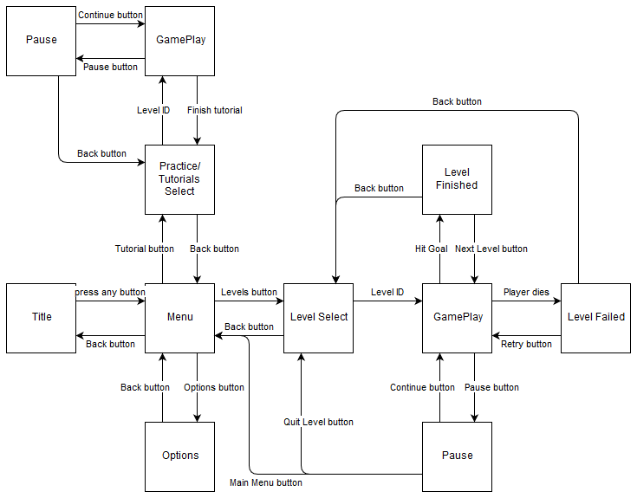
    - Screen Flow – A graphical description of how each screen is related to every other and a description of the purpose of each screen.
Title – Required by console manufacturers as part of the standard Technical Requirements Checklist. This provides a safe user-agnostic screen where simple animation can be provided to reduce screen burn and the next button press can be used to identify the primary controller.
Menu – This screen provides access to other menus that have their content sorted by topic to reduce risk of overwhelming the player with too many menu options at once.
Options – This screen allows the player to adjust setting of the game, like the main volume and the screen brightness. An option to change the default colours used in the environment to assist with colour blindness would be a wise idea.
Practice/Tutorial Select – A menu which provides access to levels designed to help the player practice the mechanics of the game. These levels will be useful in assisting development as each one is designed to explain a separate mechanic.
Level Select – A menu which provides access to the primary levels in the game. These levels are ordered by their scaling difficulty and carry a narrative throughout all of them.
Game Play – This screen is used when the player is in a level in control of the player character.
Pause – A menu the player can access during game play. Bringing it up pauses the game play
Level Finished – This screen is displayed when the player completes a level. At this point the game saves the players progress.
Level Failed – This screen displays when the player loses all their health. The level is reset if the player chooses to retry it.

  - Game Options – What are the options and how do they affect game play and mechanics?
The first option available to the players is to change the default colours of the environment to possible colour combinations that are friendlier to different types of colour blindness. The second option allows the player to adjust the volume of the music and the sound effects separately. The last option is to change the model used for the player character, though this is not an important option and so is not required for implementation.

  - Replaying and Saving
Saving should be done automatically after the player have finished one of the main levels of the game or has made changes in the options menu. This should reduce the risk of the player losing progress due to hardware or software failure.

  - Cheats and Easter Eggs
A text input box will be displayed in the options menu. Inputting different passwords into this box will activate or deactivate different cheats. These cheats will initially be used to assist with testing the game and will be left in for the players to have fun with. While I would like to include Easter eggs and references to other franchises that I enjoy, implementing then will take time out of developing other more important asset, so I will not be including any Easter eggs for now.
- Story, Setting and Character
  - Story and Narrative – Includes back story, plot elements, game progression, and cut scenes. Cut scenes descriptions include the actors, the setting, and the storyboard or script.
The main character is a treasure hunter for hire. After completing his last contract, his employer had him killed for ‘knowing to much’. Now trapped at the bottom of hell, you must help him fight his way back to the world of the living to get revenge on the man who ordered his death.
Each setting the story takes place in is comprised of 5 normal levels and 1 boss level. Visual differences between the levels are used to convey progression in the story as the player travels from area to area.
In this initial build of the game, only two cut scenes are needed. The first is the main character accepting the job from the employer, the second is the main character being killed by the employer and waking up in hell. This is because I do not see myself developing more that 4 to 5 levels for this game as a major project, however I would like to show the consideration for further development.

  - Game World
    - General look and feel of world
The environment consists of relatively simple geometric shapes with materials that emit light to give a neon rod feel to every object. This causes the world to feel much more like a game instead of an actual world.

    - Areas - Including the general description and physical characteristics as well as how it relates to the rest of the world (what levels use it, how it connects to other areas)
Areas are made distinct by the patterns and colours of the walls. An example would be using smooth, shallow curving wall and the colour green to convey the idea of an open environment with some hills. Another example would be using straight, right angled walls and different greys to convey an urban environment.

  - Characters - Each character should include the back story, personality, appearance, animations, abilities, relevance to the story and relationship to other characters
The story is just to give context to your actions in the game, there is no intention to make it particularly intercut. As a result, the characters don’t have names and little backstory; while they do have personalities, these are mostly ‘one note’ to give context as to why the characters objective is ‘this’ rather than ‘that’.

- Levels
  - Levels - Each level should include a synopsis, the required introductory material (and how it is provided), the objectives, and the details of what happens in the level. Depending on the game, this may include the physical description of the map, the critical path that the player needs to take, and what encounters are important or incidental.

  - Training Level
The training levels or ‘tutorials’ will be in a separate menu from the primary story levels. There should be a level for basic player controls, one for environmental interactions and one for combat. An additional training level to consider is a ‘playground’ where all of the games objects are available for the player to experiment with.

- Interface
  - Visual System. If you have a HUD, what is on it? What menus are you displaying? What is the camera model?

  - Control System – How does the game player control the game? What are the specific commands?

  - Audio, music, sound effects

  - Help System

- Artificial Intelligence
  - Opponent and Enemy AI – The active opponent that plays against the game player and therefore requires strategic decision making.
Three types of enemies are currently planned, each with slight variations in behaviour based on design. The first simply moves around and launches projectiles at the player, intended to be a simple enemy to introduce combat and only provide a challenge in vast numbers.
The second tries to stay within a distance from the player and tries to move out of the path of projectiles.
The third also tries to stay within a distance from the player and move out of the path of projectiles, but it is also capable of using a bat to redirect projectiles. This AI will be a mixture of state based and probabilistic systems, transitions between states will be handled by probabilities that change based on the environment.

  - Support AI -- Player and Collision Detection, Pathfinding.
AI for detecting collisions between objects will be handled by the game engine. Pathfinding will utilise a system that the game engine provides called ‘Nav Mesh’.
- Technical
  - Target Hardware
The target is to have this game be able to run on Windows PC, Xbox One, PS4 and Nintendo Switch

  - Development hardware and software - including Game Engine
This game will be developed in the Unity engine version Unity 2018.3.5 developed by Unity Technologies. This will include the uses of the Unity Editor and MonoDevelop. Most 3-D assets and animations will be developed in Blender version 2.79b. Most textures and 2-D assets will be developed in a combination of paint.net developed by dotPDN, and Aseprite developed by David Capello.

- Game Art – Key assets, how they are being developed. Intended style.

