January 9, 2009  The White House  1600 Pennsylvania Avenue NW  Washington, DC 20500  Dear Mr President,  Re: Gaza  You have blamed the current crisis on Hamas and I have often heard you say that Israel has the “right to defend itself” but you don’t seem to extend that same right to the Palestinian population. Are they not human too?  When you think of Hamas, I urge you to stop thinking Al-Queda but instead think French Resistance and even the fighters in the Warsaw Ghetto Uprising. Yes, the tactics of Hamas are sometimes horrific but that is a reflection of 60 years of Palestinian dispossession, continued land theft and violent oppression. The majority of Gaza’s population is made up of those that fled the fighting in 1948 when Israel was formed and their descendants. Although the Israelis pulled out in 2005, they kept control of the borders and maintained an economic stranglehold on the territory leading to utter desperation by the inhabitants. They voted for Hamas because they offered resistance and indeed revenge.  If the Israelis refuse the Right of Return, as demanded by UN Resolution 194, they need to ensure that the refugees of 1948 and their descendants can make a decent life wherever they are now. Instead of bombing infrastructure they should be building it.  And so I see that today, the Palestinian death toll approaches 800—utterly out of proportion to the damage and injury caused by Hamas’ rockets. Indeed, the Guardian reports that “At least 30 people were killed in the Zeitoun district of Gaza after Israeli troops repeatedly shelled a house to which more than 100 Palestinians had been evacuated by the Israeli military, the UN said today.”  This is barbaric and yet the US abstained from a vote at the UN Security Council demanding an immediate cease-fire! Demand an end to the violence, end military aid to Israel and send aid to Palestine. Now!  Peter ######  #######################  Alexandria, VA 22304 |  | 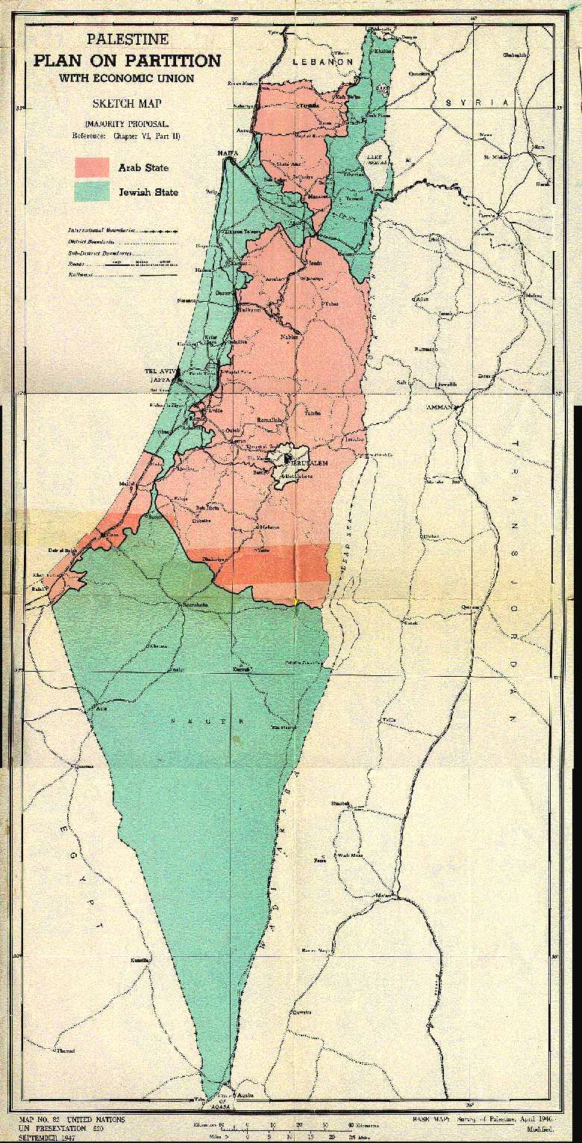  In 1947 the UN offered the Jewish population half of Palestine (green) over Arab objections.  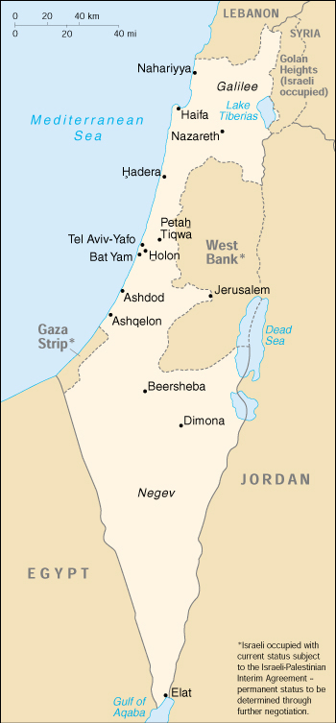  but Jewish forces seized 78% fixing the borders.  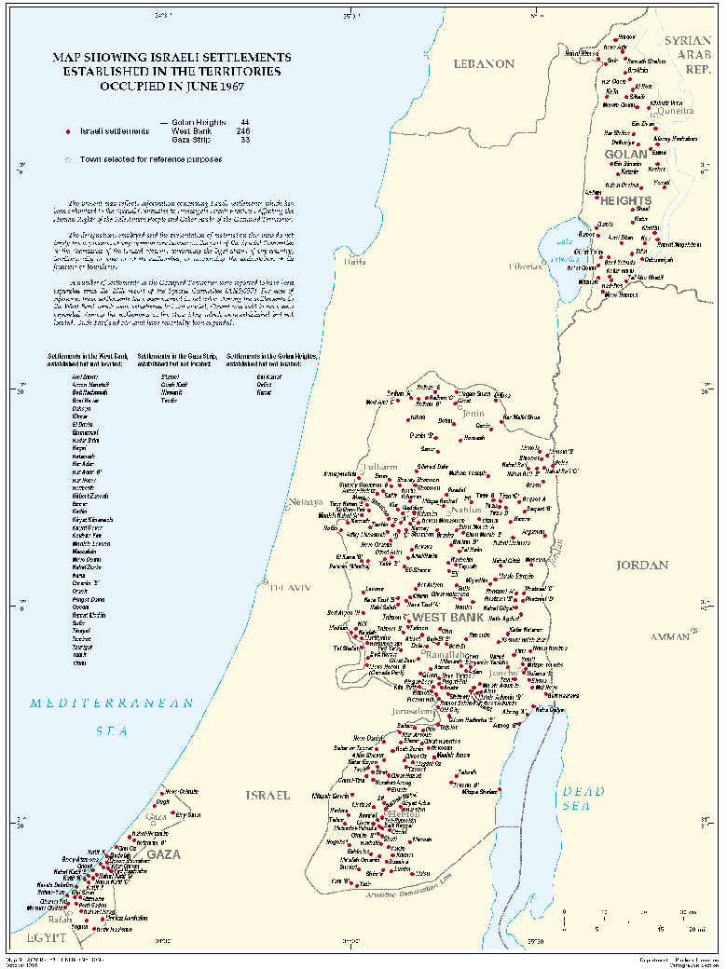  and from 1967 started building “settlements” in the rest.

