January 27, 2009  The White House  1600 Pennsylvania Avenue NW  Washington, DC 20500  Re: Palestine  Dear Mr. President,  First let me so how pleased I am that you were elected and I am thrilled that you have taken swift action to close the detention center at Guantanamo Bay and to raise fuel economy standards for vehicles.  However, where I am desperate for a change of policy compared with past administrations, both Republican and Democrat, is how we approach the Israeli-Palestinian conflict.  Specifically, we must:  - Demand that Israel cease all settlement construction immediately and cut off aid if they don’t. The removal of all settlers is the key to reaching any lasting peace. If you missed 60 Minutes last Sunday, I encourage you to see “Time Running Out For A Two-State Solution?”, the most honest thing I’ve seen on American TV about the subject.  - Demand that Israel and Egypt open the borders to Gaza. Although Israel withdrew settlers in 2005, it retained control of the borders and has effectively placed Gaza under siege. The collective punishment must stop. The tunnels’ main use was to bring in essential supplies, not weapons though they have come in too.  - Condemn the violence on both sides but deal with the underlying issues that cause it—the dispossession and continued oppression of the Palestinians. Jewish groups have sought and recovered artworks stolen by the Nazis and bank accounts stolen by the Swiss. It is time that we and the Israelis finally recognize that the Palestinians want their houses and land back. If the Israelis refuse them the Right of Return as required by UN Resolution 194, we must help them make a new life where they are now—jobs, food, water, electricity, open borders and no more land theft, assassinations, harassment by settlers or internal checkpoints.  The PLO, now Fatah, recognized Israel and renounced violence so they could participate in the Oslo Accords but Israel responded by accelerating the construction of Jewish settlements on occupied land. Many Palestinians took the lesson that negotiations were a way to keep them quiet while their land was stolen and therefore their only hope is to fight. Hamas was democratically elected in elections that we insisted upon in part because they offered resistance. Give the Palestinians a clear path to a better future and the violence will end. Talk to Hamas. Their methods can be horrific but we not only talk to the Israelis , we give them $3 billion a year, mainly as military aid, some of which they just used to kill 1,300 Gazans including 400 children! Is that not horrific? If we ask Hamas to renounce violence (and we must), then we must insist that Israel do the same.  Peter ######  #########################, Alexandria, VA 22304 |  | 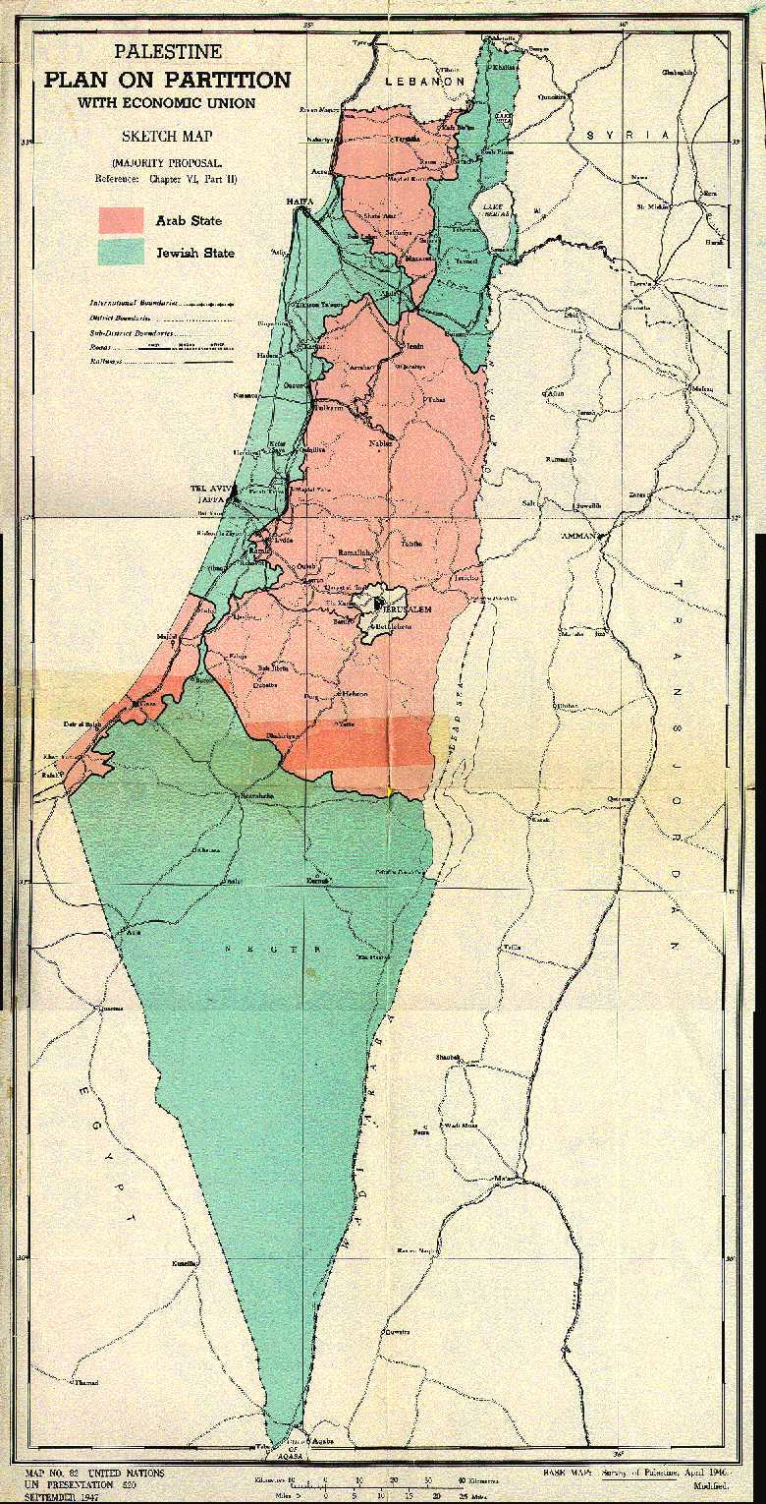  In 1947 the UN offered the Jewish population half of Palestine (green) over Arab objections.  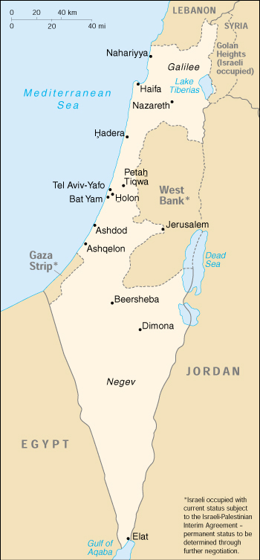  … but Jewish forces seized 78% fixing the borders  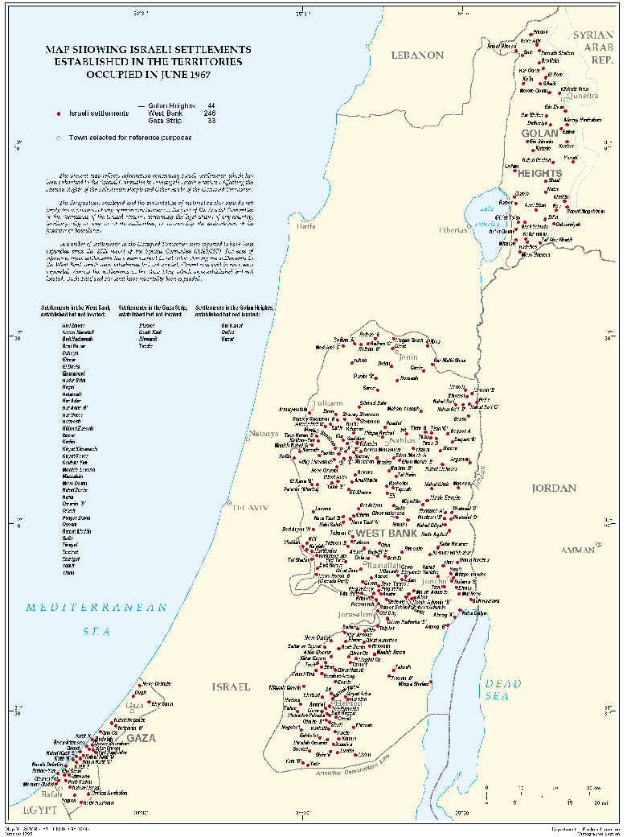  … and from 1967 started building “settlements” in the rest.

