程式碼：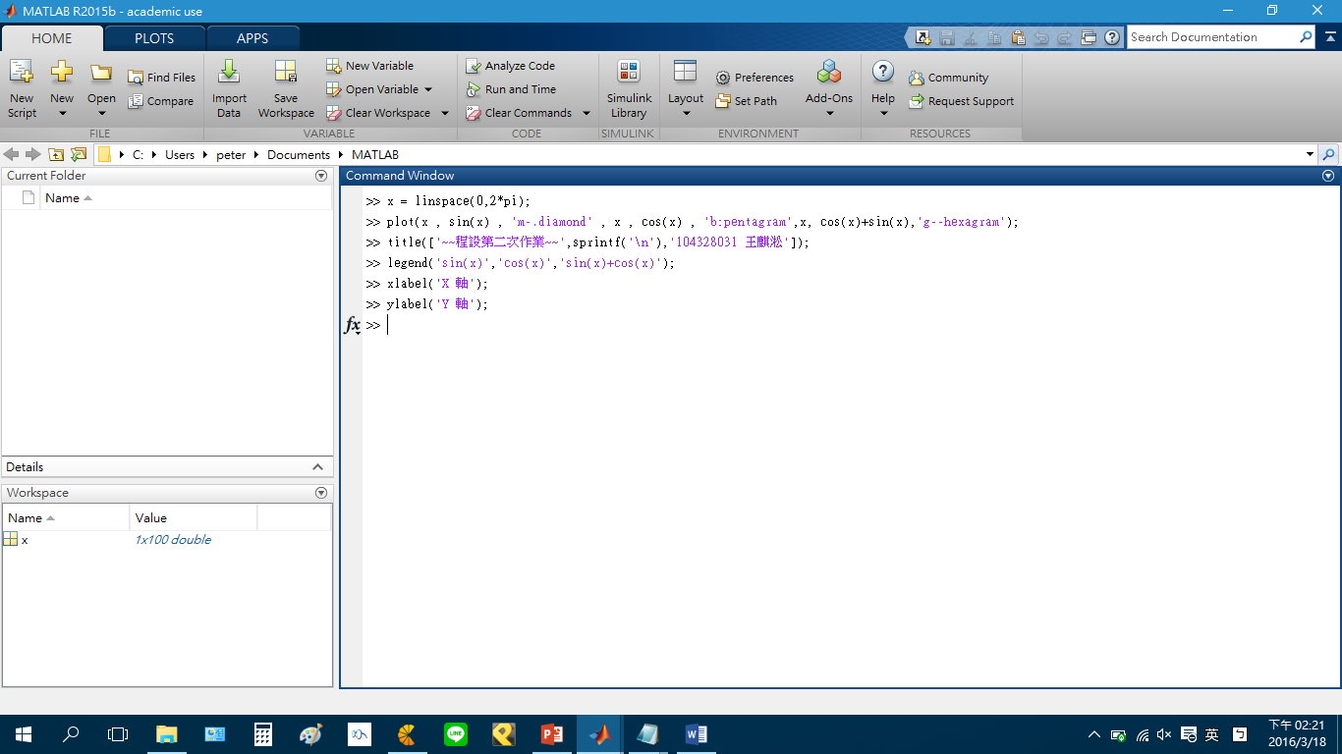

>> x = linspace(0,2\*pi);

>> plot(x , sin(x) , 'm-.diamond' , x , cos(x) , 'b:pentagram',x, cos(x)+sin(x),'g--hexagram');

>> title(['~~程設第二次作業~~',sprintf('\n'),'104328031 王麒淞']);

>> legend('sin(x)','cos(x)','sin(x)+cos(x)');

>> xlabel('X 軸');

>> ylabel('Y 軸');

圖：(匯出.png + 截圖)

